**Synergetic effect of ZnIn2S4 nanosheets with Metal organic framework molding heterostructure for efficient visible- light driven photocatalytic reduction of Cr(VI)**

Muhammad Bilal Hussain,* Umair Azhar, Herman Maloko Loussala, Rameez Razaq

Key Laboratory of Interfacial Reaction & Sensing Analysis in University of Shandong, School of Chemistry and Chemical Engineering, University of Jinan, Jinan 250022, Shandong, P. R. China

Corresponding authors E-mail:[bilal.fcc288794@qq.com](mailto:bilal.fcc288794@qq.com)*

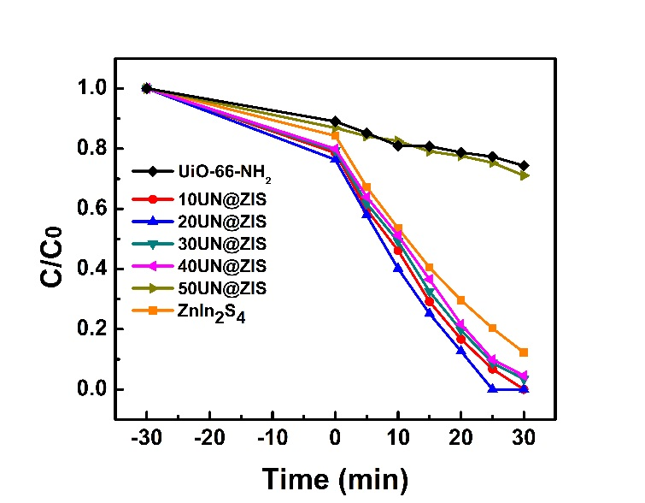

**Fig. S1** The reduction consequences (C/C0) of several photocatalysts on Cr(VI) under the similar condition.