**Figure 1**: Cytotoxic representations of the tested lead compound **3** and novels (**5-9**) against (HCT116, A549, and MDA) relative to the standard control 5-flourouracil (5FU) after 48 h of treatment using prism software program (Graphpad software incorporated, version 3).

**Figure 2**: Viability presentation of the selected novel compound **7** against human normal melanocytes (HFB4) after 48 h of treatment using prism software program (Graphpad software incorporated, version 3)



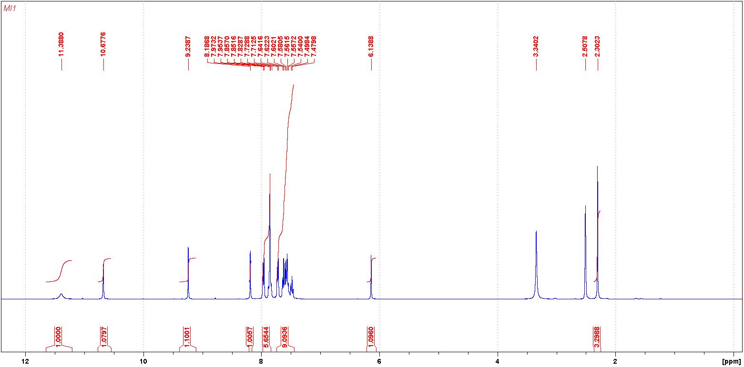

**1H NMR of compound 5**



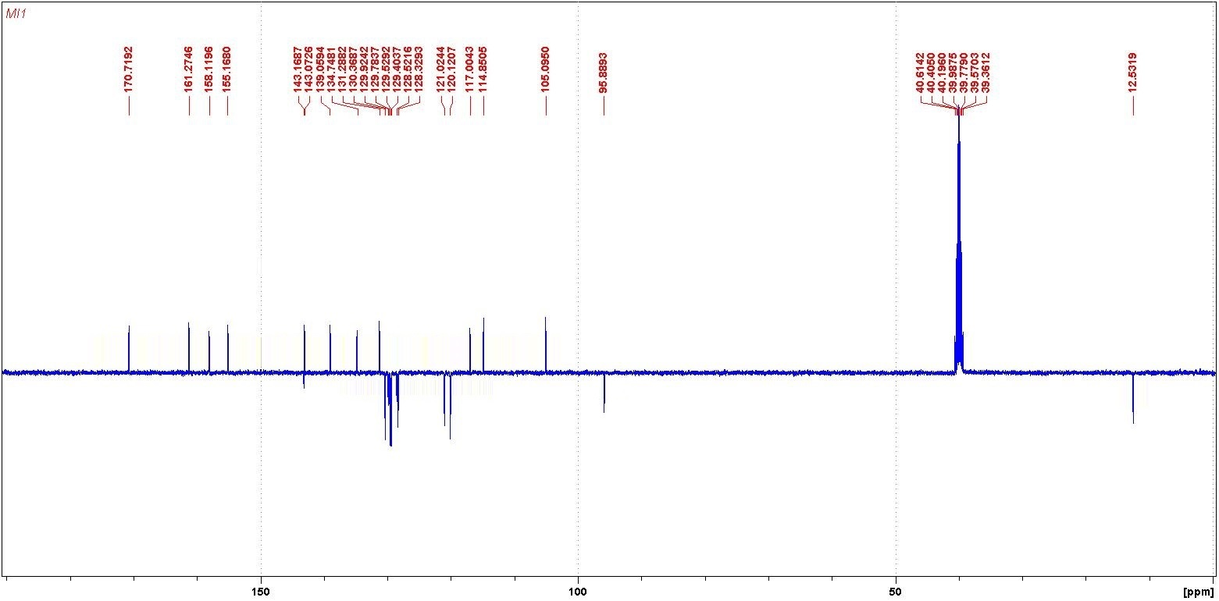

**13C NMR of compound 5**



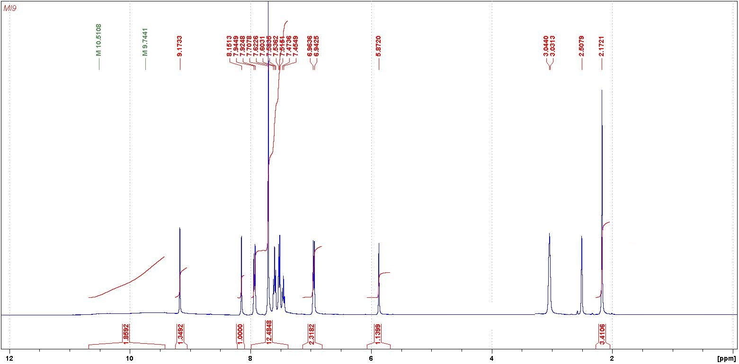

**1H NMR of compound 6**



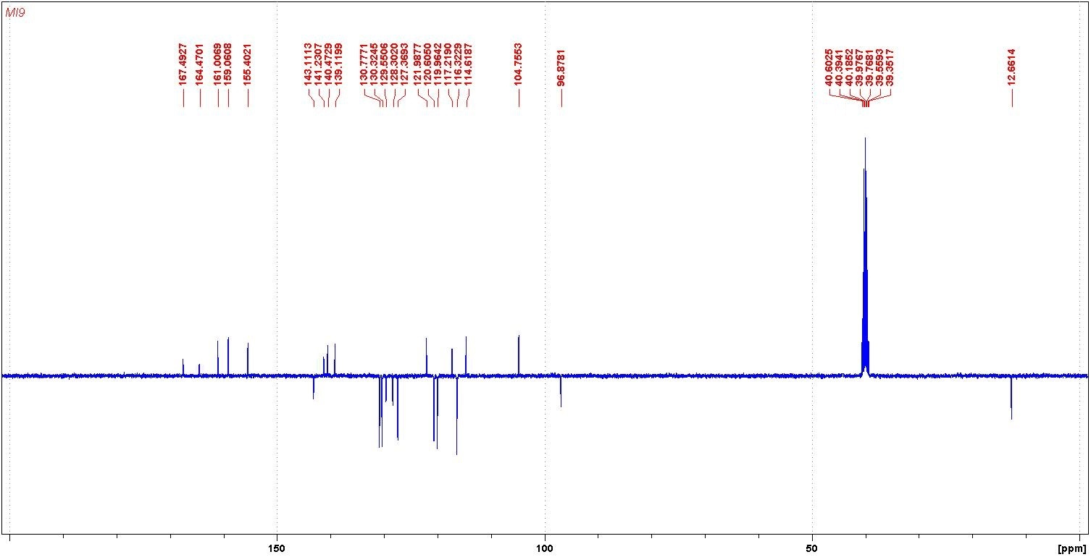

**13C NMR of compound 6**



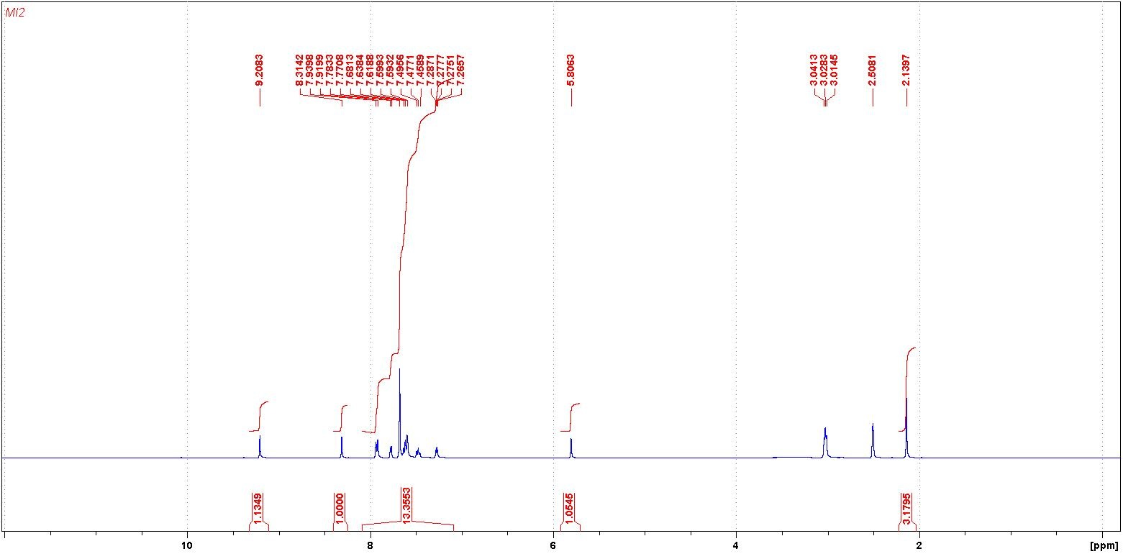

**1H NMR of compound 7**



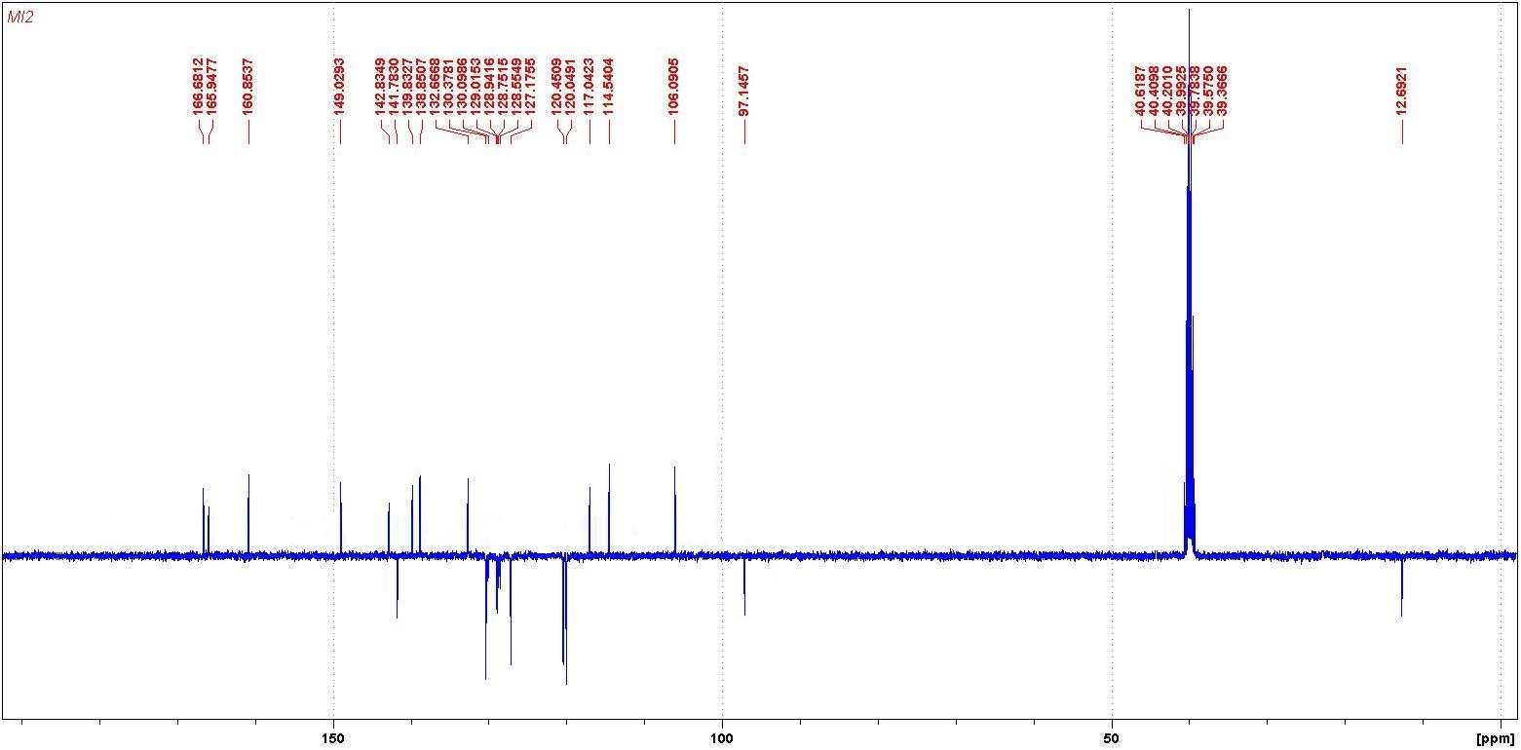

**13C NMR of compound 7**



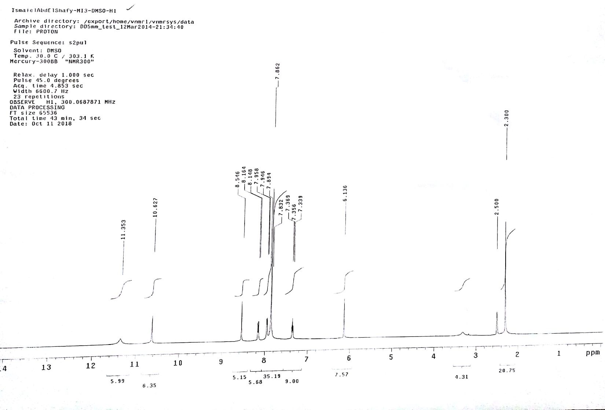

**1H NMR of compound 8**



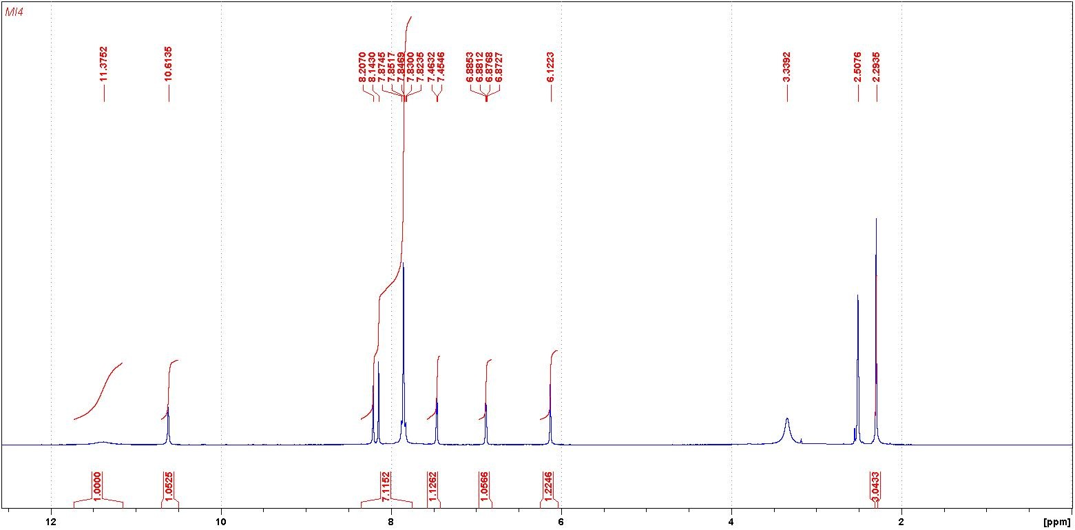

**1H NMR of compound 9**



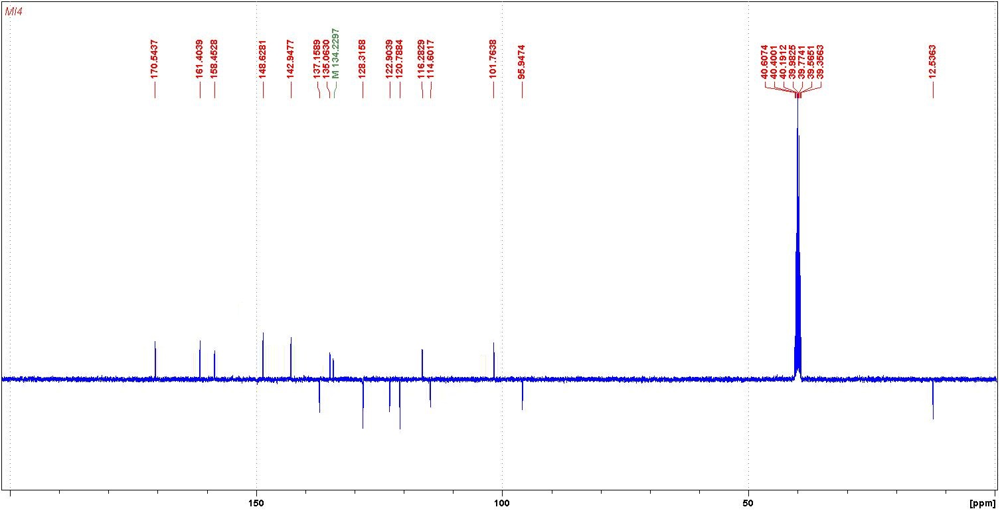

**13C NMR of compound 9**