***Electronic Supplementary Information***

**High-efficiency electrodeposition of polyindole nanocomposite using MoS2 nanosheets as electrolytes and their capacitive performance**

Liming Xua, §, Danqin Lia, §, Weiqiang Zhoua, b, *, Yongbo Dinga, Yanli Wua, Jingkun Xua,*, Xuemin Duana

a *Flexible Electronics Innovation Institute (FEII), Jiangxi Science and Technology Normal University, Nanchang 330013, PR China*

*b Jiangxi Engineering Laboratory of Waterborne Coatings, Jiangxi Science and Technology Normal University, Nanchang 330013,* PR *China*

* Corresponding author: Fax: +86-791-83823320, Tel.: +86-791-88537967, E-mail: zhouwqh@163.com; [xujingkun@tsinghua.org.cn](mailto:xujingkun@tsinghua.org.cn).

**§** Liming Xu and Danqin Li contributed equally to this work.

***Calculation of the specific capacitance***

According to the literature, it is more appropriate to use the area specific capacitance to characterize the electrode material capacity than mass specific capacitance (Horng et al., 2010; Liu et al., 2012). Therefore, the area specific capacitance was calculated from CV (Eq. 1) and GCD (Eq. 2):

$C_{s}=\left(\int{idV}\right) /\left(2S×∆V×v\right)$ (1)

$C_{s}={I∆t}/{S∆V}$ (2)

where $C_{s}$ is the area capacitance (mF cm-2), is the integrated area of the CV curve, $S$ is the surface area of active materials in the single electrode (cm2), is the potential window (V), $v$ is the scan rate (mV s-1), *I* is the current density (A), and $∆t$ is the discharge time (s).

***Calculation of the effective surface areas***

The effective surface areas of PIn and PIn/MoS2 electrodes were tested by CV with 5 mM K3Fe(CN)6 as a probe at different scan rates (T = 298 K). For a reversible process, the following Eq. 3 applies (Wang et al., 2007; Yang et al., 2009):

*i*p = 2.69 × 105 *An*3/2*DR*1/2*C*o*v*1/2 (3)

where *i*p refers to the peak current (A) and A is the electrode area (cm2). For 5 mM K3Fe(CN)6, n = 1, DR = 7.6 × 10-6 cm2 s-1 (0.1 M KCl), *C*o is the concentration of K3Fe(CN)6 (M), *v* is the scan rate (V s-1), then the effective surface areas was calculated from the slope (*k*) of the *i*p versus *v*1/2 plot (Fig. S3) to be 0.11 cm2 for PIn electrode and 0.23 cm2 for PIn/MoS2 electrode.



**Fig. S1** Digital photo of MoS2 ACN solution.

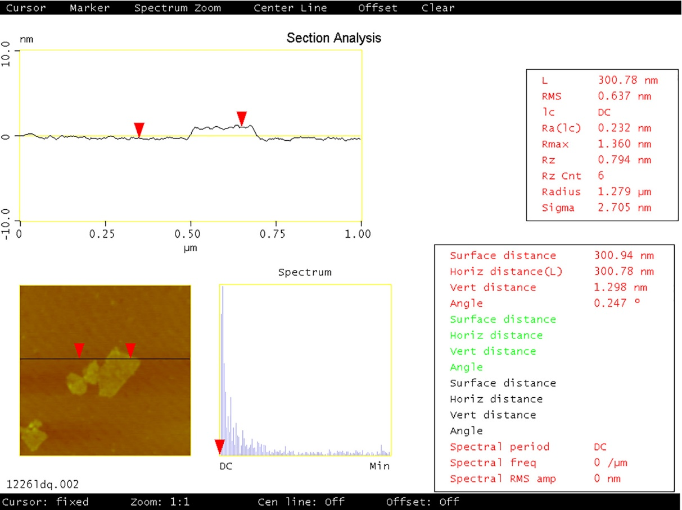

**Fig. S2** AFM images and corresponding data of exfoliated MoS2.

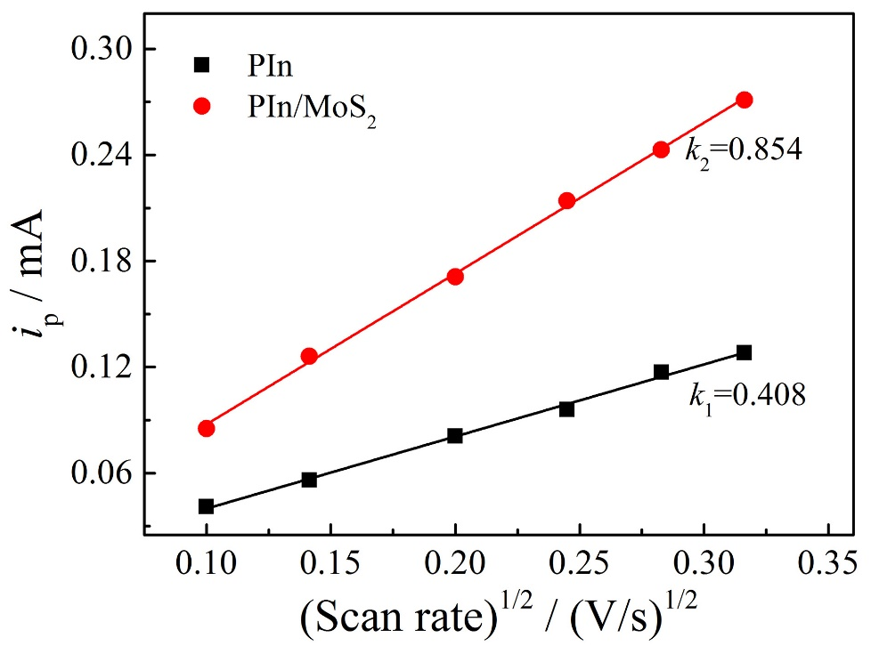

**Fig. S3** The peak current of PIn and PIn/MoS2 electrodes in 5 mM K3Fe(CN)6 containing 0.1 M KCl as a function of the square root of scan rates.

C:\Users\Administrator\Desktop\李丹琴\MoS2 PIN 文献及文章\MoS2+PIN 实验数据处理\SEM-Mapping\EDS.tif

**Fig. S4** EDX spectral of PIn/MoS2.



**Fig. S5** Survey scan X-ray photoelectron spectrum of PIn/MoS2.

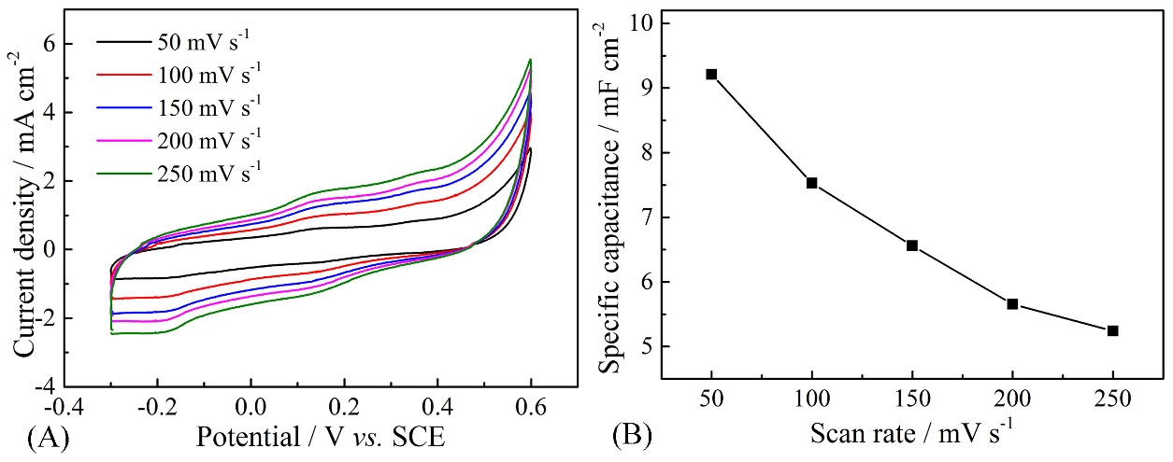

**Fig. S6** The CVs of MoS2 at different scan rates (A) and the specific capacitance as a function scan rate (B).

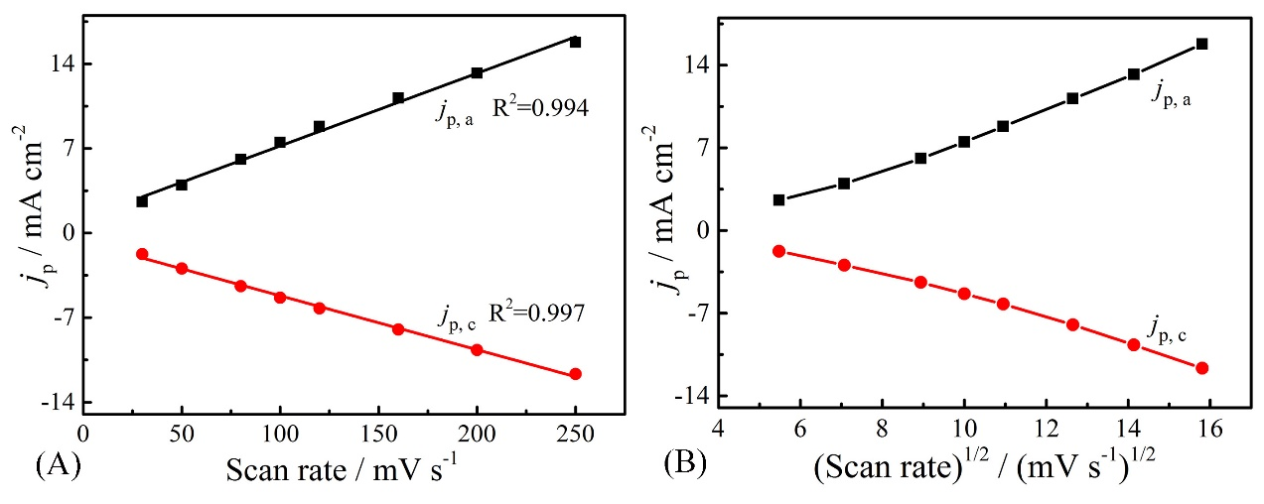

**Fig. S7** The peak current densities of PIn/MoS2 as a function of scan rates (A) and square root of scan rates (B), respectively. *j*p, *j*p,a, *j*p,c are deﬁned as the peak current densities, the anodic peak current densities at about 0.5 V, and the cathodic peak current densities at about 0.4 V, respectively.

**References**

Horng, Y., Lu, Y., Hsu, Y., Chen, C., Chen, L., Chen, K., 2010. Flexible supercapacitor based on polyaniline nanowires/carbon cloth with both high gravimetric and area-normalized capacitance. J. Power Sources 195, 4418-4422.

Liu, J., Jiang, J., Bosman, M., Fan. H., 2012. Three-dimensional tubular arrays of MnO2-NiO nanoflakes with high areal pseudocapacitance. J. Mater. Chem. 22, 2419-2426.

Wang, S., Xie, F., Hu, F., 2007. Electrochemical study of brucine on an electrode modified with magnetic carbon-coated nickel nanoparticles. Anal. Bioanal. Chem. 387, 933-939.

Yang, L., Tang, C., Xiong, H., Zhang, X., Wang, S., 2009. Electrochemical properties of catechin at a single-walled carbon nanotubes-cetylramethylammonium bromide modiﬁed electrode. Bioelectrochemistry 75, 158-162.