**SUPPORTING INFORMATION**

**Silver Nanoparticles-Decorated Reduced Graphene Oxide: A Novel Peroxidase-Like Activity Nanomaterial for Development of a Colorimetric Glucose Biosensor**

**Hoang V. Tran 1,♣, Nghia D. Nguyen 1, Chinh T. Q. Tran 1, Luyen T. Tran 1, Thu D. Le 1, Huyen T. T. Tran 1, B. Piro 1, Chinh D. Huynh 1, Thinh N . Nguyen 1, Nga T. T. Nguyen 1, Hue T. M. Dang 1, Huy L. Huy1, Tran D. Lam 3, Nghia T. Phan 1**

*1 School of Chemical Engineering, Hanoi University of Science and Technology, 1st Dai Co Viet Road, Hanoi, 100000, Vietnam*

*2 University Paris Diderot, Sorbonne Paris Cité, ITODYS, UMR 7086 CNRS, 15 rue J-A de Baïf, 75205 Paris Cedex 13, France*

*3 Institute for Tropical Technology, VAST, 18 Hoang Quoc Viet, Cau Giay, Hanoi, Viet Nam*

**I. Characterization of synthesized graphene oxide (GO)**

**G:\Dropbox\Dropbox\JOURNALS\Preparing MS\AgNPs-rGO data goc\For new-corrected\Fig\SI.1.emf**

**Figure SI.1.** *(a)* *UV-vis spectrum of 0.2 mg.mL-1 graphene oxide (GO) in water; (b) FT-IR and (c) XRD; (d) SEM and (b) TEM of synthesized graphene oxide (GO)*

**II. Optimization condition for H2O2 detection**

***II.1. pH of solution***

Experiments were carried out in acetate buffer solution at different pH (pH1, pH3, pH5, pH7, pH9 and 11, respectively). Particularly, 6 samples consisted of 440 µL buffer solution; 250 µL AgNPs/rGO, 100µL of 20 mM TMB and 100 µL of 0.5 mM H2O2. The pH of above solutions was adjusted by 1M NaOH/1M HCl solutions. The obtained mixtures were left to react in 30 minutes in 50 oC water bath, then they were cooled to room temperature and finally, they were transferred to cuvette for UV-Vis measurement and the optical density at wavelength of 652 nm (A652nm) was recorded. UV-Vis spectra are shown in Fig. SI. 2a.

***II.2. Temperature***

8 samples were prepared for this test. Each reaction solution was consisted 440 µL acetate buffer solution (pH = 3); 250 µL AgNPs/rGO solution; 100 µL 20 mM TMB solution and 100 µL 0.5mM H2O2. Above mixtures were kept at room temperature (27°C), 30°C, 40°C, 50 °C, 60 °C, 70 °C and 80 °C for 30 minutes to finish the reactions. The obtained mixtures were cooled to room temperature and transferred to cuvette for UV-Vis measurement. UV-vis spectra are shown in Fig.SI.2b.

***II.3. 3,3’,5,5’ - tetrametylbenzidin (TMB) concentration***

We use an experiment to specify the effect of TMB’s concentration: 10 samples were prepared including 250 µL AgNPs/rGO; 100 µL 0.5 mM H2O2; various volume of 20 mM TMB (22.5, 45, 67.5, 90, 112.5, 135, 157.5, 180, 202.5 and 225 µL) and acetate buffer solution (pH3) was added to fix 900 µL. The obtained mixtures were left to react in 30 minutes, then they were cooled to room temperature and finally, they were transferred to cuvette for UV-Vis measurement and the optical density at wavelength of 652 nm (A652nm) was recorded (Fig. SI.2c).

***II.4. Volume of catalyst solution***

Optimization catalyst dosageexperiments were conducted in mixtures containing 100 µL 20 mM TMB solution, 100 µL 0.5mM H2O2 and 50 to 300 µL of AgNPs/rGO solution, respectively. Different volume of acetate buffer solution (pH3) was added into above mixture to fix 900 µL. The obtained mixtures were left to react in 30 minutes, then they were cooled to room temperature and finally, they were transferred to cuvette for UV-Vis measurement (Fig. SI.2d) and the optical density at wavelength of 652 nm (A652nm) was recorded.

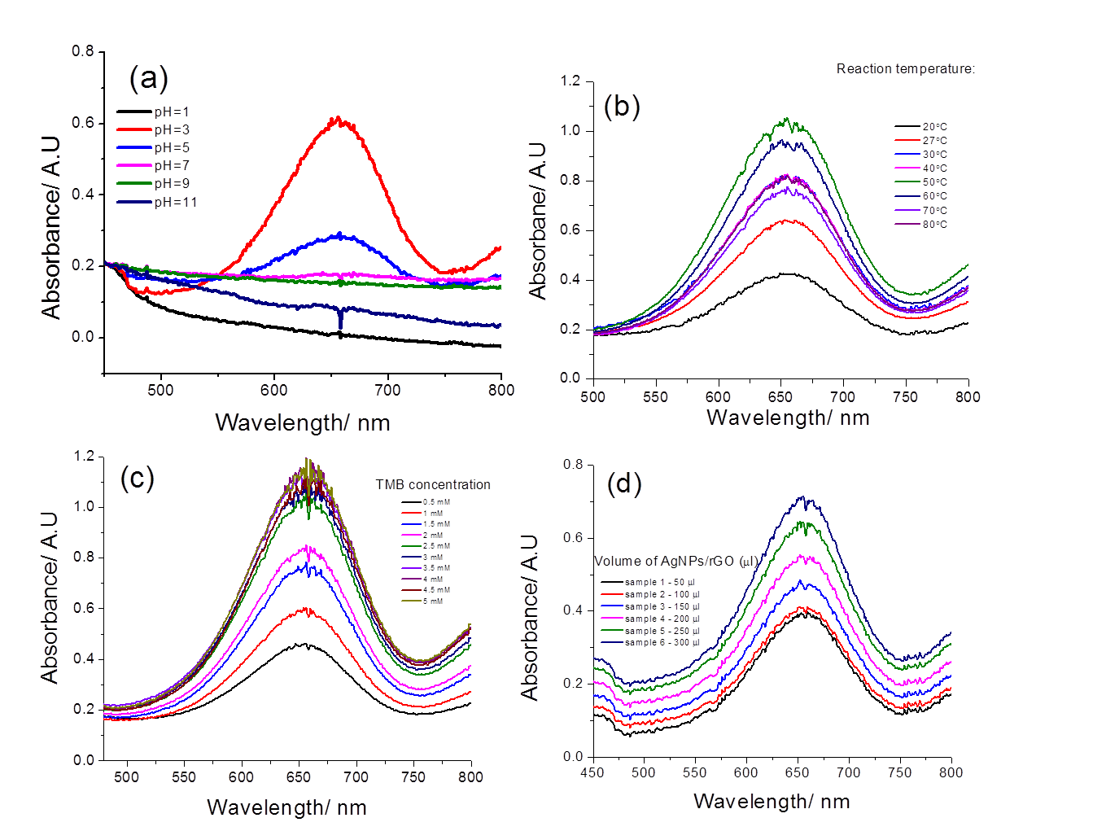

**Figure SI.2.** *UV-Vis spectra of AgNPs/rGO + H2O2 + TMB reaction at different reaction conditions: (a) pH; (b) reaction temperature; (c) TMB concentration and (d) dosage of AgNPs/rGO. Detailed reaction conditions were described in the text.*

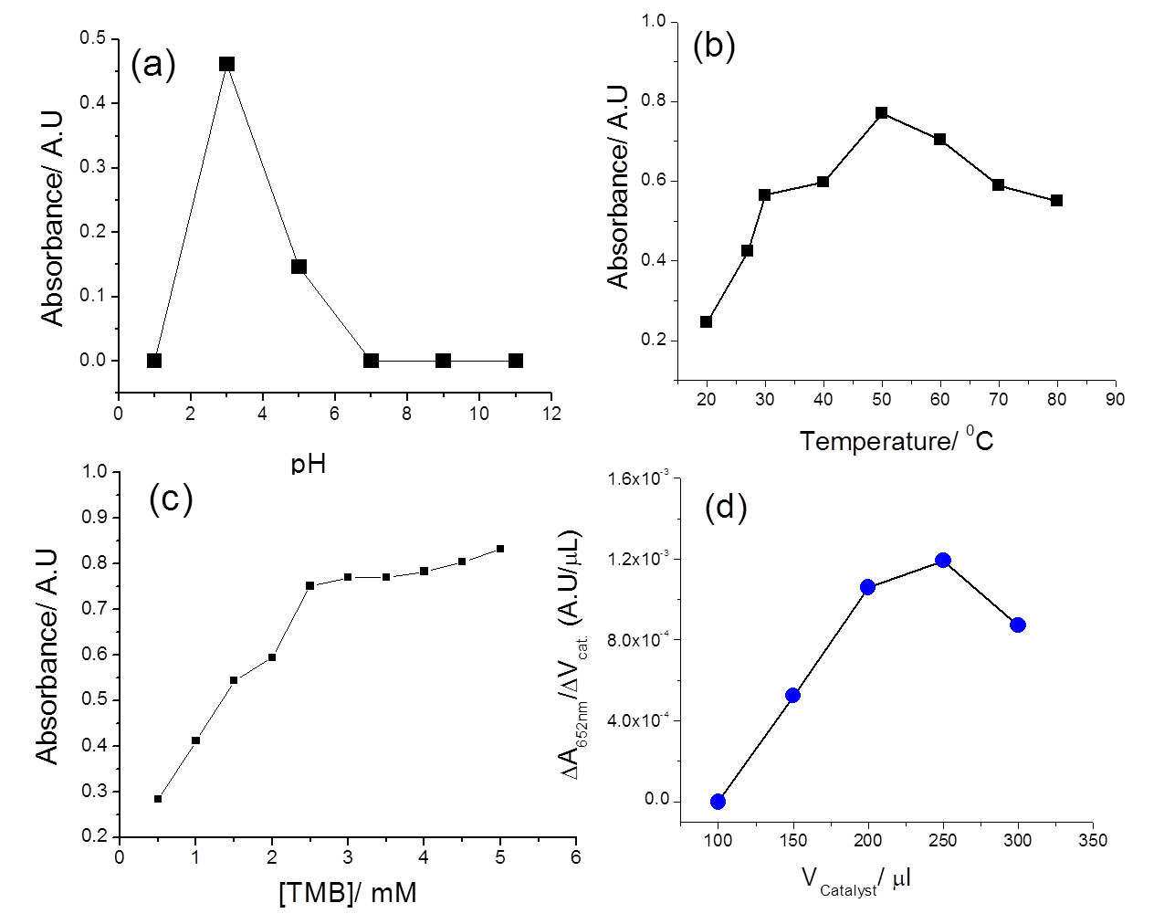

**Figure SI.3.** Effect of various factors on output signal of hydrogen peroxide test: (a) pH; (b) reaction temperature; (c) TMB concentration and (d) quantity of AgNPs@rGO. Detailed reaction conditions are described in the text.

**.**