**Supplementary Information**

**Synthesis, Structure Elucidation and Plants Growth Promoting Effects of Novel Quinolinyl Chalcones**

Mohamed M. Hassan*a, Abdel Rahman A. Alzandi b, and Mostafa M. Hassan c

*a Chemistry Department, Faculty of Education, Ain Shams University, Roxy, 11711, Cairo-Egypt.*

*b Biology Department, Faculty of Sciences & Arts (Almikhwah), Al Baha University, KSA.*

*c MSA University, Faculty of pharmacy, 26 July Mehwer Road intersection with Wahat Road, 6th*

*October City, Cairo, Egypt.*

* E-Mail: mmhassan121@yahoo.com

|  |
| --- |
|  |

1. **Analyses figuers**

 **Fig.1.** Confirmation of compound 7 and 8 structures utilizing NOE effect.

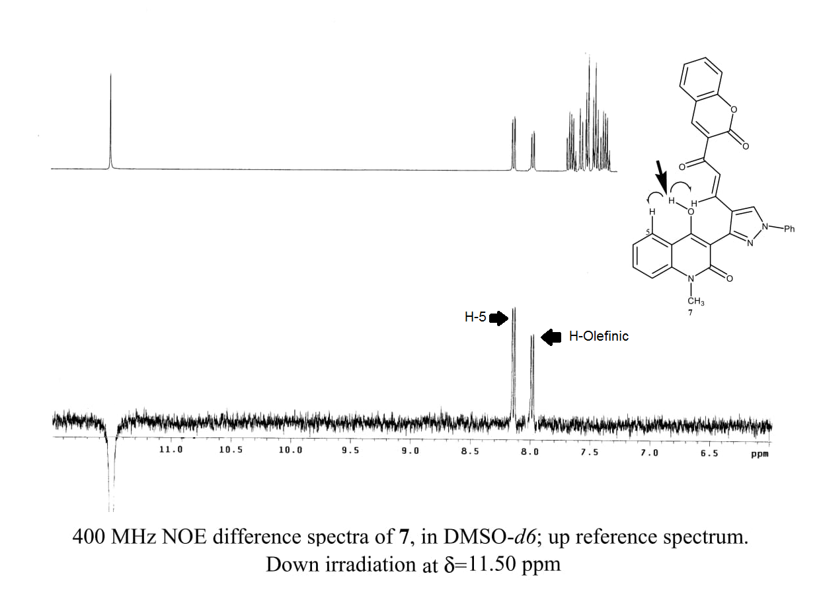

**Fig.2.** Confirmation of compound 7 structures utilizing NOE effect.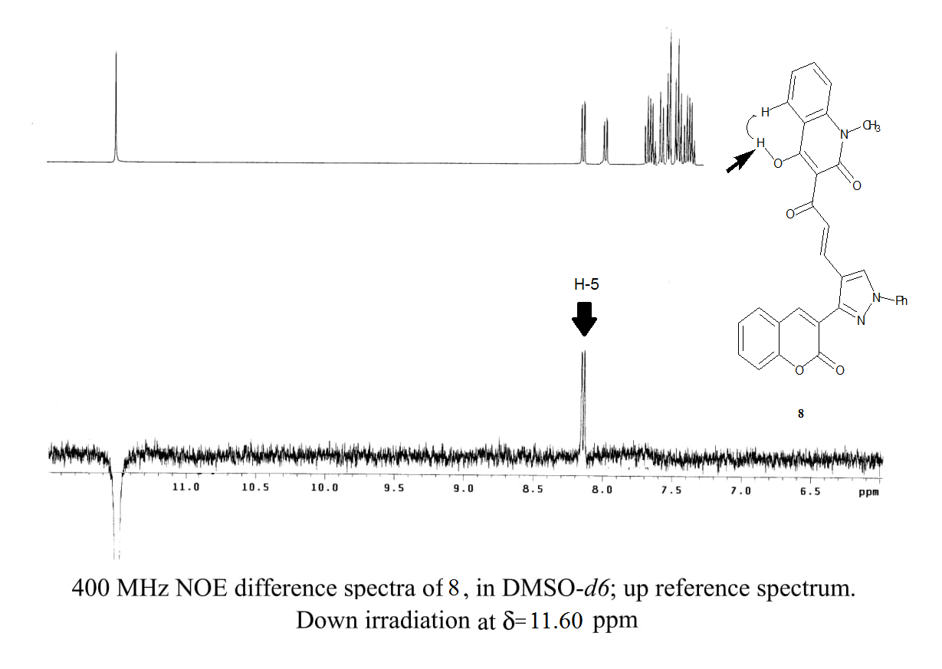

**Fig.3.** Confirmation of compound 8 structures utilizing NOE effect.

**2. Spectroscopic information**

**4.2. Procedure for preparation of 3-(4-Hydroxy-1-methyl-1,2-dihydro-2-oxoquinolin-3-yl)-1-phenyl-1*H*-pyrazole-4-carbaldehyde (5):**

Phosphoryl chloride POCl3 (30 mmol) was added up to DMF (30 mmol) with continuous stirring. The reaction content was left to cool down before adding the hydrazone**3** (10 mmol) solution in DMF (10 mL). Stirring condition was maintained for 1 h at room temperature and then gradually raised to 70-80 °C for 4 h. The reaction content was decanted onto mashed ice and then cold potassium carbonate solution was used for neutralization. The precipitated product was separated by filtration before subjected to purification using flash-chromatography with ethyl acetate/petroleum ether as eluent (1:1, v/v). Finally crystallization was performed from ethanol to yield the product as yellow crystals; (40% yield); m.p 230-232 °C (Lit. 228-230 ºC, Abdel-Megid et al., 2007).

**4.3. Procedure for preparation of 3-(2-Oxo-2*H*-chromen-3-yl)-1-phenyl-1*H*-pyrazole-4- carbaldehyde (6)**

POCl3 (14 mmol) was added to cold DMF solution (14 mmol) at 0–5 oC. 3-[1-(phenyl-hydrazono)-ethyl]-chromen-2-one **(4)** (3.5 mmol) was added and the content was subjected to contentious stirring for 4 h at room temperature. Accomplishment of the reaction was adjusted by TLC. The reaction content was poured to ice before neutralization with 10% NaOH solution. The precipitate was ﬁltered off, dried, and recrystallized from ethanol as yellow crystals; (60% yield); m.p 179-182 °C (Lit.180–185 ºC, Laxmi et al., 2013).

**4.4. Procedure for preparation of 4-hydroxy-1-methyl-3-(4-((2*H*-2-oxo-chromen-3-yl)prop-2-enoyl)-1-phenyl-1*H*-pyrazol-4-yl)quinolin-2(1*H* )-one (7)**

Magnetically stirred solution of **5** (1 mmol) and **2** (1 mmol) in absolute ethanol (15 ml) was heated at 80 oC for 8 h with addition of catalytic piperidine drops. The resulted crystalline product that produced while hot was separated by filtration and purified by crystallized from ethanol to yield 7 as pale-yellow crystals, yield (0.412g) 80%, m.p. > 300ºC. IR (KBr), (νmax, cm-1): 3430- 3200 (br, OH), 3040 (C-Harom.), 2930 (C-Haliph.),1660-1630 (3C=O), 1590 (C=N), 1530 (C=C) cm-1. 1H NMR (400 MHz, DMSO): δ 3.65 (s, 3H, NCH3),7.50 (d,1H,*J* 15.6 Hz, Hα), 7.26-8.15(m, 15H, Ar–H), 8.00(d, 1H, *J* 15.8 Hz, Hβ),11.50 (s, 1H, OH). MS(ESI) *m/z*:MS (ESI) *m/z* 538 [(M + Na)+, 45%], 516 [(M + H)+, 20%], 515(100). Anal.calc. for C31H21N3O5 (515.52): C, 72.23; H, 4.11; N, 8.15.Found: C, 72.10; H, 3.95; N, 8.00%.

**4.5. Procedure for preparation of 4-hydroxy-1-methyl-3-((2*E*)-3-(3-(2-oxo-2*H*-chromen-3-yl)-1-phenyl-1H-pyrazol-4-yl)acryloyl)quinolin-2(1*H*)-one (8)**

Solution of **6** (1 mmol) and **1** (1 mmol) in absolute ethanol (15 ml) was heated under reflux for 8 h with addition of drops of catalytic piperidine. The resulted crystalline product that produced while hot was filtered and recrystallized using ethanol to yield **7** as pale yellow crystals, yield (0.386g) 75%, m.p. > 300ºC. IR (KBr), (νmax, cm-1): 3410- 3250 (br, OH), 3030 (C-Harom.), 2910 (C-Haliph.),1665-1635 (3C=O), 1580 (C=N), 1510 (C=C) cm-1.1H NMR (400 MHz, DMSO): δ 3.60 (s, 3H, NCH3),7.40 (d,1H,*J* 15.6 Hz, Hα), 7.26-8.15(m, 15H, Ar–H), 7.95(d, 1H, *J* 15.8 Hz, Hβ),11.60 (s, 1H, OH).MS(ESI) *m/z* :MS (ESI) *m/z* 538 [(M + Na)+, 25%], 516 [(M + H)+, 40%], 515(100). Anal.calc. for C31H21N3O5 (515.52): C, 72.23; H, 4.11; N, 8.15.Found: C, 71.95; H, 3.50; N, 7.90%.

**3.Schemes and tables**



**Scheme 1.** Synthesis of the new chalcones 7 and 8.

**Table 1. Effect of 4-hydroxy-1-methyl-3-(4-((2*H*-2-oxo-chromen-3-yl)prop-2-enoyl)-1-phenyl-1*H*-pyrazol-4-yl)quinolin-2(1*H* )-one (7)**

|  |  |  |  |  |  |  |  |  |  |  |  |  |  |  |  |  |  |  |
| --- | --- | --- | --- | --- | --- | --- | --- | --- | --- | --- | --- | --- | --- | --- | --- | --- | --- | --- |
| **Periodicity of the observation**  **(days)** | **Cultivated Crops** | | | | | | | | | | | | | | | | | |
| ***Hibiscus*** | | | | | | ***Mint*** | | | | | | ***Basil*** | | | | | |
| **Shoot height** | | | **No. of leaves** | | | **Shoot height** | | | **No. of leaves** | | | **Shoot height** | | | **No. of leaves** | | |
| **C** | **T** | **% change** | **C** | **T** | **% change** | **C** | **T** | **% change** | **C** | **T** | **% change** | **C** | **T** | **% change** | **C** | **T** | **% change** |
| **15** | 8 | 13 | 62.5 | 5 | 8 | 60.0 | 8 | 10 | 25.0 | 8 | 10 | 25.0 | 10 | 13 | 30.0 | 14 | 18 | 28.6 |
| **30** | 16 | 22 | 37.5 | 8 | 11 | 37.5 | 11 | 13 | 18. 2 | 14 | 18 | 28.6 | 14 | 16 | 14.3 | 24 | 32 | 33.3 |
| **45** | 36 | 44 | 22.2 | 9 | 14 | 55. 6 | 13 | 15 | 15.4 | 17 | 20 | 17.6 | 16 | 22 | 37.5 | 38 | 46 | 21.1 |
| **60** | 54 | 62 | 14.8 | 11 | 16 | 45. 5 | 16 | 18 | 12.5 | 30 | 39 | 30.0 | 20 | 25 | 25.0 | 44 | 51 | 15.9 |
| **75** | 72 | 78 | 8.3 | 14 | 18 | 28.6 | 19 | 22 | 15.8 | 32 | 39 | 21.9 | 24 | 32 | 33.3 | 53 | 62 | 17.0 |
| **90** | 89 | 95 | 6.7 | 16 | 22 | 37.5 | 20 | 24 | 20.0 | 38 | 42 | 10.5 | 26 | 33 | 26.9 | 61 | 74 | 21.3 |

**Table 2. Effect of 4-hydroxy-1-methyl-3-((2E)-3-(3-(2-oxo-2*H*-chromen-3-yl)-1-phenyl-1H-pyrazol-4-yl)acryloyl)quinolin-2(1*H*)-one (8)**

|  |  |  |  |  |  |  |  |  |  |  |  |  |  |  |  |  |  |  |
| --- | --- | --- | --- | --- | --- | --- | --- | --- | --- | --- | --- | --- | --- | --- | --- | --- | --- | --- |
| **Periodicity of the observation**  **(days)** | **Cultivated Crops** | | | | | | | | | | | | | | | | | |
| ***Hibiscus*** | | | | | | ***Mint*** | | | | | | ***Basil*** | | | | | |
| **Shoot height** | | | **No. of leaves** | | | **Shoot height** | | | **No. of leaves** | | | **Shoot height** | | | **No. of leaves** | | |
| **C** | **T** | **% change** | **C** | **T** | **% change** | **C** | **T** | **% change** | **C** | **T** | **% change** | **C** | **T** | **% change** | **C** | **T** | **% change** |
| 15 | 7 | 20 | 185.7 | 4 | 10 | 150.0 | 9 | 12 | 33.3 | 7 | 19 | 171.4 | 11 | 17 | 54.5 | 16 | 30 | 87.5 |
| 30 | 17 | 30 | 76.5 | 9 | 14 | 55.5 | 12 | 14 | 16. 7 | 14 | 26 | 85.7 | 13 | 20 | 53.8 | 22 | 38 | 72.7 |
| 45 | 32 | 50 | 56.3 | 11 | 18 | 63.6 | 14 | 17 | 21.4 | 18 | 35 | 94.4 | 25 | 30 | 20.0 | 36 | 54 | 50.0 |
| 60 | 55 | 74 | 34.5 | 13 | 20 | 53.8 | 17 | 20 | 17.6 | 28 | 44 | 57.1 | 26 | 35 | 34.6 | 42 | 66 | 57.1 |
| 75 | 73 | 85 | 16.5 | 16 | 22 | 37.5 | 20 | 23 | 15.0 | 31 | 59 | 90.3 | 30 | 38 | 26. 7 | 50 | 78 | 56.0 |
| 90 | 90 | 100 | 11.1 | 18 | 25 | 38. 9 | 21 | 26 | 23.8 | 36 | 66 | 83.3 | 31 | 40 | 29.0 | 63 | 89 | 41.3 |