**Supporting information**

**Fig.S1** The elemental mapping images of the distribution of (a) C, (b) N, (c) O, (d) Ca, (e) P, (f) Ti, (g) La and (h) Tb ions for TNT/CS-CA@ M-HAP (II) coating.

**Fig.S2** (i) Bode and (ii) phase plots of uncoated Ti, anodized Ti, TNT/CS-CA and TNT/CS-CA@M-HAP (I) to TNT/CS-CA@M-HAP (III) coatings on Ti samples obtained in Ringer’s solution.

Fig.S3 In vitro cytotoxicity results of TNT/CS-CA@M-HAP (II) coatings on MG-63 human osteoblast cells for 1, 4 and 7 days.

**Fig.S4** MTT assay of MG63 human osteoblast cells incubated on TNT/CS-CA@M-HAP (II) on Ti specimen for 1, 4 and 7 days.

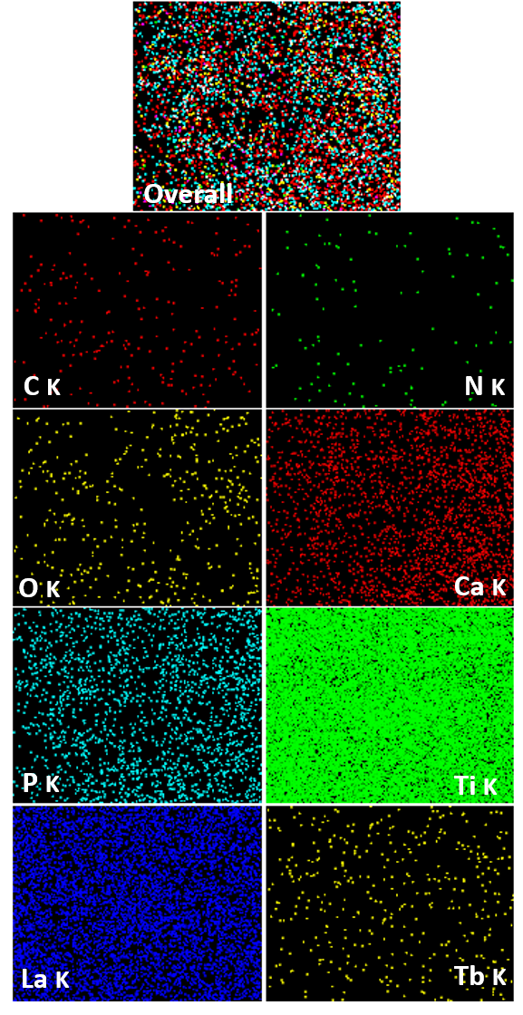

**Fig. S1**

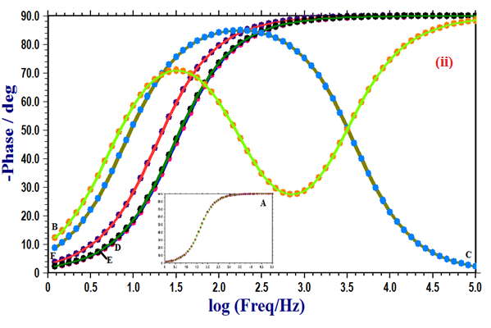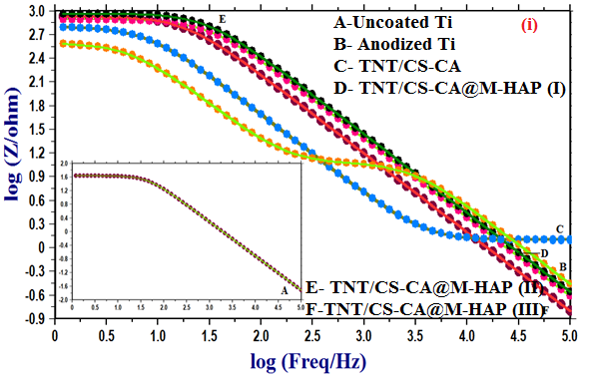

**Fig. S2**



**Fig.S3**

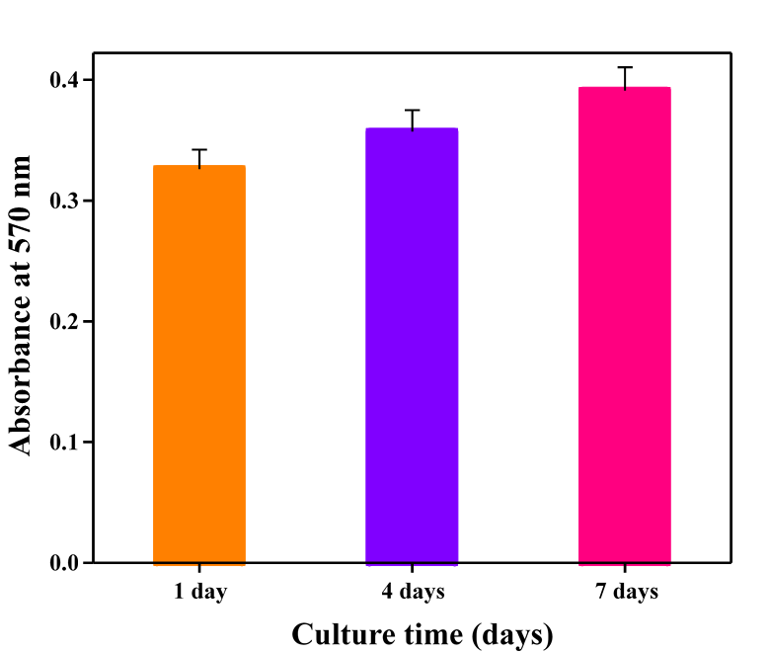

**Fig.S4**