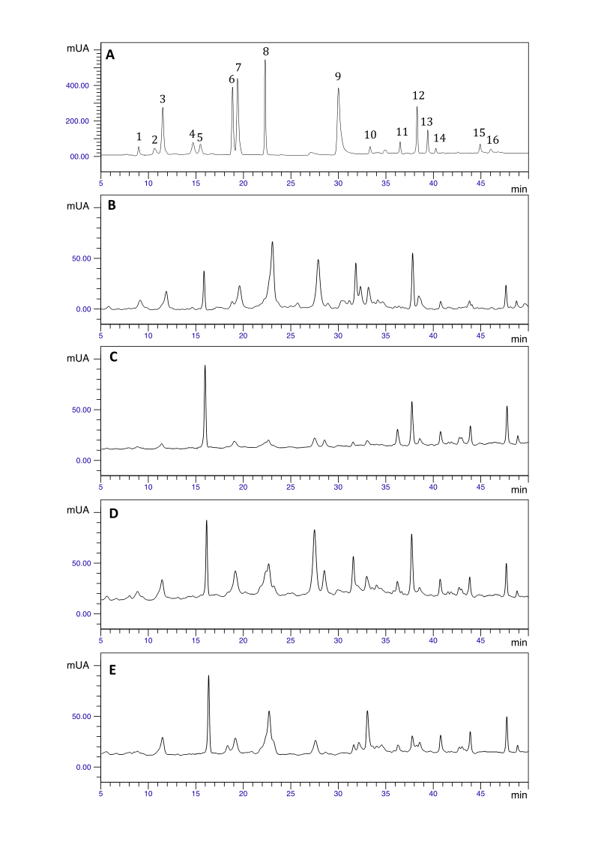

**Figure 1S.** Typical UHPLC-DAD chromatograms of standard phenolic compounds (A) and methanol extract from hydrodistilled residue by products of basil leaves (Control (B); sample treated with: cellulase (C), hemicellulase (D), and viscozyme (E)). Peak numbers refer to: catechin (1), chlorogenic acid (2), caffeic acid (3), ferulic acid (4), vanillic acid (5), quercetin-3-*O*-β-D-galactoside (6), quercetin-3-*O*-β-D-glucoside (7), rosmarinic acid (8), *p*-coumaric acid (9), rutin (10), kaempferol-3-*O*-rutinoside (11), kaempferol-3-*O*-β-D-glucoside (12), myricetin (13), quercetin (14), apigenin (15), kaempferol (16).