**Physicochemical parameter influences and their optimization on the biosynthesis of MnO2 nanoparticles using *Vernonia amygdalina* leaf extract**

Arabian Journal of Chemistry

**Yilkal Dessiea,*. Sisay Tadesseb. Rajalakshmanan Eswaramoorthya**

a Adama Science and Technology University, Department of Applied Chemistry, Adama, Ethiopia

b Hawassa University, Department of Chemistry, Hawassa, Ethiopia

*Corresponding author:

E-mail address: [yilkal.dessie@astu.edu.et](mailto:yilkal.dessie@astu.edu.et) ; [yilikaldessie@gmail.com](mailto:yilikaldessie@gmail.com)

ORCID: <https://orcid.org/0000-0001-7287-6499>

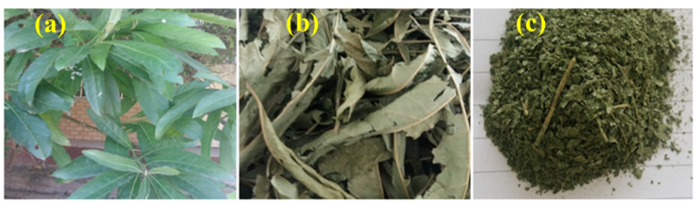

**Fig. S1** Images of (a) Fresh leaves, (b) Dried, and (c) powdered Vernonia amygdalina plant

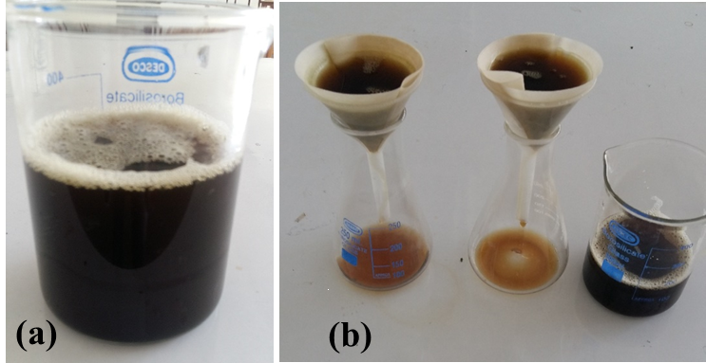

**Fig. S2** (a) Aqueous extracted and (b) filtration of *Vernonia amygdalina* (Photograph pictures).



**Fig. S3** UV-Vis spectrum of biosynthesized MnO2 NPs (R stands for experimental run)



**Fig. S4** Ramps graph of numerical optimized physicochemical conditions.



**Fig.S5** Desirability effect of absorbance on physicochemical parameters dependence



**Fig. S6** UV-vis spectrum of MnO2 NPs in optimum condition (Exp = Experimental at 320 nm)

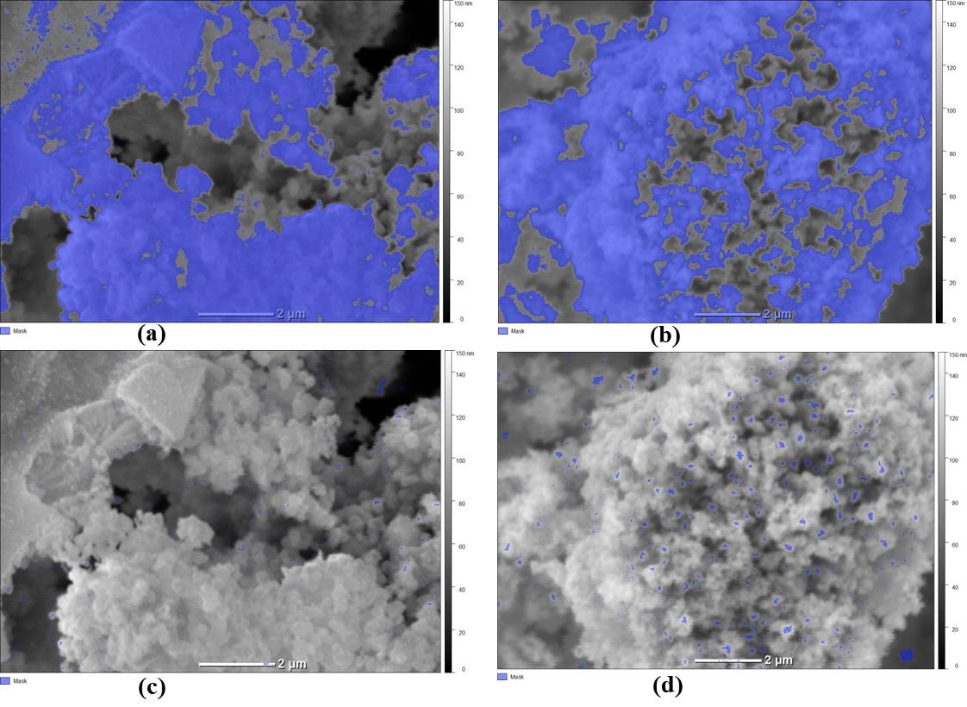**Fig. S7** Grain marked results by the threshold method (a) after 2 hour calcination time and (b) after 3 hour calcination time; Watershed method (c) after 2 hour calcination time and (d) after 3 hour calcination time for MnO2 NPs calcined at 450 oC.



**Fig. S8** Inverted height distributions versus position (z-axis) graph (total number of points are 120).