Supp. Fig. S1 MS/MS spectra of AV

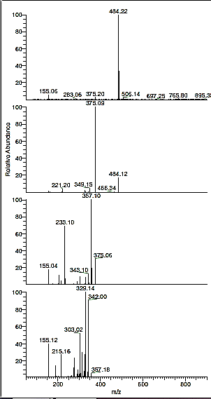

**AV**

Supp. Fig. S2 Acid degradation products MS spectra and its fragmentation

1. 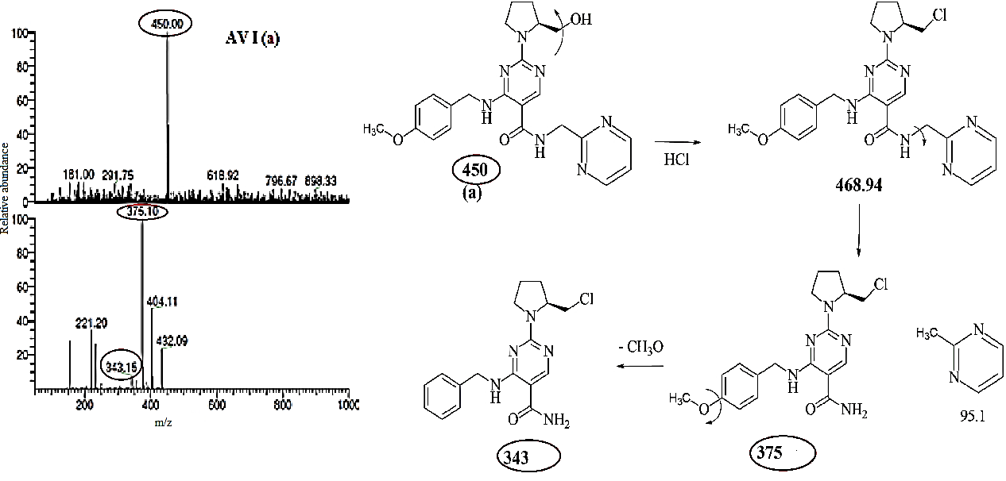
2. 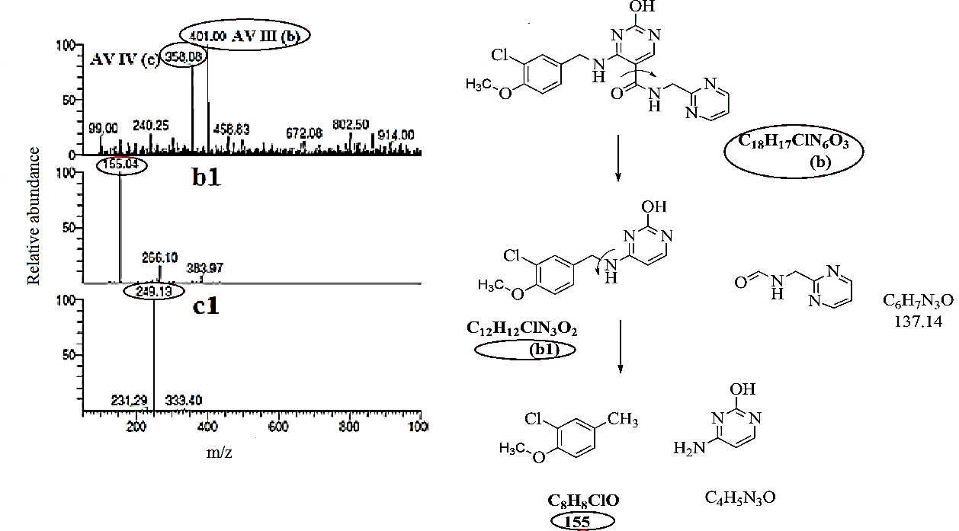
3. 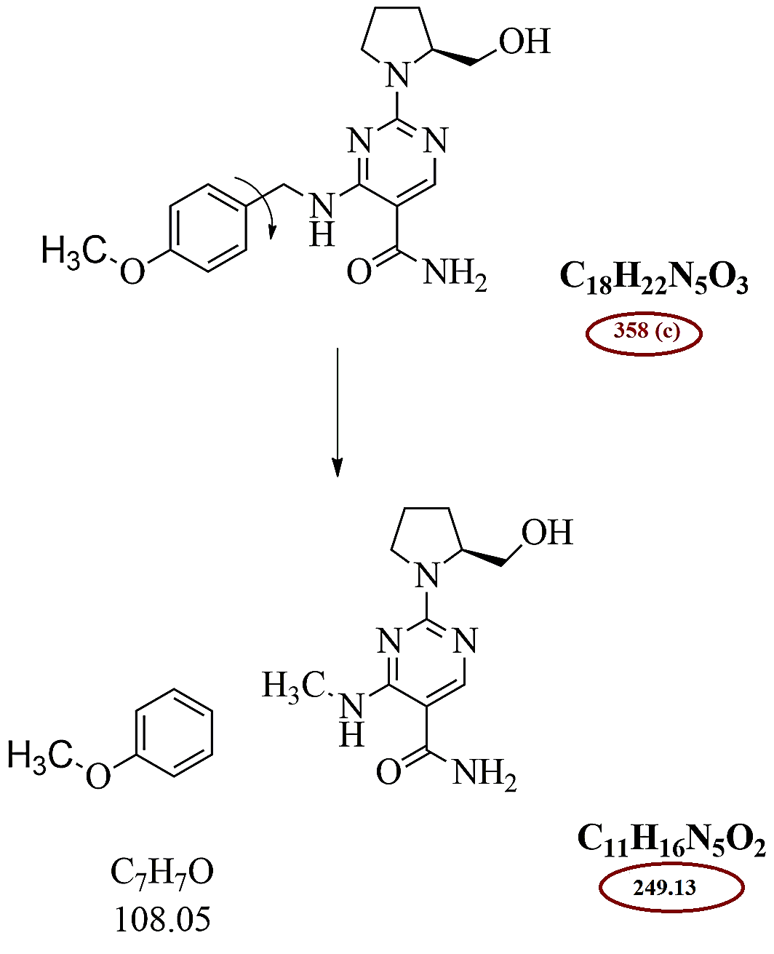
4. 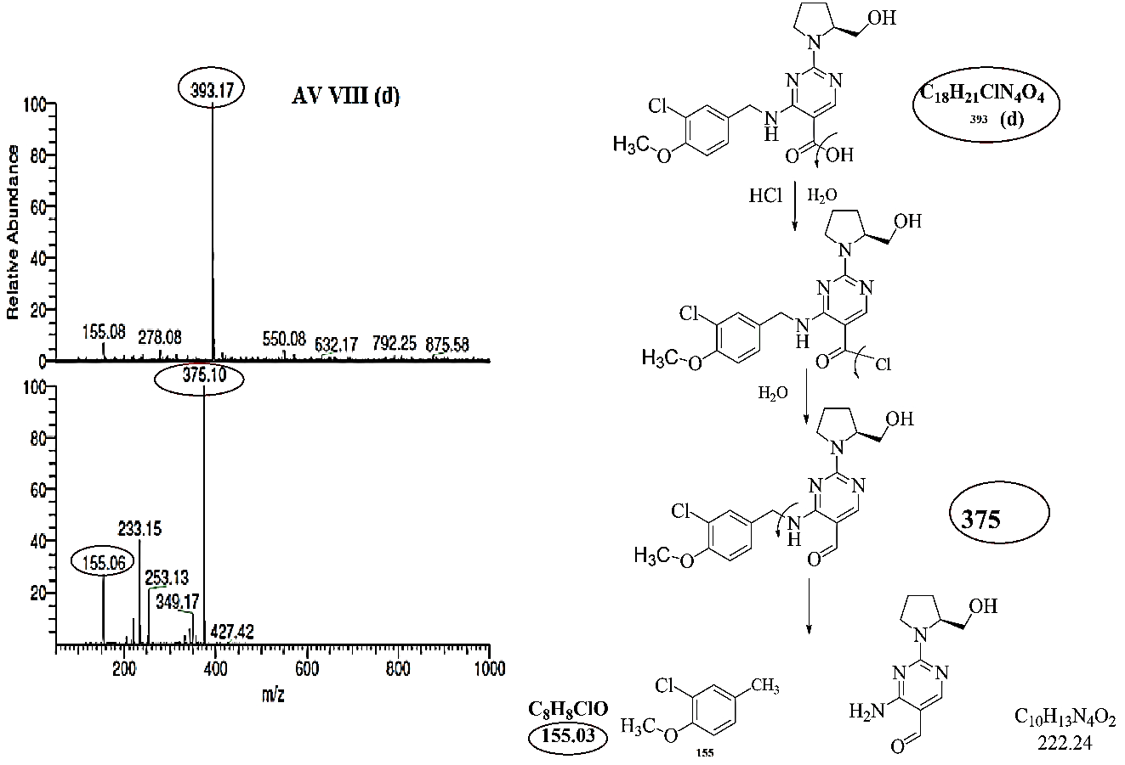
5. 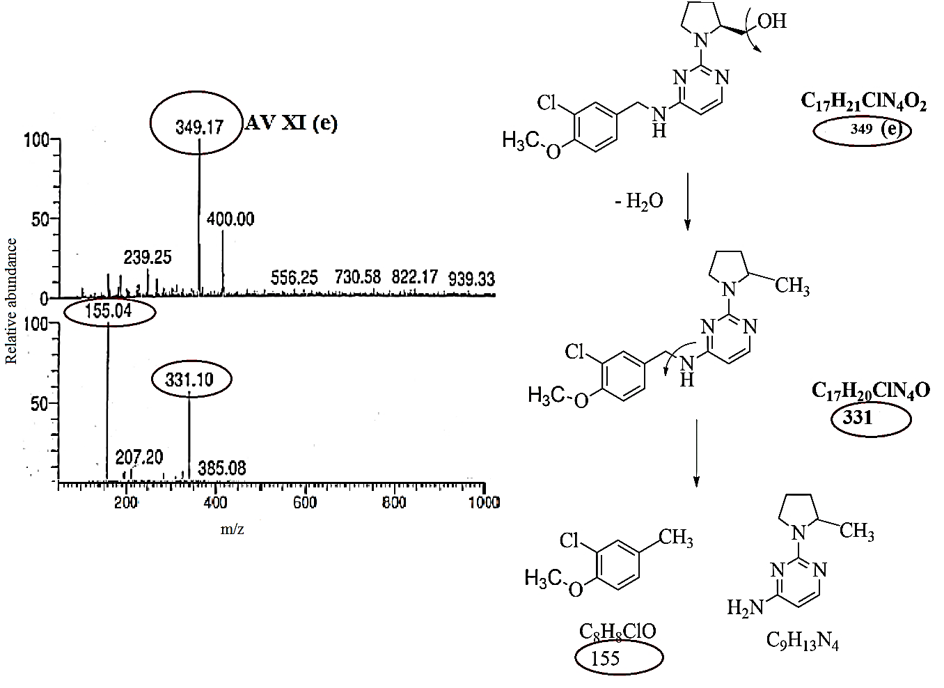

(vi)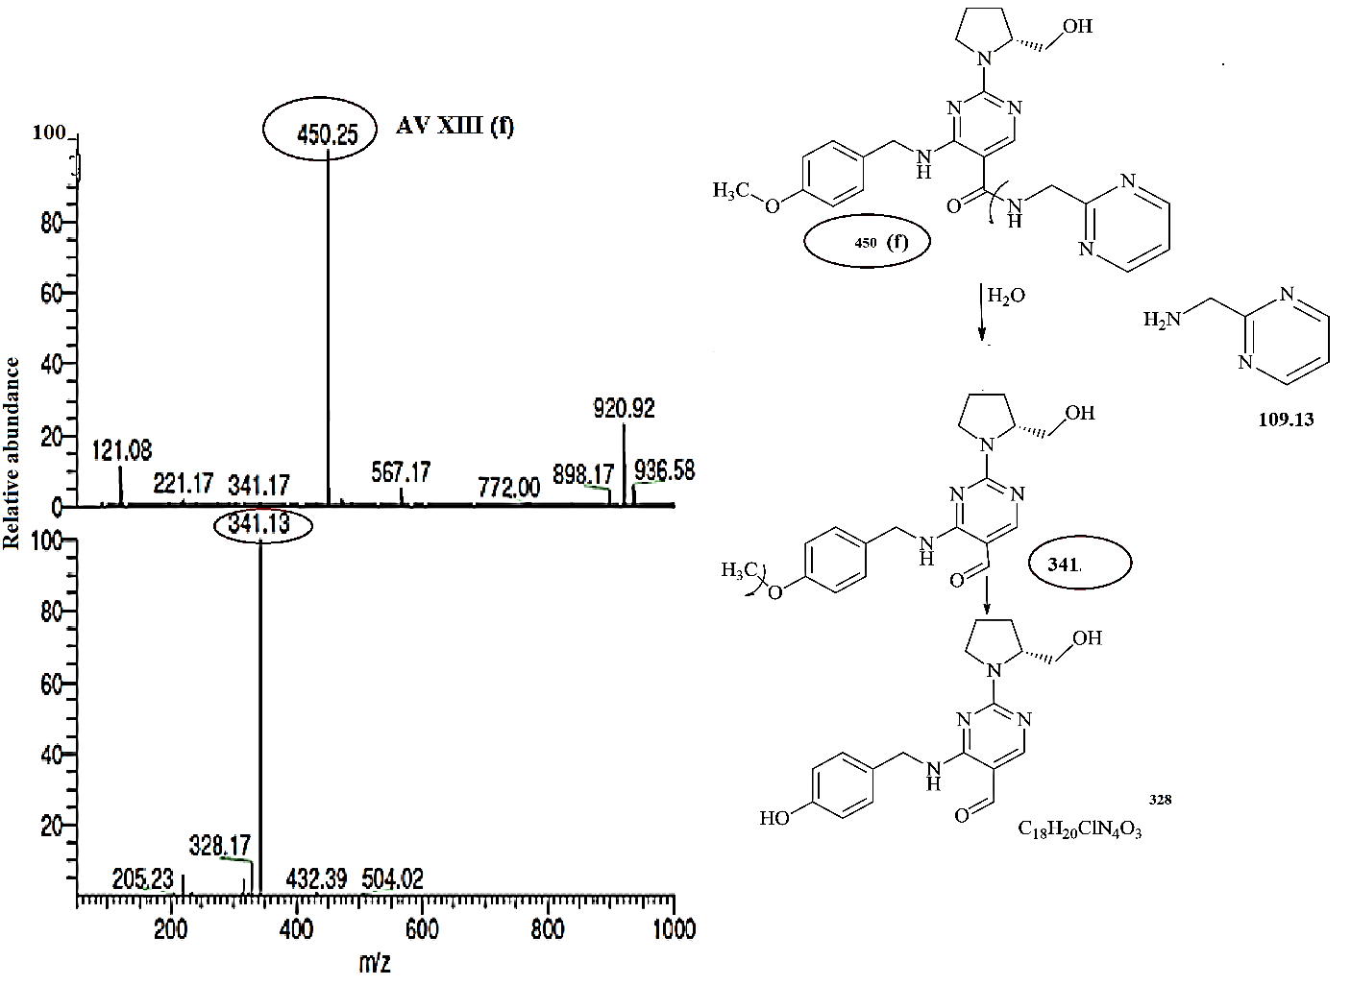

(vii) 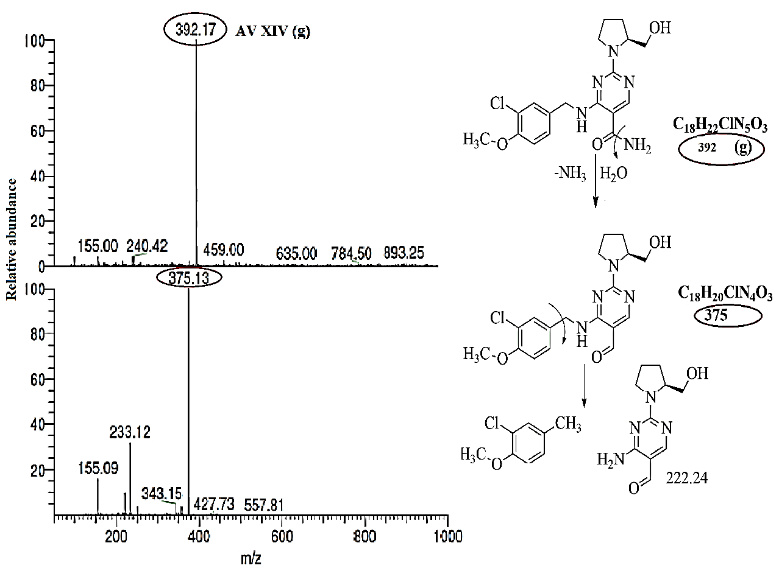

Supp. Fig. S3 Alkaline degradation product MS spectra and its fragmentation

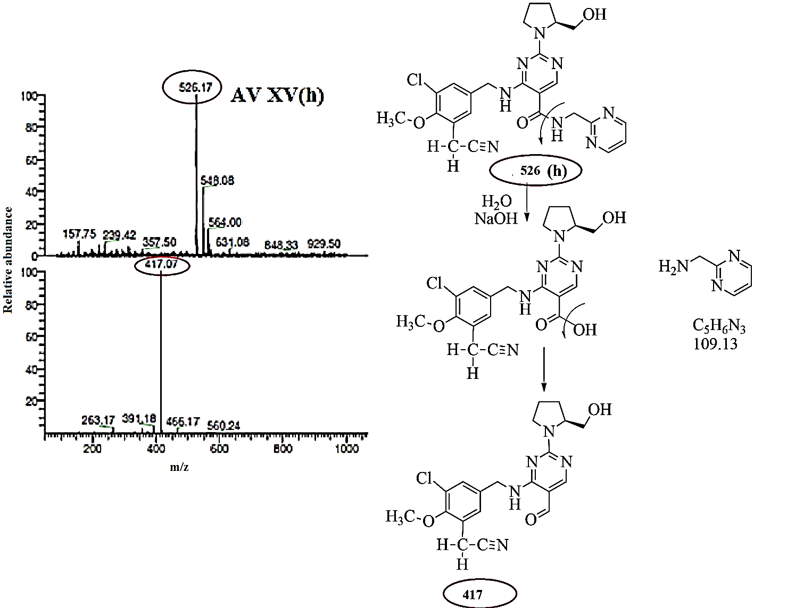

Supp. Fig. S4 Photolytic degradation products MS spectra and its fragmentation

1. 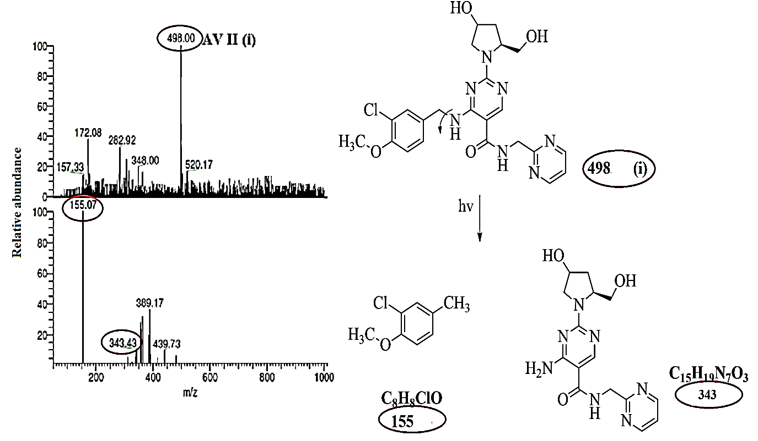
2. 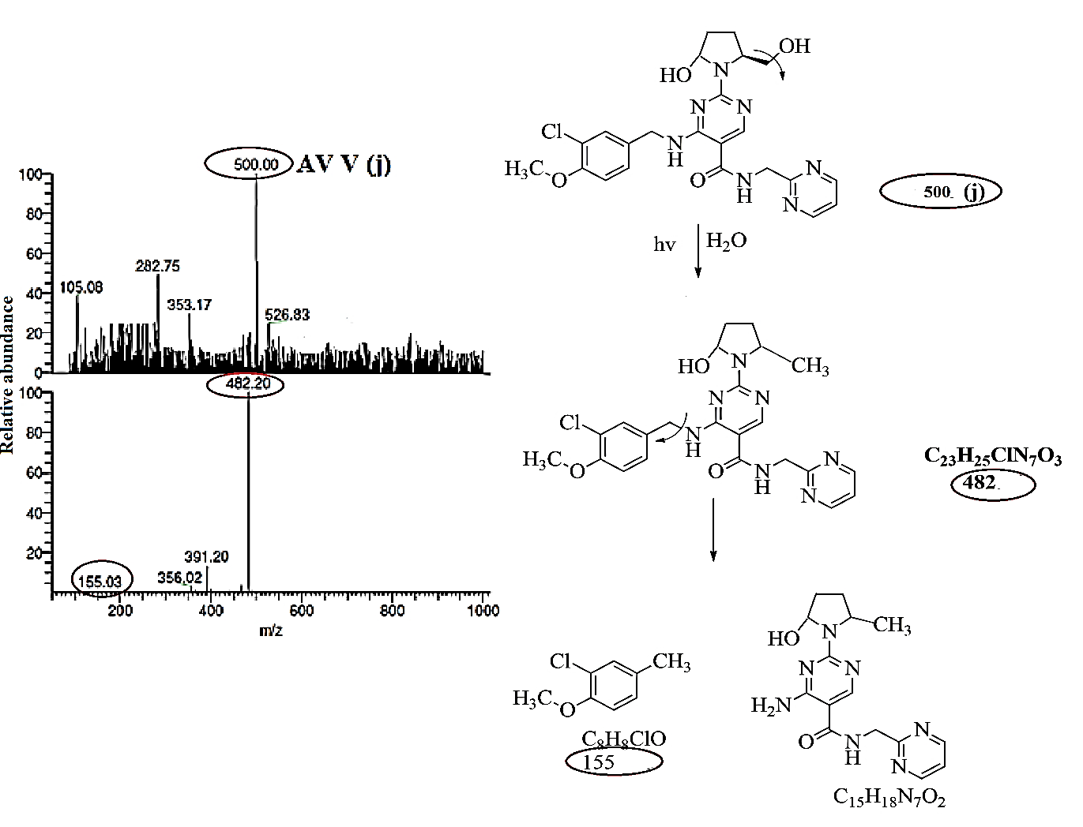
3. 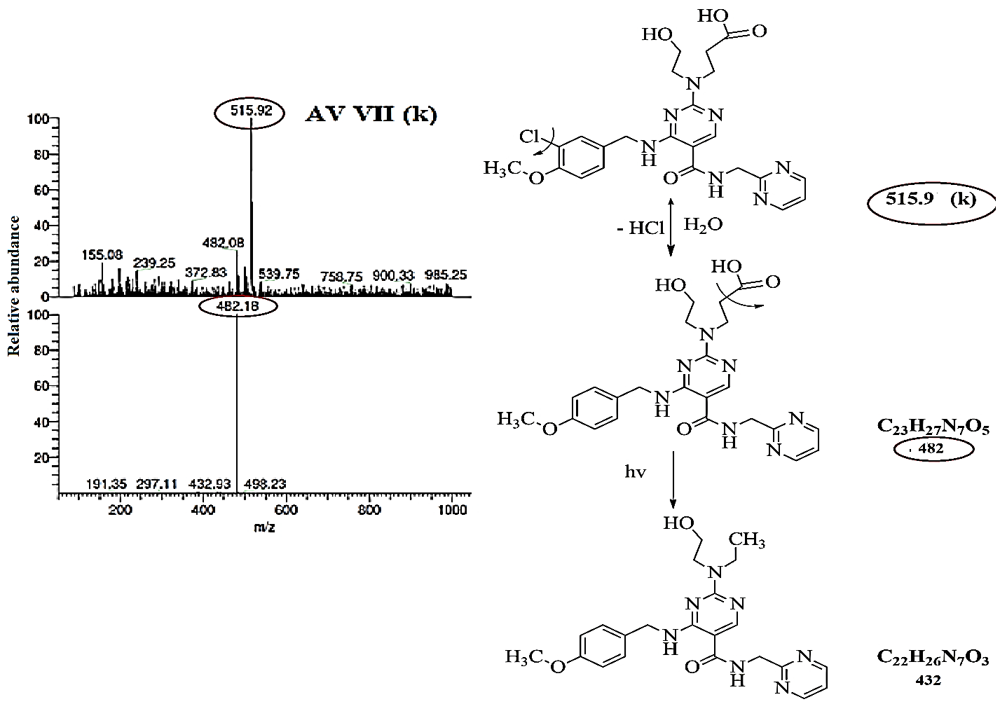
4. 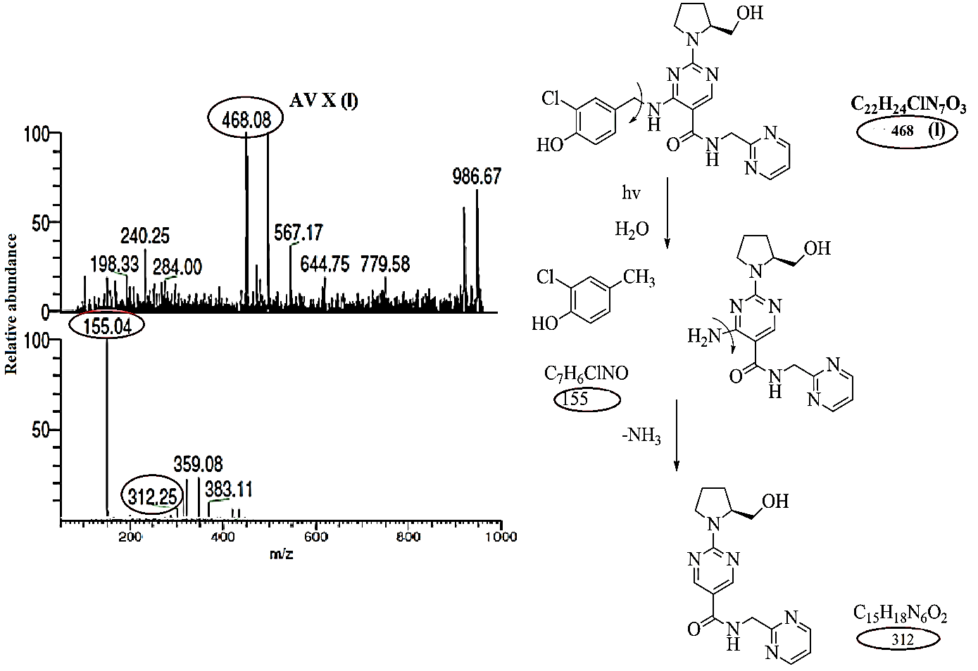
5. 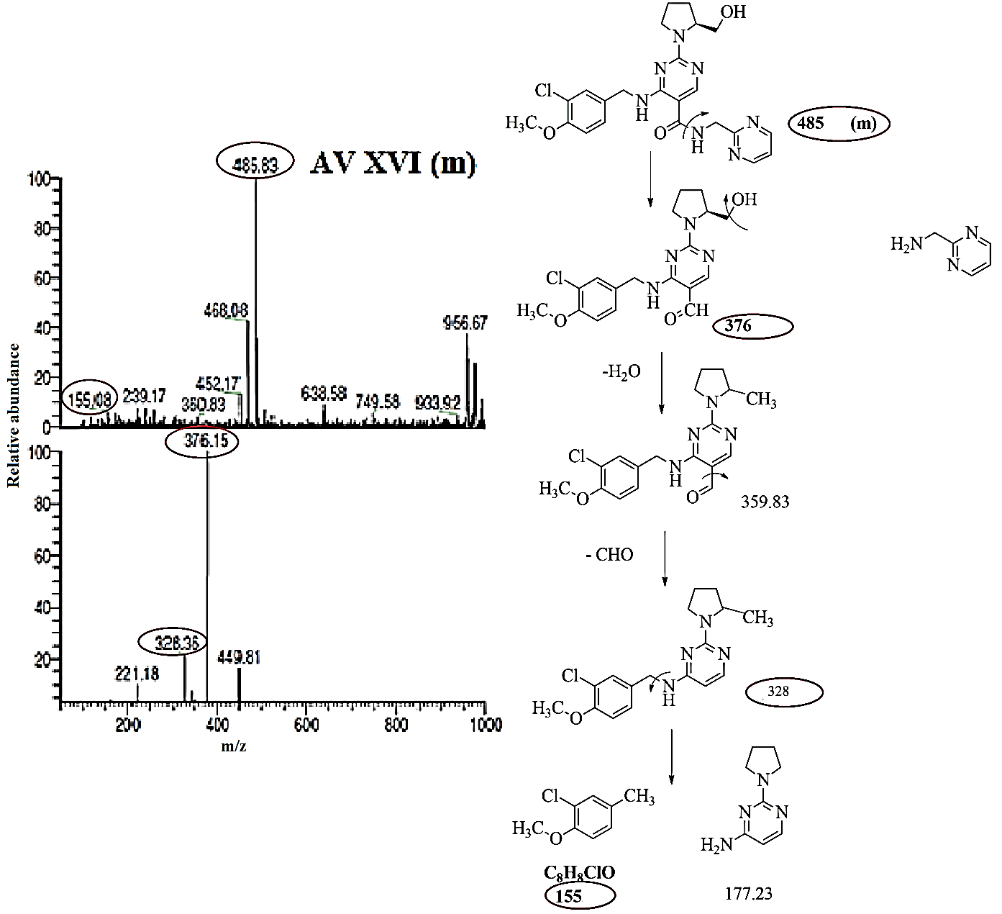

Supp. Fig. S5 Thermal degradation products MS spectra and its fragmentation

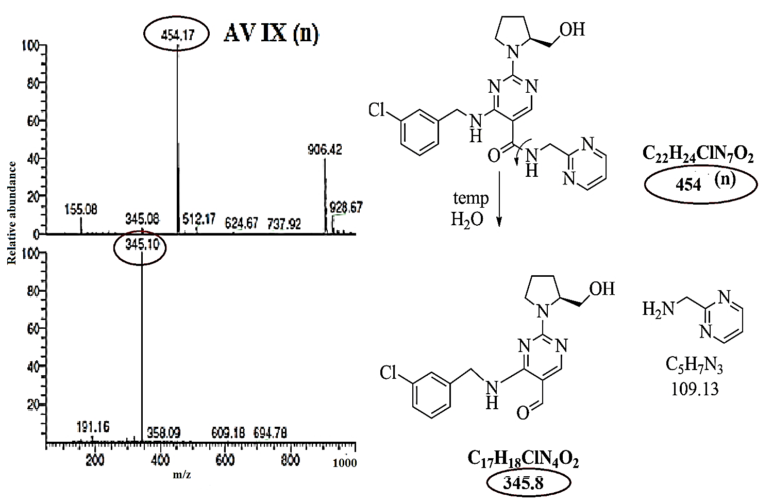

Supp. Fig. S6 Oxidative degradation products MS spectra and its fragmentation

1. 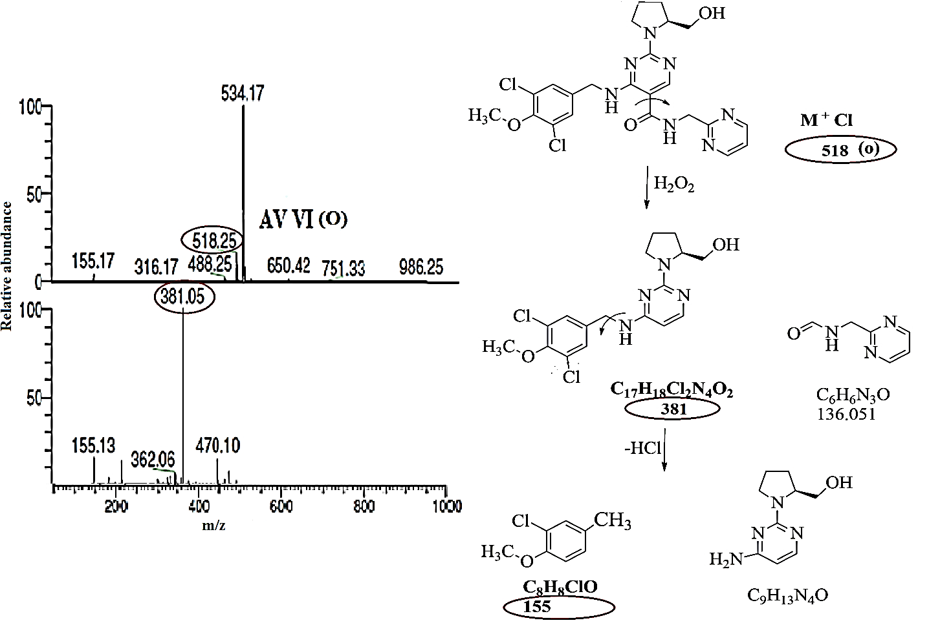
2. 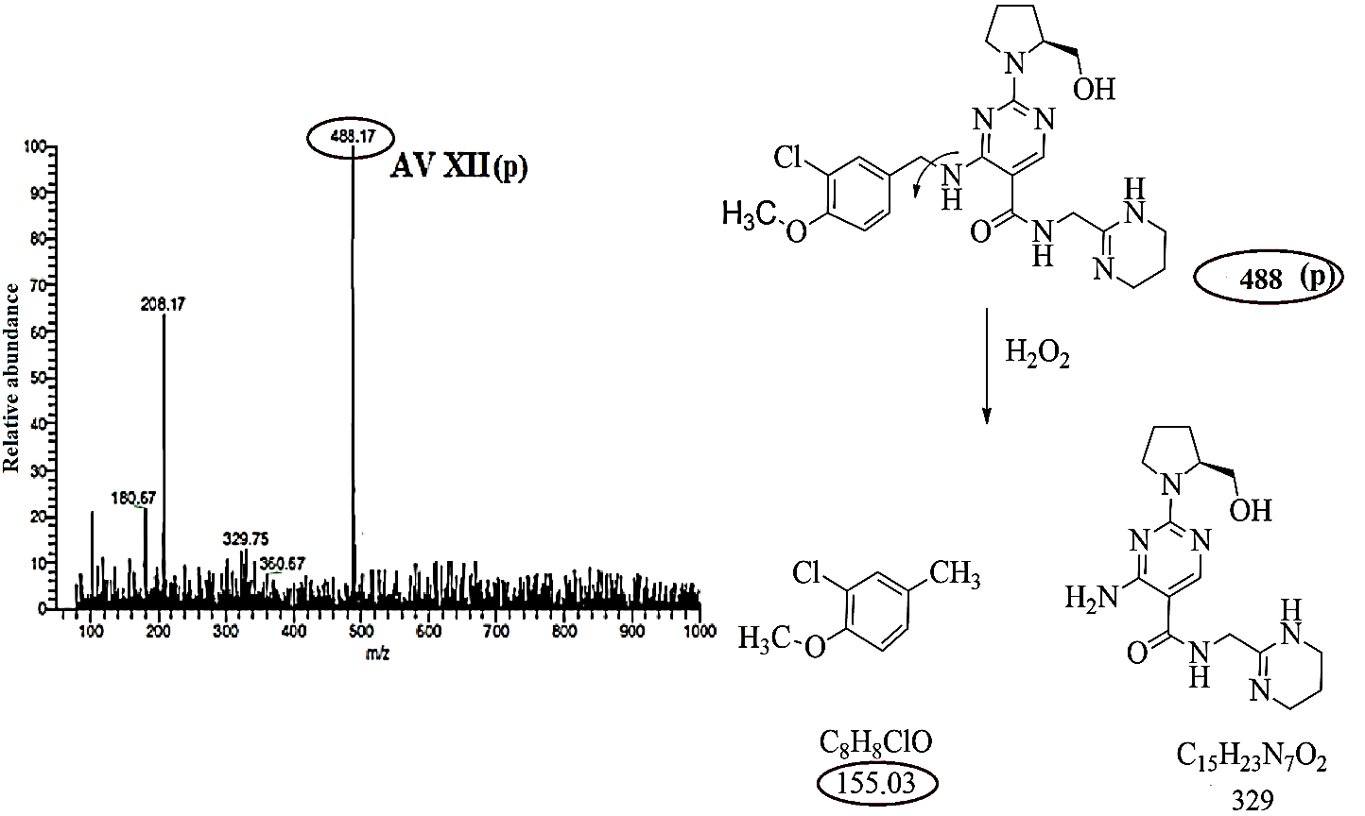

Supp. Fig. S7 AV marketed formulation degradation in different stress condition

