Supporting Information:

**Surface Reaction Strategy for Raman Probing Trace Cadmium Ion** Xiaoyu Guoa, Dongfang Xiaoa, Zhiyuan Maa, Qiangting Zhenga, Dan Wanga, Yiping Wua, Ye Yinga, Ying Wena, Feng Wanga, Haifeng Yanga*, Qinfei Kea,b*

*a The Education Ministry Key Lab of Resource Chemistry, Shanghai Key Laboratory of Rare Earth Functional Materials, Shanghai Municipal Education Committee Key Laboratory of Molecular Imaging Probes and Sensors and Department of Chemistry, Shanghai Normal University, Shanghai 200234, China  
b Shanghai Institute of Technology, Shanghai 200234, China*

Figure S1 shows the GSH/AuNPs is stable because of the protection of GSH.



FigureS1 UV-vis absorption spectra of fresh AuNPs, GSH/AuNPs and AuNPs, GSH/AuNPs stored for 3 weeks.

Figure S2 shows the changes of the size distribution of R6G/GSH/AuNPs without and with Cd2+.



**Figure S2** Size distribution of R6G/GSH/AuNPs measured by the DLS technique: (A) without and (B) with Cd2+.

Figure S3 shows that GSH was modified on AuNPs successfully.

**Figure S3** FT-IR spectra of powder GSH (a) and GSH/AuNPs (b).

Figure S4 shows the optimal concentration of NaCl used in the probe is 80 mM.



**Figure S4** (A) The Raman spectra of R6G/AuNPs under effect of different concentrations of NaCl from bottom to top is 0, 20, 50, 60, 70, 80, and 100 mM. (B) The plot of Raman intensities at 1510 cm-1 versus the varying concentrations of NaCl.

Figure S5 shows the optimal concentration of GSH used in the probe is 0.4 µM.



**Figure S5** (A) The Raman spectra of Cd2+ Raman probe R6G/GSH/AuNPs constructed using different concentrations of GSH from top to bottom is 0, 0.01, 0.1, 0.2, 0.3, 0.4, 0.5, 0.7, and 1.0 μM (0.1 M PB, pH 6.0, and 80 mM NaCl). (B) The plot of Raman intensities at 1510 cm-1 versus the concentrations of GSH.

**Table S1** Comparison of various methods for Cd2+ detection

|  |  |  |  |
| --- | --- | --- | --- |
| **Methods** | **LOD** | **Linear range** | **References** |
| Raman | 0.3 ppb | / | *Chen et al. 2014* |
| Raman | 0.1 ppm | 0.1~2 ppm | *Thatai et al. 2015* |
| Raman | 11.2 ppm | / | *Cheng et al. 2014* |
| Raman | 0.1 ppm | / | *Yin et al. 2011* |
| Raman | 10 ppt | / | *Dasary et al. 2016* |
| Raman | 28.1 ppb | 28.1~337.2 ppb | *Zamarion et al. 2008* |
| Colorimetric | 0.6 ppm | / | *Guo et al. 2014* |
| Fluorescence | 56 ppb | 56~450 ppb | *Zhang et al. 2014* |
| Fluorescence | 11.6 ppb | 11.2 ppb~5.6 ppm | *Liu et al. 2019* |
| **Raman** | **10 ppb** | **0.5~20 ppm** | ***This work*** |

Figure S6 shows the UV-vis absorbance spectra and color change of AuNPs with increase of the concentration of Cd2+.

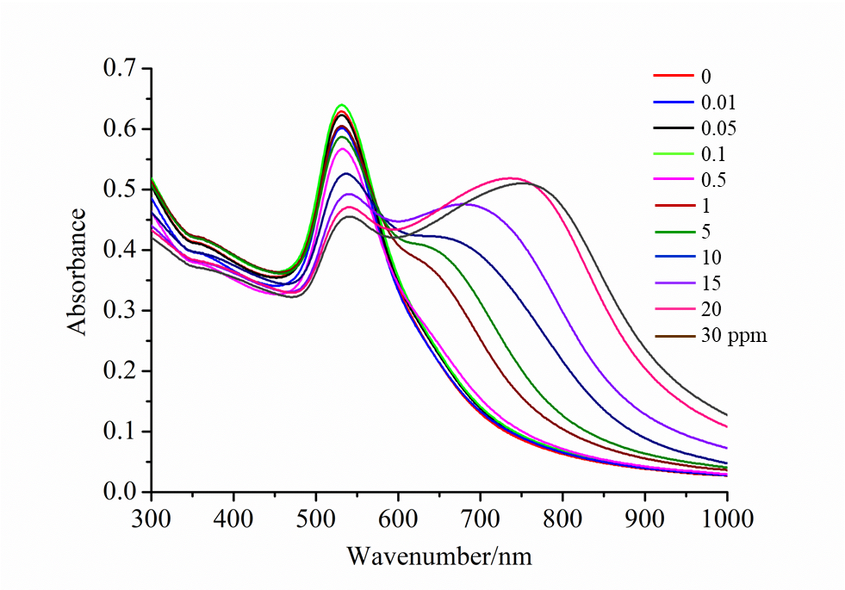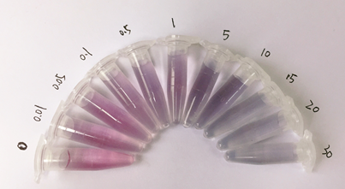

**Figure S6** The extinction spectra of R6G/GSH/AuNPs-based Raman probe in the presence of different concentration of Cd2+. Insert is the photographs of R6G/GSH/AuNPs in the presence of different concentrations of Cd2+.

Figure S7 shows the selectivity of this system at different pH.

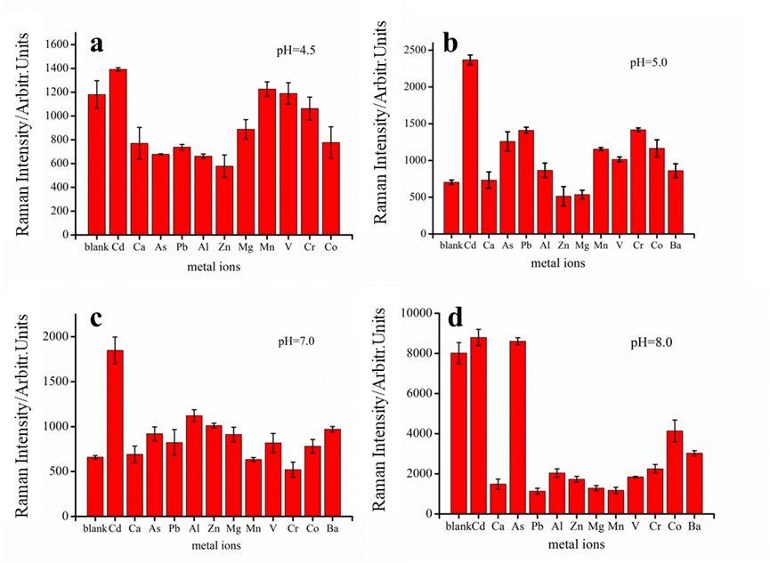**Figure S7** The plots of Raman intensity at 1510 cm-1 versus different metal ions at different pH.

Figure S8 shows the result of real sample detection

Figure S8 Raman spectra of Raman probe R6G/GSH/AuNPs with different concentrations of Cd2+ in river water.

Figure S9 shows 0.1 ppm Cd2+ could be detected by using portable Raman system.

Figure S9 The SERS spectra of R6G/GSH/AuNPs-based Raman probe before and after incubation with 0.1 ppm Cd2+.

**References**

Chen, Y., Chen, Z.P., Long, S.Y., Yu, R.Q.,2014. Generalized Ratiometric Indicator based surface-enhanced Raman spectroscopy for the detection of Cd2+ in environmental water samples. Anal. Chem. 86, 12236-12242.

Cheng, F.S., Xu, H.B., Wang, C., Gong, Z.J., Tang, C.Y., Fan, M.K., 2014. Surface enhanced Raman scattering fiber optic sensor as an ion selective optrode: the example of Cd2+ detection. RSC Adv. 4, 64683-64687.

Dasary, S.S., Zones, Y.K., Barnes, S.L., Ray, P.C., Singh, A.K., 2016. Alizarin dye based ultrasensitive plasmonic SERS probe for trace level cadmium detection in drinking water. Sens. Actuators B: Chem. 224, 65-72.

Guo, Y.M., Zhang, Y., Shao, H.W., Wang, Z., Wang, X.F., Jiang, X.Y., 2014. Label-Free Colorimetric Detection of cadmium ions in rice samples using gold nanoparticles. Anal. Chem. 86, 8530-8534.

Liu, X.Q., Li, N., Xu, M.M., Jiang, C.H., Wang, J.H., Song, G.Q., Wang, Y., 2019. Turn on fluorescent detection for Cd2+ based on surfactant controlled squaraine aggregation. Spectrochim. Acta A 208, 236-242.

Thatai, S., Khurana, P., Prasad, S., Kumar, D., 2015. Plasmonic detection of Cd2þ ions using surface-enhanced Raman scattering active core–shell nanocomposite. Talanta 134, 568-575.

Yin, J., Wu, T., Song, J., Zhang, Q., Liu, S., Xu, R., Duan, H., 2011. SERS-active nanoparticles for sensitive and selective detection of cadmium Ion (Cd2+). Chem. Mater. 23, 4756-4764.

Zamarion, V.M., Timm, R.A., Araki, K., Toma, H.E., 2008. Ultrasensitive SERS nanoprobes for hazardous metal ions based on trimercaptotriazine-modified gold nanoparticles. Inorg. Chem. 47, 2934-2936.

Zhang, Y., Li, H., Niu, L.Y., Yang, Q. Z., Guan, Y.F., Feng, L., 2014. An SPE-assisted BODIPY fluorometric paper sensor for the highly selective and sensitive determination of Cd2+ in complex sample: rice. Analyst 139, 3146-3153.