**Synthesis, characterization and antimicrobial studies of novel *ONO* donor hydrazone Schiff base complexes with some Divalent Metal (II) ions**

**R.S. Bhaskar, C.A. Ladole, N.G. Salunkhe, J.M. Barabde and A.S. Aswar**

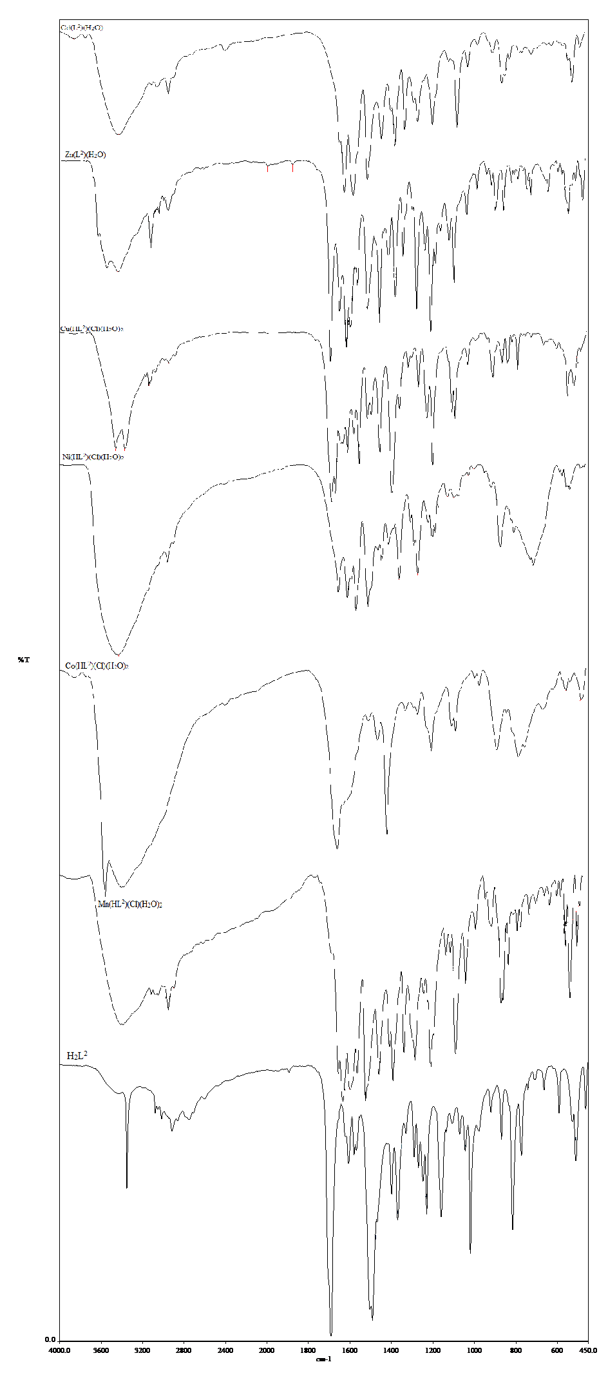

**Figure S1.** FT-IR spectra of ligand and its metal complexes

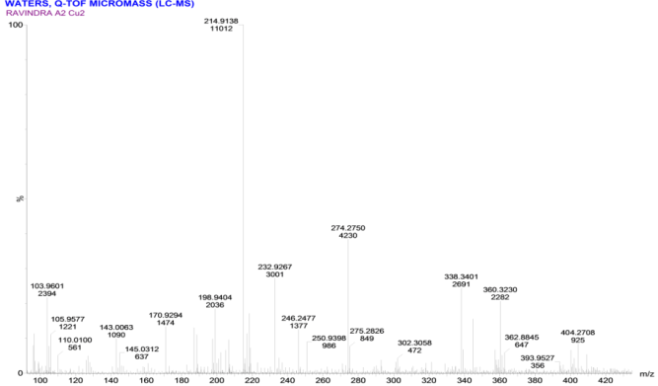

**Figure S2.** Mass spectrum of [Cu(H2L)(Cl)(H2O)2] complex

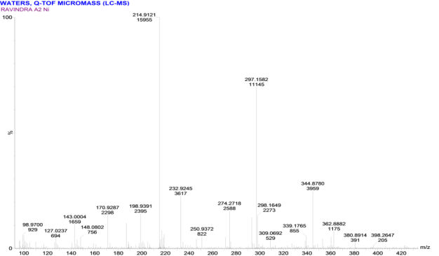

**Figure S3.** Mass spectrum of [Ni(H2L)(Cl)(H2O)2] complex

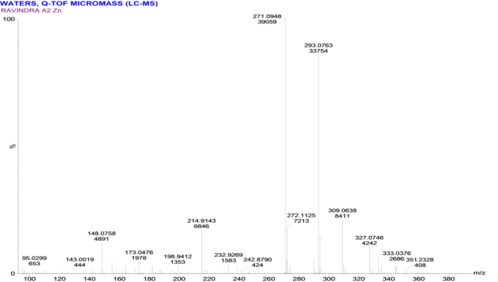

**Figure S4.** Mass spectrum of [Zn(L)(H2O)] complex

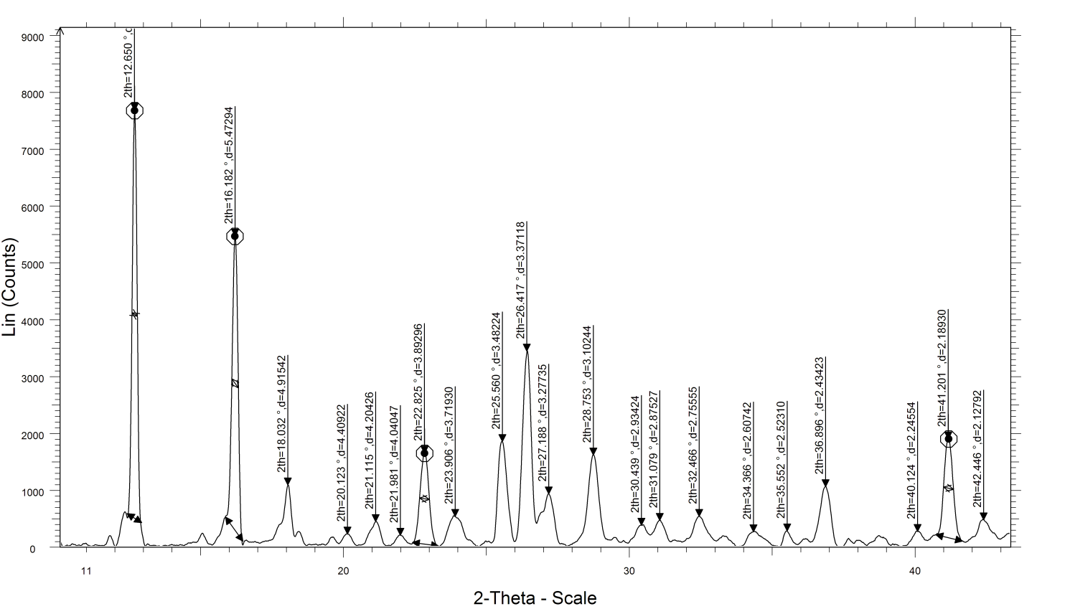

**Figure S5.** XRD image of the ligand (H2L)

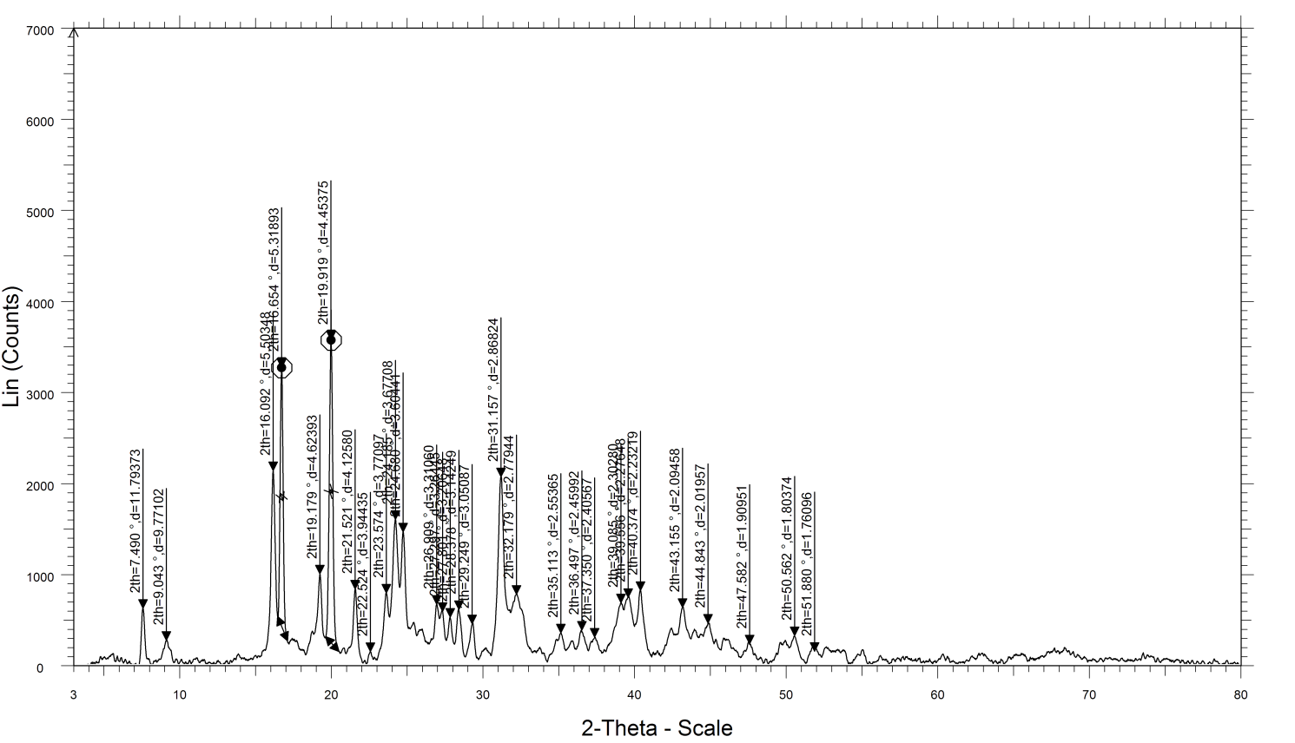

**Figure S6.** XRD image of [Cu(H2L)(Cl)(H2O)2] complex

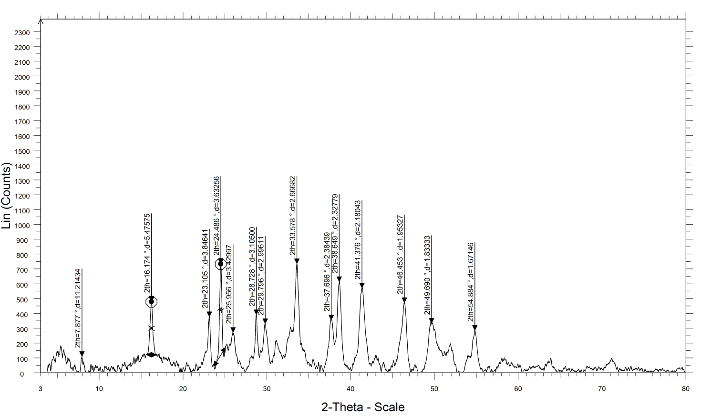

**Figure S7.** XRD image of [Zn(L)(H2O)] complex

**Table S1.** Indexed X-ray diffraction data of H2L Ligand

|  |  |  |  |  |  |  |  |  |
| --- | --- | --- | --- | --- | --- | --- | --- | --- |
| Peak no. | d(Obs.) | d(Cal.) | Int.wt. | 2θ(Obs.) | 2θ(Cal.) | SinSqTheta  *E4(Obs.) | SinSqTheta  *E4(Cal.) | h k l |
| 1 | 6.9916 | 6.9782 | 1.0 | 12.65 | 12.67 | 121.4 | 121.8 | 0 1 0 |
| 2 | 5.4733 | 5.4798 | 1.0 | 16.18 | 16.16 | 198.0 | 197.6 | 1 0 0 |
| 3 | 4.9157 | 4.9090 | 1.0 | 18.03 | 18.05 | 245.5 | 246.2 | 0 1 1 |
| 4 | 4.4074 | 4.4166 | 1.0 | 20.13 | 20.09 | 305.4 | 304.1 | 1 1 0 |
| 5 | 4.2049 | 4.2103 | 1.0 | 21.11 | 21.08 | 335.5 | 334.7 | 1 1 0 |
| 6 | 4.0404 | 4.0400 | 1.0 | 21.98 | 21.98 | 363.4 | 363.5 | 1 1 1 |
| 7 | 3.8936 | 3.9300 | 1.0 | 22.82 | 22.61 | 391.4 | 384.1 | 0 0 2 |
| 8 | 3.7200 | 3.6852 | 1.0 | 23.90 | 24.13 | 428.7 | 436.9 | 1 1 1 |
| 9 | 3.4820 | 3.4891 | 1.0 | 25.56 | 25.51 | 489.3 | 487.4 | 0 2 0 |
| 10 | 3.3719 | 3.3648 | 1.0 | 26.41 | 26.47 | 521.8 | 524.0 | 1 1 1 |
| 11 | 3.2781 | 3.2473 | 1.0 | 27.18 | 27.44 | 552.1 | 562.6 | 0 1 2 |
| 12 | 3.1025 | 3.1061 | 1.0 | 28.75 | 28.72 | 616.4 | 614.9 | 1 1 2 |
| 13 | 2.9350 | 2.9326 | 1.0 | 30.43 | 30.46 | 688.8 | 689.9 | 1 2 1 |
| 14 | 2.8759 | 2.8796 | 1.0 | 31.07 | 31.03 | 717.3 | 715.5 | 1 2 0 |
| 15 | 2.7559 | 2.7399 | 1.0 | 32.46 | 32.65 | 781.2 | 790.3 | 2 0 0 |
| 16 | 2.6077 | 2.6025 | 1.0 | 34.36 | 34.43 | 872.5 | 876.0 | 2 1 1 |
| 17 | 2.5252 | 2.5215 | 1.0 | 35.52 | 35.57 | 930.4 | 933.1 | 1 2 1 |
| 18 | 2.5000 | 2.5087 | 1.0 | 35.89 | 35.76 | 949.3 | 942.7 | 2 1 0 |
| 19 | 2.1892 | 2.1880 | 1.0 | 41.20 | 41.22 | 1237.9 | 1239.3 | 2 2 1 |
| 20 | 2.1281 | 2.1275 | 1.0 | 42.44 | 42.45 | 1310.1 | 1310.8 | 0 3 2 |

**Unit cell data and crystal lattice parameters**

|  |  |
| --- | --- |
| a= 5.6400A | V=312.03 Å3 |
| b= 7.0400 |
| c= 8.1500 | Crystal system: triclinic |
| alpha= 97.060D | Nature: Crystalline |
| beta=103.400 | Partical size = 32.31 nm |
| gamma= 91.090 |

**Table S2.** Indexed X-ray diffraction data of [Cu(HL)(Cl)(H2O)2] complexes

|  |  |  |  |  |  |  |  |  |
| --- | --- | --- | --- | --- | --- | --- | --- | --- |
| Peak no. | d(Obs.) | d(Cal.) | Int.wt. | 2θ(Obs.) | 2θ(Cal.) | SinSqTheta  *E4(Obs.) | SinSqTheta  *E4(Cal.) | h k l |
| 1 | 11.7927 | 11.8344 | 1.0 | 7.49 | 7.46 | 42.7 | 42.4 | 0 1 0 |
| 2 | 9.7739 | 9.8462 | 1.0 | 9.04 | 8.97 | 62.1 | 61.2 | 1 1 0 |
| 3 | 5.2356 | 5.3239 | 1.0 | 16.92 | 16.64 | 216.4 | 209.3 | 3 0 0 |
| 4 | 4.6259 | 4.6286 | 1.0 | 19.17 | 19.16 | 277.3 | 276.9 | 1 1 1 |
| 5 | 4.4556 | 4.4585 | 1.0 | 19.91 | 19.90 | 298.9 | 298.5 | 1 1 1 |
| 6 | 4.1257 | 4.1186 | 1.0 | 21.52 | 21.56 | 348.6 | 349.8 | 2 2 1 |
| 7 | 3.9413 | 3.9438 | 1.0 | 22.54 | 22.53 | 381.9 | 381.5 | 3 1 1 |
| 8 | 3.7713 | 3.7684 | 1.0 | 23.57 | 23.59 | 417.1 | 417.8 | 1 3 0 |
| 9 | 3.6042 | 3.5895 | 1.0 | 24.68 | 24.78 | 456.7 | 460.5 | 1 3 1 |
| 10 | 2.8315 | 2.8339 | 1.0 | 31.57 | 31.54 | 740.0 | 738.7 | 1 2 2 |
| 11 | 2.7801 | 2.7776 | 1.0 | 32.17 | 32.20 | 767.6 | 769.0 | 5 1 1 |
| 12 | 2.5537 | 2.5542 | 1.0 | 35.11 | 35.10 | 909.8 | 909.4 | 3 2 2 |
| 13 | 2.4602 | 2.4616 | 1.0 | 36.49 | 36.47 | 980.2 | 979.2 | 4 4 0 |
| 14 | 2.4087 | 2.4099 | 1.0 | 37.30 | 37.28 | 1022.6 | 1021.5 | 0 5 1 |
| 15 | 2.3629 | 2.3652 | 1.0 | 38.05 | 38.01 | 1062.6 | 1060.6 | 1 5 1 |
| 16 | 2.2323 | 2.2293 | 1.0 | 40.37 | 40.43 | 1190.6 | 1193.9 | 2 2 2 |
| 17 | 1.9095 | 1.9086 | 1.0 | 47.58 | 47.60 | 1627.2 | 1628.7 | 6 0 2 |
| 18 | 1.8037 | 1.8034 | 1.0 | 50.56 | 50.57 | 1823.7 | 1824.3 | 7 2 2 |
| 19 | 1.7634 | 1.7659 | 1.0 | 51.80 | 51.72 | 1908.0 | 1902.6 | 7 4 1 |
| 20 | 1.7628 | 1.7605 | 1.0 | 51.82 | 51.89 | 1909.3 | 1914.2 | 6 4 2 |

**Unit cell data and crystal lattice parameters**

|  |  |
| --- | --- |
| a=16.0200A | V=1127.44 Å3 |
| b=12.2400 |
| c= 5.9500 | Crystal system: triclinic |
| alpha=104.240D | Nature: Crystalline |
| beta= 91.880 | Partical size = 36.22 nm |
| gamma= 93.450 |

**Table S3.** Indexed X-ray diffraction data of [Zn(L)(H2O)] complexes

|  |  |  |  |  |  |  |  |  |
| --- | --- | --- | --- | --- | --- | --- | --- | --- |
| Peak no. | d(Obs.) | d(Cal.) | Int.  wt. | 2θ(Obs.) | 2θ(Cal.) | SinSqTheta  *E4(Obs.) | SinSqTheta  *E4(Cal.) | h k l |
| 1 | 11.2242 | 11.1750 | 1.0 | 7.87 | 7.90 | 47.1 | 47.5 | 0 1 0 |
| 2 | 5.4767 | 5.4761 | 1.0 | 16.17 | 16.17 | 197.8 | 197.8 | 1 0 0 |
| 3 | 3.8470 | 3.8435 | 1.0 | 23.10 | 23.12 | 400.9 | 401.6 | 0 0 1 |
| 4 | 3.6332 | 3.6307 | 1.0 | 24.48 | 24.50 | 449.5 | 450.1 | 1 0 1 |
| 5 | 3.4306 | 3.4227 | 1.0 | 25.95 | 26.01 | 504.1 | 506.4 | 1 1 1 |
| 6 | 3.1057 | 3.1025 | 1.0 | 28.72 | 28.75 | 615.1 | 616.4 | 1 1 1 |
| 7 | 2.9965 | 3.0032 | 1.0 | 29.79 | 29.72 | 660.7 | 657.8 | 1 2 1 |
| 8 | 2.6673 | 2.6601 | 1.0 | 33.57 | 33.66 | 833.9 | 838.4 | 2 1 1 |
| 9 | 2.3846 | 2.3827 | 1.0 | 37.69 | 37.72 | 1043.3 | 1045.0 | 2 1 1 |
| 10 | 2.3282 | 2.3266 | 1.0 | 38.64 | 38.67 | 1094.6 | 1096.1 | 2 3 1 |
| 11 | 2.1806 | 2.1824 | 1.0 | 41.37 | 41.33 | 1247.7 | 1245.6 | 1 4 1 |
| 12 | 1.9533 | 1.9530 | 1.0 | 46.45 | 46.46 | 1555.1 | 1555.5 | 2 6 1 |
| 13 | 1.8332 | 1.8350 | 1.0 | 49.69 | 49.64 | 1765.4 | 1762.0 | 1 2 2 |
| 14 | 1.6715 | 1.6707 | 1.0 | 54.88 | 54.91 | 2123.5 | 2125.5 | 3 7 0 |

**Unit cell data and crystal lattice parameters**

|  |  |
| --- | --- |
| a= 6.3300A | V= 285.94 Å3 |
| b=13.1000 |
| c= 4.0810 | Crystal system: triclinic |
| alpha=102.390D | Nature: Crystalline |
| beta= 97.900 | Partical size = 26.51 nm |
| gamma=116.210 |