**Supplementary Information**

**Novel silver-platinum bimetallic nanoalloy synthesized from *Vernonia mespilifolia* extract: antioxidant, antimicrobial and cytotoxic activities**

Jeremiah O. Unuofin a, Adewale O. Oladipo b*, Titus A.M. Msagati b, Sogolo L. Lebelo a, Stephen Meddows-Taylor c, Garland K. More c

aDepartment of Life and Consumer Sciences, College of Agriculture and Environmental Sciences, University of South Africa, Science Campus, Florida, Johannesburg 1710, South Africa

bNanotechnology and Water Sustainability Research Unit, College of Science, Engineering and Technology, University of South Africa, Science Campus, Florida, Johannesburg 1709, South Africa

cCollege of Agriculture and Environmental Sciences Laboratories, University of South Africa, Science Campus, Florida, Johannesburg 1710, South Africa

Author for correspondence: walexy20002001@gmail.com



Figure S1. UV-vis absorption spectra of extract synthesized AgNPs.

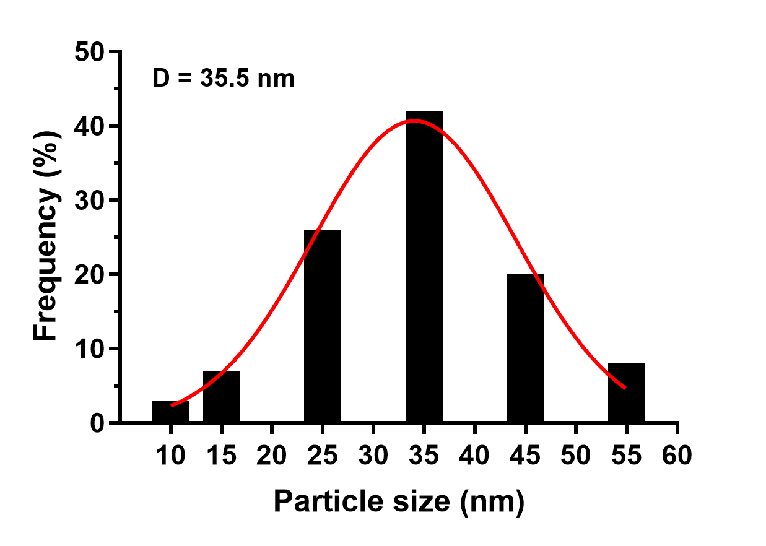

Figure S2. Histogram of particle size distribution of extract synthesized AgPtNPs.

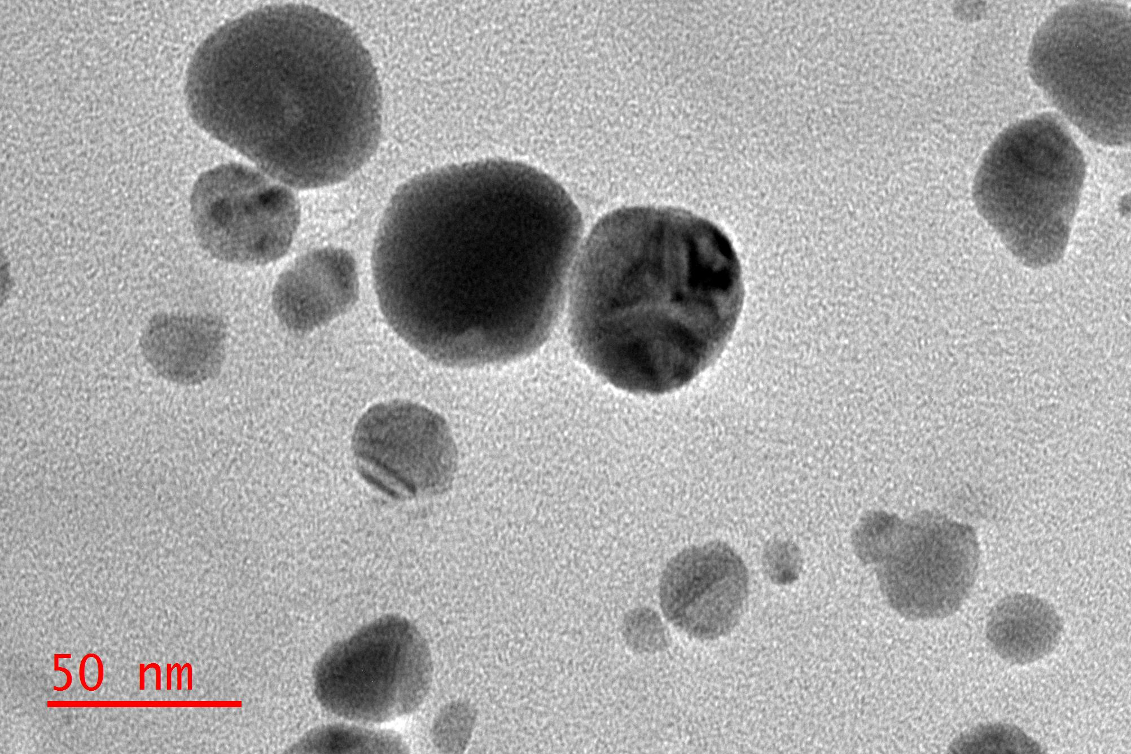

Figure S3. TEM micrograph of extract synthesized AgNPs.

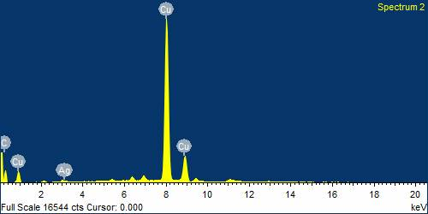

Figure S4. Representative EDS profile of extract synthesized AgNPs confirming the presence of Ag metal.