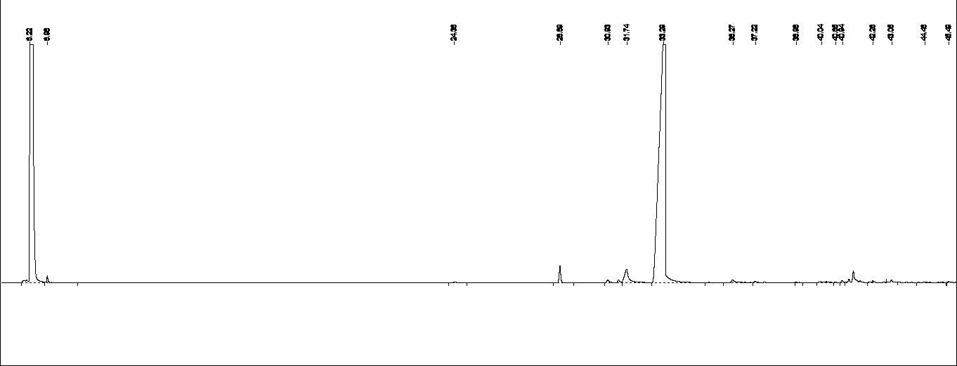

A

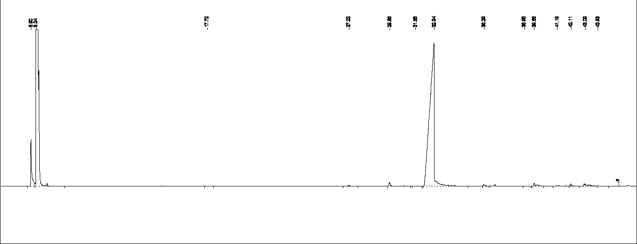

B

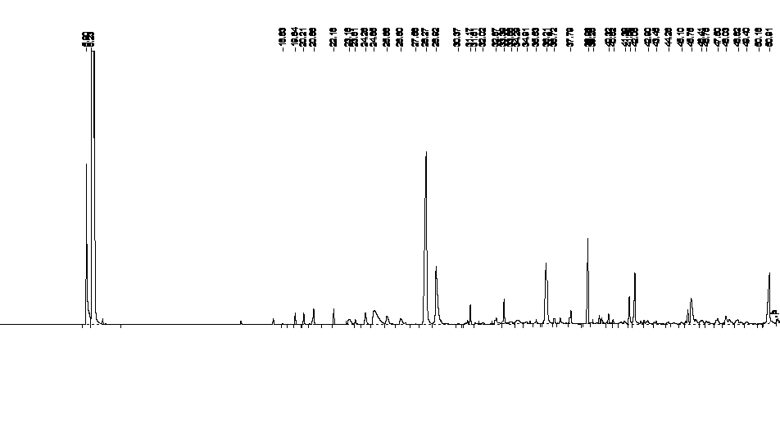

C

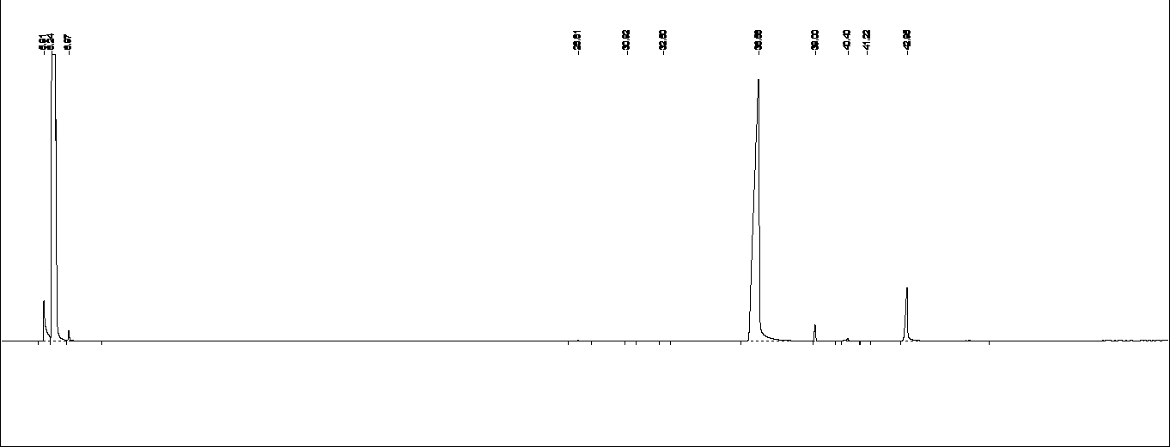

D

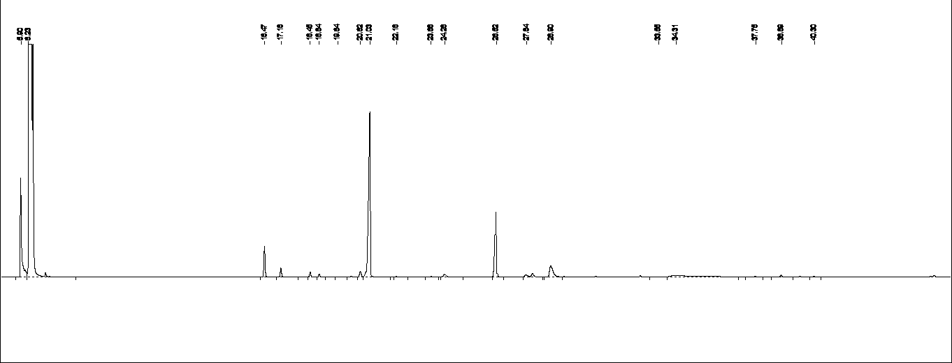

E

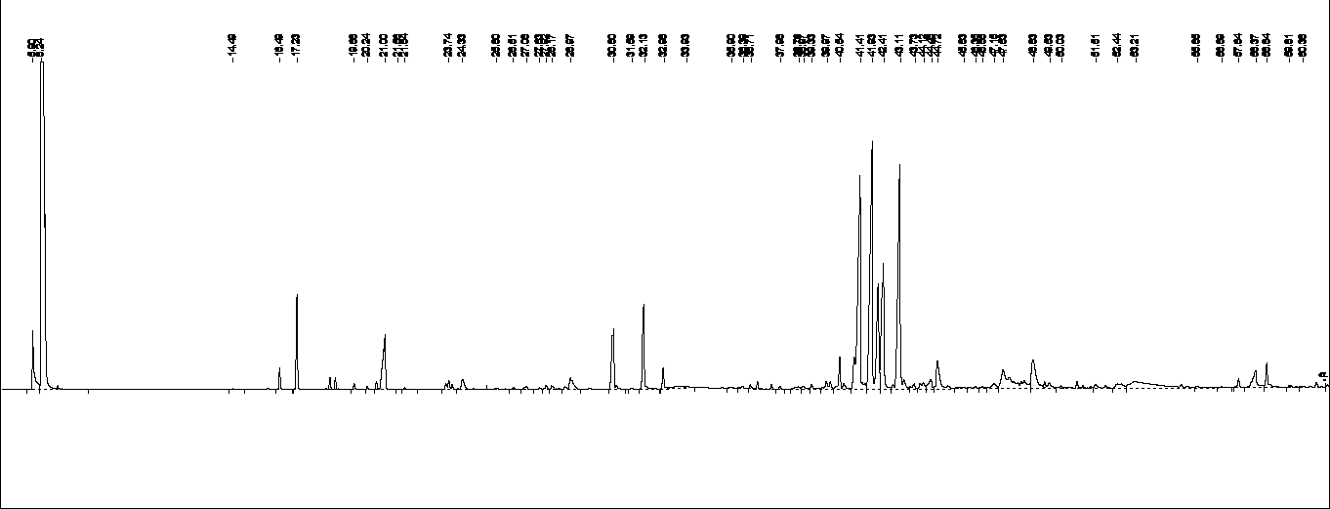

F

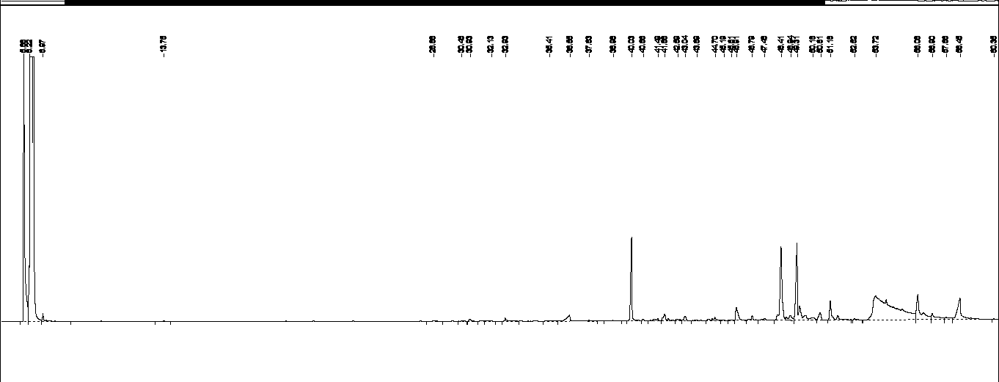

G

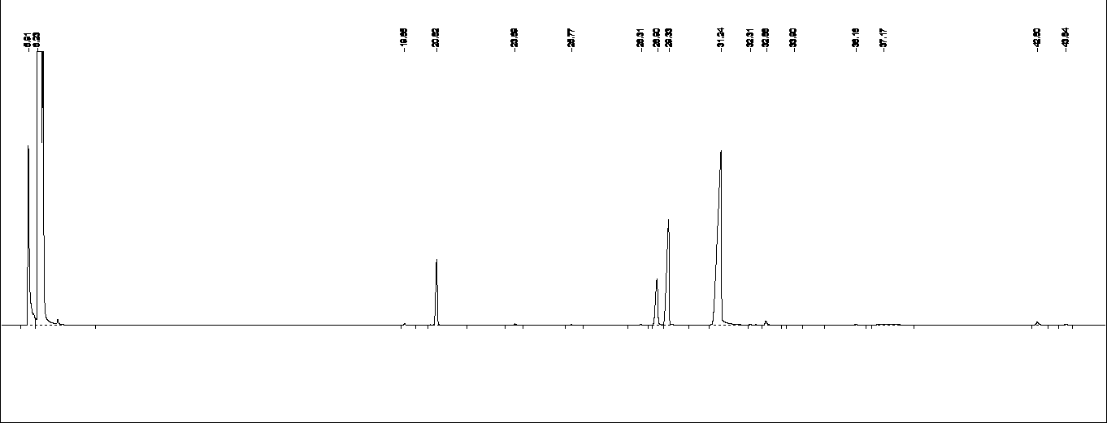

H

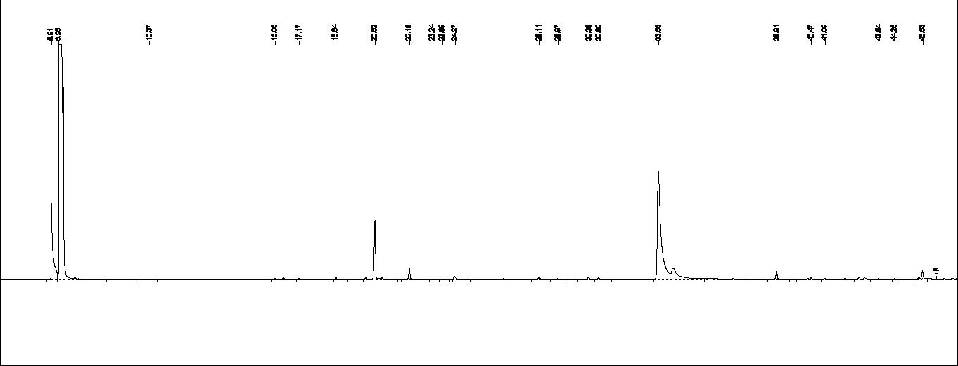

I

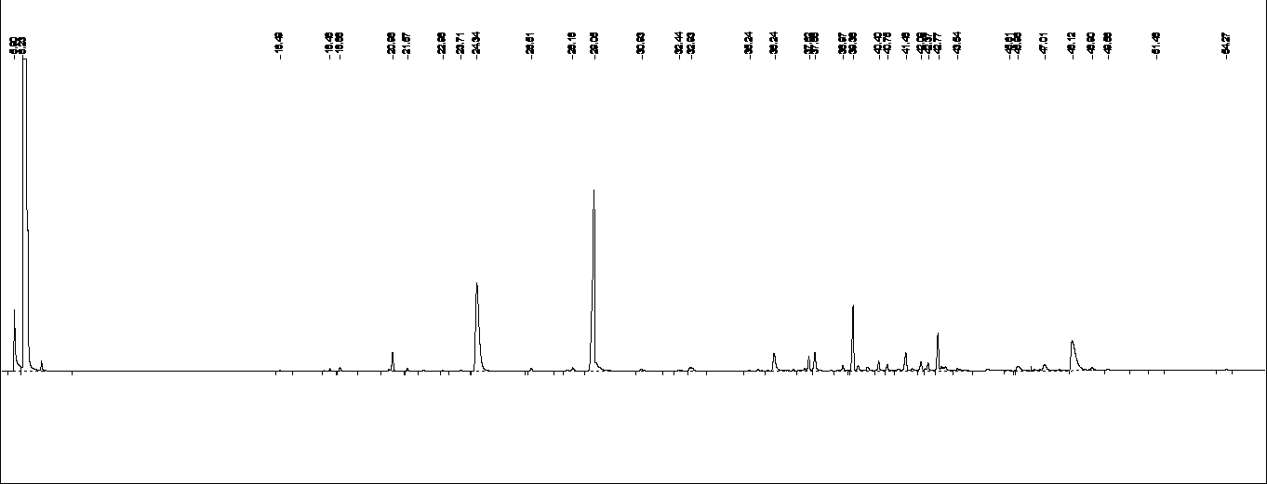

J

**Fig. 1S: Typical gas chromatograms of the ten aromatic plant EOs.; (A) Anise; (B) Cinnamon bark; (C) Marjoram; (D) Clove; (E) Rosemary; (F) Ginger; (G) Chamomile; (H) Dill ; (I) Thyme; (J) Basil.**

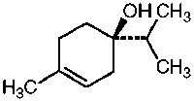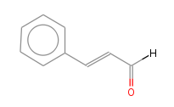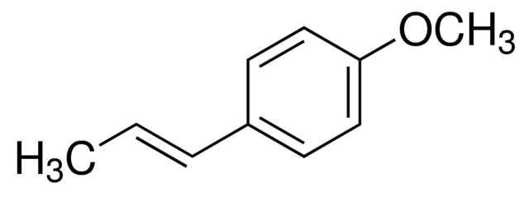

***Trans*- Anethole *cis*-Cinamaldehyde Terpien-4-ol**

**(Anise) (Cinnamon) (Marjoram)**

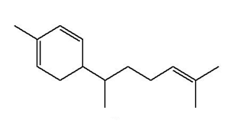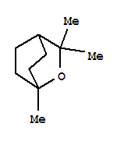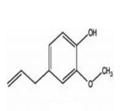

**Eugenol 1,8-Cineol Zingiberene**

**(Clove) (Rosemary) (Ginger)**

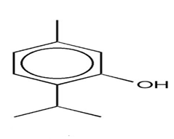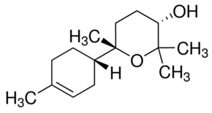 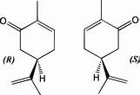

**α-Bisabolol oxide A Carvone Thymol**

**(Chamomile) (Dill) (Thyme)**

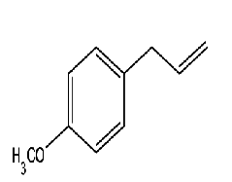

**Methyl chavicol**

**(Basil)**

**Fig. 2 S. The major compounds identified in the essential oils of the ten aromatic plants**

**Table 1 S: Volatile compounds identified in clove EO extracted from CE-Alg, CE-Ch and CE-CMC beads.**

|  |  |  |  |  |
| --- | --- | --- | --- | --- |
| **Compounds** | **Relative area %a** | | | |
| **Clove EO** | **CE-Alg** | **CE-Ch** | **CE-CMC** |
| **Terpinolene** | 0.1 | --- | --- | --- |
| **Borneol** | 0.1a | 0.2b | 0.1a | 0.4c |
| **Eugenol** | 89.9a | 96.9b | 96.0b | 88.8c |
| **β-Caryophyllene** | 1.4a | 0.4b | 1.0c | 0.9c |
| **α-Humulene** | 0.4a | --- | 0.1b | --- |
| **α-Farnesene** | 0.1 | --- | --- | --- |
| **Eugenyl acetate** | 7.9a | 1.7b | 1.5c | 8.2a |

aValues (average of triplicate determinations) expressed as relative area percentages to total identified compounds

Different letters among the values in each row mean significant difference at p<0.05