**Supplemental material**

**Supplemental material for “Enhanced cuttings transport efficiency of water-based muds using (3–Aminopropyl) triethoxysilane on polypropylene-nanosilica composite”**

**Figure B.1**

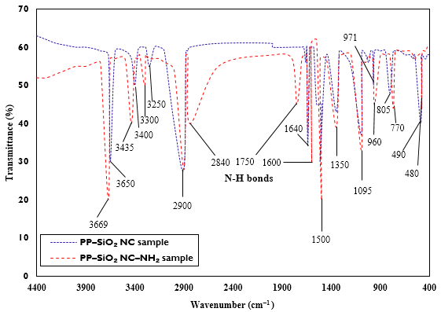

**Figure B.1** FTIR spectra of modified and unmodified PP-SiO2 NC.

**Figure B.2**

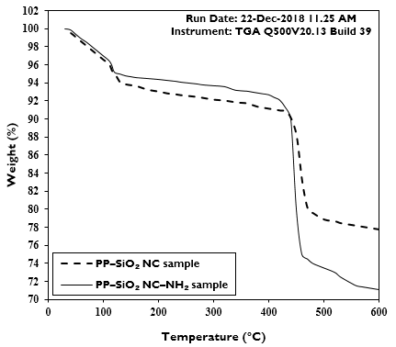

**Figure B.2** Thermal stability of modified and unmodified PP–SiO2 NC samples.

**Figure C.1**

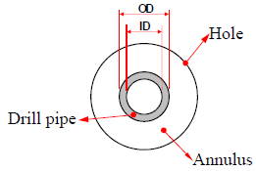

**Figure C.1** Schematic of the measured annular test area.