Supplementary file

**A novel silica supported chitosan/glutaraldehyde as an efficient sorbent in solid phase extraction coupling with HPLC for the determination of Penicillin G from water and wastewater samples**

Mohammad Hassan Mahmoudian 1, Mehdi Fazlzadeh 2,3, Maryam Hazrati Niari 4,5, Ali Azari 6,2, 7*, Eder C. Lima 8**

1 Department of Environmental Health Engineering, School of Public Health, Qom University of Medical Sciences, Qom, Iran

2 Department of Environmental Health Engineering, School of Public Health, Tehran University of Medical Sciences, Tehran, Iran

3 Social Determinants of Health Research Center, Ardabil University of Medical Sciences, Ardabil, Iran

4 Student Research Committee, Ahvaz Jundishapur University of Medical Sciences, Ahvaz, Iran

5 Department of Environmental Health Engineering, School of Health, Ahvaz Jundishapur University of Medical Sciences, Ahvaz, Iran

6 Department of Environmental Health Engineering, School of Public Health, Kashan University of Medical Sciences, Kashan, Iran

7 Students’ Scientific Research Center (SSRC), Tehran University of Medical Sciences, Tehran, Iran

8 Institute of Chemistry, Federal University of Rio Grande do Sul, Porto Alegre, RS, Brazil

**\* Correspondence to:**

Ali Azari

E-mail addresses: [Azari.hjh@gmail.com](mailto:Azari.hjh@gmail.com)

**\*\* Co-Correspondence:**

Eder C. Lima

E-mail addresses: [profederlima@gmail.com](mailto:profederlima@gmail.com)

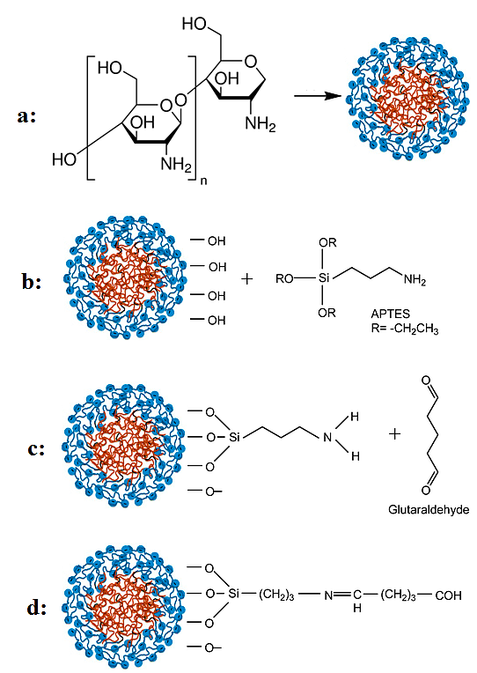

Fig. S1. Schematic illustration of the synthesis for the Si/Cs/GA

Table S1. N2 adsorption-desorption isotherms, pore size distribution and BET surface areas of samples.

|  |  |  |  |  |
| --- | --- | --- | --- | --- |
| Samples | Surface area  (m2/g) | Average pore diameter  (nm) | Pore volume  (cm3/g) | Pores structure |
| CS | 223.66 | 3.49 | 1.069 | Mesopore |
| Si@Cs | 224.27 | 3.46 | 1.074 | Mesopore |
| Si @CS-G (1:1) | 298.5 | 3.4 | 1.168 | Mesopore |
| Si @CS-G (1:2) | 301.45 | 3.38 | 1.172 | Mesopore |
| Si @CS-G (1:3) | **313.54** | **3.35** | **1.179** | **Mesopore** |
| Si @CS-G (1:4) | 291.43 | 3.41 | 1.171 | Mesopore |
| Si @CS-G (1:5) | 278.32 | 3.43 | 1.169 | Mesopore |

Fig S2. Effect of desorption time on PG extraction efficiency

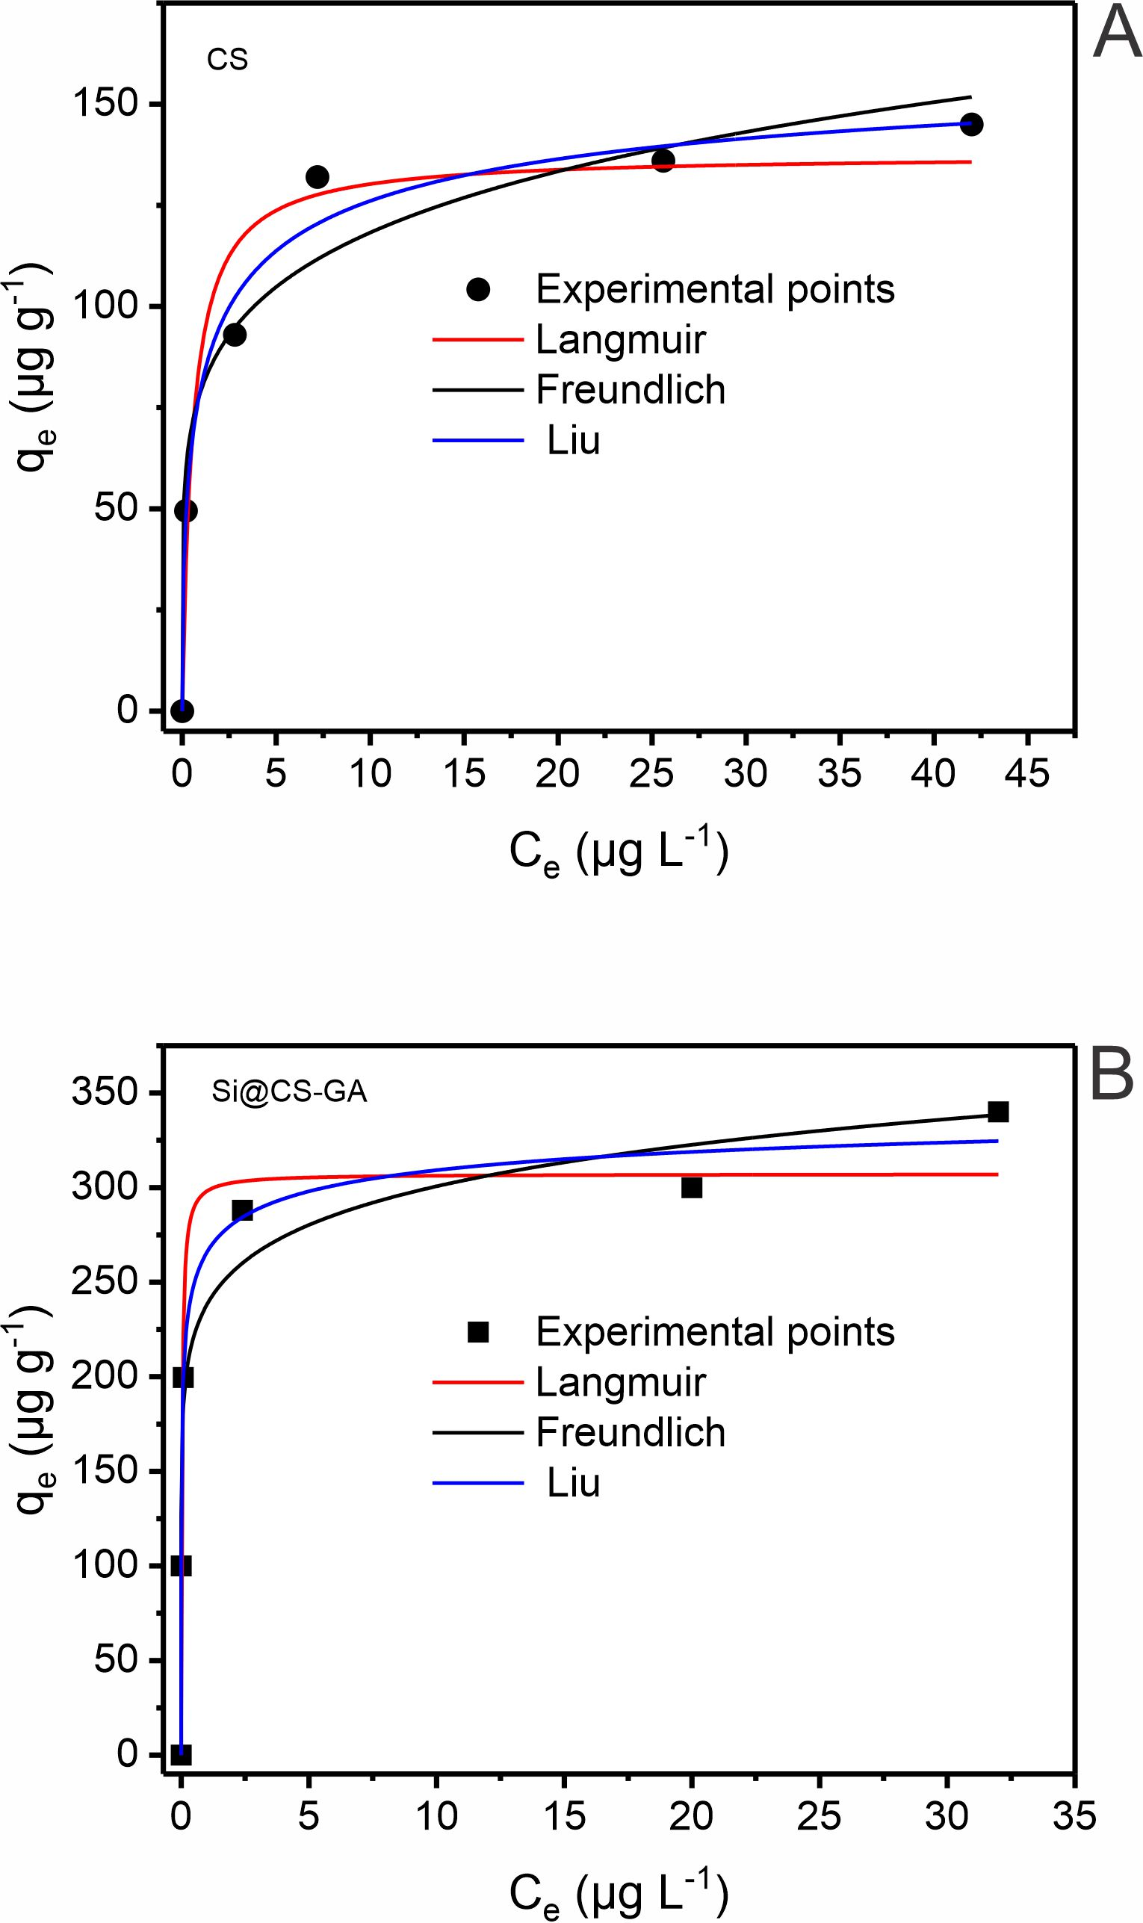

Fig S3. Isotherm study the PG adsorption onto Cs (A) and Si@Cs-G (B) adsorbents.

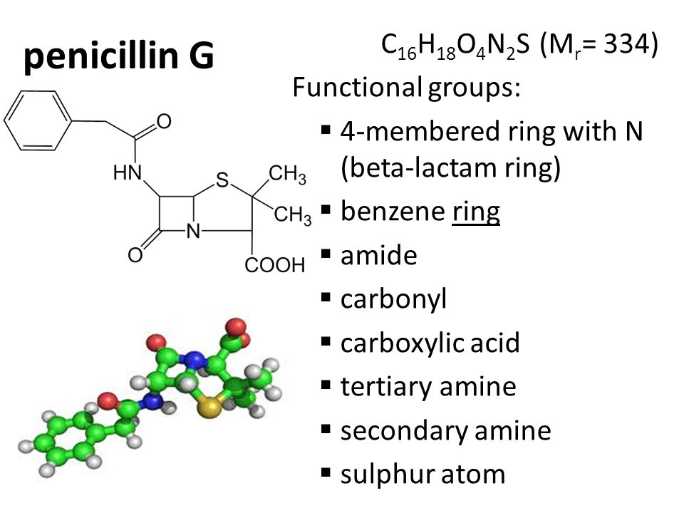

Fig S4. Aromatic structure of PG