Supplementary files
Figures
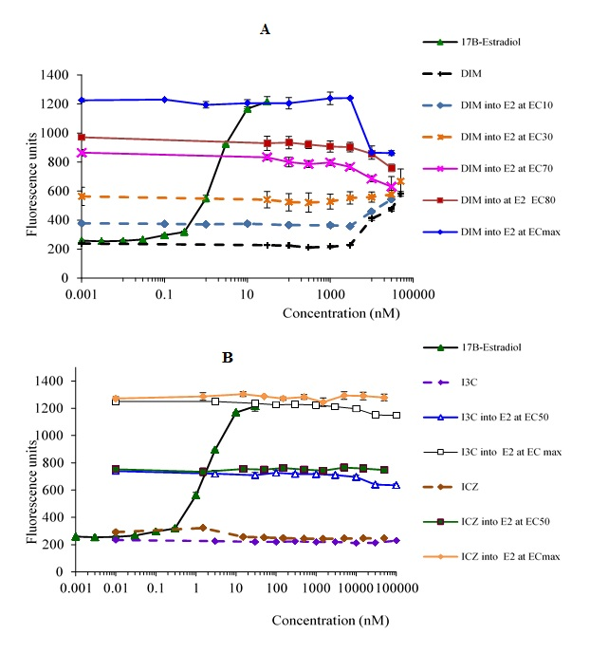
Figure S1. Responses of A) 3,3’-diindolylmethane (DIM) or B), Indolo-[3,2b]carbazole (ICZ) and Indole-3-carbinol (I3C) in the yeast estrogen bioassay with and without the addition of 17β-estradiol (E2). The standard curve for estradiol is also included. Each data point represents the mean ± SD for triplicate measurements. Significant difference (P≤0.05) was observed for E2 (the last 6 data points), DIM (the last 4 data points), DIM into E2 at EC₁₀ (the last 2 data points), DIM into E2 at EC₃₀ (the last 1 data point), DIM into E2 at EC₇₀ (the last 3 data points), DIM into E2 at EC₈₀ (the last 2 data points), DIM into E2 at ECmax (the last 4 data points), I3C into E2 at EC₅₀ (the last 2 data points), I3C into E2 at ECmax (the last 2 data points) compared to their respective control (DMSO).

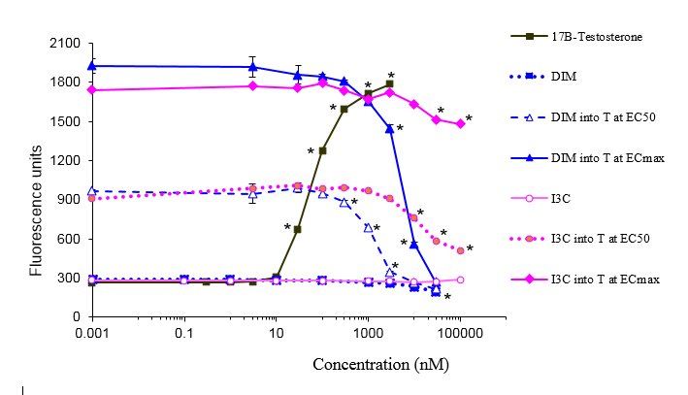
Figure S2. Response of I3C and DIM with and without the addition of 17β-testosterone (T) in the yeast androgen bioassay. The full dose-response curve for testosterone is given as well. Each data point represents the mean ± SD for triplicate measurements. *, Significant difference between treatment and control (DMSO) at the level of P≤0.05.

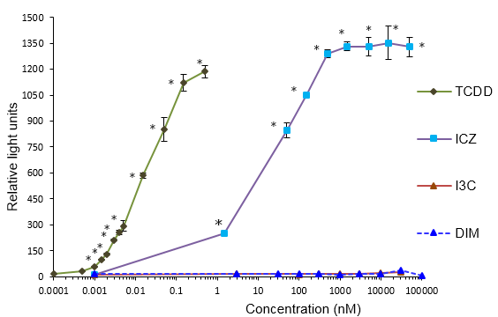
Figure S3. Response of TCDD, I3C, DIM and ICZ in the DR CALUX bioassay. Each data point represents the mean ± SD for triplicate measurements. *, Significant difference between treatment and control (DMSO) at the level of P≤0.001.
F
E

