Supporting Information

The synthesis of coumarin thiazoles containing a trifluoromethyl group and their antifungal activities
Guoyu Yangª, Lijun Shiª, Zhenliang Panª, Lulu Wuª, Liangxin Fanª, Caixia Wang*ª , Cuilian Xu*ª, Jun Liang^{b}
( a.College of Sciences，Henan Agricultural University，Zhengzhou 450002, P. R. of China; b. Zhengzhou Institute of Veterinary Drug and Feed Control, Zhengzhou 450002, P. R. of China)

* Author to whom correspondence should be addressed.
E-mail:wangcaixia1111@163.com；xucuilian666@126.com

- X-ray crystallographic analysis of compound 3b
To confirm the structure of the synthesized compounds, the suitable single crystal of compound 3b for X-ray crystallographic analysis was obtained via slow volatilization of its ethyl acetate solution, and its crystal structures is shown in Fig. S-1. Compound 3b had an E configuration of the C=N double bond. The dihedral angle between the benzene ring and the thiazole ring was 32.444°, and the dihedral angle between the coumarin ring and the thiazole ring was 82.099°. We also found that the bond length between the C12 and N2 atoms connecting coumarin and the thiazole ring was 1.3117 Å, which is less than that a C-N single bond (1.47 Å) and showed that the bond style of the two atoms was a double bond. Single crystal X-ray diffraction data of compound 3b is deposited with the CCDC at No. 1525208, and the refinement information is listed in the supplementary information.
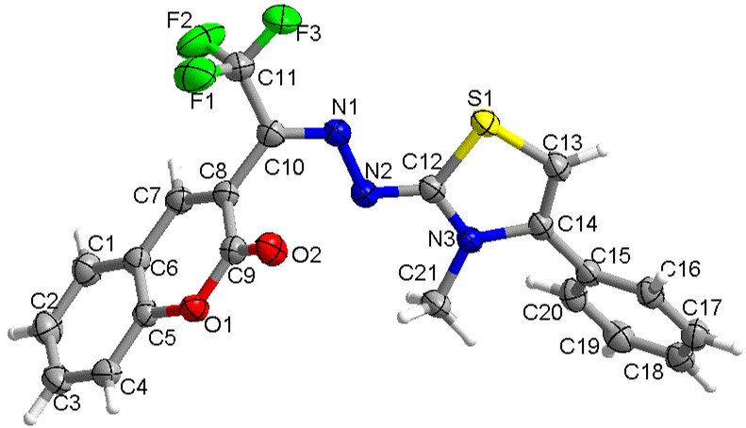
Fig. S-1. Crystal structure of compound 3b (displacement ellipsoids).

Fig. S-2. Packing of the molecule in unit cell.

Table S-1. Crystal data and experimental details for compound 3b.
Empirical formula | C₂₁H₁₄F₃N₃O₂S
Formula weight | 429.41
Wavelength | 1.54184 Å
Crystal system, space group  Unit cell dimensions | Triclinic, P-1  a=8.0776(2)Å, α = 119.306(5)°.  b=16.8791(7)Å, β = 94.065(3)°.  c=16.9242(9)Å, γ = 95.209(3)°.
Volume  Z, Calculated density  Absorption coefficient  F(000)  Crystal size  2θ range for data collection  Limiting indices | 1986.10(17)Å³  4, 1.436 mg/m³  1.911 mm⁻¹  880  0.21×0.18×0.16 mm  6.042 to 134.142°.  -6≦h≦9, -20≦k≦19, -20≦l≦20
Reflections collected/unique  Completeness to theta  Absorption correction  Data / restraints / parameters  Goodness-of-fit on F^2  Final R indices [I>2sigma(I)]  R indices (all data)  Largest diff. peak and hole | 14185/7087[R_{int}=0.0254,R_{sigma} = 0.0275]  66.97%  None  7087/0/544  1.040  R1 = 0.0447, wR2 = 0.1238  R1 = 0.0514, wR2 = 0.1317  0.35/-0.25 e. Å-3
- The H NMR, C NMR and HRMS of the comound 3a
3a(C₂₀H₁₂F₃N₃O₂S ): light yellow powder, m.p.: 159.0-161.7℃.
Figure S-3. IR spectra of the compound 3a

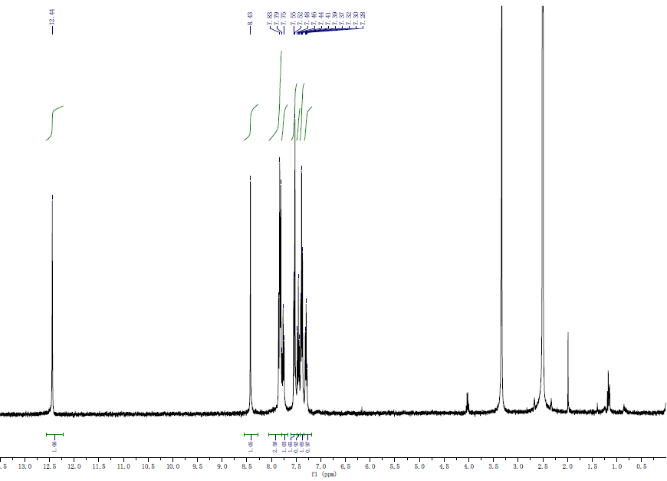
Figure S-4. ¹H NMR spectra of the compound 3a.
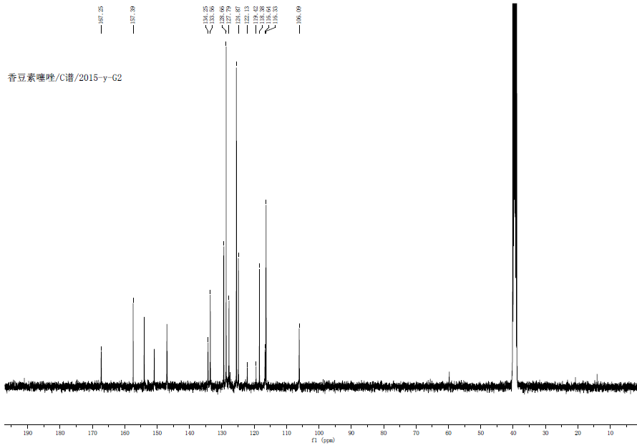
Figure S-5. ¹³C NMR spectra of the compound 3a.
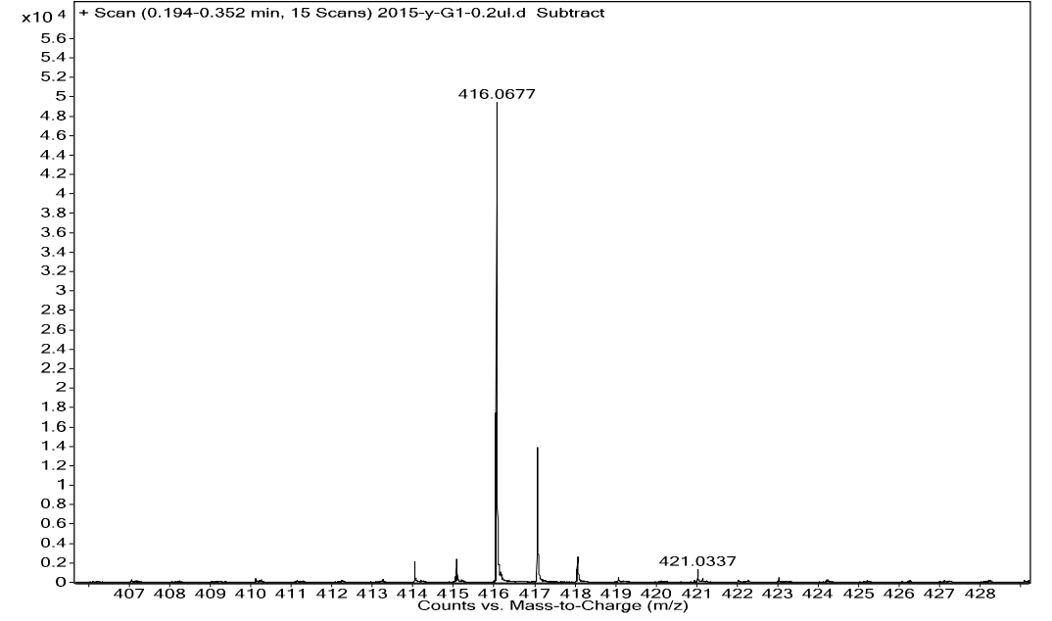
Figure S-6. HRMS of the compound 3a.
Calcd for C₂₀H₁₂F₃N₃O₂S [M + H]⁺: m/z = 416.0681, found 416.0677.

2. The H NMR, C NMR and HRMS of the comound 3b
3b(C21H15F3N3O2S): yellow powder, m.p.: 183.0-183.4℃.
Figure S-7. IR spectra of the compound 3b

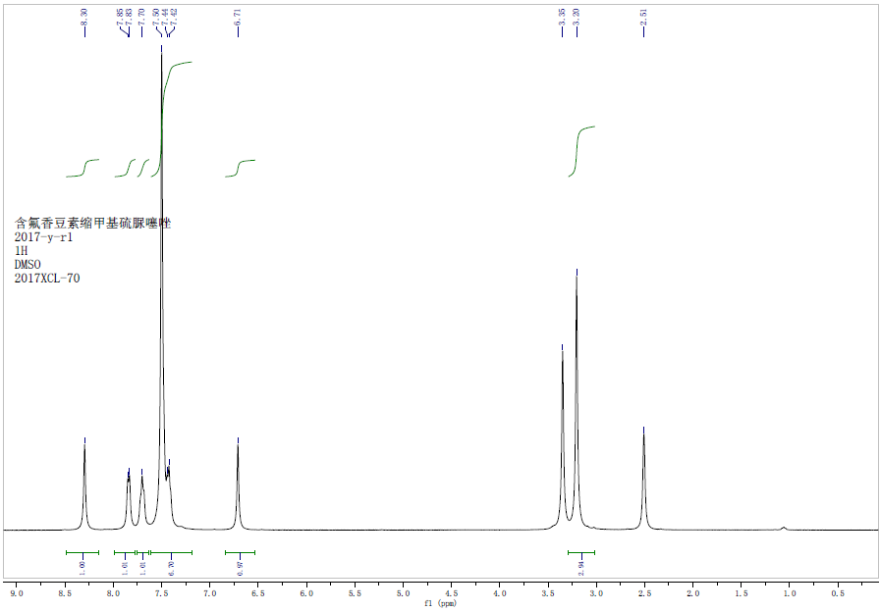
Figure S-8. ¹H NMR spectra of the compound 3b.

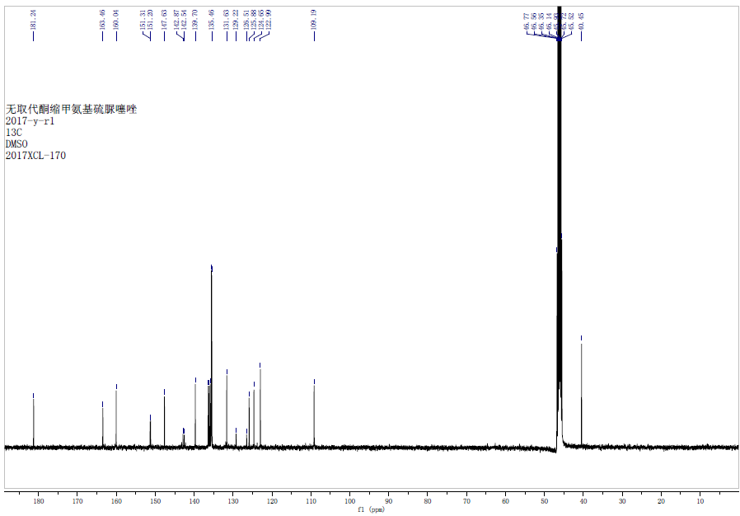

Figure S-9. ¹³C NMR spectra of the compound 3b.
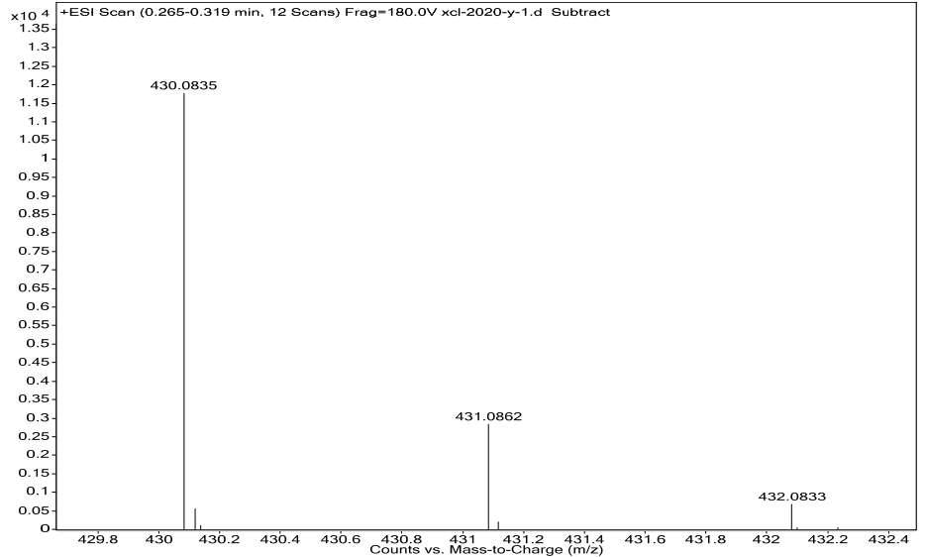
Figure S-10. HRMS of the compound 3b.
Calcd for C₂₁H₁₅F₃N₃O₂S: (M + H⁺) 430.0837; found: 430.0835.
3 .The H NMR, C NMR and HRMS of the comound 3c
3c(C26H16F3N3O2S): yellow powder.
Figure S-11. IR spectra of the compound 3c
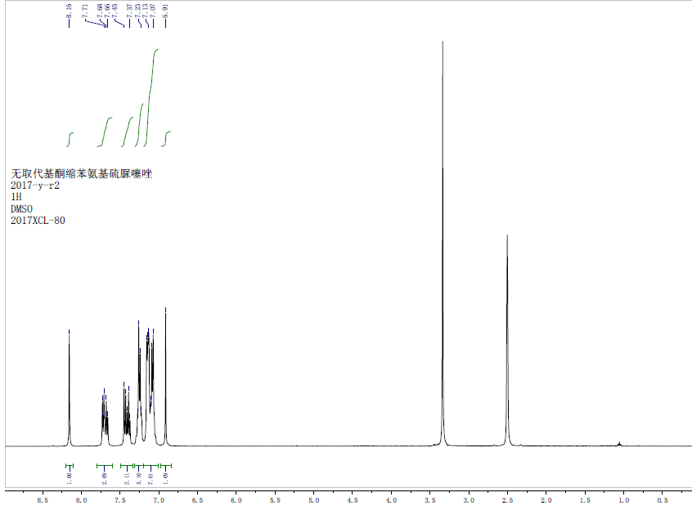
Figure S-12. ¹H NMR spectra of the compound 3c.
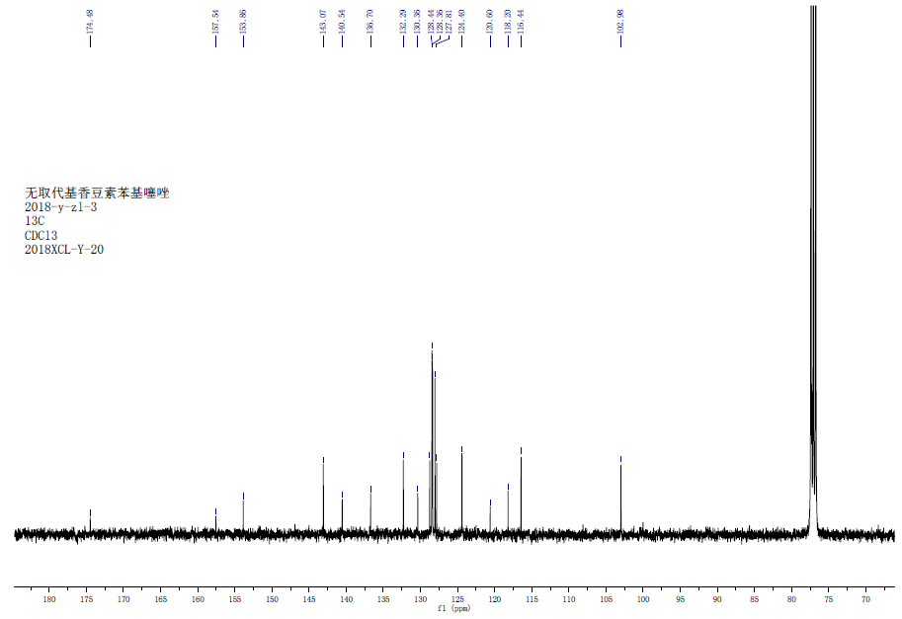
Figure S-13. ¹³C NMR spectra of the compound 3c.
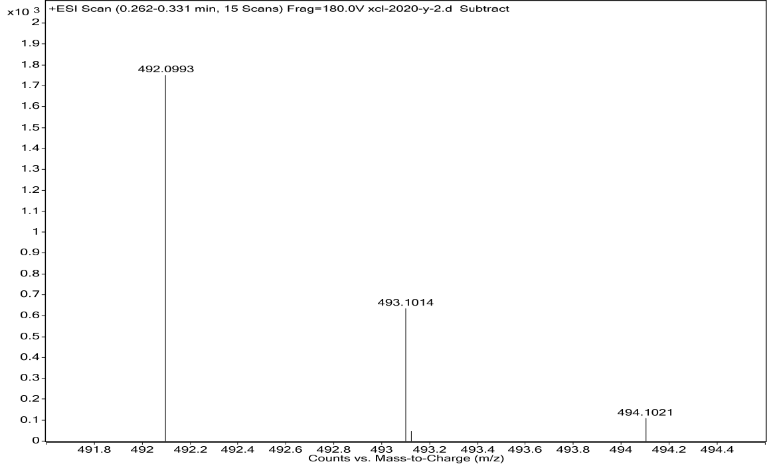
Figure S-14. HRMS of the compound 3c.
Calcd for C₂₆H₁₇F₃N₃O₂S (M + H⁺): 492.0994; found: 492.0993.
3. The IR, H NMR, C NMR and HRMS of the comound 3d
3d (C₂₆H₁₄ClF₃N₃O₂S): white powder.
Figure S-15. IR spectra of the compound 3d

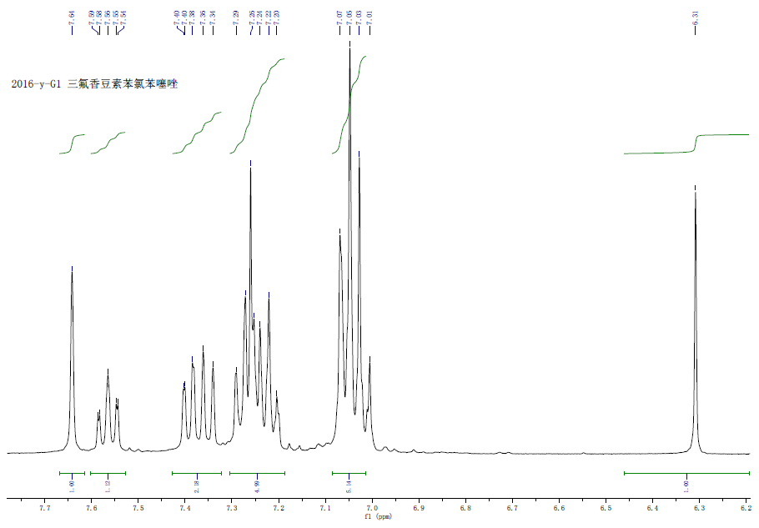
Figure S-16. ¹H NMR spectra of the compound 3d.

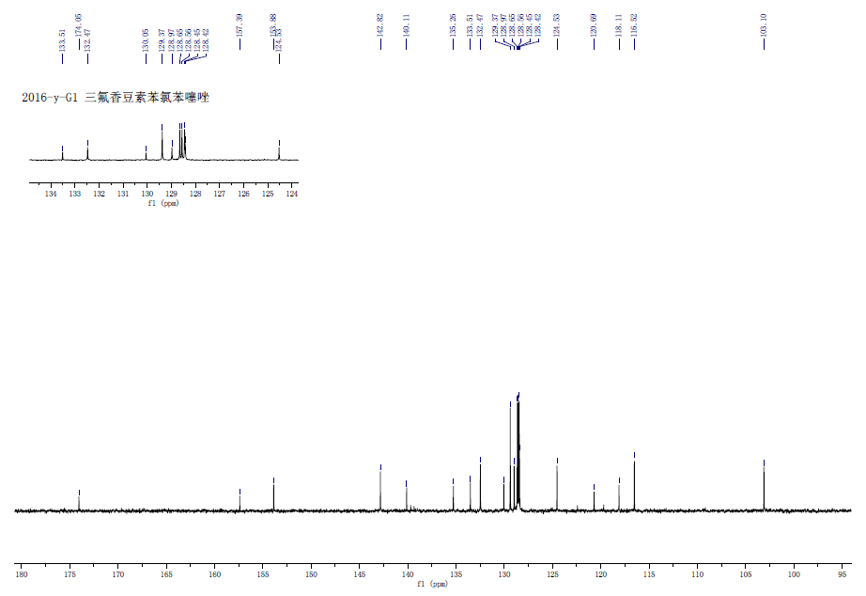
Figure S-17. ¹³C NMR spectra of the compound 3d.
Figure S-18. HRMS of the compound 3d.
Calcd for C₂₆H₁₅ClF₃N₃O₂S (M + H⁺): 526.0604; found: 526.0595.
4. The IR, H NMR, C NMR and HRMS of the comound 3e
3e (C₂₁H₁₄F₃N₃O₂S): yellow powder, m.p.: 210.5-212.8℃.
Figure S-19. IR spectra of the compound 3e

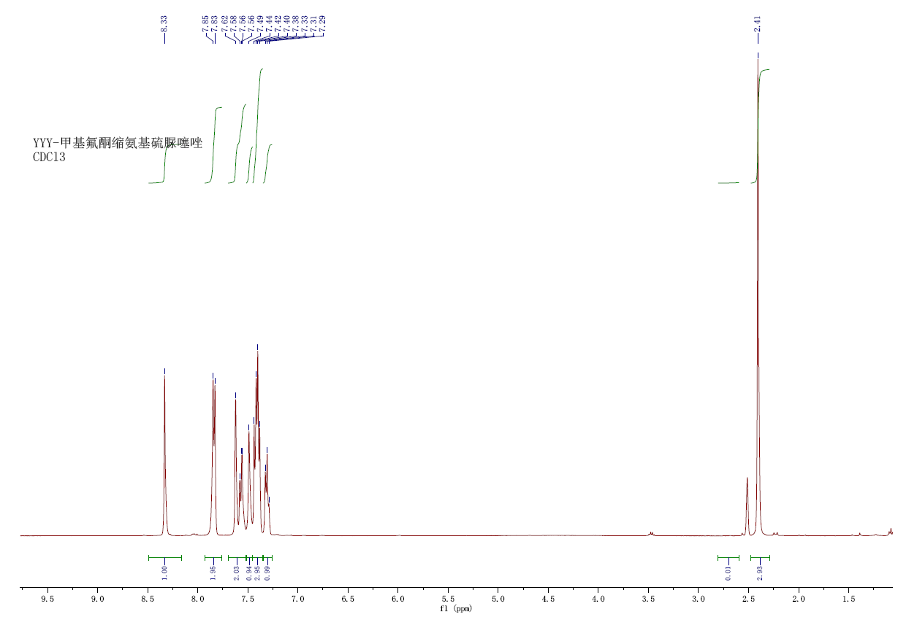
Figure S-20. ¹H NMR spectra of the compound 3e.
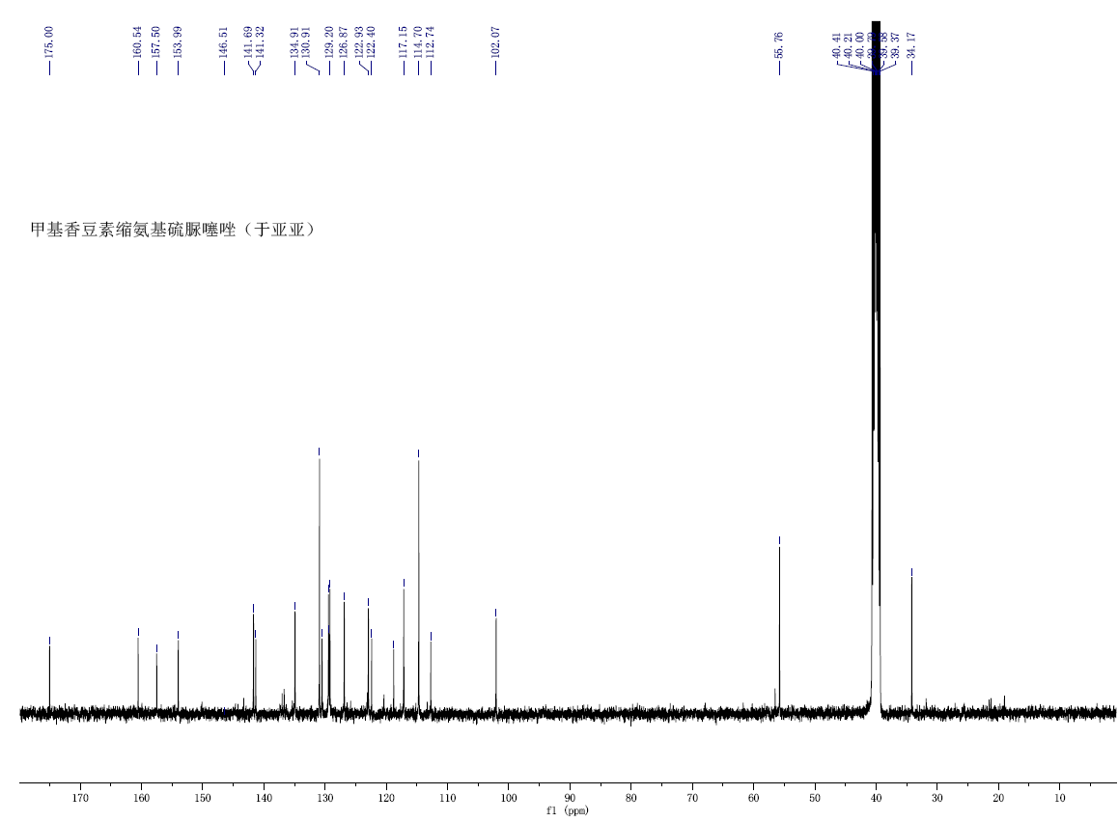
Figure S-21. ¹³C NMR spectra of the compound 3e.
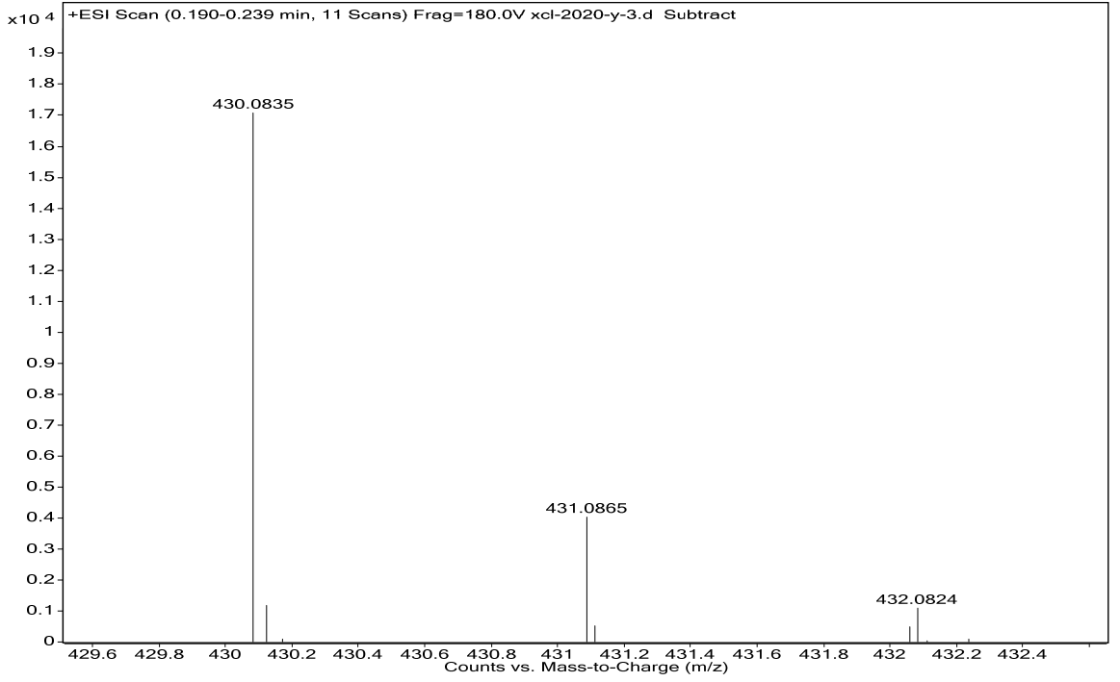
Figure S-22. HRMS of the compound 3e.
Calcd for C₂₁H₁₅F₃N₃O₂S (M + H⁺): 430.0837; found:430.0835.
5 .The IR, H NMR, C NMR and HRMS of the comound 3f
3f (C₂₁H₁₄F₃N₃O₃S): light yellow powder, m.p.: 190.1-191.9℃.
Figure S-23. IR spectra of the compound 3f
Figure S-24. ¹H NMR spectra of the compound 3f

Figure S-25. ¹³C NMR spectra of the compound 3f
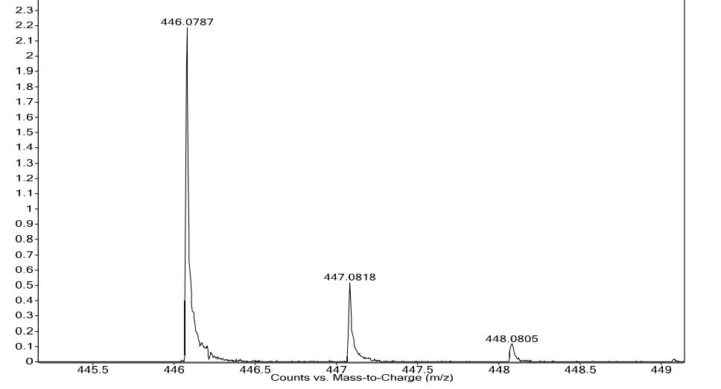
Figure S-26. HRMS of the compound 3f.
Calcd for C₂₁H₁₅F₃N₃O₃S (M + H⁺): 446.0786; found: 446.0787. .
6. The IR, H NMR, C NMR and HRMS of the comound 3g
3g (C₂₁H₁₂ClF₃N₃O₂S): yellow powder, m.p.: 185.4-188.3℃.
Figure S-27. IR spectra of the compound 3g
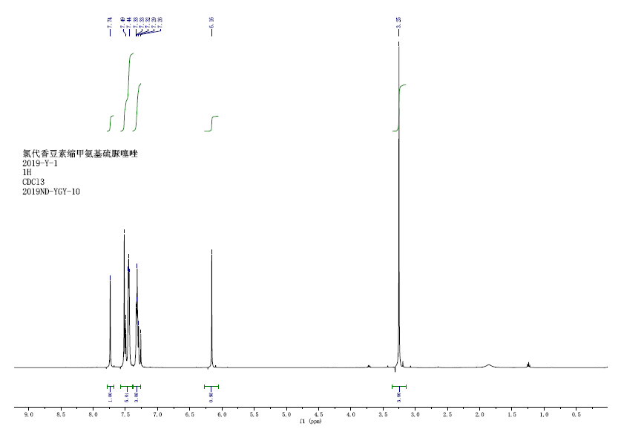
Figure S-28. ¹H NMR spectra of the compound 3g
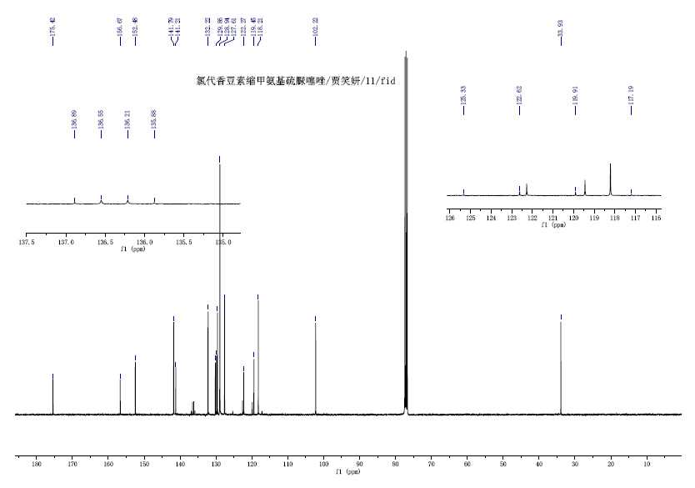
Figure S-29. ¹³C NMR spectra of the compound 3g
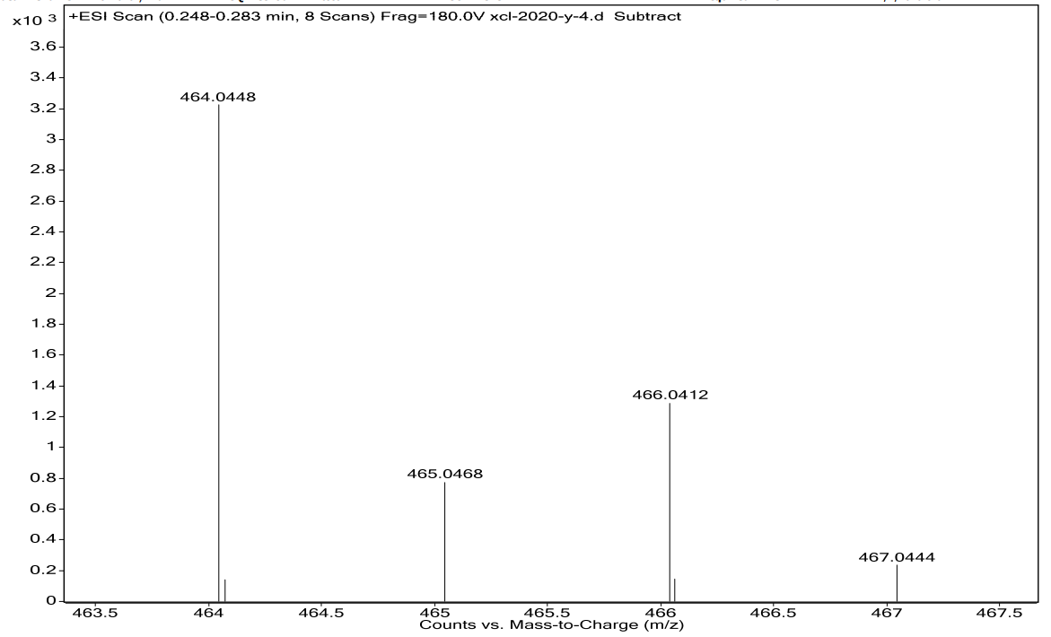
Figure S-30. HRMS of the compound 3g.
Calcd for C₂₁H₁₃ClF₃N₃O₂S (M + H⁺): 464.0447. found: 464.0448.
7 .The IR, H NMR, C NMR and HRMS of the comound 3h
3h(C₂₁H₁₃BrF₃N₃O₂S): yellow powder, m.p.:193.2-195.5℃.
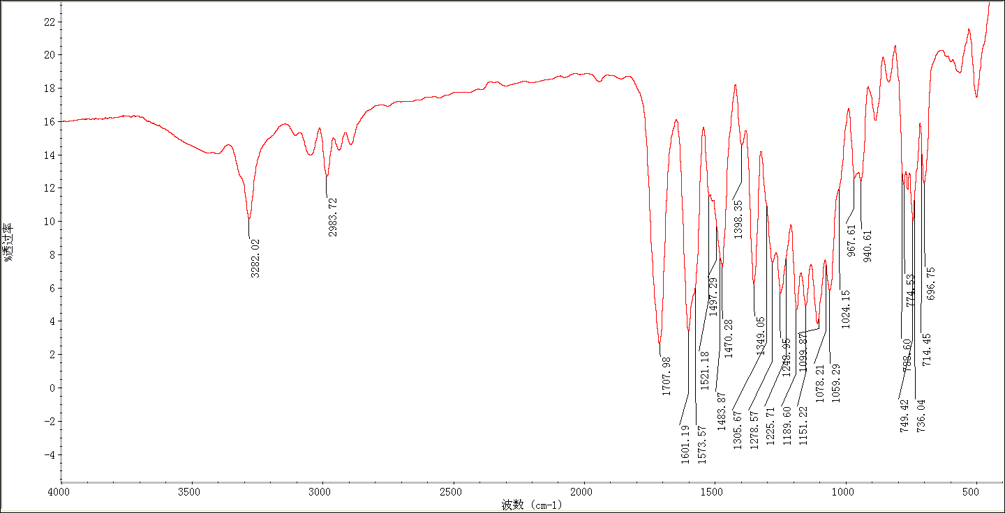
Figure S-31. IR spectra of the compound 3h
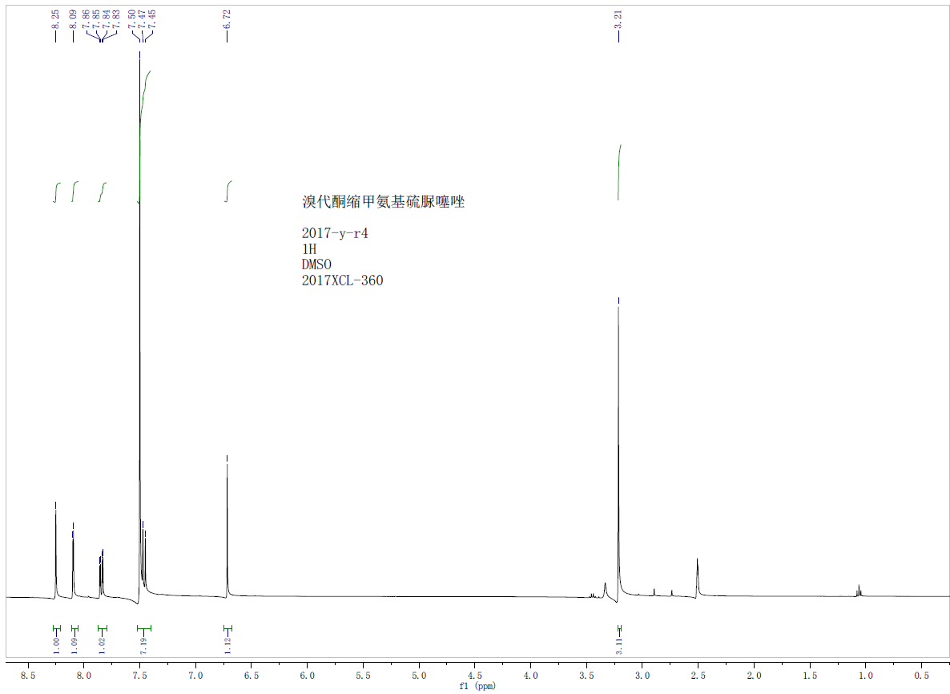
Figure S-32. ¹H NMR spectra of the compound 3h
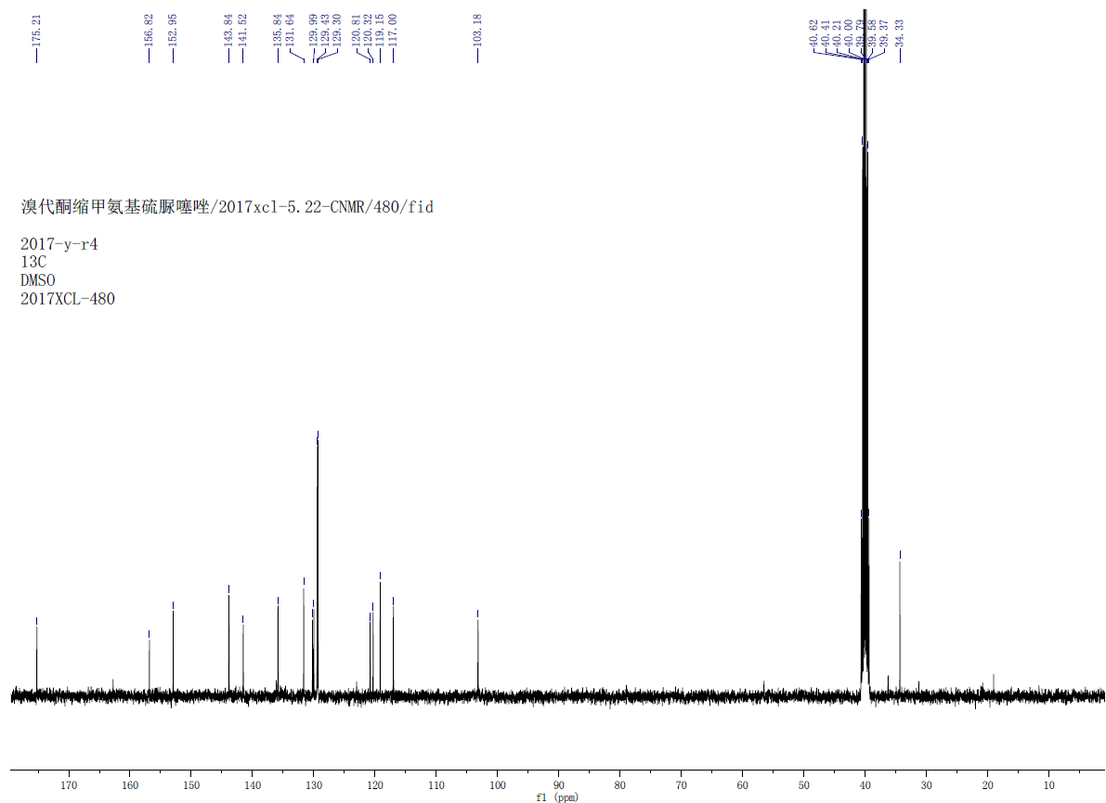
Figure S-33. ¹³C NMR spectra of the compound 3h

Figure S-34. HRMS of the compound 3h.
Calcd for C₂₁H₁₄BrF₃N₃O₂S (M + H⁺): 507.9942. found: 507.9928.

8. The IR, H NMR, C NMR and HRMS of the comound 3i
3i (C₂₀H₁₀BrF₃N₃O₂S): yellow powder, m.p.: 160.0-162.5℃.
Figure S-35. IR spectra of the compound 3i
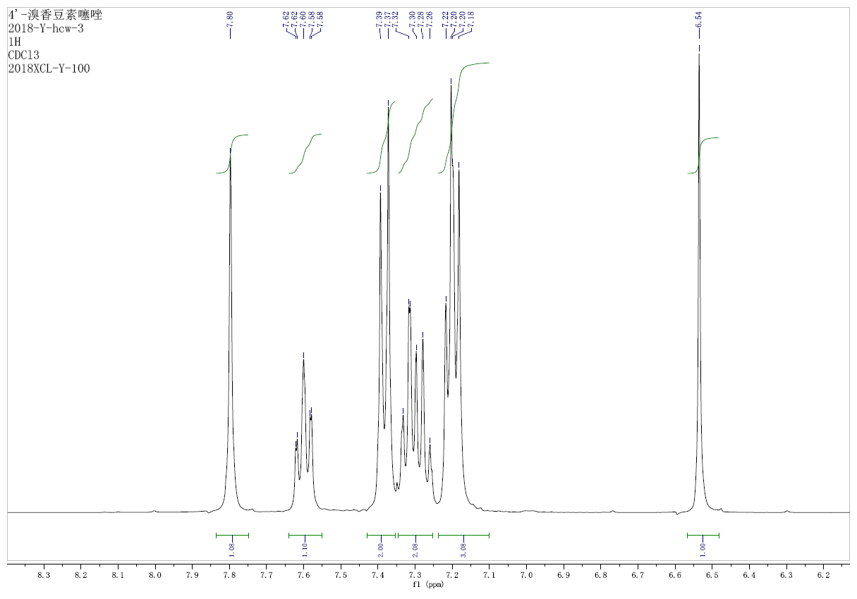
Figure S-36. ¹H NMR spectra of the compound 3i
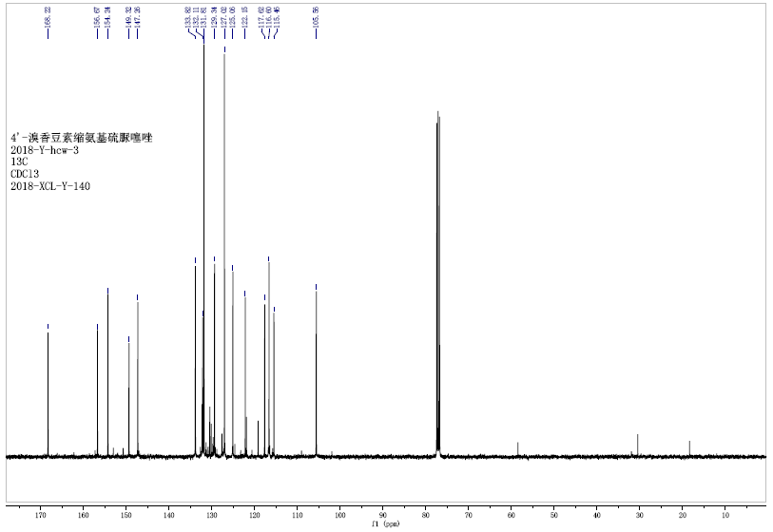
Figure S-37. ¹³C NMR spectra of the compound 3i
Figure S-38. HRMS of the compound 3i.
Calcd for C₂₀H₁₁BrF₃N₃O₂S (M + H⁺): 493.9780, found: 493.9575.
9. The IR, H NMR, C NMR and HRMS of the comound 3j
3j (C₂₁H₁₄F₃N₃O₃S): yellow powder, m.p.: 155.0-157.0℃.
Figure S-39. IR spectra of the compound 3j
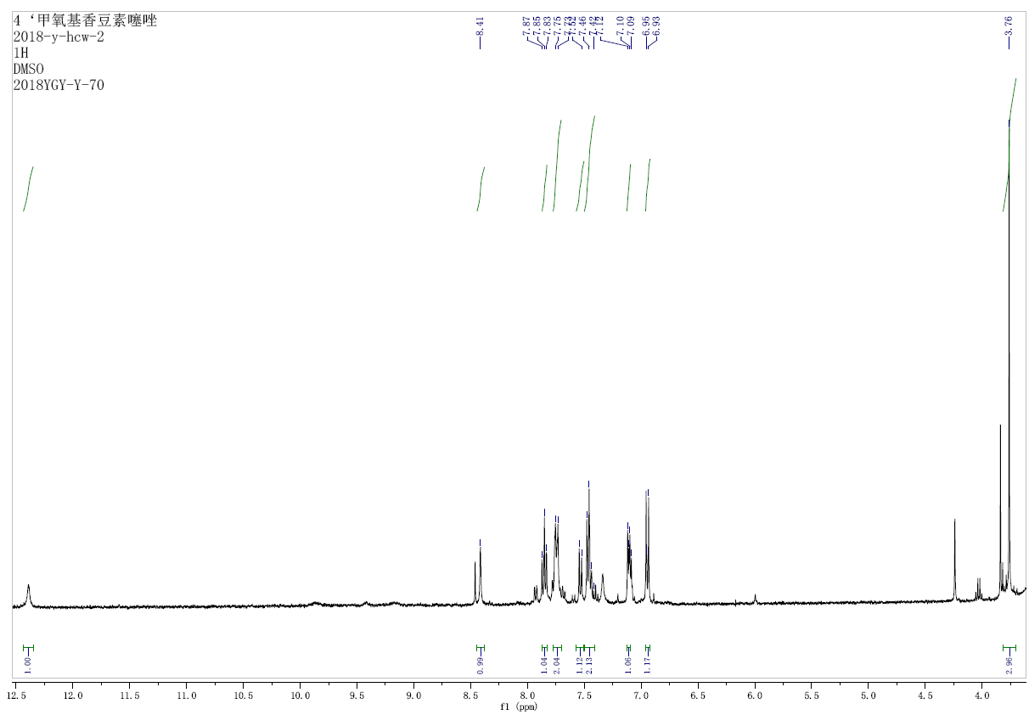
Figure S-40. ¹H NMR spectra of the compound 3j

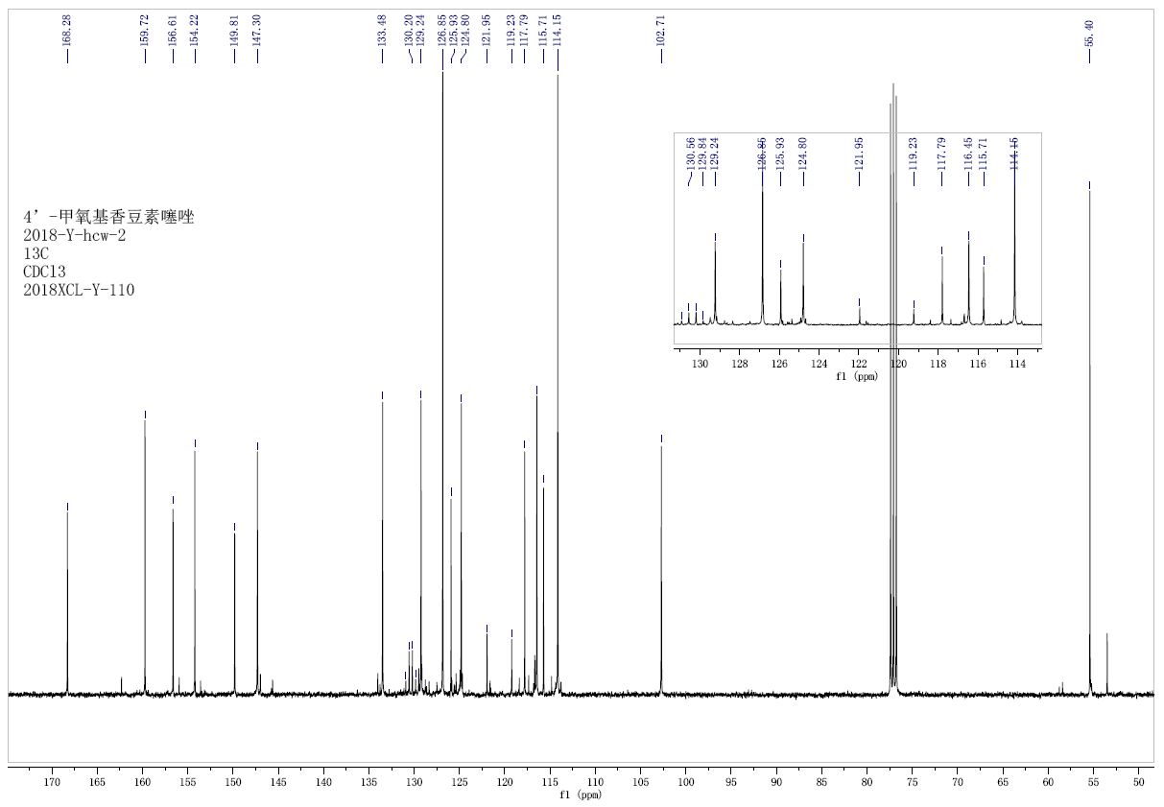
Figure S-41. ¹³C NMR spectra of the compound 3j
Figure S-42. HRMS of the compound 3j.
Calcd for C₂₁H₁₅F₃N₃O₃S (M + H⁺): 446.0786. found: 446.0703.
11. The IR, H NMR, C NMR and HRMS of the comound 3k
3k(C₂₅H₁₆F₃N₃O₂S): yellow powder, m.p.: 267.6-268.8℃.
Figure S-43. IR spectra of the compound 3k

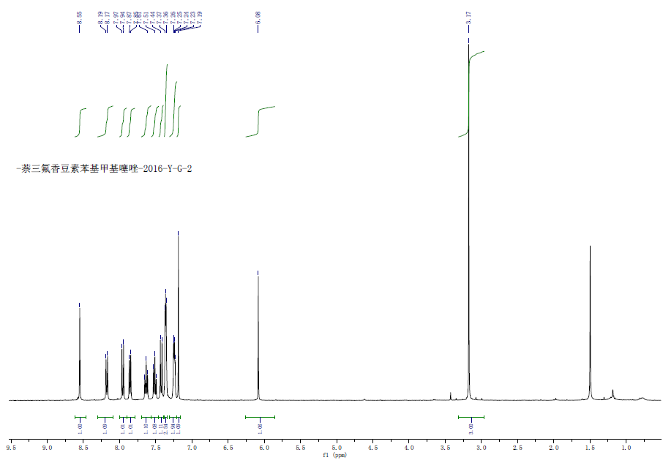
Figure S-44. ¹H NMR spectra of the compound 3k
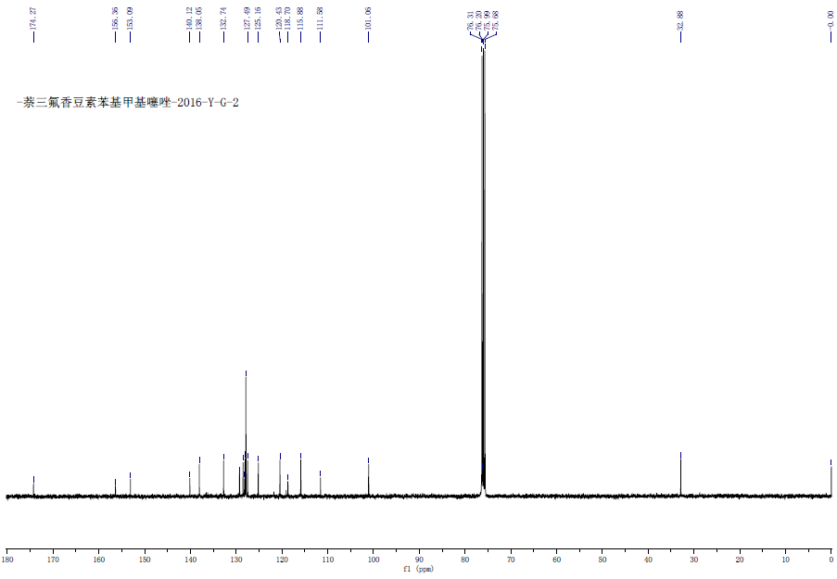
Figure S-45. ¹³C NMR spectra of the compound 3k
Figure S-46. HRMS of the compound 3k.
Calcd for C₂₅H₁₇F₃N₃O₂S₄ (M + H⁺): 480.0994. found: 480.0996.
12. The IR, H NMR, C NMR and HRMS of the comound 3l
3l(C₂₆H₁₉F₃N₃O₃S): yellow powder.
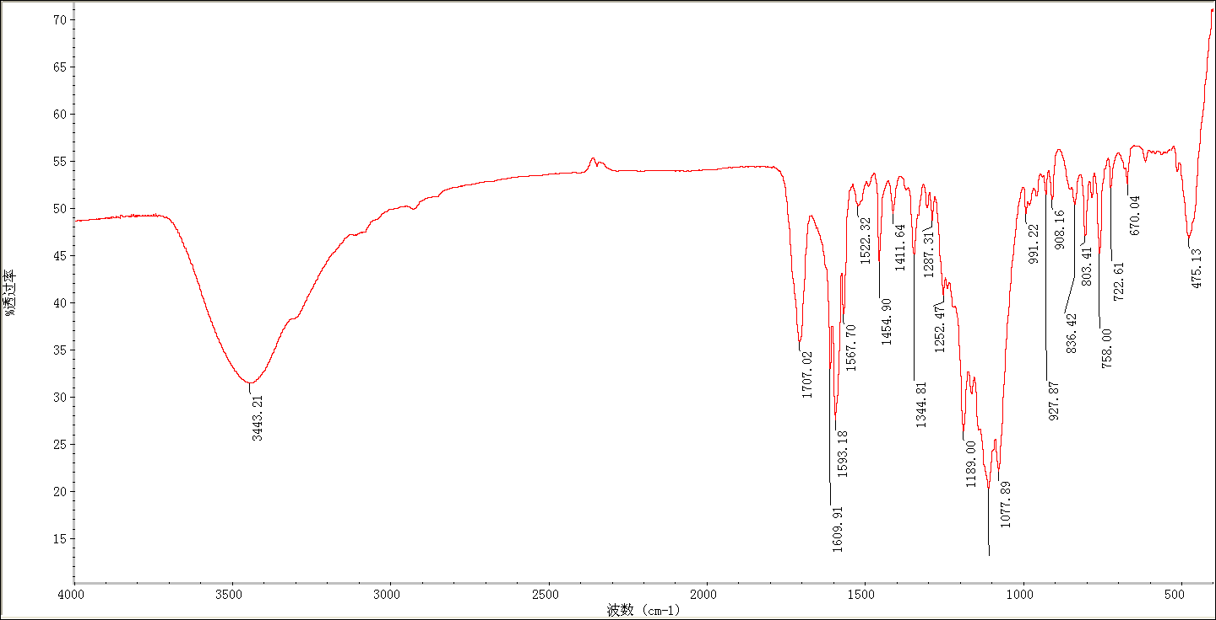
Figure S-47. IR spectra of the compound 3l

Figure S-48. ¹H NMR spectra of the compound 3l
Figure S-49. ¹³C NMR spectra of the compound 3l
Figure S-50. HRMS of the compound 3l.
Calcd for C₂₆H₁₉F₃N₃O₃S (M + H⁺): 510.1099. found: 510.1095.
- The H NMR, C NMR and HRMS of the comound 4
4(C₂₁H₁₆ClN₃O₂S): orange powder.

Figure S-51. IR spectra of the compound 4

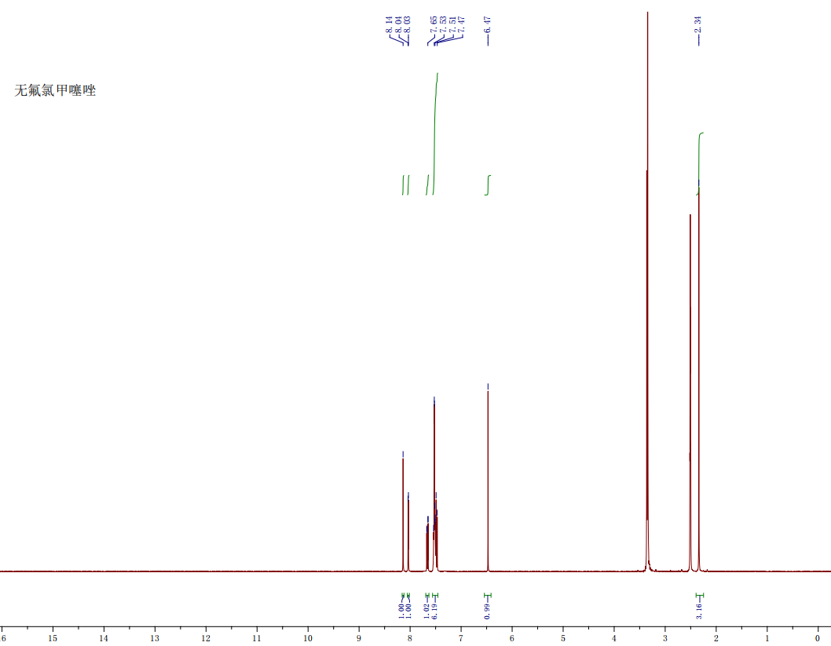
Figure S-52. ¹H NMR spectra of the compound 4
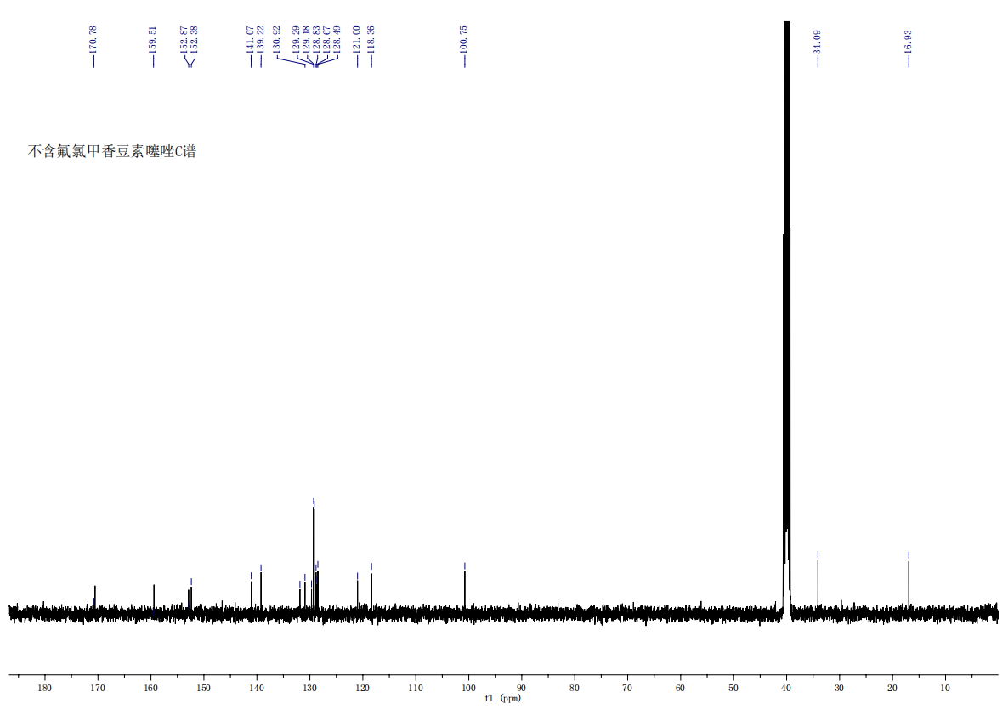
Figure S-53. ¹³C NMR spectra of the compound 4

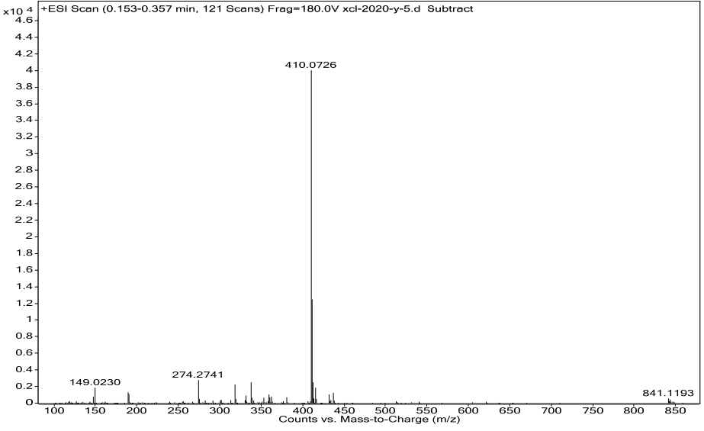
Figure S-54. HRMS of the compound 4.
Calcd for C₂₁H₁₆ClN₃O₂S (M + H⁺): 410.0725. found: 410.0726 .

