**Supplementary Material**

**Insights into Methyl Orange Adsorption Behavior on a Cadmium Zeolitic-Imidazolate Framework Cd-ZIF-8: A Joint Experimental and Theoretical Study**

**Bouchra Ba Mohammed 1, Hassane Lgaz 2,*, Awad A. Alrashdi 3, Khalid Yamni 1, Najib Tijani 1, Younes Dehmani 4, Hicham El Hamdani 5, Ill-Min Chung 2,\***

1Laboratory of Chemistry of Materials and Biotechnology of Natural Products. (E.M.M.P.) Moulay Ismail University, Faculty of Sciences of Meknes, Meknes, Morocco

2Department of Crop Science, College of Sanghur Life Science, Konkuk University, Seoul 05029, South Korea

3Chemistry Department, Umm Al-Qura University, Al-Qunfudah University College, Saudi Arabia

4Laboratory of Chemistry and Biology Applied to the Environment, Moulay Ismail University, Faculty of Sciences of Meknes, Meknes, Morocco

5Métallation, Complexes Moléculaires et Applications (MCMA), Université Moulay Ismail, Faculté des Sciences de Meknès.

*Corresponding authors:* [*hlgaz@konkuk.ac.kr*](mailto:hlgaz@konkuk.ac.kr) *(H. L.),* [*imcim@konkuk.ac.kr*](mailto:imcim@konkuk.ac.kr) *(I-M. C.)*

**Table S1.** Equations of kinetic and adsorption models.

|  |  |  |  |
| --- | --- | --- | --- |
|  | **Model** | **Equation** | **Reference** |
| Kinetic models | Pseudo-first order |  | (Lagergren, 1898) |
| Pseudo-second order |  | (Ho and McKay, 1999) |
| Isotherms models | Langmuir |  | (Banerjee et al., 2019) |
| Freundlich |  | (Banerjee et al., 2019) |

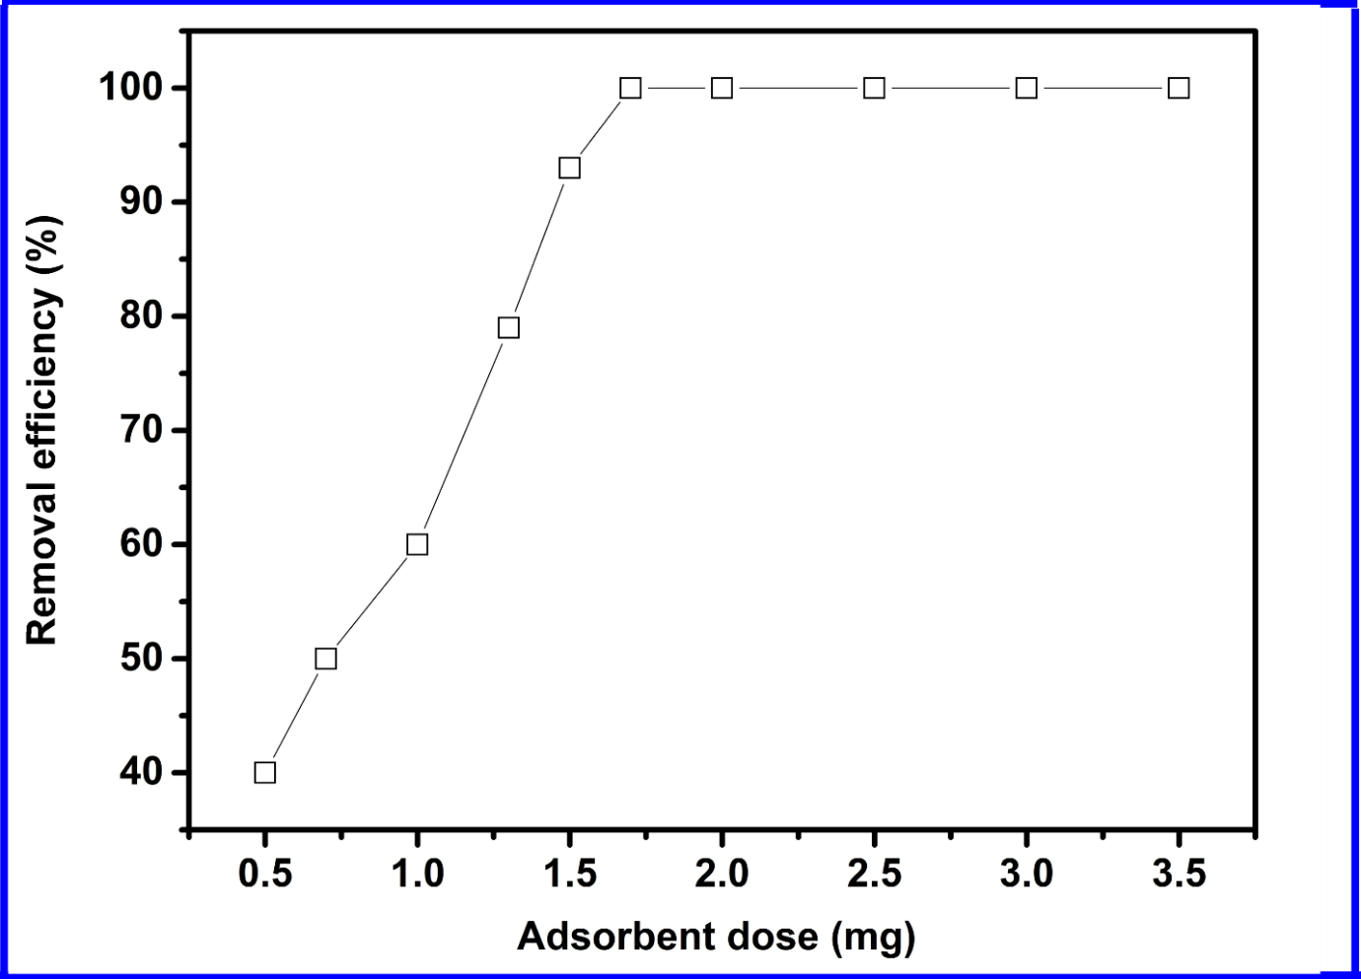

**Figure S1.** Effect of adsorbent dose on the removal of MO by Cd-ZIF-8.



**Figure S2.** Linear relationship between $\ln\left(K_{e}^{°}\right)$ and 1/T.

Banerjee S., Dubey S., Gautam R.K., Chattopadhyaya M.C., Sharma Y.C., Adsorption characteristics of alumina nanoparticles for the removal of hazardous dye, Orange G from aqueous solutions Arab. J. Chem. 2019 5339-5354

Ho Y.-S., McKay G., Pseudo-second order model for sorption processes Process Biochem. 1999 451-465

Lagergren S.K., About the theory of so-called adsorption of soluble substances Sven Vetenskapsakad Handingarl 1898 1-39