Fluorescent sensor for in-vivo bio-imaging, precise tracking of Fe³⁺ ions in Zebrafish embryos and visual measuring of Cu²⁺ ions in pico-molar level
- Senthil Muruganª, M. Kiruthiga^{b}, E. R. Abel Noelsonª, P. Yogapandi^{b}, G. Gnana kumar^{c} and J. Annarajª*
E-mail address: annaraj.chem@mkuniversity.org
ªDepartment of Materials Science, School of Chemistry, Madurai Kamaraj University, Madurai-21, India.
^{b}Department of Chemistry, Pasumpon Muthuramalinga Thevar College, Usilampatti, Madurai-32, India. (Affiliated to Madurai Kamaraj University, Madurai-21, India)
^{c}Department of Physical Chemistry, School of Chemistry, Madurai Kamaraj University, Madurai-21, India.
S.No | Contents | Page. No
1 | Determination of the binding constant | 2
2 | Determination of the Limit of Detection | 3
3 | ¹H NMR spectrum of the RS (Figure S1) | 4
4 | ¹³C NMR spectrum of the RS (Figure S2) | 4
5 | Mass spectrum of the chemosensor RS in Methanol (Figure S3) | 5
6 | HR-MS spectroscopy of the chemosensor RS in methanol  (Figure S4) | 5
6 | Linearity plot derived from sensitivity experiment of RS with increasing concentration of the Fe³⁺ ions in fluorescence spectroscopy (Figure S5) | 5
7 | Determination of the binding constant value RS towards Fe³⁺ ions by using B-H plot analysis (Figure S6) | 6
8 | Linearity plot derived from sensitivity experiment of RS with increasing concentrations of the Fe³⁺ ions in UV-vis. spectroscopy (Figure S7) | 6
9 | Determination of the binding constant value RS towards Fe³⁺ ions by using B-H plot analysis in UV-vis. spectroscopy  (Figure S8) | 6
10 | Linearity plot derived from sensitivity experiment RS with increasing concentration of the Cu²⁺ ions in UV-vis. spectroscopy (Figure S9) | 7
11 | Determination of the binding constant value of RS towards Cu²⁺ ions by using B-H plot analysis in UV-vis. spectroscopy  (Figure S10) | 7
12 | ESI-MS spectrum of the RS with 1 equivalent of Cu²⁺ ions (Figure S11) | 8
13 | ESI-MS spectrum of the RS with 1 equivalent of Fe³⁺ ions  (Figure S12) | 8
14 | Masking of Cu²⁺ ions by the addition of the cysteine in fluorescence spectroscopy (Figure S13) | 9
15 | ESI-MS spectrum of the RS with 1 equiv. of Cu²⁺ and Fe³⁺ ions  (Figure S14) | 9
16 | Reversibility experiment for Fe³⁺ ions with ETDA in absorbance spectroscopy (Figure S15) | 9
17 | Reversibility experiment for Fe³⁺ ions with ETDA in absorbance spectroscopy (Figure S16) | 10
18 | Reversibility experiment for Fe³⁺ ions with ETDA in fluorescence spectroscopy (Figure S17) | 10
19 | Stability of chemosensor RS in CH₃CN solution for 30 days using absorbance spectroscopy (Figure S18) | 10
20 | Mortality experiments of chemosensor RhS and Fe³⁺ ions on zebrafish embryos (Figure S19) | 11
21 | Table: S2. Comparison Table with the recent literature | 11
22 | References | 12

1. UV-vis. and Fluorescence spectroscopic studies
10⁻³ M concentration of RS was prepared as stock solution. 5 μL from this stock solution was diluted to 2 mL with double distilled water to cover the final concentration of 2.5 μM for UV-vis. and fluorescence studies. The stock solutions of various metal ions (Pb²⁺, Cd²⁺, Hg²⁺, Zn²⁺, Cu²⁺, Ni²⁺, Co²⁺, Mn²⁺, Fe²⁺, Fe³⁺, Cr³⁺, Ca²⁺, Ba²⁺, Mg²⁺, Na⁺, K⁺ and Ag⁺) were prepared in the concentrations of 10⁻² M. For Jobs plot analysis, 10⁻⁶ M of RS and metal solutions were used. All the fluorescence experiments were carried out at 375 nm as an excitation wavelength.

2. Determination of the Binding constant¹.
The binding constant values of Cu²⁺ and Fe³⁺ ions with RS has been determined by using electronic absorption and fluorescence spectroscopic techniques respectively. Linear relationship was achieved with fixed concentration of RS in all experiments and varying concentrations of Cu²⁺ and Fe³⁺ ions. The binding constant value of Cu²⁺ with RS was determined by using Benesi-Hildebrand equation¹. K_{a} was calculated using the following equation.

1/(A-A_{o}) = 1/{K_{a}(Amax–A_{o}) [Cu²⁺]} + 1/[Amax-A_{o}]

Where,
A_{o} is the absorbance of receptor in the absence of metal ions,
A is the absorbance recorded in the presence of added Cu²⁺ ions,
Amax is absorbance in presence of added [Cu²⁺]_{max} and K_{a} is the association constant (M⁻¹). The association constant (K_{a}) could be determined from the slope of the straight line of the plot of 1/(A-A_{o}) against 1/[Cu].

The binding constant value of the Fe³⁺ with RS was determined by using modified Benesi-Hildebrand equation stated below,

1/ I-I_{min} = 1/ I_{max}-I_{min} + (1/K[C])(1/ I_{max}-I_{min}).

Where,
I_{min}, I, and I_{max} are the emission intensities of RS, at intermediate Fe³⁺ concentration with RS, and at concentration of complete saturation, K is the binding constant and [C] is the Fe³⁺ concentration respectively. From the plot of (I_{max}-I_{min})/(I-I_{min}) against [C]⁻¹ for RS-Fe, the value of K has been determined from the slope.

3. Determination of Limit of Detection (LOD)²

LOD for Cu²⁺ and Fe³⁺ ions with RS were determined by UV-visible/fluorometric titrations using the formulae 3σ/slope, where, σ is standard division of the blank solution and slope was derived from titration curve.

Figure S1: ¹H-NMR spectrum of the chemosensor RS in DMSO-d⁶.
Figure S2: ¹³C-NMR spectrum of the chemosensor RS in DMSO-d⁶.

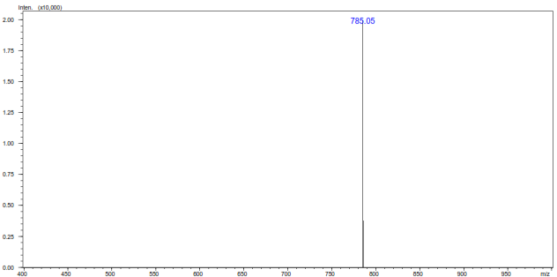
Figure S3: ESI-MS spectrum of the chemosensor RS in methanol.
Figure S4: HRMS spectroscopy of the chemosensor RS in methanol.
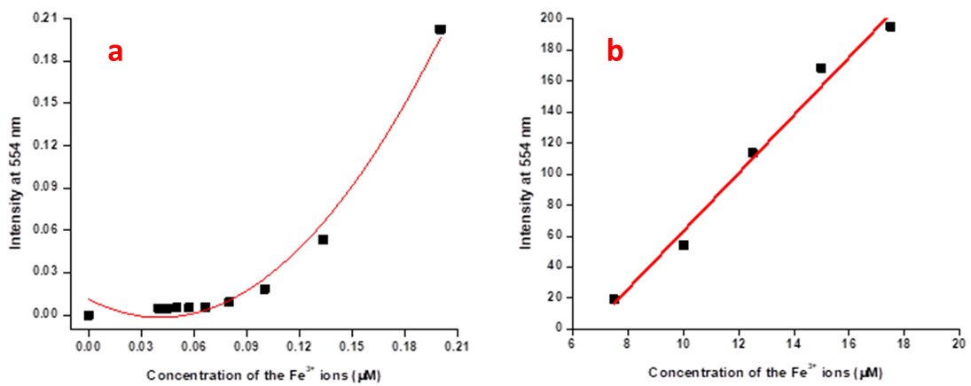
Figure S5: Linearity plot derived from sensitivity experiment of RS with increasing concentration of the Fe³⁺ ions in fluorescence spectroscopy.

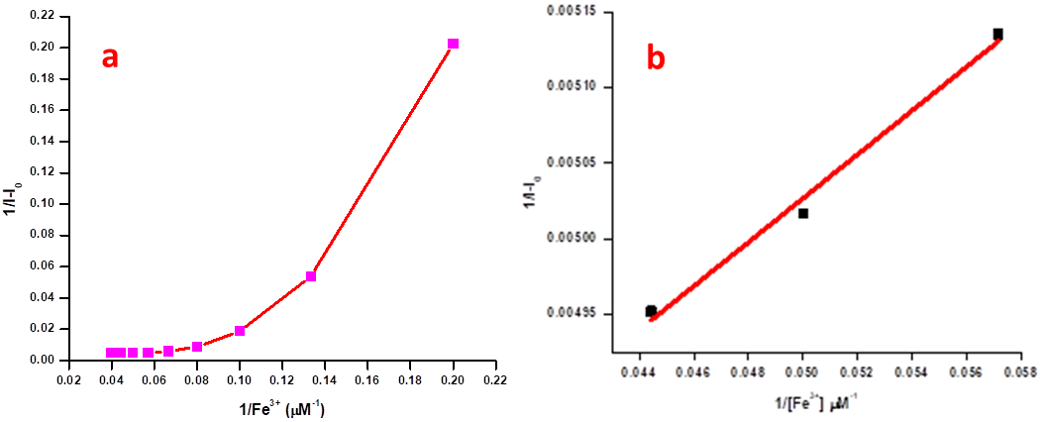
Figure S6: Determination of the binding constant value of RS towards Fe³⁺ ions by using B-H plot analysis.

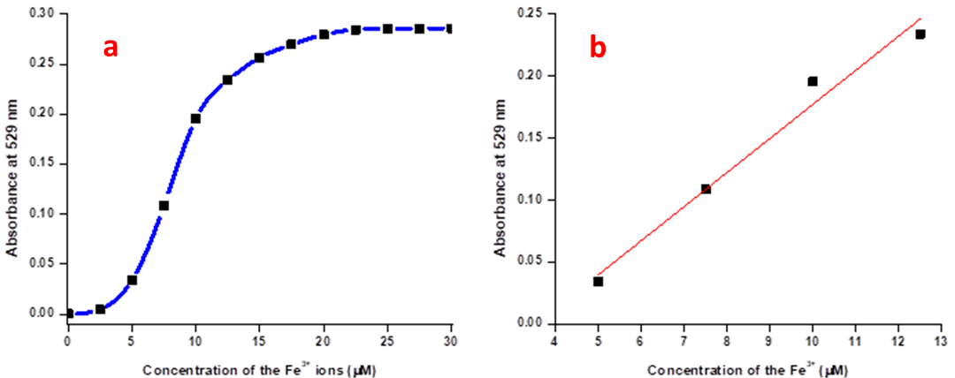
Figure S7: Linearity plot derived from sensitivity experiment of RS with increasing concentrations of the Fe³⁺ ions in UV-vis. spectroscopy.
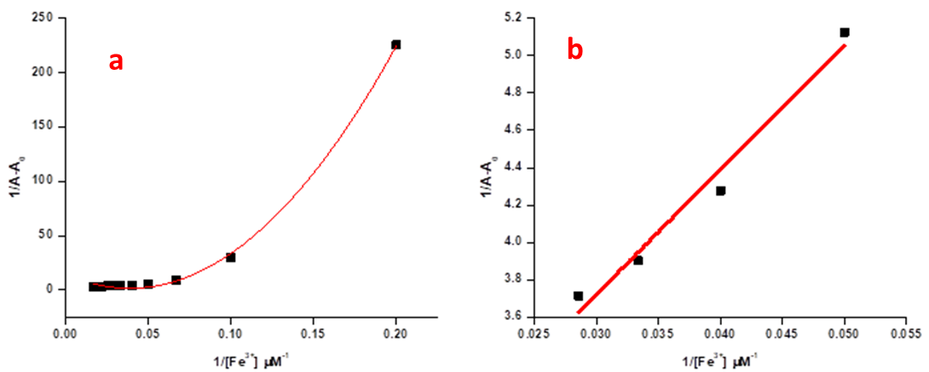
Figure S8: Determination of the binding constant value of RS towards Fe³⁺ ions by using B-H plot analysis in UV-vis. spectroscopy.
Figure S9: Linearity plot derived from sensitivity experiment of RS with increasing concentration of the Cu²⁺ ions in UV-vis. spectroscopy.

Figure S10: Determination of the binding constant value of RS towards Cu²⁺ ions by using B-H plot analysis in UV-vis. spectroscopy.
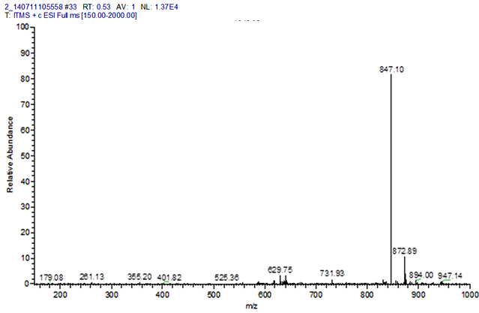
Figure S11: ESI-MS spectrum of the RS with 1 equivalent of Cu²⁺ ions in methanol.
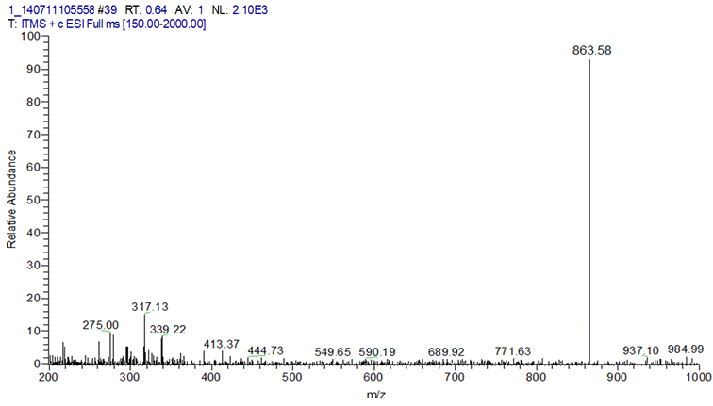
Figure S12: ESI-MS spectrum of the RS with 1 equivalent of Fe³⁺ ions in methanol.
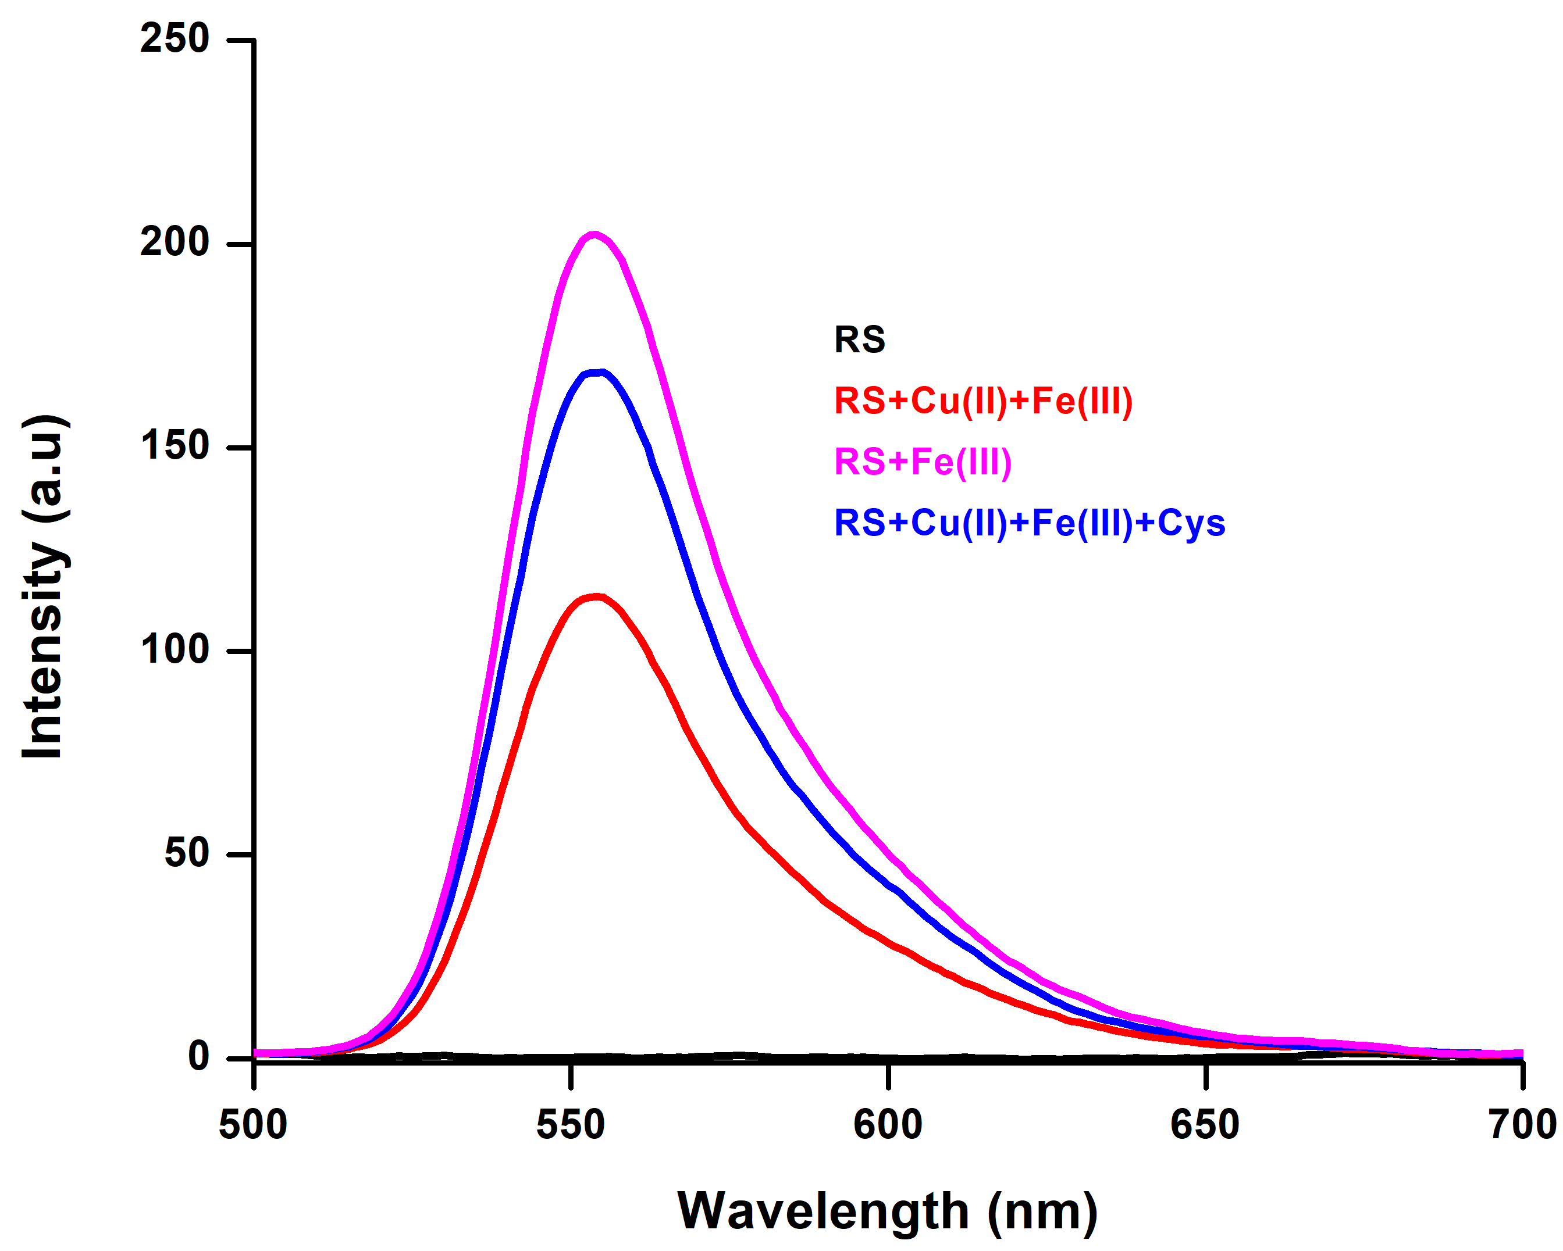
Figure S13: Masking of Cu²⁺ ions by the addition of the cysteine in fluorescence spectroscopy in CH₃CN/H₂O (9:1).
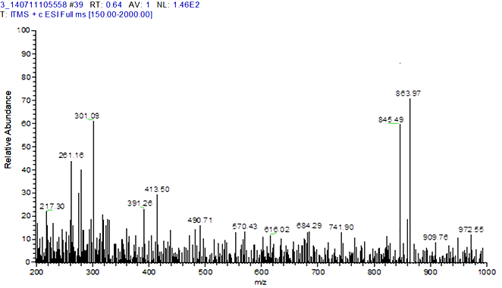
Figure S14: ESI-MS spectrum of the RS with 1 equiv. of Cu²⁺ and Fe³⁺ ions in methanol.
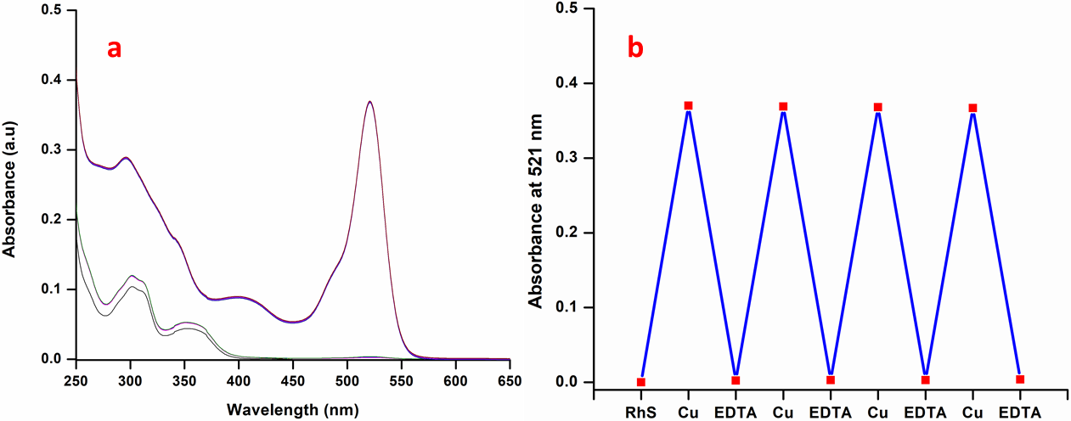
Figure S15: Reversibility experiments for Fe³⁺ ions with ETDA in electronic absorbance spectroscopy.

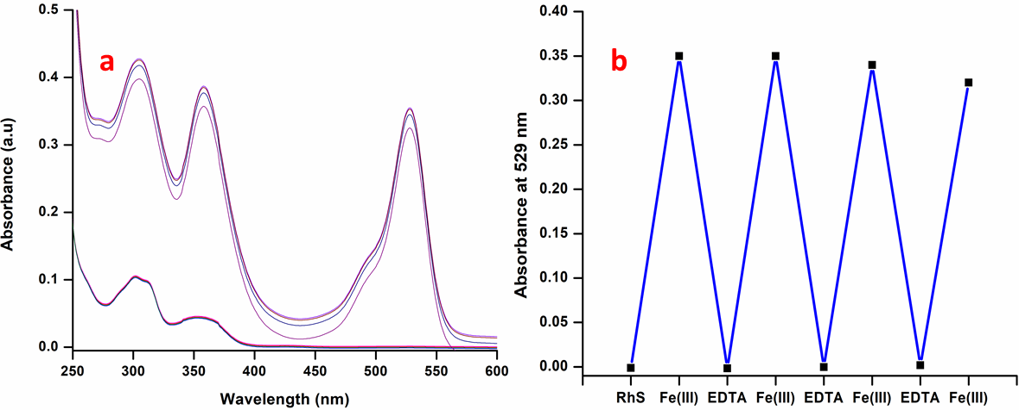
Figure S16: Reversibility experiment for Fe³⁺ ions with ETDA in electronic absorbance spectroscopy.
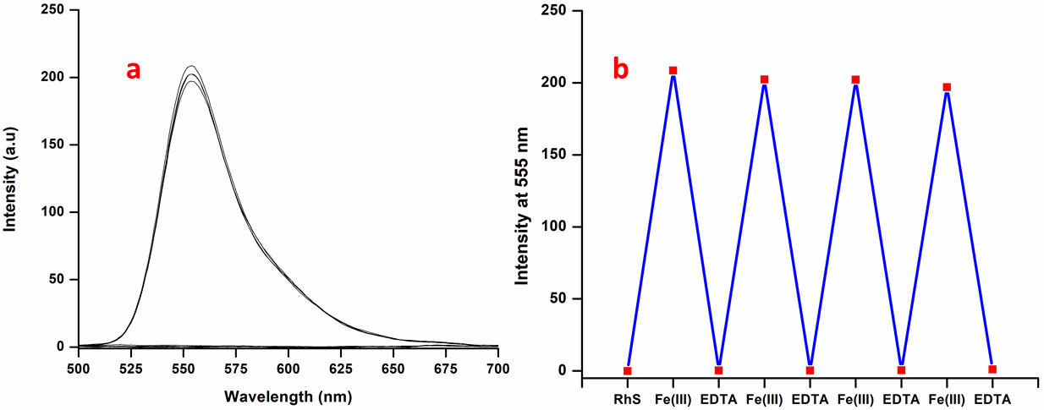
Figure S17: Reversibility experiment for Fe³⁺ ions with ETDA in fluorescence spectroscopy.

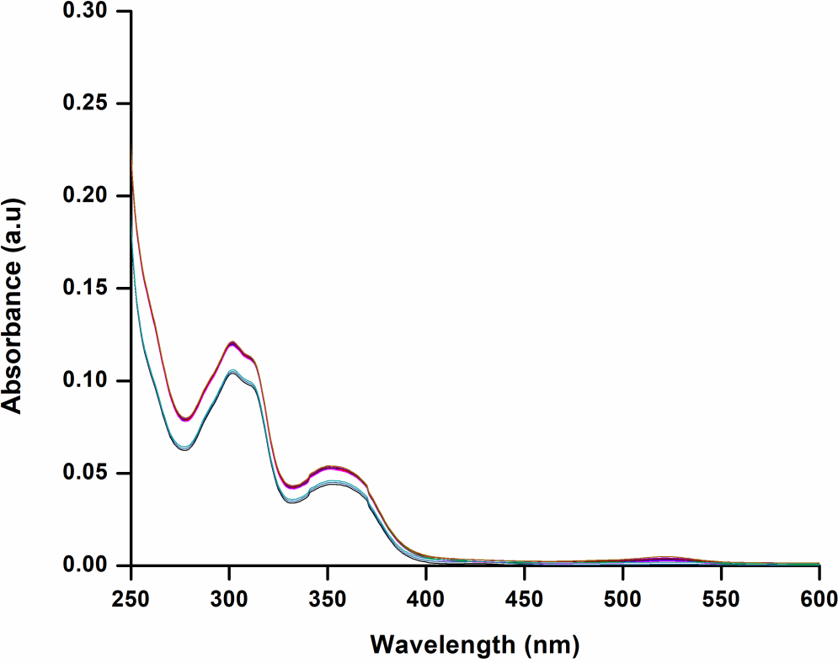
Figure S18: Stability of chemosensor RS in DMSO solution for 30 days using absorbance spectroscopy.
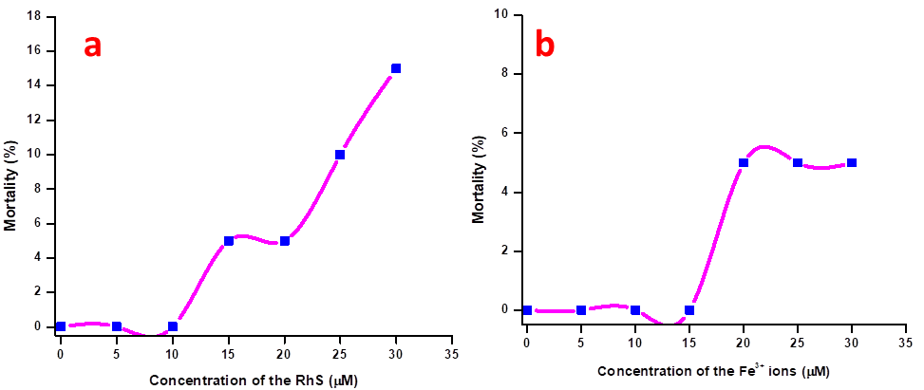
Figure S19: Mortality experiments between chemosensor RS and Fe³⁺ ions on zebrafish embryos.
Table: S1. Comparison table of the recent literature
S. No | Chemosensor | Analytes | Limit of Detection | Application | Reference
1 | Rhodamine B | Hg²⁺ | 32 nM | Molecular Logic gates | 3
2 | Rhodamine B | Zn²⁺, Cr³⁺, Al³⁺ and Fe³⁺ | 88 nM (Zn²⁺), 89 nM (Cr³⁺), 161 nM (Al³⁺) and 87 nM | --- | 4
3 | Rhodamine Dye | Hg²⁺ | 0.08 | --- | 5
4 | Rhodamine 6G | Fe³⁺ | μM level | Bio-imaging studies on HepG2 cells | 6
5 | 2-amino benzoic acid based chemosensor | Fe³⁺, Fe²⁺ and Cu²⁺ | 2.17 μM (Fe³⁺), 2.0 μM (Fe²⁺) and 2.5 μM (Cu²⁺) | ---- | 7
6 | Rhodamine 6G | Cu²⁺ | NA | Bio-imaging studies on HepG2 cells | 8
7 | Rhodamine 6G | Cu²⁺ | 3.9 X 10⁻⁷ M | --- | 9
8 | Rhodamine 6G | Hg²⁺ | RA | --- | 10
9 | Rhodamine 6G | Fe³⁺ | 41 nM | --- | 11
10 | imidazole-based chemosensor | Fe²⁺, Fe³⁺ and Al³⁺ | 0.32 for Fe³⁺, 0.27 for Fe ²⁺ and 2.9 for Al³⁺ | Live cell imaging | 12
11 | Salicylaldehyde conjugated rhodamine based Dye | Cu²⁺ and Fe³⁺ | 263 pM for Cu²⁺ and 2 nM for Fe³⁺ | Bio-imaging studies on Zebrafish embryos for Fe³⁺ ion detection | Present Work
References
- S. Goswami, D. Sena , N. K. Dasa , H-K Funb, C. K. Quah A new rhodamine based colorimetric ‘off–on’ fluorescence sensor selective for Pd²⁺ along with the first bound X-ray crystal structure, Chem. Commun., 2011,47, 9101-9103.
- Y. Zhang, Y. Fang, H. Liang, H. Wang, K. Hu, X. Liu, Y. Peng, X. Yi, Synthesis and antioxidant activities of 2-oxo-quinoline-3-carbaldehyde Schiff-base derivatives, Bioorg. Med. Chem. Lett. 2013, 23, 107-111
- H. Ding, C. Zheng, B. Li, G. Liu, S. Pu, D. Jia, and Y. Zhou A rhodamine-based sensor for Hg²⁺ and resultant complex as a fluorescence sensor for I⁻, RSC Adv.,2016, 6, 80723-80728
- X. Tang, Y. Wang, J. Han, L. Ni, J. Li, H. Zhang, C. Li and Y. Qiu, A novel fluorescent probe based on biphenyl and rhodamine for multi-metal ion recognition and its application, Dalton Trans., 2018, 47, 3378-3387.
- J. Tao, X. Wang, X. Chen, T. Li, Q. Diao, H. Yu, T. Wang. Si-rhodamine B thiolactone: A simple long wavelength operating chemosensor for direct visual recognition of Hg²⁺, Dyes and Pigments 2017, 137, 601-07.
- R. Bhowmick, A. S. M. Islam, A. Giri, A. Katarkar and M. Ali A rhodamine based turn-on chemosensor for Fe³⁺ in aqueous medium and interactions of its Fe³⁺ complex with HAS, NewJ. Chem., 2017, 41, 11661-11671.
- X. Zhu, Y. Duan, P. Li, H. Fan, T. Han and X. Huang, A highly selective and instantaneously responsive Schiff base fluorescent sensor for the “turn-off” detection of iron(III), iron(II), and copper(II) ions, Anal. Methods 2019, 11, 642-647
- H. Park, K-L. An, M. Naveen, K. Jun and Y-A Son Rhodamine‐based Colorimetric and Fluorescent Chemosensors for the Detection of Cu²⁺ Ions and its Application to Bioimaging, Bull. Korean Chem. Soc. 2018, 39, 972–981
- Q. Huang, Y. T. Chen, Y. W. Ren, Z. Y. Wang, Y. X. Zhu and Y. Zhang A rapid and naked-eye visible rhodamine 6G-based chemosensor for sensitive detection of copper(II) ions in aqueous solution, Anal. Methods, 2018, 10, 5731-5737
- P. G. Rao, B. Saritha, T. S. Rao Colorimetric and turn-on Fluorescence Chemosensor for Hg²⁺ Ion Detection in Aqueous Media, JFluoresc 2019, 29, 353–360.
- R. Qiao, W-Z. Xiong, C-B. Bai, J-X. Liao and L. Zhang A highly selective fluorescent chemosensor for Fe (III) based on rhodamine 6G dyes derivative Supramolecular chemistry 2018, 30, 911–917
- T. G. Jo, K. H. Bok, J. Han, M. H. Lim, C. Kim, Colorimetric detection of Fe³⁺ and Fe²⁺ and sequential fluorescent detection of Al³⁺ and pyrophosphate by an imidazole-based chemosensor in a near-perfect aqueous solution, Dyes and Pigments 2017, 139, 136-147.

