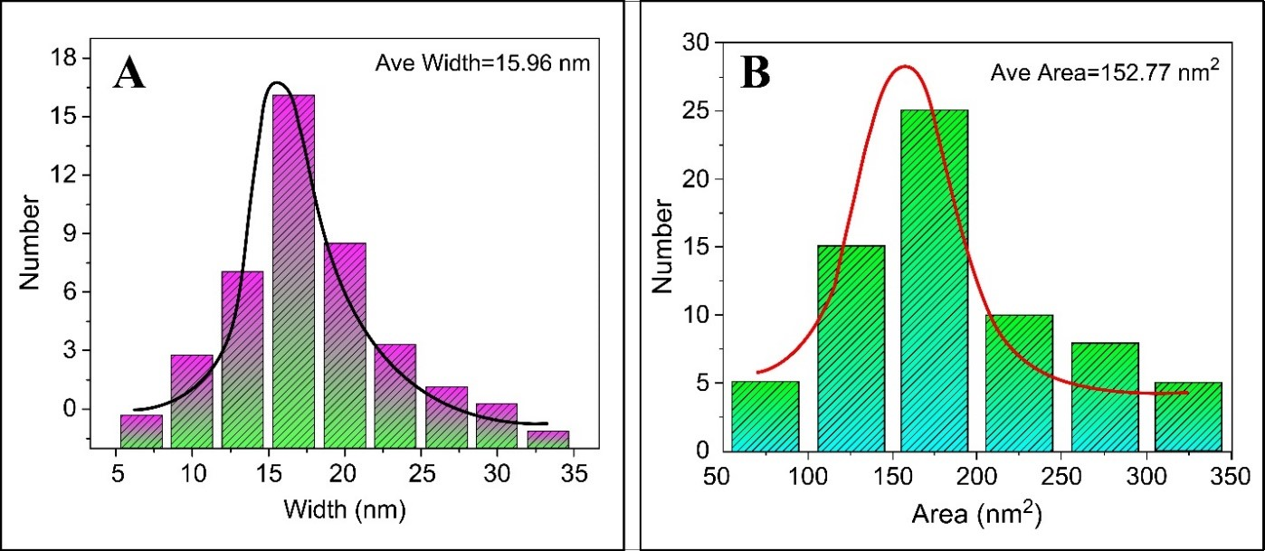

**Fig. S1** (A) Particle size distribution and average size; (B) Average area of AuNPs.