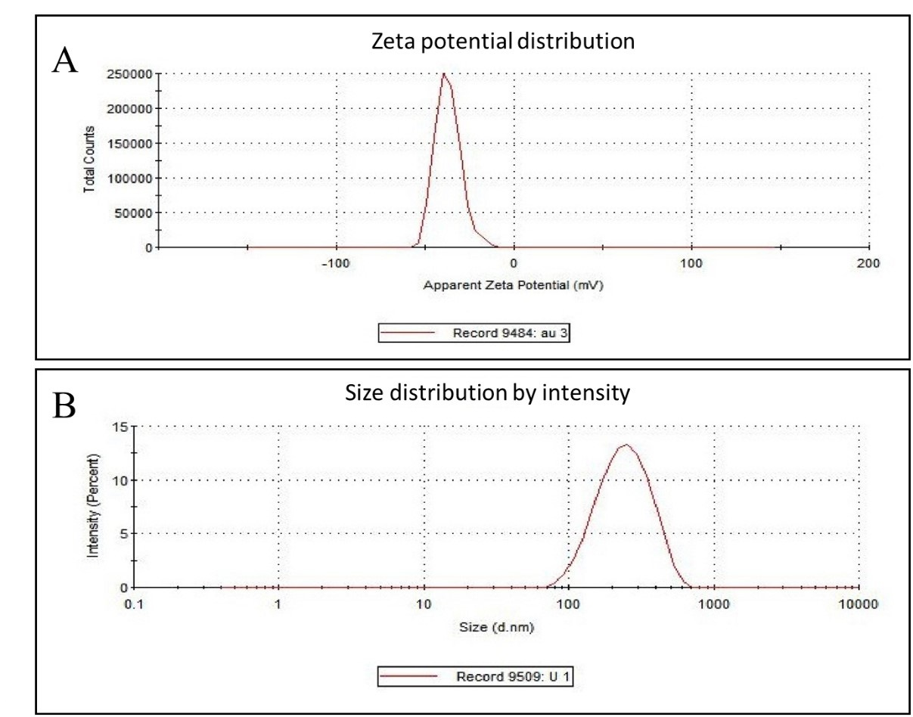

**Fig. S2** (A) Zeta potential and (B) Zeta size of AuNPs.