An amphiphilic fluorogen with aggregation-induced emission characteristic for highly sensitive and selective detection of Cu2+ in aqueous solution and biological system

Deqiang Wanga, Xin Zhoua, Chong Maa, Meiying Liua,c, Hongye Huanga,b, Xiaoyong Zhanga,*, Yen Weib,*

a Department of Chemistry, Nanchang University, Nanchang, 330031, PR China

b Department of Chemistry and the Tsinghua Center for Frontier Polymer Research, Tsinghua University, Beijing, 100084, PR China

c Jiangxi University of Traditional Chinese Medicine, Nanchang 330004, China

**1 Experiment**

**1.1 The measurement method of absolutely fluorescence quantum yield**

The tetrahydrofuran/water mixed solution containing the probe (0.1 mM) was prepared in advance, and the ratio of tetrahydrofuran to water is 5:95, and then the solution was sonicated for 1 min. The absolutely fluorescence quantum yield of probe was measured by FLS1000 (Edinburgh Instruments).

**1.2 The measurement method of LOD**

The fluorescence titration measure is the way to measure the limit of detection (LOD) of probe. The fluorescence intensity of the probe without Cu2+ was measured by fluorescence spectrometer. In order to get the value of standard deviation, ten test samples are used for parallel test and comparison. Then, the standard deviation was obtained by integral calculation and statistical calculation. The line shows that there is a linear relationship between fluorescence intensity and the concentration of Cu2+, and the linear relationship was obtained by data integration and linear calculation of integration data in 0-40 nM concentration ranges (R2 = 0.964). LOD = 3σbi/m, σbi is the standard deviation of blank measurements in this equation, and m is the slope of the line. In the equation, σbi = 1831.23, m = 841.99. By calculation, LOD is 6.11 × 10-9 M.

**Results**

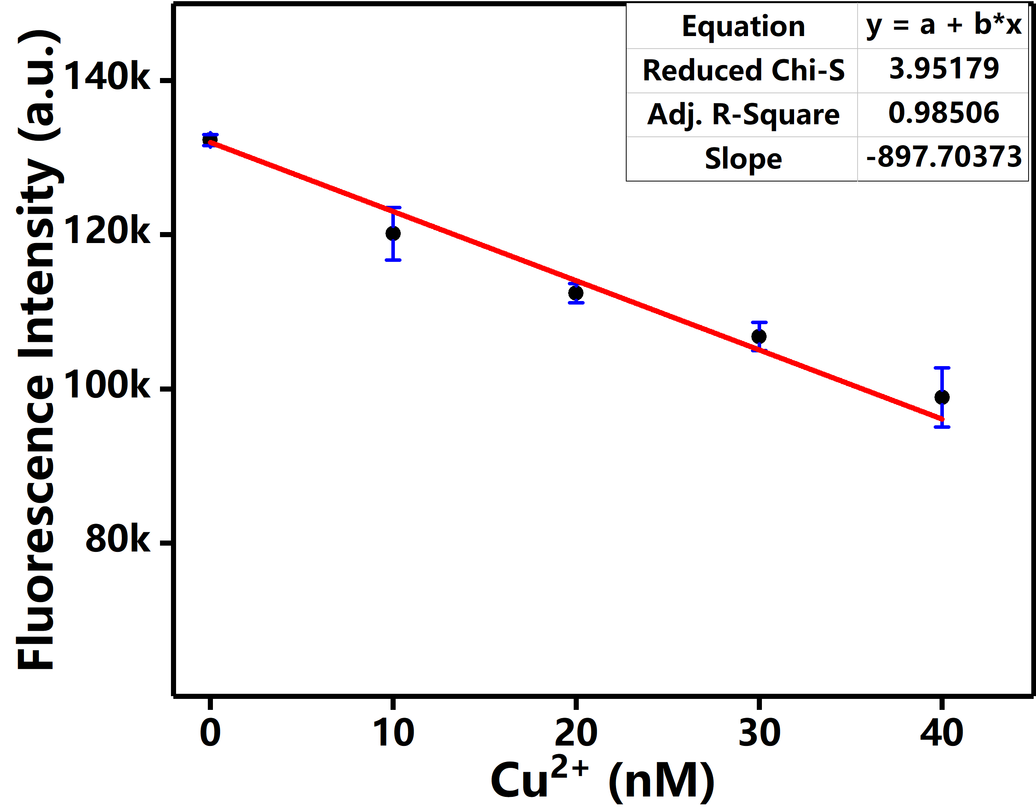

**Fig. S1** The fluorescence intensity of probe after it was incubated with 0-40 nM Cu2+. Based on these data, the LOD is calculated to be 6.11 × 10 -9 M.

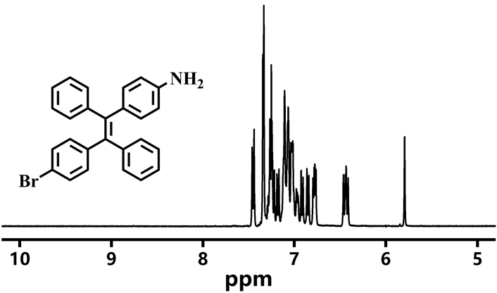

**Fig. S2** The 1H NMR spectrum of BDPA in Chloroform-d.

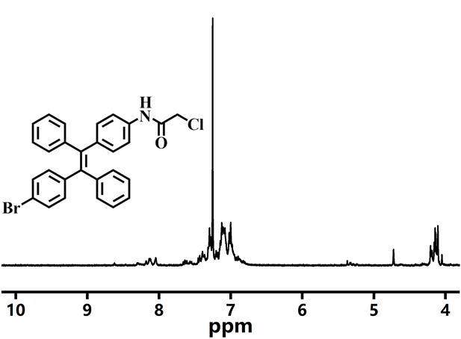

**Fig. S3** The 1H NMR spectrum of CDPA in Chloroform-d.

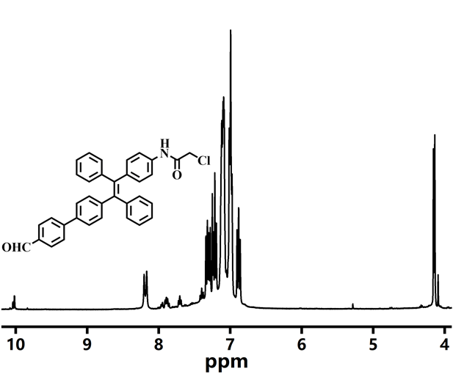

**Fig. S4** The 1H NMR spectrum of CFDPA in Chloroform-d.

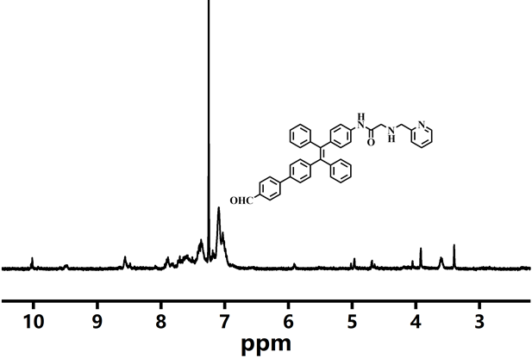

**Fig. S5** The 1H NMR spectrum of FDPA in Chloroform-d.

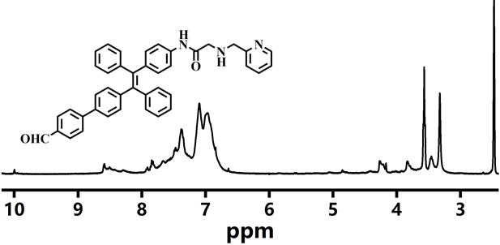

**Fig. S6** The 1H NMR spectrum of FDPA in DMSO-d6.

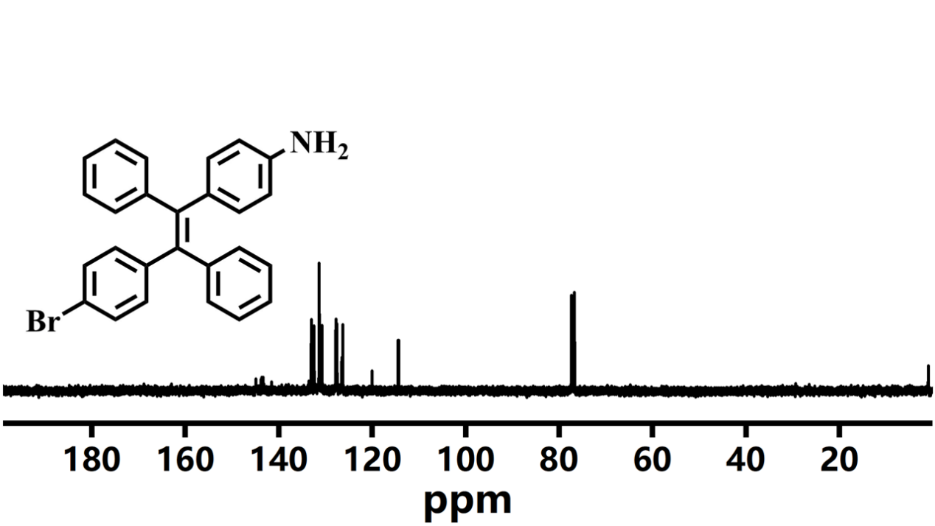

**Fig. S7** The 13C NMR spectrum of BDPA in Chloroform-d.

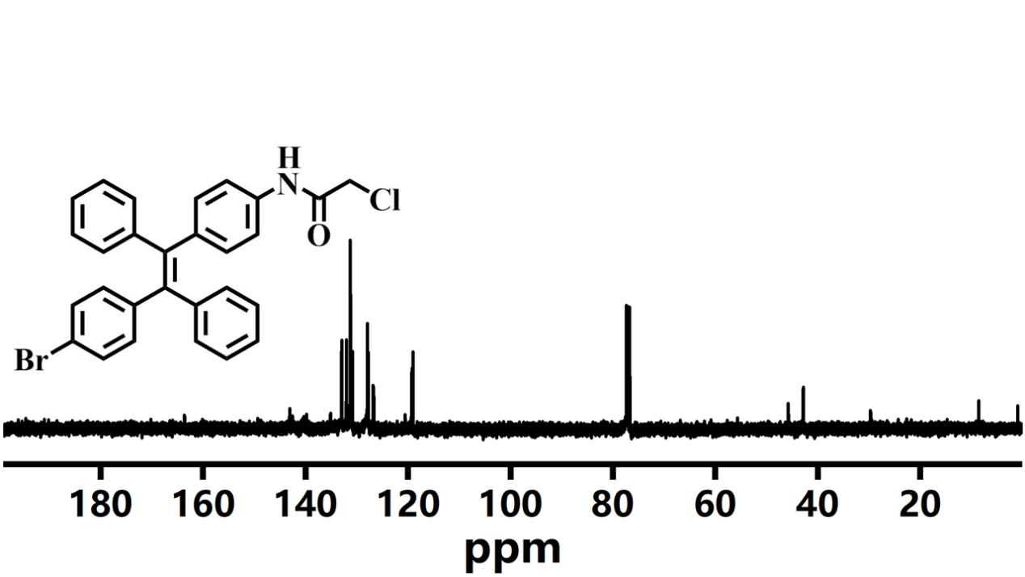

**Fig. S8** The 13C NMR spectrum of CDPA in Chloroform-d.

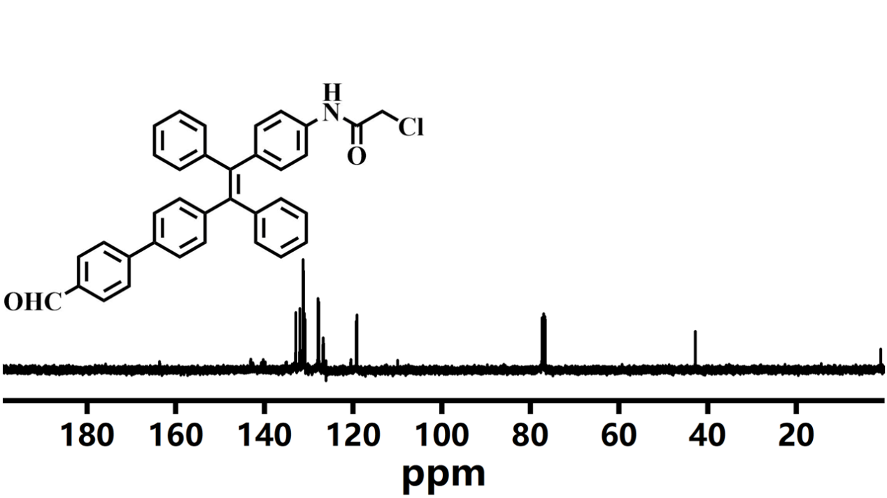

**Fig. S9** The 13C NMR spectrum of CFDPA in Chloroform-d.

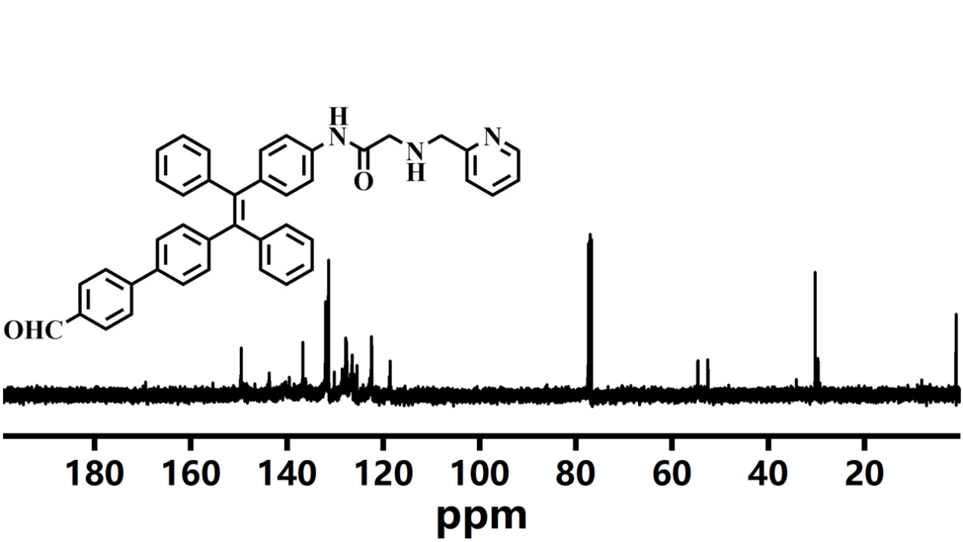

**Fig. S10** The 13C NMR spectrum of FDPA in Chloroform-d.

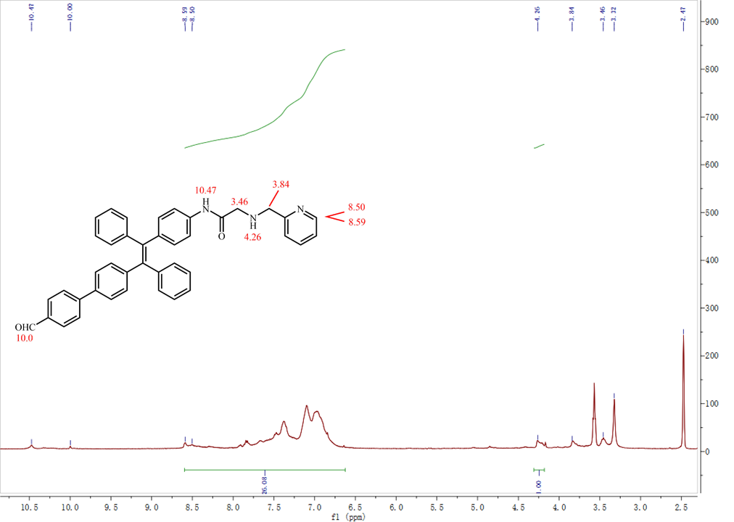

**Fig. S11** The 1H NMR spectrum of the peak integral comparison chart of FDPA in DMSO-d6.

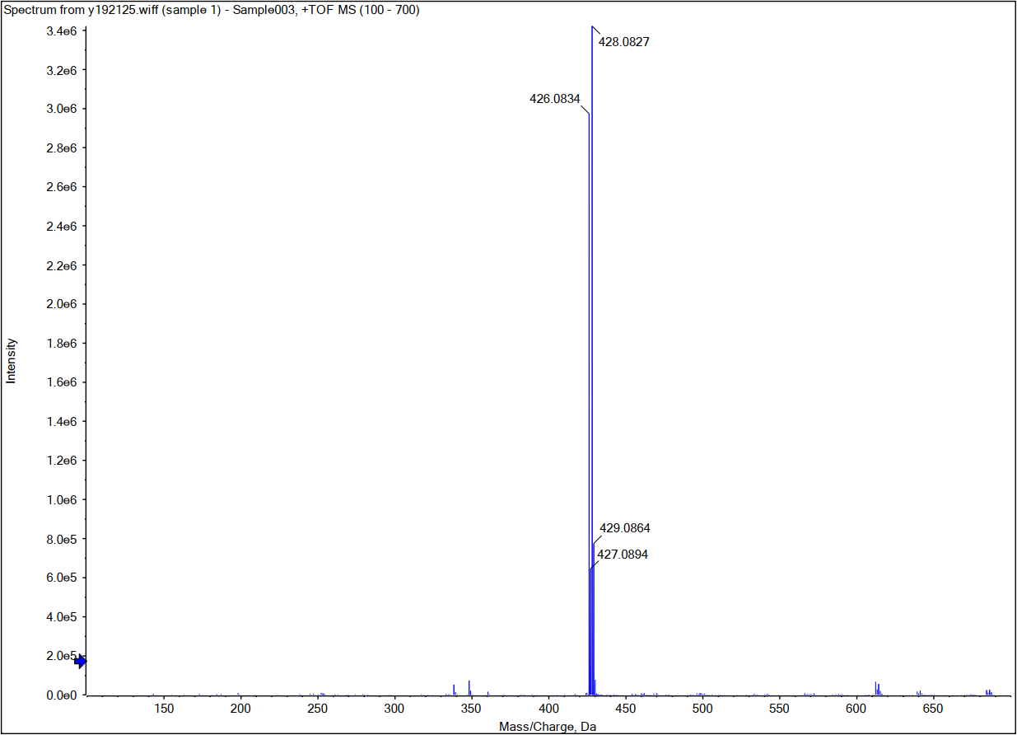

**Fig. S12** The mass spectrum of BDPA

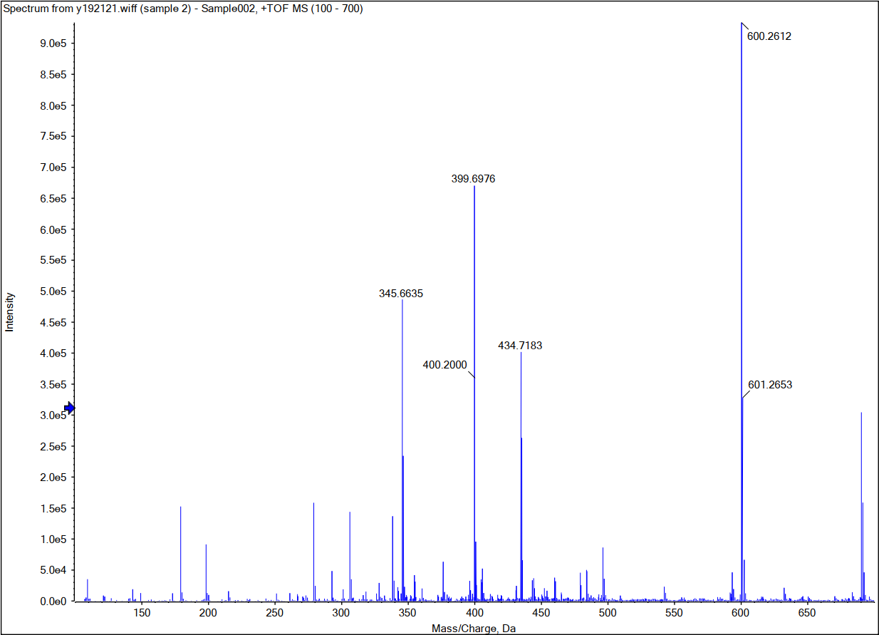

**Fig. S13** The mass spectrum of FDPA

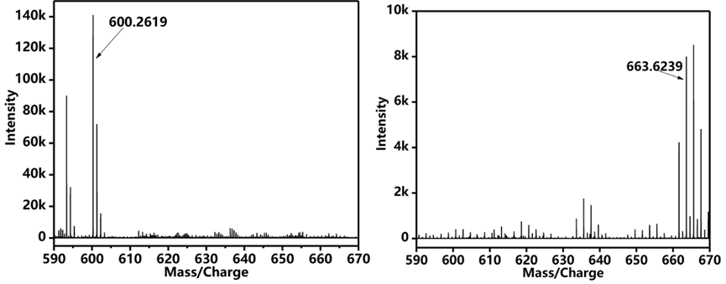

**Fig. S14** The mass spectrum of FDPA in THF/H2O (VTHF : Vwater = 1 : 9 ) solution

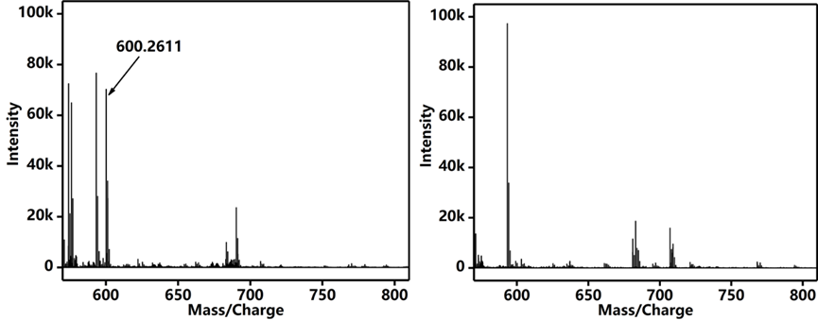

**Fig. S15** The mass spectrum of FDPA in DMSO.

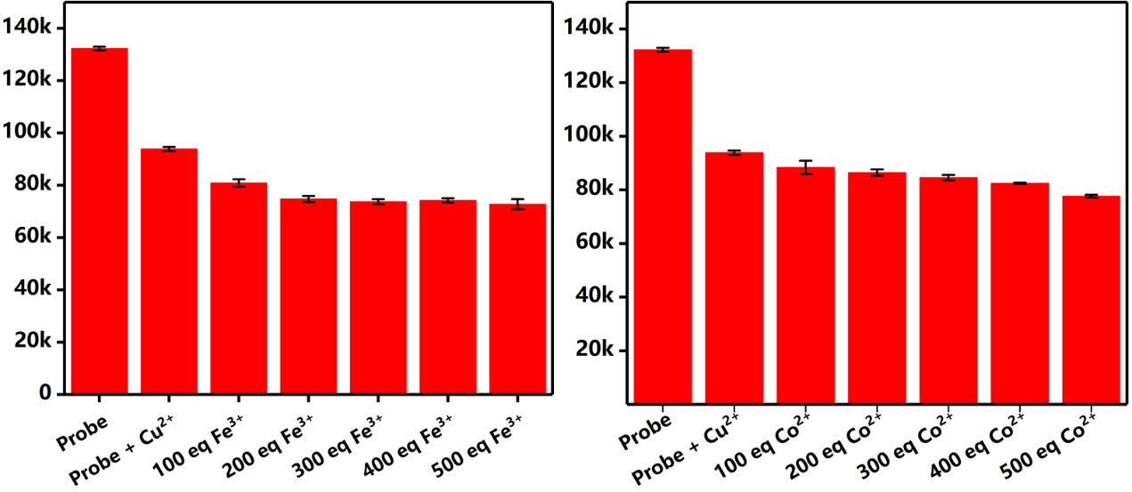

**Fig. S16** Metal ion anti-interference result of Fe3+ and Co2+.

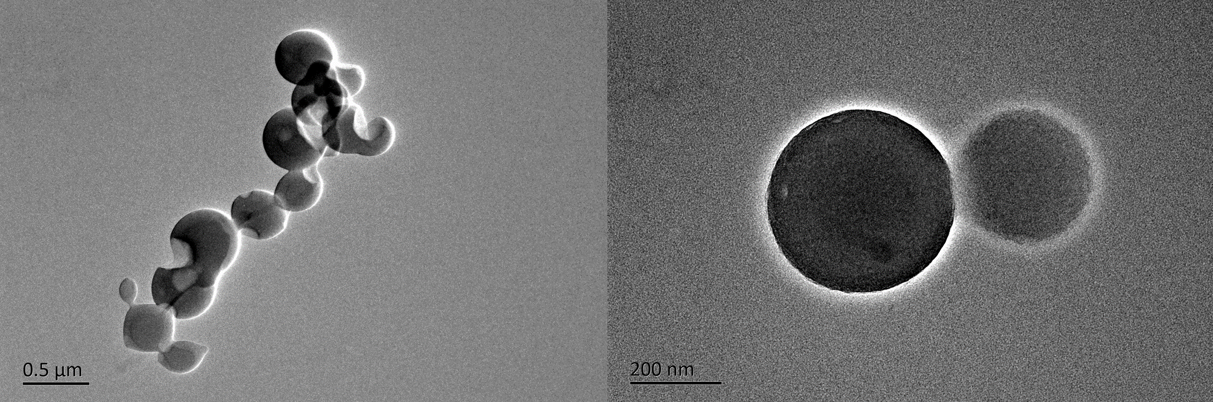

**Fig. S17** Metal ion anti-interference result of Fe3+ and Co2+.

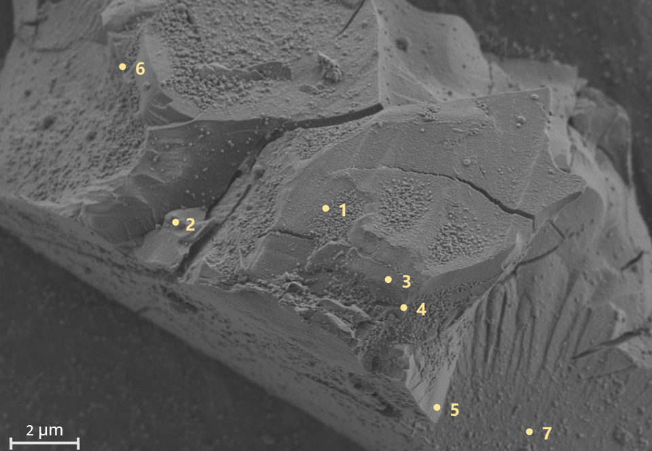

**Fig. S18** the SEM-EDX of FDPA.

**Table S1 the results of SEM-EDX**

|  |  |  |  |
| --- | --- | --- | --- |
| Number | Carbon | Nitrogen | Oxygen |
| 1 | 87.8 | 9.2 | 3.1 |
| 2 | 86.7 | 9.2 | 4.1 |
| 3 | 90.6 | 6.7 | 2.7 |
| 4 | 87 | 9.9 | 3.1 |
| 5 | 90.1 | 6.8 | 3.1 |
| 6 | 87 | 8.9 | 4 |
| 7 | 86.1 | 9.9 | 4 |
| Average Value | 87.9 | 8.65714 | 3.44286 |
| Standard Deviation | 1.75309 | 1.35506 | 0.57113 |
| Theoretical value | 89.1 | 6.6 | 4.3 |

**References**

[1] B. Situ, J. Zhao, W. Lv, J. Liu, H. Li, B. Li, Z. Chai, N. Cao, L. Zheng, Sensors and Actuators B: Chemical240 (2017) 560.

[2] Y. Cai, J. Fang, H. Zhu, W. Qin, Y. Cao, H. Yu, G. Shao, Y. Liu, W. Liu, Sensors and Actuators B: Chemical303 (2020) 127214.

[3] Y. Wang, X. Hao, L. Liang, L. Gao, X. Ren, Y. Wu, H. Zhao, RSC Advances10 (2020) 6109.

[4] S. Xie, Q. Liu, F. Zhu, M. Chen, L. Wang, Y. Xiong, Y. Zhu, Y. Zheng, X. Chen, Journal of Materials Chemistry C8 (2020) 10408.

[5] J.Y. Shang, Y. Li, K. Chen, H. Li, Chemical Papers(2021).