Facile synthesis of MIL-100 metal-organic framework via heatless technique
for the adsorptive treatment of cationic and anionic pollutants
K.L. Tan, K.Y. Foo*

River Engineering and Urban Drainage Research Center (REDAC)
Universiti Sains Malaysia, 14300 Nibong Tebal,
Penang, Malaysia

*Corresponding author: Tel: +60 45996539, Fax: +60 45996926
E-mail: k.y.foo@usm.my (K.Y. Foo)

Table S1: Molecular structure and physicochemical properties of MB and NPX.
Property | MB | NPX
Chemical formula | C₁₆H₁₈ClN₃S | C₁₄H₁₄O₃
Category (sub-category) | Dye (basic dye) | Drug (NSAID)
CAS no. | 61-73-4 | 22204-53-1
Molecular weight | 319.85 | 230.26
Solubility (g/L at 20 °C) | 44 | 0.03
pKa | − | 4.19
Log K_{ow} | 0.75 | 3.18
λ_{max} (nm) | 664 | 232
Molecular size (nm)* | 1.41 x 0.54 x 0.19 | 1.14 x 0.53 x 0.40
Structure
 | 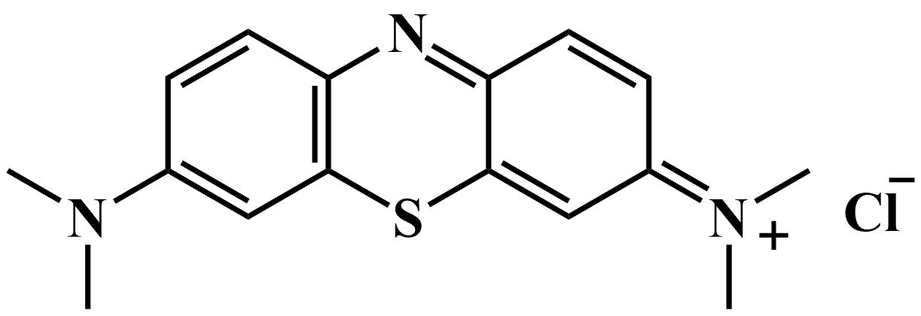 | 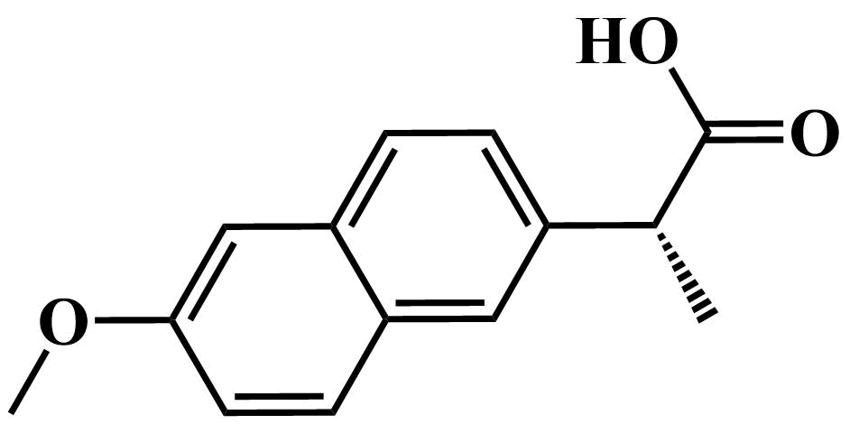
*Measured by Chem3D on MM2 method-optimized configuration.

Table S2: Elemental analysis of MIL-100(FeSO₄).
 | Weight% (dry basis)
C | 30.22
H | 1.55
N | 0.00
S | 0.14
(O+Ash)* | 68.09
*Estimated by difference.

Table S3: Compositions of the simulated MB dye wastewater.
Constituent | Concentration (mg/L) | Function
MB | 100 | Coloring agent
Sodium bicarbonate (NaHCO₃) | 1000 | Fixing agent
Sodium carbonate (Na₂CO₃) | 1000 | Fixing agent
Sodium chloride (NaCl) | 1500 | Fixing agent
Sodium hydroxide (NaOH) | 1000 | Fabric hydrolysis
Starch | 2500 | Sizing agent
Sulfuric acid (H₂SO₄) | 1500 | pH neutralization

Table S4: Chemical constituents of the simulated NPX pharmaceutical wastewater.
Constituent | Concentration (mg/L)
NPX | 100
Glucose (C₆H₁₂O₆) | 400
Iron (II) sulfate (FeSO₄) | 15
Magnesium sulfate (MgSO₄) | 20
Monopotassium phosphate (KH₂PO₄) | 20
Sodium acetate (CH₃COONa) | 50
Urea (CH₄N₂O) | 35

