**Supporting information**

**for**

**Influence of suspended natural sands on the photolysis of ciprofloxacin in water**

Qi Chena, Xiaomin Houa, Jianrong Wanga, QingfengWu*, a, Zhaohui Li*, b, WeibinZhanga

aSchool of Physics and Optoelectronic Engineering, Yangtze University, 1 Nanhuan Road, Jingzhou, Hubei 434023, China

bDepartment of Geosciences, University of Wisconsin-Parkside, 900 Wood Road, Kenosha, WI 53144, USA

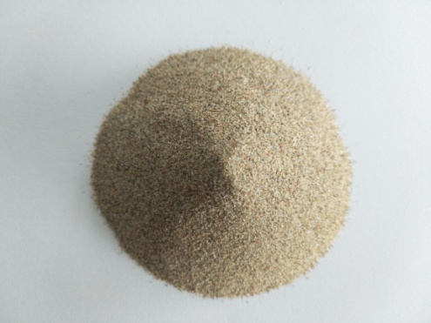 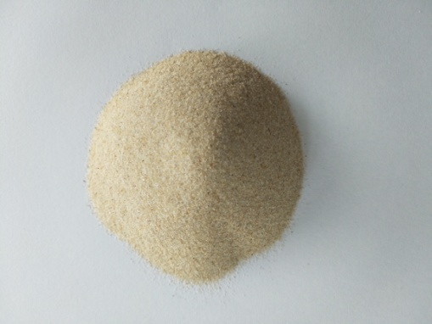

DS

SS

**Fig. S1.** The sand samples used in this study

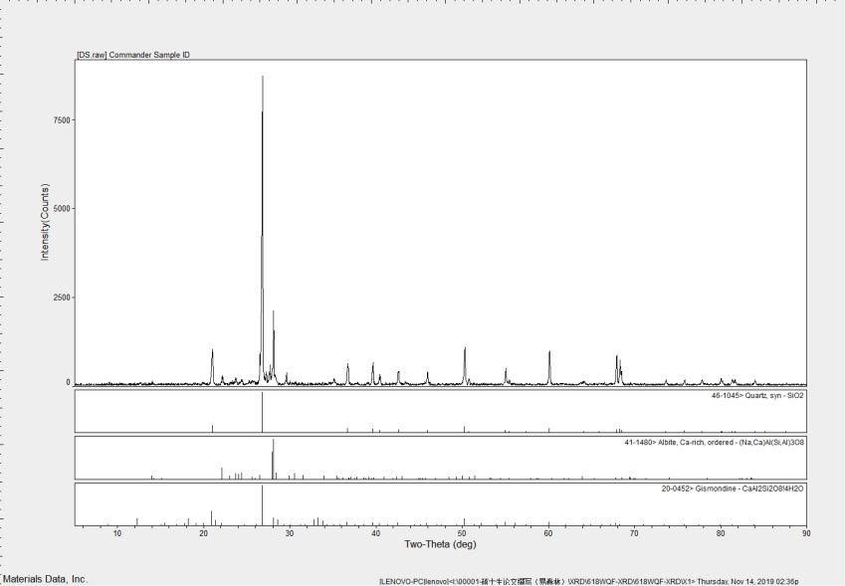

**(a)**

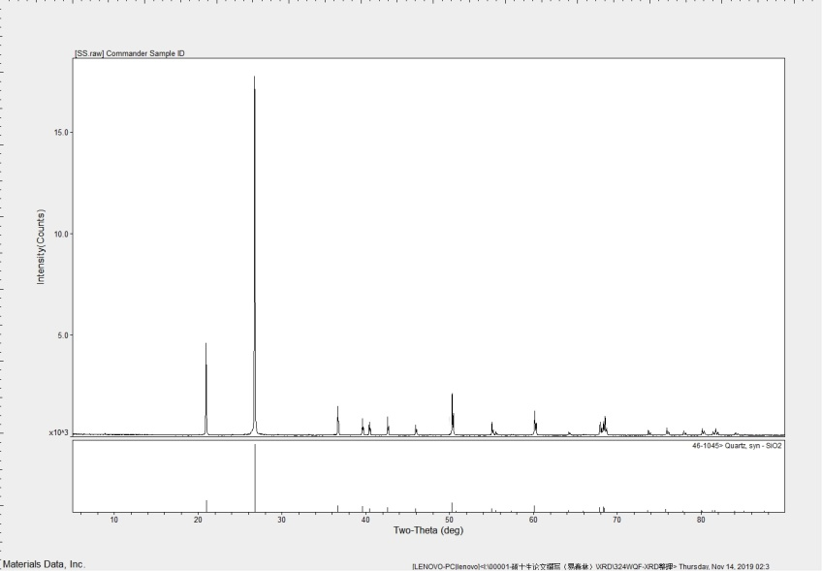

**(b)**

**Fig. S2.** The XRD analysis of the natural sand DS (a) and SS (b) with Jade 6.5 software. The results showed that the DS sand mainly contained quartz, albite, and gismondine, and the SS sand contained predominantly quartz.



PEAK LIST

se-45.raw

RT: 0.03 - 14.85

Number of detected peaks: 6

Apex RT Start RT End RT Area %Area Height %Height

5.04 4.91 5.18 295807.906 11.29 64096.794 10.69

5.32 5.26 5.44 90093.321 3.44 26410.136 4.40

5.94 5.84 6.08 166189.271 6.34 42486.564 7.09

6.33 6.23 6.75 1961249.659 74.84 451050.591 75.22

7.65 7.52 7.81 63512.897 2.42 10100.426 1.68

8.38 8.29 8.54 43656.310 1.67 5460.292 0.91





**Fig. S3** HRMS spectra of major photoproducts in the presence of SS and DS sands.