**Supplementary Figures with legends**

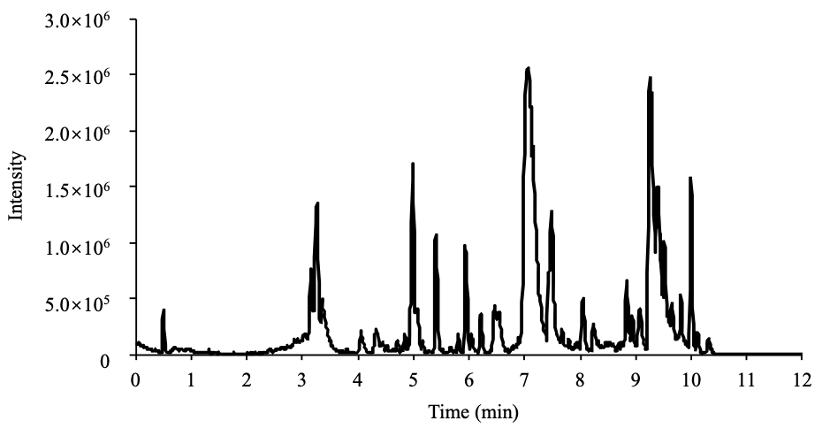

**Supplementary Figure S1** Total ion chromatogram of ethanol extract of mulberry leaves. A total of 248 components were detected, which included flavonoids, polyphenols, and alkaloids, etc.

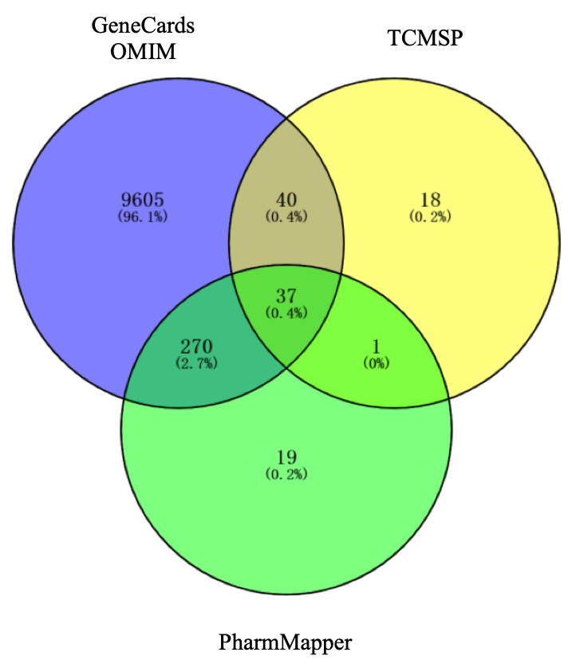

**Supplementary Figure S2** Intersections of target genes related with T2DM. Purple Circle: targets sourced from GeneCards and OMIM databases. Yellow Circle: targets sourced from TCMSP database. Green Circle: green circle sourced from PharmMapper databases.

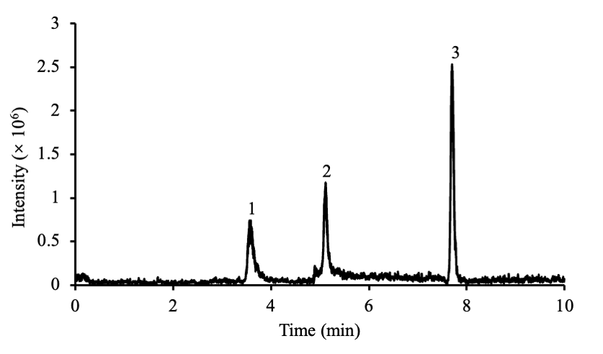

**Supplementary Figure S3** The multiple reaction monitoring (MRM) chromatogram of the three representative compounds in the mixed standard solution operated in negative mode. Peaks in order in the figure represented 1) Morin, 2) Kaempferol, and 3) Licoricone.

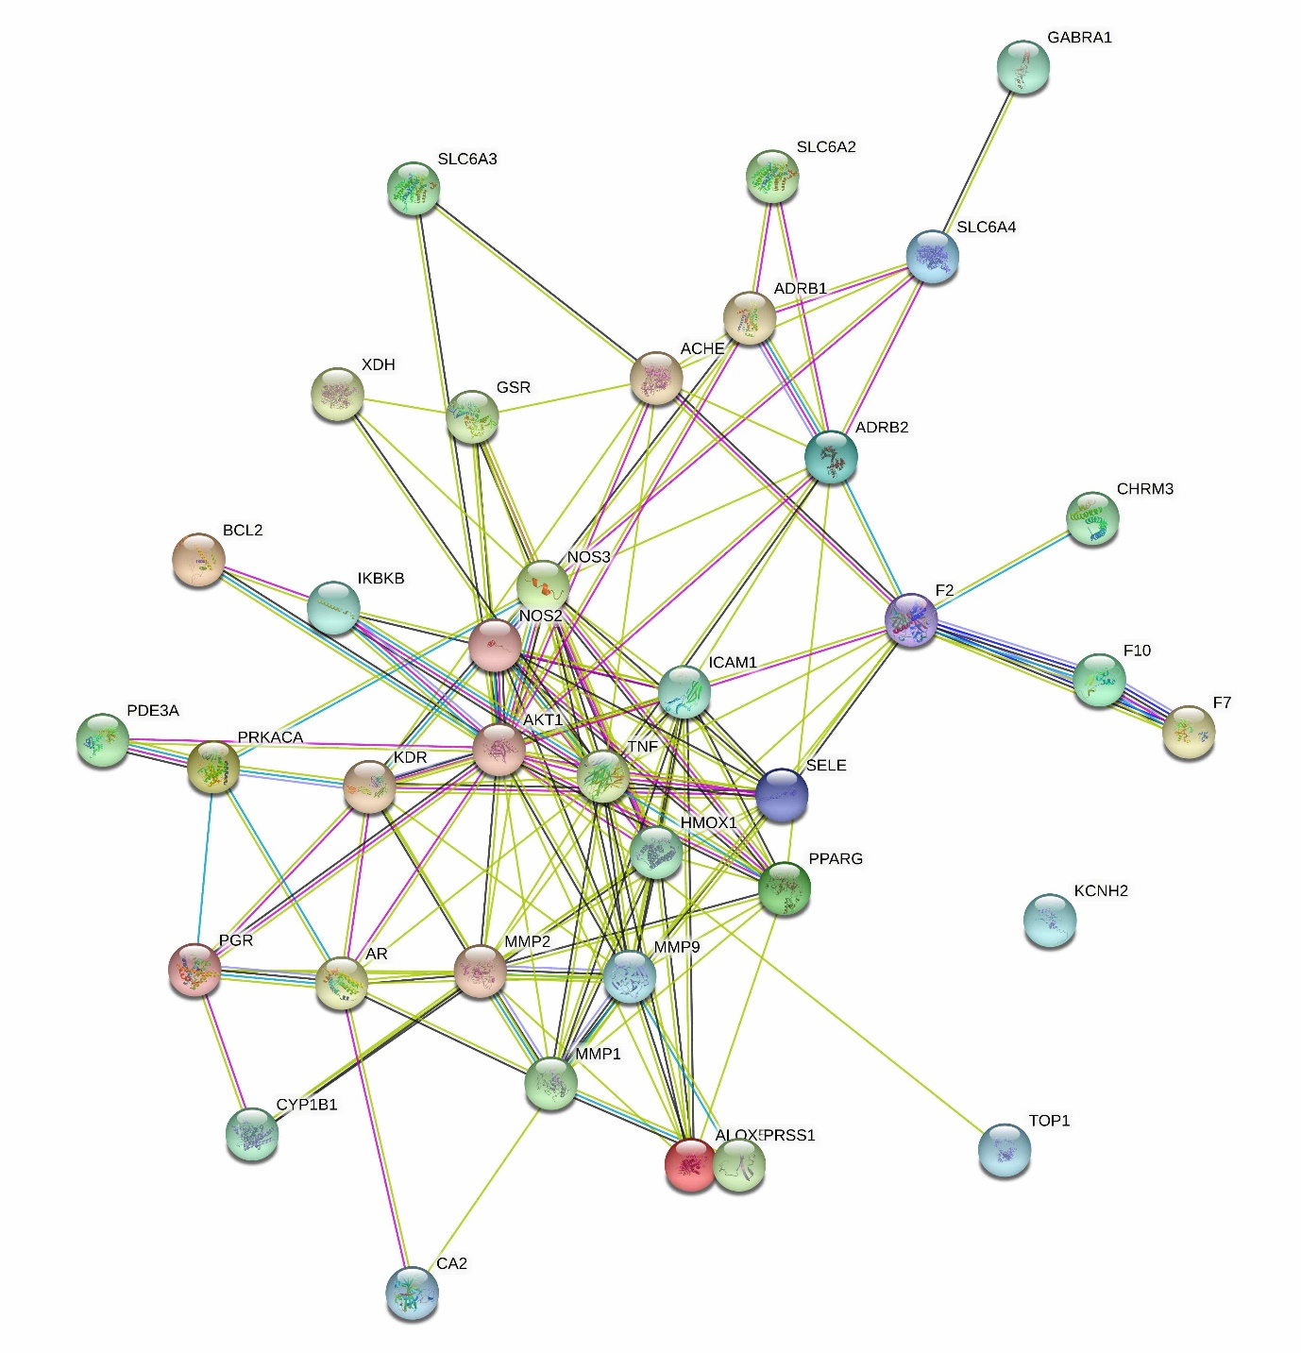

**Supplementary Figure S4** Schematic illustration of protein-protein interactions among target proteins that are related with T2DM. The network was visualized via STRING database, which had 37 nodes and 138 connections (enrichment *P*-value < 1.0e-16).

**Supplementary Table 1** Chemical compounds detected by LC/MS in mulberry leaves ranked via observed retention time in ascending order.

|  |  |  |  |  |  |  |
| --- | --- | --- | --- | --- | --- | --- |
| **Components** | **Formula** | **Observed m/z Ratio** | **Observed Retention Time** | **Response** | **Mass Error** | **Adduct** |
| Fuzinoside | C15H28O13 | 439.1417 | 0.49 | 32197 | -0.5 | +Na |
| 3-(2'-Carboxyphenyl)-4(3H)-quinazolinone | C15H10N2O3 | 289.0565 | 0.5 | 3258 | -1.8 | +Na |
| Deoxyadenosine | C10H13N5O3 | 252.1073 | 0.5 | 3436 | -1.8 | +H |
| Methyl kushenol C | C26H28O7 | 475.1752 | 0.5 | 5278 | 2.4 | +Na |
| Nigellamose | C18H32O16 | 527.1574 | 0.5 | 34005 | -0.8 | +Na |
| Proline | C5H9NO2 | 138.0543 | 0.51 | 10694 | 1.8 | +Na |
| Ranunculin | C11H16O8 | 277.0935 | 0.51 | 7198 | 1.7 | +H |
| Sucrose | C12H22O11 | 365.1051 | 0.51 | 132716 | -0.4 | +Na, +H |
| β-D-Fructose | C6H12O6 | 203.0521 | 0.51 | 20374 | -0.6 | +Na |
| Heterodendrin | C11H19NO6 | 262.1281 | 0.52 | 10686 | -0.4 | +H |
| Salsoline | C11H15NO2 | 194.117 | 0.55 | 9485 | -0.6 | +H |
| Adenine | C5H5N5 | 136.0608 | 0.62 | 5174 | -0.9 | +H |
| Maltol | C6H6O3 | 149.0227 | 0.63 | 13482 | 1.8 | +Na |
| 2-O-α-D-Glycosides of galactose-1-deoxynojirimycin | C12H23NO9 | 326.1436 | 0.66 | 12702 | -1 | +H |
| 1-Deoxynojirimycin (DNJ) | C6H13NO4 | 164.0914 | 0.69 | 23030 | -0.3 | +H |
| Fagomine | C6H13NO3 | 148.0961 | 0.74 | 10216 | -0.8 | +H |
| 1,7-Bis(4-hydroxyphenyl)-hepta-4E,6E-dien-3-one | C19H18O3 | 317.1149 | 0.82 | 76212 | 0.1 | +Na |
| Benzyl benzoate | C14H12O2 | 235.072 | 0.83 | 5060 | -1 | +Na |
| Digiprolactone | C11H16O3 | 197.1173 | 0.93 | 118107 | 0 | +H |
| p-Methoxybenzylacetone | C11H14O2 | 179.1063 | 0.93 | 21670 | -0.4 | +H |
| Blumenol C glucoside | C19H32O7 | 395.2034 | 2.39 | 8137 | -0.6 | +Na |
| Isoxanthanol | C17H24O5 | 331.1533 | 2.54 | 6921 | 1.7 | +Na |
| Bistortaside | C22H24O14 | 535.107 | 2.64 | 41512 | 1.2 | +Na |
| Catenarin | C15H10O6 | 287.054 | 2.64 | 11061 | -1 | +H |
| Urolignoside | C26H34O11 | 545.198 | 2.64 | 8146 | -1.3 | +Na |
| Asterinin D | C25H33N5O7 | 538.2271 | 2.7 | 14658 | -0.1 | +Na |
| Herbacetin | C15H10O7 | 303.0498 | 2.72 | 37822 | -0.1 | +H |
| 3-O-[β-D-Glucopyra-nosyl-(1→2)]-β-D-glucopyranosyl-kaempferol | C27H30O16 | 611.1604 | 2.74 | 163757 | -0.2 | +H, +Na |
| Taurodeoxycholic acid | C26H45NO6S | 522.2875 | 2.74 | 5436 | 1.5 | +Na |
| Asterinin B | C26H35N5O8 | 568.2354 | 2.79 | 4626 | -2.4 | +Na |
| Zederone | C15H18O3 | 247.1317 | 2.82 | 10125 | -1.1 | +H |
| Delphatine | C26H43NO7 | 504.2951 | 2.85 | 8198 | 2 | +Na |
| Lucidenic acid A | C27H38O6 | 481.2586 | 2.86 | 13454 | 2.5 | +Na |
| 6-Hydroxykaempferol-3-O-glucoside | C21H20O12 | 465.1024 | 2.87 | 155741 | -0.4 | +H, +Na |
| Demethylwedelolactone | C15H8O7 | 301.0337 | 2.87 | 24321 | -0.6 | +H |
| Morin | C15H10O7 | 303.0499 | 2.87 | 163264 | 0 | +H |
| 1-Methoxy-3,7-dimethyl-2,6-octadiene | C11H20O | 191.1428 | 2.92 | 8202 | 2.1 | +Na |
| n-Nonyl acetate | C11H22O2 | 209.1533 | 2.92 | 10648 | 2.1 | +Na |
| Quercetin-3-O-α-L-rhamnoside | C21H20O11 | 449.1071 | 2.92 | 21678 | -0.7 | +H |
| Picrasin G | C21H28O7 | 393.1881 | 2.93 | 18651 | -2.7 | +H |
| Digiprolactone | C11H16O3 | 219.1011 | 2.96 | 4687 | 2 | +Na |
| 5,7,2',5'-Tetrahydroxy-flavone | C15H10O6 | 287.0546 | 2.99 | 21723 | -0.4 | +H |
| Morusimic acid E | C24H45NO10 | 508.3107 | 3 | 22471 | -0.9 | +H |
| 1-Methyl-2-[(6Z,9Z)-6,9-pentadecadienyl]-4(1H)-quinolone | C25H35NO | 388.2631 | 3.02 | 13212 | 2 | +Na |
| Genistein-7,4'-di-O-β-D-glucoside | C27H30O15 | 595.1649 | 3.02 | 63103 | -0.8 | +H, +Na |
| (+)-Syringaresinol-O-β-D-glucopyranoside | C28H36O13 | 603.2035 | 3.05 | 24350 | -1.3 | +Na |
| Lobetyolin | C20H28O8 | 419.1687 | 3.05 | 5418 | 1.1 | +Na |
| Deoxypaeonisuffrone | C10H14O3 | 205.0855 | 3.06 | 9516 | 2 | +Na |
| Asterinin C | C26H35N5O8 | 568.2376 | 3.1 | 6890 | -0.2 | +Na |
| Blestriarene B | C30H24O6 | 481.1661 | 3.11 | 11589 | 1.5 | +H |
| Blumenol C glucoside | C19H32O7 | 373.2211 | 3.12 | 20818 | -1 | +H, +Na |
| Neoline | C24H39NO6 | 460.2695 | 3.13 | 19062 | 2.6 | +Na |
| 7-Hydroxy-1-methoxy-2-methoxyxanthone | C15H10O6 | 287.0549 | 3.15 | 136569 | -0.2 | +H |
| Kaempferol 3-O-β-D-glucopyranoside | C21H20O11 | 449.1072 | 3.15 | 131456 | -0.6 | +H, +Na |
| (S)-Shihulimonin A | C26H30O10 | 503.19 | 3.17 | 7724 | -1.2 | +H |
| Baicalein-7-O-β-D glucopyranoside | C21H20O10 | 433.1112 | 3.23 | 8850 | -1.7 | +H |
| Albiflorin | C23H28O11 | 481.1676 | 3.26 | 10608 | -2.8 | +H |
| Morusimic acid A | C24H45NO9 | 492.3168 | 3.26 | 1162818 | 0.1 | +H |
| Ent-eudesmane-2α,4β,11-triol 11-O-β-D-glucopyranoside | C21H38O8 | 441.244 | 3.27 | 14585 | -1.9 | +Na |
| Chrysoeriol-7-O-β-D-glucuroside | C22H22O11 | 463.1222 | 3.28 | 5447 | -1.3 | +H |
| 7β-(3-Ethyl-cis-crotonoyloxy)-14-hydroxynotonipetranone | C21H32O4 | 349.2378 | 3.32 | 4780 | 0.4 | +H |
| Eclalbasaponin ⅩⅢ | C37H58O10 | 685.3943 | 3.33 | 5829 | 2.1 | +Na |
| Picroside Ⅲ | C25H30O13 | 561.1583 | 3.33 | 4808 | 0.4 | +Na |
| Morusimic acid B | C18H35NO4 | 330.2641 | 3.37 | 596700 | 0.2 | +H |
| Eugenol | C10H12O2 | 165.0911 | 3.4 | 6254 | 0 | +H |
| Eugenyl glucoside | C16H22O7 | 349.1255 | 3.4 | 25690 | -0.3 | +Na |
| 2,3,5,4'-Tetrahydroxystilbene-2-O-β-D-glucopyranoside | C20H22O9 | 429.1145 | 3.47 | 8114 | -1.1 | +Na |
| Oriediterpenoside | C25H40O6 | 437.2899 | 3.49 | 22736 | 0.2 | +H |
| Ganoderenic acid B | C30H42O7 | 515.3022 | 3.5 | 8856 | 1.9 | +H |
| Paristerone | C27H44O7 | 481.3159 | 3.56 | 13335 | -0.1 | +H |
| 2-Hydroxy-5-methoxy acetophenone | C9H10O3 | 167.0687 | 3.61 | 3133 | -1.6 | +H |
| 2′-Hydroxy-7,3′,4′-trimethoxy-isoflavan | C18H20O5 | 317.138 | 3.61 | 9739 | -0.3 | +H |
| Courmaric acid | C9H8O2 | 149.0588 | 3.61 | 4400 | -0.9 | +H |
| 1,2,3-Trimethoxy-5-(2-propenyl)-benzene | C12H16O3 | 209.1166 | 3.67 | 5418 | -0.6 | +H |
| N-cis-Feruloyl typamine | C18H19NO4 | 314.1382 | 3.71 | 22046 | -0.5 | +H |
| 2′-Hydroxy-4,4′,6′-trimethoxydihydrochalcone | C18H20O5 | 317.1371 | 3.8 | 11796 | -1.2 | +H |
| Coniferol | C10H12O3 | 181.086 | 3.8 | 11037 | 0.1 | +H |
| Phenethyl ferulate | C18H18O4 | 299.1268 | 3.8 | 6577 | -0.9 | +H |
| Rengyoside C | C22H32O10 | 479.1895 | 3.8 | 14427 | 0.7 | +Na |
| Safrol | C10H10O2 | 163.0753 | 3.8 | 10358 | 0 | +H |
| Pinocembrin_1 | C15H12O4 | 257.0796 | 3.88 | 4198 | -1.2 | +H |
| 6-Feruloyl catalpol | C25H30O12 | 545.1614 | 3.9 | 8345 | -1.5 | +Na |
| Oxyphyllenone A | C12H18O3 | 211.1323 | 3.95 | 11002 | -0.6 | +H |
| Physalin D | C28H32O11 | 567.1809 | 3.97 | 4733 | -2.7 | +Na |
| 12-α-Hydroxylimonin | C26H30O9 | 509.1787 | 3.98 | 11232 | 0.5 | +Na |
| Glehlinoside A | C34H42O14 | 675.2644 | 3.98 | 37429 | -0.3 | +H, +Na |
| Indigotin | C16H10N2O2 | 285.0619 | 3.99 | 16637 | -1.5 | +Na |
| Kaempferol | C15H10O6 | 287.0553 | 4 | 10364 | 0.3 | +H |
| 1-Deoxyeucommiol | C9H16O3 | 173.1163 | 4.06 | 5646 | -0.9 | +H |
| 9,16-Dioxyhydroxy-10,12,14-triene-18 carbonic acid | C18H30O4 | 311.2203 | 4.06 | 28768 | -1.4 | +H |
| Cimidahuside C | C37H58O12 | 695.4015 | 4.06 | 8956 | 1.4 | +H |
| Eclalbasaponin Ⅴ | C36H58O12S | 715.3734 | 4.06 | 13151 | 1.3 | +H |
| Picrasinoside H | C30H44O13 | 613.2841 | 4.06 | 10364 | -1.4 | +H |
| (+)-Bakuchiol | C18H24O | 257.1891 | 4.07 | 7308 | -0.9 | +H |
| 10-O-Methyl alismoxide | C16H28O2 | 275.2008 | 4.07 | 110718 | 2.6 | +Na |
| 14-Deoxy-11-hydro-xyandrographolide | C20H30O5 | 351.214 | 4.07 | 204526 | -2.6 | +H |
| 3,7-Dimethyloctane-1,3,6-triol | C10H22O3 | 213.147 | 4.07 | 9892 | 0.9 | +Na |
| Cnidilide | C12H18O2 | 195.1374 | 4.07 | 10482 | -0.6 | +H |
| Licoricone | C22H22O6 | 383.1501 | 4.07 | 15645 | 1.2 | +H |
| Tenuifoliside D | C18H24O9 | 385.151 | 4.07 | 34481 | 1.7 | +H |
| Ginkgol | C21H34O | 325.2479 | 4.13 | 8377 | -2.2 | +Na |
| 13-Hydroxygermacrone | C15H22O2 | 235.1688 | 4.14 | 13744 | -0.5 | +H |
| (3R)-Abruquinone B | C20H22O8 | 413.1192 | 4.15 | 6475 | -1.5 | +Na |
| BaohuosideⅠ | C27H30O10 | 515.1884 | 4.19 | 6968 | -2.8 | +H |
| (E,E)-9-Oxooctadeca-10,12-dienoic acid | C18H30O3 | 295.2265 | 4.33 | 22759 | -0.3 | +H |
| Sanleng acid | C18H34O5 | 353.2293 | 4.33 | 54249 | -0.5 | +Na |
| 14-epi-Andrographolide | C20H30O5 | 351.2142 | 4.34 | 64874 | -2.4 | +H |
| Kihadanin B | C26H30O9 | 509.1789 | 4.35 | 8403 | 0.7 | +Na |
| Rubilactone | C15H10O5 | 271.0597 | 4.37 | 5770 | -0.4 | +H |
| Ciwujiatone | C22H26O9 | 435.1665 | 4.58 | 97507 | 1.5 | +H |
| Bigelovin | C17H20O5 | 327.1207 | 4.65 | 7916 | 0.4 | +Na |
| Tribulusamide A | C36H36N2O8 | 625.2517 | 4.65 | 9083 | -2.8 | +H |
| 14-Deoxy-12S-methoxyandrographolide | C21H32O5 | 365.2299 | 4.66 | 5037 | -2.4 | +H |
| Evodin | C26H30O8 | 493.1839 | 4.66 | 16370 | 0.6 | +Na |
| Sanleng acid | C18H34O5 | 353.2293 | 4.68 | 37586 | -0.5 | +Na |
| Physalin G | C28H30O10 | 549.172 | 4.72 | 101584 | -1.1 | +Na |
| Morachalcone A | C20H20O5 | 341.1363 | 4.77 | 6750 | -2.1 | +H |
| Dihydrocostunolide | C15H22O2 | 235.1689 | 4.81 | 24824 | -0.3 | +H |
| Acsonine | C31H41NO8 | 556.2935 | 4.84 | 11452 | 3 | +H |
| Demethyl auraptenol | C14H14O4 | 269.0804 | 4.84 | 11230 | 2 | +Na |
| Dihydroactinidiolide | C11H16O2 | 181.1223 | 4.85 | 66441 | 0 | +H |
| Maokonine | C12H17NO3 | 224.1276 | 4.89 | 17729 | -0.5 | +H |
| Dihydro-N-methylisopelletierine | C9H19NO | 158.1538 | 4.95 | 89103 | -0.1 | +H |
| 13-Hydroxy-9,11-hexadecadienoic acid | C16H28O3 | 291.1957 | 4.97 | 358302 | 2.7 | +Na |
| Meso-dihydroguaiaretic acid | C20H26O4 | 331.1878 | 4.97 | 147185 | -2.6 | +H |
| α-Estradiol | C18H24O2 | 273.1846 | 4.97 | 45682 | -0.3 | +H |
| 2-((3R,4R)-7-Hydroxy-4-(4-hydroxy-5-((R)-7-hydroxychroman-3-yl)-2-methoxyphenyl)chroman-3-yl)-5-methoxycyclohexa-2,5-diene-1,4-dione | C32H28O9 | 557.1792 | 4.99 | 67582 | -1.4 | +H, +Na |
| α-Ionone | C13H20O | 193.1584 | 5.04 | 3900 | -0.3 | +H |
| Astragaline F | C12H18N2O5 | 293.109 | 5.06 | 36176 | -1.8 | +Na |
| Cuscohygrine | C13H24N20 | 225.1965 | 5.06 | 248375 | 0.4 | +H |
| Chloranoside A | C21H28O9 | 425.1818 | 5.12 | 5690 | 1.2 | +H |
| 4,7-Didehydroneophysalin B | C28H28O9 | 509.1804 | 5.17 | 97897 | -0.2 | +H, +Na |
| Astin E | C25H32ClN57 | 572.1876 | 5.17 | 8439 | -0.7 | +Na |
| Bletilol B | C27H26O7 | 463.1746 | 5.17 | 26549 | -0.5 | +H |
| Jangomolide | C26H28O8 | 491.1699 | 5.17 | 36833 | 2.3 | +Na |
| 2,7-Dihydroxy-4-methoxyphenanthrene-2-O-glucoside | C21H22O8 | 403.1386 | 5.18 | 8037 | -0.1 | +H |
| Bufotalin | C26H36O6 | 467.2424 | 5.21 | 6318 | 1.9 | +Na |
| Scutellone I | C28H36O7 | 507.2347 | 5.21 | 10285 | -0.6 | +Na |
| 12S-Hydroxyandrographolide | C20H32O6 | 391.2068 | 5.26 | 12317 | -2.3 | +Na |
| Thymol isobutyrate | C14H20O2 | 221.1535 | 5.27 | 6547 | -0.1 | +H |
| (10E)1,10-Heptadeca-diene-4,6-diyne-3,8,9-triol | C17H24O3 | 277.1799 | 5.28 | 45944 | 0.1 | +H |
| 2β-(Isobutryloxy) florenalin | C19H26O5 | 335.1828 | 5.28 | 41179 | -2.5 | +H |
| 6-Gingerol | C17H26O4 | 295.1893 | 5.28 | 13841 | -1.1 | +H |
| Methyl arteannuate | C16H24O2 | 271.1687 | 5.37 | 5462 | 1.9 | +Na |
| Florilenalin angelate | C20H26O5 | 369.1698 | 5.41 | 7981 | 2.5 | +Na |
| Maglifloenone (Denudatone) | C22H26O6 | 387.1802 | 5.41 | 576257 | -0.1 | +H, +Na |
| 2′,4′-Dihydroxy-4,6′-dimethoxy-dihydrochalcone | C17H18O5 | 325.1063 | 5.47 | 4874 | 1.7 | +Na |
| Rhodojaponin Ⅵ | C20H34O7 | 387.2362 | 5.47 | 14218 | -1.6 | +H |
| 14-Deoxyandrographolide | C20H30O4 | 335.2188 | 5.55 | 47497 | -2.9 | +H |
| Fibraurin | C20H20O7 | 373.1272 | 5.6 | 6036 | -1 | +H |
| Isolappaol C | C30H34O10 | 577.2036 | 5.63 | 11037 | -0.8 | +Na |
| 9,16-Dioxyhydroxy-10,12,14-triene-18 carbonic acid | C18H30O4 | 333.2026 | 5.75 | 66849 | -1 | +Na |
| Methyl lucidenate P | C30H44O8 | 555.2921 | 5.75 | 18271 | -0.8 | +Na |
| Interiotherin C | C30H36O10 | 579.2171 | 5.78 | 5015 | -2.9 | +Na |
| 2,7-Dihydroxy-1-(4'-hydroxybenzyl)-4-methoxy-9,10-dihydrophenanthrene-4'-O-glucoside | C28H30O9 | 511.1941 | 5.8 | 13930 | -2.2 | +H |
| Corypalline | C11H15NO2 | 194.1174 | 5.81 | 42108 | -0.2 | +H |
| Ilexin Ⅱ | C23H30O10 | 467.1938 | 5.81 | 80501 | 2.7 | +H |
| N-Benzoylphenylalanyl-L-phenylalaninol acetate | C27H28N2O4 | 445.2119 | 5.81 | 125277 | -0.3 | +H, +Na |
| Sanjoinenine | C29H35N3O4 | 490.2685 | 5.81 | 5138 | -1.5 | +H |
| Kushenol M | C30H36O7 | 531.2341 | 5.87 | 3819 | -1.2 | +Na |
| Burchellin | C20H20O5 | 341.1372 | 5.89 | 6081 | -1.1 | +H |
| Isosamarcandin | C29H38O6 | 505.2554 | 5.91 | 5675 | -0.6 | +Na |
| Aduncin | C15H18O6 | 295.1178 | 5.94 | 4487 | 0.1 | +H |
| Blestrianol D | C29H24O5 | 453.1674 | 5.94 | 19624 | -2.3 | +H |
| Delbrusine | C27H43NO7 | 516.2958 | 5.94 | 41478 | 2.6 | +Na |
| Pterosin Y | C15H20O5 | 281.1374 | 5.94 | 8193 | -1 | +H |
| Delbruline | C26H41NO7 | 502.2802 | 5.95 | 84634 | 2.7 | +Na |
| Foresticine | C24H39NO6 | 460.2697 | 5.95 | 35348 | 2.8 | +Na |
| Glycocholic acid | C26H43NO6 | 488.3011 | 5.95 | 9339 | 2.9 | +Na |
| Nigakihemiacetal F | C22H32O6 | 415.2118 | 5.95 | 643627 | 2.7 | +Na |
| 3,6-Dihydroxy-p-menth-1-ene | C11H20O | 191.143 | 5.96 | 4258 | 2.4 | +Na |
| 9,12-Dihydroxy-15-nonadecenoic acid | C19H36O4 | 351.2526 | 5.99 | 11342 | 2 | +Na |
| Lobelanidine | C22H29NO2 | 340.2297 | 6.04 | 26672 | 2.6 | +H |
| Schininallylol | C20H24O5 | 367.1494 | 6.04 | 4300 | -2.2 | +Na |
| Panaxytriol | C17H26O3 | 279.1957 | 6.06 | 21995 | 0.3 | +H |
| Bufotalinin | C24H30O6 | 437.1936 | 6.08 | 55240 | 0.1 | +Na |
| Kadsurenin J | C23H28O6 | 423.1798 | 6.09 | 43490 | 2 | +Na |
| 2-Benzyl octanal | C15H22O | 219.1745 | 6.1 | 82346 | 0.1 | +H |
| Daturametelin A | C34H48O9 | 601.3383 | 6.22 | 7068 | 1.2 | +H |
| Picrasinol B | C22H32O6 | 415.21 | 6.24 | 9734 | 0.9 | +Na |
| Ophiopogonanone B | C18H18O5 | 337.104 | 6.3 | 14178 | -0.6 | +Na |
| Baimuxifuranic acid | C15H24O3 | 253.179 | 6.39 | 4555 | -0.8 | +H |
| 2-Methoxybenzyl-2,3,6-trimethoxybenzoate | C18H20O6 | 333.1356 | 6.47 | 37440 | 2.4 | +H |
| Lignoceryl ferulate | C34H58O4 | 553.4246 | 6.47 | 22769 | 1.8 | +Na |
| Stearidonic acid | C18H28O2 | 277.2166 | 6.48 | 624786 | 0.4 | +H |
| 14(R)-Hydroxy-7β-isovaleroyloxyoplop-8(10)-en-2-one | C20H32O4 | 359.2183 | 6.49 | 6193 | -1 | +Na |
| Andrograpanin | C20H30O3 | 319.2255 | 6.49 | 8407 | -1.3 | +H |
| Saurufuran A | C20H28O3 | 317.2088 | 6.53 | 126396 | -2.3 | +H |
| Yakuchinone B | C20H22O3 | 311.1661 | 6.55 | 4411 | 1.9 | +H |
| Hexadecanoic acid | C16H32O2 | 279.2285 | 6.57 | 11808 | -1 | +Na |
| Ajugaside A | C32H50O14 | 659.3245 | 6.58 | 98307 | -2.8 | +H |
| N-Benzoyl-phenylalanine-2-benzoylamino-3-phenylpropyl ester | C32H30N2O4 | 507.2265 | 6.58 | 3882 | -1.4 | +H |
| Tomentogenin | C21H36O5 | 391.2445 | 6.71 | 11299 | -1 | +Na |
| 19β-Glucosyl-14-deoxyandrographoside | C26H40O9 | 497.2757 | 6.79 | 8990 | 1.2 | +H |
| Thymol isobutyrate | C14H20O2 | 243.1356 | 6.79 | 10370 | 0 | +Na |
| Xanthorrhizol | C15H22O | 219.1742 | 6.81 | 20798 | -0.2 | +H |
| Oxyphyllacinol | C20H26O3 | 315.1932 | 6.83 | 106290 | -2.3 | +H |
| Nobilin C | C18H22O6 | 335.1506 | 6.97 | 12743 | 1.7 | +H |
| Trichosanic acid | C18H30O2 | 279.2321 | 6.97 | 97201 | 0.3 | +H |
| Shanciol F | C25H24O6 | 421.1636 | 7.21 | 8388 | -1 | +H |
| 7β-Angeloyloxyoplopa-3(14)Z,8(10)-dien-2-one | C20H28O3 | 317.209 | 7.34 | 56903 | -2.1 | +H |
| Lactinolide | C10H16O4 | 223.0955 | 7.44 | 3661 | 1.4 | +Na |
| Lupinifolin | C25H26O5 | 407.1846 | 7.45 | 7911 | -0.7 | +H |
| 7β-Angeloyloxyoplopa-3(14)Z,8(10)-dien-2-one | C20H28O3 | 317.2087 | 7.46 | 44953 | -2.5 | +H |
| Butyl isobutyl phthalate | C16H22O4 | 301.1414 | 7.48 | 904857 | 0.4 | +Na, +H |
| Dendronobilin B | C15H24O5 | 285.1672 | 7.48 | 59581 | -2.5 | +H |
| Nobilin D | C16H18O6 | 307.1189 | 7.48 | 7233 | 1.3 | +H |
| Phthalic anhydride | C8H4O3 | 149.0234 | 7.48 | 79125 | 0 | +H |
| Paeonisothujone | C10H14O3 | 205.0858 | 7.49 | 127669 | 2.2 | +Na |
| Heptadecylamine | C17H37N | 256.3 | 7.72 | 36019 | 0.1 | +H |
| Coronaric acid | C18H32O3 | 319.2239 | 7.8 | 14656 | -0.4 | +Na |
| 5-Ene-methylcholate-3-O-β-D-glucuronopyranosyl-(1→4)-α-L-rhamnopyranoside | C37H58O15 | 743.3822 | 7.88 | 76890 | -2.7 | +H |
| Darutigenol | C20H34O3 | 345.2391 | 8.04 | 13620 | -0.9 | +Na |
| Oriediterpenol | C20H32O2 | 305.2474 | 8.04 | 27061 | -0.1 | +H |
| 12S-Hydroxyandrographolide | C20H32O6 | 369.2262 | 8.05 | 13360 | -1 | +H |
| Nigakilactone H | C22H32O8 | 425.2146 | 8.06 | 104361 | -2.4 | +H |
| Coronaric acid | C18H32O3 | 297.2397 | 8.22 | 13428 | -2.7 | +H |
| Pingpeimine B | C27H45NO6 | 502.3166 | 8.25 | 107191 | 2.7 | +Na |
| 5-Ene-methylcholate-3-O-β-D-glucuronopyranosyl-(1→4)-α-L-rhamnopyranoside | C37H58O15 | 743.3825 | 8.26 | 255202 | -2.3 | +H |
| AH20 | C51H46O14 | 883.2974 | 8.26 | 10298 | 1.4 | +H |
| (25S)-5β-Spirostan-3β-ol-3-O-α-L-rhamnop-yranosyl(1→2)-[β-D-glucopyranosyl(1→4)]-β-D-galactopyranoside | C45H74O17 | 887.4979 | 8.45 | 6577 | -2 | +H |
| ent-Kauran-16α,17-diol | C20H34O2 | 307.2628 | 8.47 | 9332 | -0.4 | +H |
| Ginkgolic acid | C22H34O3 | 347.2559 | 8.47 | 6298 | -2.2 | +H |
| 2-Monolinolein | C21H38O4 | 377.2634 | 8.49 | 5262 | -2.9 | +Na |
| Linolenic acid | C18H30O2 | 279.2317 | 8.49 | 54883 | -0.1 | +H |
| 2-Monolinolein | C21H38O4 | 355.2818 | 8.55 | 104503 | -2.5 | +H |
| Periplocoside O | C36H56O10 | 671.3792 | 8.69 | 13076 | 2.6 | +Na |
| Daturametelin E | C29H42O10S | 605.2387 | 8.78 | 95134 | -0.4 | +Na |
| Vitetrifolin E | C22H36O4 | 365.2672 | 8.8 | 14509 | -1.4 | +H, +Na |
| Dibutyl sebacate | C18H34O4 | 337.234 | 8.86 | 10496 | -1 | +Na |
| 11-O-p-Coumarylnepeticin | C39H56O4 | 589.4278 | 8.93 | 70281 | 2.7 | +H |
| Cynanoside Q2 | C40H60O14 | 787.3857 | 8.95 | 12462 | -1.9 | +Na |
| Kosamol A | C30H38O8 | 549.2484 | 9.05 | 68261 | 2.5 | +Na |
| Azedarachin C | C32H42O10 | 609.2699 | 9.08 | 507880 | 2.9 | +Na |
| Daturametelin B | C34H48O10 | 639.3149 | 9.37 | 58758 | 1 | +Na |
| Sesquipinsapol B | C30H36O9 | 563.2269 | 9.56 | 5700 | 1.8 | +Na |
| Ingenol-20-hexadecanoate | C36H58O6 | 609.4104 | 9.62 | 15251 | -2.2 | +Na |
| Lucidenic acid D2 methyl ester | C30H40O8 | 551.2633 | 9.63 | 30626 | 1.7 | +Na |
| Bilirubin | C33H36N4O6 | 607.2554 | 9.68 | 301103 | 2.7 | +Na |
| N-Isobutyl-(2E,4E)-octadecadienamide | C22H41NO | 336.3247 | 9.72 | 5710 | -1.4 | +H |
| Pyrophaeophorbide A | C33H34N4O3 | 535.2702 | 9.79 | 643616 | -0.2 | +H |
| 6α-Acetoxy-5-epilimonin | C30H38O9 | 565.2425 | 9.83 | 29238 | 1.7 | +Na |
| Glycerol-β-steariate | C21H42O4 | 359.315 | 9.83 | 7848 | -0.6 | +H |
| Chenodeoxycholic acid | C24H40O4 | 393.2978 | 9.88 | 38420 | -2.2 | +H |
| Campesterol acetate | C30H50O2 | 465.3723 | 9.93 | 9052 | 2 | +Na |
| Bis(2-ethylhexyl)phthalate | C24H38O4 | 391.2842 | 9.99 | 112083 | -0.1 | +H, +Na |
| epi-Kansenone | C30H48O2 | 441.3697 | 10.09 | 7871 | -3 | +H |
| Melianol | C35H48O9 | 635.3213 | 10.15 | 12994 | 2.2 | +Na |

**Supplementary Table S2** Basic information of 49 chemical compounds in the ethanol extract of mulberry leaves.

|  |  |  |  |
| --- | --- | --- | --- |
| **PubChem CID** | **Compound** | **Molecular Formula** | **Structure** |
| 44575259 | 12S-Hydroxyandrographolide | C20H32O6 | 44575259 |
| 73194724 | 13-Hydroxy-9,11-hexadecadienoic acid | C16H28O3 | 73194724 |
| 5365849 | 1-Methoxy-3,7-dimethyl-2,6-octadiene | C11H20O | 5365849 |
| 270057 | 2′-Hydroxy-4,4′,6′-trimethoxydihydrochalcone | C18H20O5 | 270057 |
| 69714 | 2-Hydroxy-5-methoxy acetophenone | C9H10O3 | 69714 |
| 4381224 | 3-(2'-Carboxyphenyl)-4(3H)-quinazolinone | C15H10N2O3 | 4381224 |
| 145865397 | 3,7-Dimethyloctane-1,3,6-triol | C10H22O3 | 145865397 |
| 73825227 | 4,7-Didehydroneophysalin B | C28H28O9 | 73825227 |
| 101667552 | Asterinin B | C26H35N5O8 | 101667552 |
| 101667553 | Asterinin C | C26H35N5O8 | 101667553 |
| 164513 | Asterinin D | C25H33N5O7 | 164513 |
| 3080597 | Bigelovin | C17H20O5 | 3080597 |
| 101688453 | Bletilol B | C27H26O7 | 101688453 |
| 12302120 | Bufotalin | C26H36O6 | 12302120 |
| 13019955 | Campesterol acetate | C30H50O2 | 13019955 |
| 10150 | Catenarin | C15H10O6 | 10150 |
| 11962123 | Chloranoside A | C21H28O9 | 11962123 |
| 5315944 | Ciwujiatone | C22H26O9 | 5315944 |
| 6246154 | Coronaric acid | C18H32O3 | 6246154 |
| 7986 | Dibutyl sebacate | C18H34O4 | 7986 |
| 13816757 | ent-Kauran-16α,17-diol | C20H34O2 | 13816757 |
| 21629616 | epi-Kansenone | C30H48O2 | 21629616 |
| 71457627 | Ganoderenic acid B | C30H42O7 | 71457627 |
| 15791 | Heptadecylamine | C17H37N | 15791 |
| 181804 | Heterodendrin | C11H19NO6 | 181804 |
| 6442630 | Isosamarcandin | C29H38O6 | 6442630 |
| 139595441 | Isoxanthanol | C17H24O5 | 139595441 |
| 14240958 | Jangomolide | C26H28O8 | 14240958 |
| 156766 | Kihadanin B | C26H30O9 | 156766 |
| 10250777 | Lupinifolin | C25H26O5 | 10250777 |
| 146159849 | Maglifloenone (Denudatone) | C22H26O6 | 146159849 |
| 54704413 | Maokonine | C12H17NO3 | 54704413 |
| 11203394 | Methyl lucidenate P | C30H44O8 | 11203394 |
| 11733698 | Morusimic acid A | C24H45NO9 | 11733698 |
| 11023984 | Morusimic acid B | C18H35NO4 | 11023984 |
| 10885684 | Morusimic acid E | C24H45NO10 | 10885684 |
| 9974234 | N-Isobutyl-(2E,4E)-octadecadienamide | C22H41NO | 9974234 |
| 53468064 | Ophiopogonanone B | C18H18O5 | 53468064 |
| 25421101 | Paristerone | C27H44O7 | 25421101 |
| 56683730 | Physalin G | C28H30O10 | 56683730 |
| 184965 | Picrasinol B | C22H32O6 | 184965 |
| 44576015 | Picrasinoside H | C30H44O13 | 44576015 |
| 9849283 | Picroside Ⅲ | C23H28O13 | 9849283 |
| 46695 | Salsoline | C11H15NO2 | 46695 |
| 643734 | Saurufuran A | C20H28O3 | 643734 |
| 5321166 | Schininallylol | C20H24O5 | 5321166 |
| 102316582 | Shanciol F | C25H24O6 | 102316582 |
| 5321809 | Tenuifoliside D | C18H24O9 | 5321809 |
| 228738 | Thymol isobutyrate | C14H20O2 | 228738 |

**Supplementary Table S3** The regression equations and correlation coefficients for the three representative compounds in the ethanol extract of mulberry leaves that were quantified for concentrations in this studied through UPLC-MS/MS. *Y*: peak area ratio of analyte with external standard (ES). *X*: corresponding concentrations for the working standard solutions. *R2*: correlation coefficients.

|  |  |  |
| --- | --- | --- |
| **Analyte** | **Regression** | **Correlation Coefficient (*R*2)** |
| Kaempferol | *Y*=50999*X*+22421 | 0.993 |
| Morin | *Y*=11538*X*+57309 | 0.998 |
| Licoricone | *Y*=29492*X*+34776 | 0.992 |

**Supplementary Table S4** The TSV file generated via STRING database automatically for the protein-protein interaction (PPI) network of 37 targets.

|  |  |  |  |  |  |  |  |  |  |  |  |  |
| --- | --- | --- | --- | --- | --- | --- | --- | --- | --- | --- | --- | --- |
| **node1** | **node2** | **node1_string_id** | **node2_string_id** | **neighborhood_on_chromosome** | **gene_fusion** | **phylogenetic_cooccurrence** | **homology** | **coexpression** | **experimentally_determined_interaction** | **database_annotated** | **automated_textmining** | **combined_score** |
| ACHE | GSR | 9606.ENSP00000303211 | 9606.ENSP00000221130 | 0 | 0 | 0 | 0 | 0 | 0 | 0 | 0.631 | 0.631 |
| ACHE | SLC6A4 | 9606.ENSP00000303211 | 9606.ENSP00000261707 | 0 | 0 | 0 | 0 | 0 | 0 | 0 | 0.433 | 0.433 |
| ACHE | KDR | 9606.ENSP00000303211 | 9606.ENSP00000263923 | 0 | 0 | 0 | 0 | 0 | 0 | 0 | 0.427 | 0.426 |
| ACHE | SLC6A3 | 9606.ENSP00000303211 | 9606.ENSP00000270349 | 0 | 0 | 0 | 0 | 0.061 | 0 | 0 | 0.479 | 0.489 |
| ACHE | TNF | 9606.ENSP00000303211 | 9606.ENSP00000398698 | 0 | 0 | 0 | 0 | 0 | 0 | 0 | 0.405 | 0.405 |
| ACHE | F2 | 9606.ENSP00000303211 | 9606.ENSP00000308541 | 0 | 0 | 0 | 0 | 0.062 | 0.052 | 0 | 0.41 | 0.429 |
| ACHE | AKT1 | 9606.ENSP00000303211 | 9606.ENSP00000451828 | 0 | 0 | 0 | 0 | 0 | 0.062 | 0 | 0.448 | 0.46 |
| ACHE | ADRB2 | 9606.ENSP00000303211 | 9606.ENSP00000305372 | 0 | 0 | 0 | 0 | 0 | 0 | 0 | 0.563 | 0.563 |
| ACHE | ADRB1 | 9606.ENSP00000303211 | 9606.ENSP00000358301 | 0 | 0 | 0 | 0 | 0 | 0 | 0 | 0.573 | 0.573 |
| ADRB1 | SLC6A2 | 9606.ENSP00000358301 | 9606.ENSP00000219833 | 0 | 0 | 0 | 0 | 0 | 0.073 | 0 | 0.556 | 0.57 |
| ADRB1 | SLC6A4 | 9606.ENSP00000358301 | 9606.ENSP00000261707 | 0 | 0 | 0 | 0 | 0 | 0.073 | 0 | 0.473 | 0.49 |
| ADRB1 | NOS3 | 9606.ENSP00000358301 | 9606.ENSP00000297494 | 0 | 0 | 0 | 0 | 0.061 | 0 | 0 | 0.532 | 0.541 |
| ADRB1 | ADRB2 | 9606.ENSP00000358301 | 9606.ENSP00000305372 | 0 | 0 | 0 | 0.937 | 0 | 0.299 | 0.9 | 0.864 | 0.93 |
| ADRB1 | AKT1 | 9606.ENSP00000358301 | 9606.ENSP00000451828 | 0 | 0 | 0 | 0 | 0 | 0.072 | 0 | 0.4 | 0.419 |
| ADRB2 | SLC6A2 | 9606.ENSP00000305372 | 9606.ENSP00000219833 | 0 | 0 | 0 | 0 | 0 | 0.073 | 0 | 0.538 | 0.553 |
| ADRB2 | SLC6A4 | 9606.ENSP00000305372 | 9606.ENSP00000261707 | 0 | 0 | 0 | 0 | 0 | 0.073 | 0 | 0.511 | 0.527 |
| ADRB2 | ICAM1 | 9606.ENSP00000305372 | 9606.ENSP00000264832 | 0 | 0 | 0 | 0 | 0 | 0 | 0 | 0.529 | 0.529 |
| ADRB2 | PPARG | 9606.ENSP00000305372 | 9606.ENSP00000287820 | 0 | 0 | 0 | 0 | 0 | 0 | 0 | 0.416 | 0.416 |
| ADRB2 | NOS3 | 9606.ENSP00000305372 | 9606.ENSP00000297494 | 0 | 0 | 0 | 0 | 0 | 0 | 0 | 0.539 | 0.539 |
| ADRB2 | AKT1 | 9606.ENSP00000305372 | 9606.ENSP00000451828 | 0 | 0 | 0 | 0 | 0 | 0.072 | 0 | 0.44 | 0.458 |
| ADRB2 | TNF | 9606.ENSP00000305372 | 9606.ENSP00000398698 | 0 | 0 | 0 | 0 | 0.065 | 0 | 0 | 0.448 | 0.461 |
| ADRB2 | F2 | 9606.ENSP00000305372 | 9606.ENSP00000308541 | 0 | 0 | 0 | 0 | 0 | 0 | 0.9 | 0.143 | 0.91 |
| AKT1 | HMOX1 | 9606.ENSP00000451828 | 9606.ENSP00000216117 | 0 | 0 | 0 | 0 | 0 | 0.379 | 0 | 0.828 | 0.889 |
| AKT1 | MMP2 | 9606.ENSP00000451828 | 9606.ENSP00000219070 | 0 | 0 | 0 | 0 | 0.061 | 0 | 0 | 0.833 | 0.836 |
| AKT1 | GSR | 9606.ENSP00000451828 | 9606.ENSP00000221130 | 0 | 0 | 0 | 0 | 0.045 | 0 | 0 | 0.449 | 0.451 |
| AKT1 | KDR | 9606.ENSP00000451828 | 9606.ENSP00000263923 | 0 | 0 | 0 | 0.555 | 0 | 0.096 | 0 | 0.905 | 0.458 |
| AKT1 | ICAM1 | 9606.ENSP00000451828 | 9606.ENSP00000264832 | 0 | 0 | 0 | 0 | 0 | 0 | 0 | 0.818 | 0.818 |
| AKT1 | SLC6A3 | 9606.ENSP00000451828 | 9606.ENSP00000270349 | 0 | 0 | 0 | 0 | 0.062 | 0 | 0 | 0.4 | 0.413 |
| AKT1 | PPARG | 9606.ENSP00000451828 | 9606.ENSP00000287820 | 0 | 0 | 0 | 0 | 0.061 | 0.085 | 0 | 0.674 | 0.695 |
| AKT1 | NOS3 | 9606.ENSP00000451828 | 9606.ENSP00000297494 | 0 | 0 | 0 | 0 | 0.049 | 0.693 | 0.9 | 0.97 | 0.999 |
| AKT1 | F2 | 9606.ENSP00000451828 | 9606.ENSP00000308541 | 0 | 0 | 0 | 0 | 0 | 0.05 | 0 | 0.662 | 0.665 |
| AKT1 | MMP1 | 9606.ENSP00000451828 | 9606.ENSP00000322788 | 0 | 0 | 0 | 0 | 0 | 0 | 0 | 0.547 | 0.547 |
| AKT1 | PGR | 9606.ENSP00000451828 | 9606.ENSP00000325120 | 0 | 0 | 0 | 0 | 0.061 | 0.085 | 0 | 0.661 | 0.683 |
| AKT1 | NOS2 | 9606.ENSP00000451828 | 9606.ENSP00000327251 | 0 | 0 | 0 | 0 | 0.063 | 0.065 | 0.8 | 0.543 | 0.909 |
| AKT1 | SELE | 9606.ENSP00000451828 | 9606.ENSP00000331736 | 0 | 0 | 0 | 0 | 0 | 0.063 | 0 | 0.53 | 0.54 |
| AKT1 | PDE3A | 9606.ENSP00000451828 | 9606.ENSP00000351957 | 0 | 0 | 0 | 0 | 0 | 0.472 | 0 | 0.195 | 0.556 |
| AKT1 | TOP1 | 9606.ENSP00000451828 | 9606.ENSP00000354522 | 0 | 0 | 0 | 0 | 0 | 0 | 0 | 0.452 | 0.452 |
| AKT1 | MMP9 | 9606.ENSP00000451828 | 9606.ENSP00000361405 | 0 | 0 | 0 | 0 | 0.061 | 0 | 0 | 0.885 | 0.887 |
| AKT1 | ALOX5 | 9606.ENSP00000451828 | 9606.ENSP00000363512 | 0 | 0 | 0 | 0 | 0 | 0 | 0 | 0.429 | 0.429 |
| AKT1 | AR | 9606.ENSP00000451828 | 9606.ENSP00000363822 | 0 | 0 | 0 | 0 | 0 | 0.407 | 0 | 0.89 | 0.932 |
| AKT1 | BCL2 | 9606.ENSP00000451828 | 9606.ENSP00000381185 | 0 | 0 | 0 | 0 | 0.061 | 0 | 0.9 | 0.426 | 0.941 |
| AKT1 | TNF | 9606.ENSP00000451828 | 9606.ENSP00000398698 | 0 | 0 | 0 | 0 | 0 | 0.05 | 0 | 0.874 | 0.876 |
| AKT1 | IKBKB | 9606.ENSP00000451828 | 9606.ENSP00000430684 | 0 | 0 | 0 | 0.601 | 0 | 0.682 | 0.9 | 0.574 | 0.974 |
| ALOX5 | HMOX1 | 9606.ENSP00000363512 | 9606.ENSP00000216117 | 0 | 0 | 0 | 0 | 0.06 | 0 | 0 | 0.389 | 0.401 |
| ALOX5 | MMP2 | 9606.ENSP00000363512 | 9606.ENSP00000219070 | 0 | 0 | 0 | 0 | 0 | 0 | 0 | 0.501 | 0.501 |
| ALOX5 | ICAM1 | 9606.ENSP00000363512 | 9606.ENSP00000264832 | 0 | 0 | 0 | 0 | 0.06 | 0 | 0 | 0.4 | 0.411 |
| ALOX5 | PPARG | 9606.ENSP00000363512 | 9606.ENSP00000287820 | 0 | 0 | 0 | 0 | 0 | 0 | 0 | 0.421 | 0.42 |
| ALOX5 | MMP9 | 9606.ENSP00000363512 | 9606.ENSP00000361405 | 0 | 0 | 0 | 0 | 0.159 | 0 | 0 | 0.423 | 0.494 |
| ALOX5 | TNF | 9606.ENSP00000363512 | 9606.ENSP00000398698 | 0 | 0 | 0 | 0 | 0.121 | 0 | 0 | 0.56 | 0.597 |
| AR | MMP2 | 9606.ENSP00000363822 | 9606.ENSP00000219070 | 0 | 0 | 0 | 0 | 0.061 | 0 | 0 | 0.4 | 0.412 |
| AR | KDR | 9606.ENSP00000363822 | 9606.ENSP00000263923 | 0 | 0 | 0 | 0 | 0 | 0.051 | 0 | 0.414 | 0.42 |
| AR | CA2 | 9606.ENSP00000363822 | 9606.ENSP00000285379 | 0 | 0 | 0 | 0 | 0 | 0.048 | 0 | 0.497 | 0.5 |
| AR | PRKACA | 9606.ENSP00000363822 | 9606.ENSP00000309591 | 0 | 0 | 0 | 0 | 0 | 0 | 0.9 | 0.105 | 0.906 |
| AR | MMP1 | 9606.ENSP00000363822 | 9606.ENSP00000322788 | 0 | 0 | 0 | 0 | 0.061 | 0 | 0 | 0.499 | 0.509 |
| AR | PGR | 9606.ENSP00000363822 | 9606.ENSP00000325120 | 0 | 0 | 0 | 0.813 | 0.069 | 0 | 0.9 | 0.904 | 0.919 |
| AR | MMP9 | 9606.ENSP00000363822 | 9606.ENSP00000361405 | 0 | 0 | 0 | 0 | 0 | 0 | 0 | 0.716 | 0.717 |
| AR | TNF | 9606.ENSP00000363822 | 9606.ENSP00000398698 | 0 | 0 | 0 | 0 | 0 | 0 | 0 | 0.639 | 0.639 |
| BCL2 | IKBKB | 9606.ENSP00000381185 | 9606.ENSP00000430684 | 0 | 0 | 0 | 0 | 0 | 0.379 | 0 | 0.129 | 0.435 |
| CA2 | MMP9 | 9606.ENSP00000285379 | 9606.ENSP00000361405 | 0 | 0 | 0 | 0 | 0 | 0 | 0 | 0.414 | 0.414 |
| CHRM3 | F2 | 9606.ENSP00000255380 | 9606.ENSP00000308541 | 0 | 0 | 0 | 0 | 0 | 0 | 0.9 | 0.041 | 0.9 |
| CYP1B1 | HMOX1 | 9606.ENSP00000478561 | 9606.ENSP00000216117 | 0 | 0 | 0 | 0 | 0.099 | 0 | 0 | 0.398 | 0.434 |
| CYP1B1 | MMP2 | 9606.ENSP00000478561 | 9606.ENSP00000219070 | 0 | 0 | 0 | 0 | 0.063 | 0 | 0 | 0.479 | 0.491 |
| CYP1B1 | PGR | 9606.ENSP00000478561 | 9606.ENSP00000325120 | 0 | 0 | 0 | 0 | 0 | 0.085 | 0 | 0.403 | 0.431 |
| F10 | F2 | 9606.ENSP00000364709 | 9606.ENSP00000308541 | 0 | 0 | 0.391 | 0.763 | 0.2 | 0 | 0.9 | 0.806 | 0.938 |
| F10 | F7 | 9606.ENSP00000364709 | 9606.ENSP00000364731 | 0 | 0 | 0.423 | 0.897 | 0.404 | 0.379 | 0.9 | 0.786 | 0.964 |
| F2 | HMOX1 | 9606.ENSP00000308541 | 9606.ENSP00000216117 | 0 | 0 | 0 | 0 | 0 | 0 | 0 | 0.508 | 0.508 |
| F2 | MMP9 | 9606.ENSP00000308541 | 9606.ENSP00000361405 | 0 | 0 | 0 | 0 | 0 | 0 | 0 | 0.481 | 0.481 |
| F2 | F7 | 9606.ENSP00000308541 | 9606.ENSP00000364731 | 0 | 0 | 0.376 | 0.705 | 0.264 | 0 | 0 | 0.921 | 0.518 |
| F2 | SELE | 9606.ENSP00000308541 | 9606.ENSP00000331736 | 0 | 0 | 0 | 0 | 0.046 | 0 | 0 | 0.539 | 0.542 |
| F2 | TNF | 9606.ENSP00000308541 | 9606.ENSP00000398698 | 0 | 0 | 0 | 0 | 0 | 0 | 0 | 0.581 | 0.581 |
| GABRA1 | SLC6A4 | 9606.ENSP00000393097 | 9606.ENSP00000261707 | 0 | 0 | 0 | 0 | 0.058 | 0 | 0 | 0.398 | 0.409 |
| GSR | HMOX1 | 9606.ENSP00000221130 | 9606.ENSP00000216117 | 0 | 0 | 0 | 0 | 0.082 | 0.125 | 0 | 0.692 | 0.731 |
| GSR | TNF | 9606.ENSP00000221130 | 9606.ENSP00000398698 | 0 | 0 | 0 | 0 | 0 | 0 | 0 | 0.461 | 0.461 |
| GSR | NOS2 | 9606.ENSP00000221130 | 9606.ENSP00000327251 | 0 | 0 | 0 | 0 | 0 | 0 | 0 | 0.522 | 0.522 |
| GSR | XDH | 9606.ENSP00000221130 | 9606.ENSP00000368727 | 0 | 0 | 0 | 0 | 0 | 0 | 0 | 0.563 | 0.563 |
| GSR | NOS3 | 9606.ENSP00000221130 | 9606.ENSP00000297494 | 0 | 0 | 0 | 0 | 0 | 0 | 0 | 0.626 | 0.626 |
| HMOX1 | MMP2 | 9606.ENSP00000216117 | 9606.ENSP00000219070 | 0 | 0 | 0 | 0 | 0 | 0 | 0 | 0.449 | 0.449 |
| HMOX1 | SELE | 9606.ENSP00000216117 | 9606.ENSP00000331736 | 0 | 0 | 0 | 0 | 0 | 0 | 0 | 0.511 | 0.511 |
| HMOX1 | MMP1 | 9606.ENSP00000216117 | 9606.ENSP00000322788 | 0 | 0 | 0 | 0 | 0.068 | 0 | 0 | 0.583 | 0.595 |
| HMOX1 | ICAM1 | 9606.ENSP00000216117 | 9606.ENSP00000264832 | 0 | 0 | 0 | 0 | 0.077 | 0 | 0 | 0.64 | 0.653 |
| HMOX1 | PPARG | 9606.ENSP00000216117 | 9606.ENSP00000287820 | 0 | 0 | 0 | 0 | 0 | 0 | 0 | 0.735 | 0.735 |
| HMOX1 | MMP9 | 9606.ENSP00000216117 | 9606.ENSP00000361405 | 0 | 0 | 0 | 0 | 0.088 | 0 | 0 | 0.745 | 0.759 |
| HMOX1 | TNF | 9606.ENSP00000216117 | 9606.ENSP00000398698 | 0 | 0 | 0 | 0 | 0 | 0 | 0 | 0.816 | 0.816 |
| HMOX1 | NOS2 | 9606.ENSP00000216117 | 9606.ENSP00000327251 | 0 | 0 | 0 | 0 | 0 | 0.185 | 0 | 0.789 | 0.821 |
| HMOX1 | NOS3 | 9606.ENSP00000216117 | 9606.ENSP00000297494 | 0 | 0 | 0 | 0 | 0 | 0.185 | 0 | 0.829 | 0.855 |
| ICAM1 | MMP2 | 9606.ENSP00000264832 | 9606.ENSP00000219070 | 0 | 0 | 0 | 0 | 0 | 0 | 0 | 0.743 | 0.743 |
| ICAM1 | KDR | 9606.ENSP00000264832 | 9606.ENSP00000263923 | 0 | 0 | 0 | 0 | 0.055 | 0 | 0 | 0.591 | 0.597 |
| ICAM1 | IKBKB | 9606.ENSP00000264832 | 9606.ENSP00000430684 | 0 | 0 | 0 | 0 | 0.061 | 0 | 0 | 0.45 | 0.461 |
| ICAM1 | NOS2 | 9606.ENSP00000264832 | 9606.ENSP00000327251 | 0 | 0 | 0 | 0 | 0 | 0.061 | 0 | 0.544 | 0.554 |
| ICAM1 | MMP1 | 9606.ENSP00000264832 | 9606.ENSP00000322788 | 0 | 0 | 0 | 0 | 0.088 | 0 | 0 | 0.575 | 0.596 |
| ICAM1 | NOS3 | 9606.ENSP00000264832 | 9606.ENSP00000297494 | 0 | 0 | 0 | 0 | 0 | 0 | 0 | 0.705 | 0.705 |
| ICAM1 | PPARG | 9606.ENSP00000264832 | 9606.ENSP00000287820 | 0 | 0 | 0 | 0 | 0.061 | 0 | 0 | 0.698 | 0.705 |
| ICAM1 | MMP9 | 9606.ENSP00000264832 | 9606.ENSP00000361405 | 0 | 0 | 0 | 0 | 0.093 | 0 | 0 | 0.722 | 0.737 |
| ICAM1 | SELE | 9606.ENSP00000264832 | 9606.ENSP00000331736 | 0 | 0 | 0 | 0 | 0.058 | 0 | 0 | 0.953 | 0.954 |
| ICAM1 | TNF | 9606.ENSP00000264832 | 9606.ENSP00000398698 | 0 | 0 | 0 | 0 | 0.119 | 0 | 0 | 0.957 | 0.96 |
| IKBKB | TNF | 9606.ENSP00000430684 | 9606.ENSP00000398698 | 0 | 0 | 0 | 0 | 0.061 | 0.993 | 0.9 | 0.684 | 0.999 |
| KDR | MMP2 | 9606.ENSP00000263923 | 9606.ENSP00000219070 | 0 | 0 | 0 | 0 | 0.098 | 0 | 0 | 0.648 | 0.668 |
| KDR | PGR | 9606.ENSP00000263923 | 9606.ENSP00000325120 | 0 | 0 | 0 | 0 | 0 | 0.051 | 0 | 0.421 | 0.427 |
| KDR | SELE | 9606.ENSP00000263923 | 9606.ENSP00000331736 | 0 | 0 | 0 | 0 | 0.128 | 0.124 | 0 | 0.571 | 0.643 |
| KDR | MMP1 | 9606.ENSP00000263923 | 9606.ENSP00000322788 | 0 | 0 | 0 | 0 | 0 | 0 | 0 | 0.655 | 0.655 |
| KDR | MMP9 | 9606.ENSP00000263923 | 9606.ENSP00000361405 | 0 | 0 | 0 | 0 | 0 | 0 | 0 | 0.677 | 0.677 |
| KDR | TNF | 9606.ENSP00000263923 | 9606.ENSP00000398698 | 0 | 0 | 0 | 0 | 0 | 0 | 0 | 0.727 | 0.727 |
| KDR | PRKACA | 9606.ENSP00000263923 | 9606.ENSP00000309591 | 0 | 0 | 0 | 0.578 | 0 | 0 | 0.9 | 0.073 | 0.901 |
| KDR | NOS3 | 9606.ENSP00000263923 | 9606.ENSP00000297494 | 0 | 0 | 0 | 0 | 0.062 | 0 | 0.9 | 0.832 | 0.982 |
| MMP1 | MMP2 | 9606.ENSP00000322788 | 9606.ENSP00000219070 | 0 | 0 | 0 | 0.869 | 0.154 | 0 | 0.9 | 0.921 | 0.922 |
| MMP1 | PPARG | 9606.ENSP00000322788 | 9606.ENSP00000287820 | 0 | 0 | 0 | 0 | 0 | 0 | 0 | 0.567 | 0.567 |
| MMP1 | PRSS1 | 9606.ENSP00000322788 | 9606.ENSP00000308720 | 0 | 0 | 0 | 0 | 0.066 | 0 | 0.9 | 0.105 | 0.909 |
| MMP1 | SELE | 9606.ENSP00000322788 | 9606.ENSP00000331736 | 0 | 0 | 0 | 0 | 0.051 | 0 | 0 | 0.473 | 0.478 |
| MMP1 | TNF | 9606.ENSP00000322788 | 9606.ENSP00000398698 | 0 | 0 | 0 | 0 | 0.063 | 0 | 0 | 0.794 | 0.798 |
| MMP1 | MMP9 | 9606.ENSP00000322788 | 9606.ENSP00000361405 | 0 | 0 | 0 | 0.75 | 0.518 | 0 | 0.9 | 0.91 | 0.961 |
| MMP2 | PGR | 9606.ENSP00000219070 | 9606.ENSP00000325120 | 0 | 0 | 0 | 0 | 0 | 0 | 0 | 0.42 | 0.42 |
| MMP2 | SELE | 9606.ENSP00000219070 | 9606.ENSP00000331736 | 0 | 0 | 0 | 0 | 0 | 0 | 0 | 0.516 | 0.516 |
| MMP2 | NOS3 | 9606.ENSP00000219070 | 9606.ENSP00000297494 | 0 | 0 | 0 | 0 | 0 | 0 | 0 | 0.572 | 0.572 |
| MMP2 | PPARG | 9606.ENSP00000219070 | 9606.ENSP00000287820 | 0 | 0 | 0 | 0 | 0.061 | 0 | 0 | 0.65 | 0.658 |
| MMP2 | TNF | 9606.ENSP00000219070 | 9606.ENSP00000398698 | 0 | 0 | 0 | 0 | 0 | 0 | 0 | 0.798 | 0.798 |
| MMP2 | MMP9 | 9606.ENSP00000219070 | 9606.ENSP00000361405 | 0 | 0 | 0 | 0.929 | 0.061 | 0 | 0.9 | 0.958 | 0.908 |
| MMP9 | PPARG | 9606.ENSP00000361405 | 9606.ENSP00000287820 | 0 | 0 | 0 | 0 | 0 | 0 | 0 | 0.709 | 0.709 |
| MMP9 | NOS3 | 9606.ENSP00000361405 | 9606.ENSP00000297494 | 0 | 0 | 0 | 0 | 0.062 | 0 | 0 | 0.778 | 0.783 |
| MMP9 | PRSS1 | 9606.ENSP00000361405 | 9606.ENSP00000308720 | 0 | 0 | 0 | 0 | 0 | 0 | 0.9 | 0.2 | 0.916 |
| MMP9 | PGR | 9606.ENSP00000361405 | 9606.ENSP00000325120 | 0 | 0 | 0 | 0 | 0 | 0 | 0 | 0.473 | 0.473 |
| MMP9 | NOS2 | 9606.ENSP00000361405 | 9606.ENSP00000327251 | 0 | 0 | 0 | 0 | 0.064 | 0 | 0 | 0.519 | 0.53 |
| MMP9 | SELE | 9606.ENSP00000361405 | 9606.ENSP00000331736 | 0 | 0 | 0 | 0 | 0 | 0 | 0 | 0.644 | 0.644 |
| MMP9 | TNF | 9606.ENSP00000361405 | 9606.ENSP00000398698 | 0 | 0 | 0 | 0 | 0.176 | 0 | 0 | 0.935 | 0.944 |
| NOS2 | PPARG | 9606.ENSP00000327251 | 9606.ENSP00000287820 | 0 | 0 | 0 | 0 | 0.062 | 0.091 | 0 | 0.417 | 0.459 |
| NOS2 | NOS3 | 9606.ENSP00000327251 | 9606.ENSP00000297494 | 0 | 0 | 0.447 | 0.944 | 0 | 0 | 0.8 | 0.814 | 0.813 |
| NOS2 | SELE | 9606.ENSP00000327251 | 9606.ENSP00000331736 | 0 | 0 | 0 | 0 | 0.062 | 0 | 0 | 0.423 | 0.435 |
| NOS2 | TNF | 9606.ENSP00000327251 | 9606.ENSP00000398698 | 0 | 0 | 0 | 0 | 0.063 | 0 | 0.9 | 0.844 | 0.984 |
| NOS3 | SLC6A4 | 9606.ENSP00000297494 | 9606.ENSP00000261707 | 0 | 0 | 0 | 0 | 0 | 0.261 | 0 | 0.237 | 0.412 |
| NOS3 | PPARG | 9606.ENSP00000297494 | 9606.ENSP00000287820 | 0 | 0 | 0 | 0 | 0.053 | 0.091 | 0 | 0.741 | 0.757 |
| NOS3 | XDH | 9606.ENSP00000297494 | 9606.ENSP00000368727 | 0 | 0 | 0 | 0 | 0 | 0 | 0 | 0.559 | 0.559 |
| NOS3 | SELE | 9606.ENSP00000297494 | 9606.ENSP00000331736 | 0 | 0 | 0 | 0 | 0.078 | 0 | 0 | 0.669 | 0.681 |
| NOS3 | TNF | 9606.ENSP00000297494 | 9606.ENSP00000398698 | 0 | 0 | 0 | 0 | 0.061 | 0 | 0 | 0.828 | 0.832 |
| NOS3 | PRKACA | 9606.ENSP00000297494 | 9606.ENSP00000309591 | 0 | 0 | 0 | 0 | 0 | 0 | 0.9 | 0.048 | 0.9 |
| PDE3A | PRKACA | 9606.ENSP00000351957 | 9606.ENSP00000309591 | 0 | 0 | 0 | 0 | 0.064 | 0.47 | 0.6 | 0.156 | 0.81 |
| PGR | PRKACA | 9606.ENSP00000325120 | 9606.ENSP00000309591 | 0 | 0 | 0 | 0 | 0 | 0 | 0.9 | 0 | 0.9 |
| PPARG | TNF | 9606.ENSP00000287820 | 9606.ENSP00000398698 | 0 | 0 | 0 | 0 | 0 | 0 | 0.9 | 0.827 | 0.982 |
| SELE | TNF | 9606.ENSP00000331736 | 9606.ENSP00000398698 | 0 | 0 | 0 | 0 | 0.057 | 0.185 | 0 | 0.92 | 0.933 |
| TNF | XDH | 9606.ENSP00000398698 | 9606.ENSP00000368727 | 0 | 0 | 0 | 0 | 0.061 | 0 | 0 | 0.411 | 0.423 |