# Supplementary information

Influence of pH values on the electrochemical performance of low carbon steel coated by plasma thin SiO*x*C*y* films

*Amr Gangana, Mansour ElSabbaghb, Hayam M. Ahmedc,* *Mahmoud Bedaira, Mohsen El-Sabbaha, Salah M. El-Bahyd, Alaa Fahmya,e\**

aDepartment of Chemistry, Faculty of Science (Men’s Campus), Al-Azhar University, Nasr City 11884, Cairo, Egypt.

bPhysics Department and Plasma Center, Faculty of Science, Al Azhar University, 11884 Cairo, Egypt.

cDepartment of Chemistry, Faculty of Science (Girls Campus), Al-Azhar University, Nasr City, Cairo, Egypt.

dDepartment of Chemistry, Turabah University College, Taif University, P.O.Box 11099, Taif 21944, Saudi Arabia.

eBAM Federal Institute for Materials Research and Testing, 12205 Berlin, Germany

Corresponding author*: Alaa Fahmy (Associate Prof. of Physical Chemistry); Email: [alaa.fahmy@azhar.edu.eg](mailto:alaa.fahmy@azhar.edu.eg)

Table S1. Buffer solutions with different pH values used for electrochemical measurements.

|  |  |
| --- | --- |
| **pH** | **Composition of buffer solution** |
| **1** | 295 mL 0.2 M HCl + 205 mL distilled water. |
| **3** | 125 mL 0.2 M potassium hydrogen phthalate + 51 mL 0.2 M HCl + 324 mL distilled water. |
| **5** | 125 mL 0.2 M potassium hydrogen phthalate + 74 mL 0.2 M NaOH +301 mL distilled water. |
| **9** | 100 mL 0.2 M Na2B4O7.10H2O (borax) + 125 mL 0.2 M KCl + 53.5 mL 0.2 M NaOH +221.5 mL distilled water. |
| **12** | 500 mL 1 M NaOH. |

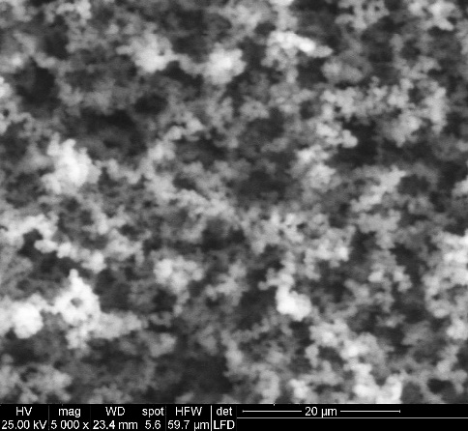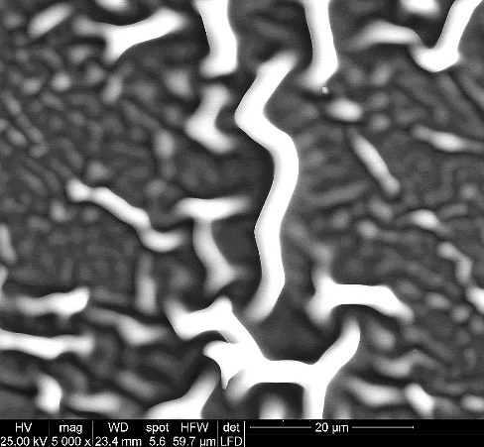

**b**

**a**

Figure S1. SEM image of the plasma deposited carbon steel sample with a gap distance: 2 cm (a), 3 cm

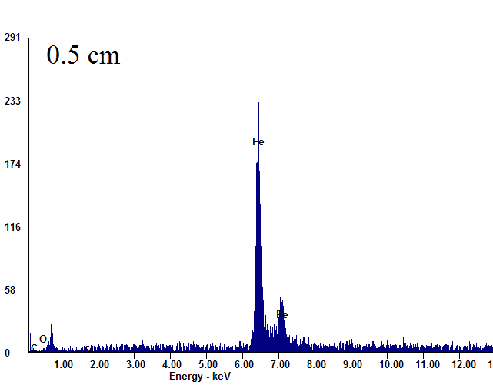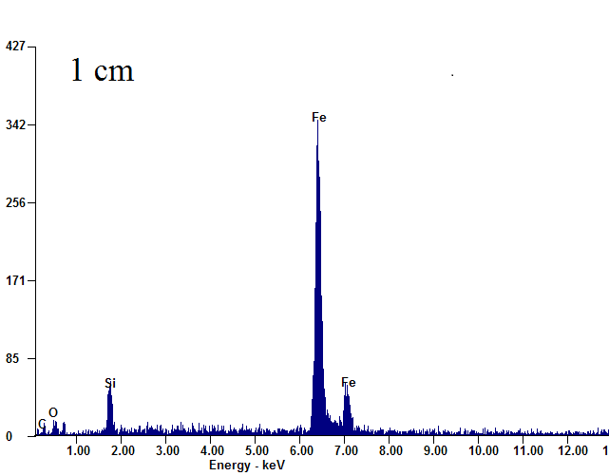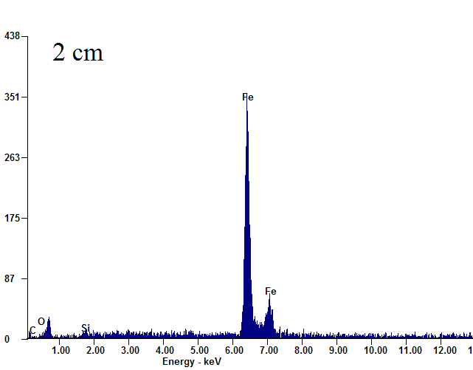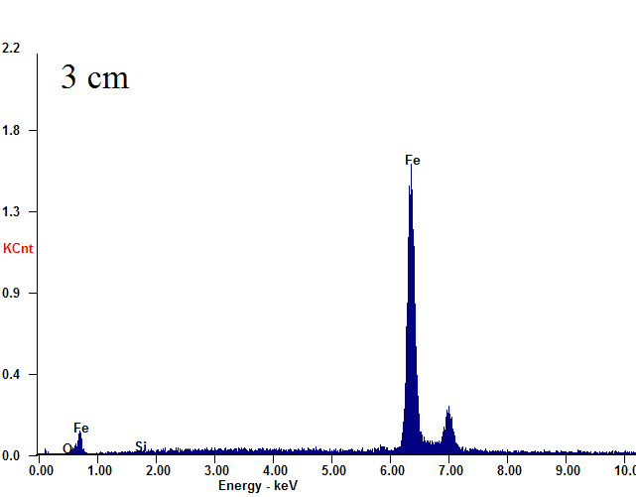

Figure S3. EDX spectra of plasma treated steel samples at different gap distances.