Synthesis and antimicrobial, anti-proliferative and anti-inflammatory activities of novel 1,3,5-substituted pyrazoline sulfonamides.

Supplementary Data

Fig S1. ¹H NMR Spectrum of compound 1b (DMSO) 10
Fig S2. ¹³C NMR Spectrum of compound 1b (DMSO) 10
Fig S3. DEPT NMR Spectra of compound 1b (DMSO) 11
Fig S4. HR-MS spectrum of compound 1b 11
Fig S5. ¹H NMR Spectrum of compound 2b (DMSO) 12
Fig S6. ¹³C NMR Spectrum of compound 2b (DMSO) 12
Fig S7. DEPT NMR Spectrum of compound 2b (DMSO) 13
Fig S8. HR-MS Spectrum of compound 2b 13
Fig S9. ¹H NMR Spectrum of compound 4b (DMSO) 14
Fig S10. ¹³C NMR Spectrum of compound 4b (DMSO) 14
Fig S11. DEPT NMR Spectra of compound 4b (DMSO) 15
Fig S12. HR-MS spectrum of compound 4b 15
Fig S13. ¹H NMR Spectrum of compound 6b (DMSO) 16
Fig S14. ¹³C NMR Spectrum of compound 6b (DMSO) 16
Fig S15. DEPT NMR Spectrum of compound 6b (DMSO) 17
Fig S16. HR-MS spectrum of compound 6b 17
Fig S17. ¹H NMR Spectrum of compound 7b (DMSO) 18
Fig S18. ¹³C NMR Spectrum of compound 7b (DMSO) 18
Fig S19. DEPT NMR Spectrum of compound 7b (DMSO) 19
Fig S20. HR-MS Spectrum of compound 7b 19
Fig S21. ¹H NMR Spectrum of compound 8b (DMSO) 20
Fig S22. ¹³C NMR Spectrum of compound 8b (DMSO) 20
Fig S23. DEPT NMR Spectrum of compound 8b (DMSO) 21
Fig S24. HR-MS spectrum of compound 8b 21
Fig S25. ¹H NMR Spectrum of compound 9b (DMSO) 22
Fig S26. ¹³C NMR Spectrum of compound 9b (DMSO) 22
Fig S27. HR-MS spectrum of compound 9b 23
Fig S28. ¹H NMR Spectrum of compound 12b (DMSO) 23
Fig S29. ¹³C NMR Spectrum of compound 12b (DMSO) 24
Fig S30. DEPT NMR Spectrum of compound 12b (DMSO) 24
Fig S31. HR-MS spectrum of compound 12b 25
Fig S32. ¹H NMR Spectrum of compound 13b (DMSO) 25
Fig S33. ¹³C NMR Spectrum of compound 13b (DMSO) 26
Fig S34. DEPT NMR Spectra of compound 13b (DMSO) 26
Fig S35. HR-MS spectrum of compound 13b 27
Fig S36. ¹H NMR Spectrum of compound 14b (DMSO) 27
Fig S37. ¹³C NMR Spectrum of compound 14b (DMSO) 28
Fig S38. DEPT NMR Spectrum of compound 14b(DMSO) 28
Fig S39. HR-MS spectrum of compound 14b 29
Fig S40. ¹H NMR Spectrum of compound 16b (DMSO) 29
Fig S41. ¹³C NMR Spectrum of compound 16b (DMSO) 30
Fig S42. DEPT NMR Spectrum of compound 16b (DMSO) 30
Fig S43. HR-MS spectrum of compound 16b 31
Fig S44. ¹H NMR Spectrum of compound 17b (DMSO) 31
Fig S45. ¹³C NMR Spectrum of compound 17b (DMSO) 32
Fig S46. DEPT NMR Spectrum of compound 17b (DMSO) 32
Fig S47. HR-MS Spectrum of compound 17b 33
Fig S48. ¹H NMR Spectrum of compound 18b (DMSO) 33
Fig S49. ¹³C NMR Spectrum of compound 18b (DMSO) 34
Fig S50. DEPT NMR Spectrum of compound 18b (DMSO) 34
Fig S51. HR-MS spectrum of compound 18b 35
Fig S52. ¹H NMR Spectrum of compound 19b (DMSO) 35
Fig S53. ¹³C Spectrum of compound 19b (DMSO) 36
Fig S54. HR-MS spectrum of compound 19b 36
Fig S55. ¹H NMR Spectrum of compound 20b (DMSO) 37
Fig S56. ¹³C NMR Spectrum of compound 20b (DMSO) 37
Fig S57. HR-MS spectrum of compound 20b 38
Fig S58. ¹H NMR Spectrum of compound 21b (DMSO) 38
Fig S59. ¹³C NMR Spectrum of compound 21b (DMSO) 39
Fig S60. DEPT NMR Spectrum of compound 21b (DMSO) 39
Fig S61. HR-MS spectrum of compound 21b 40
Fig S62. ¹H NMR Spectrum of compound 22b (DMSO) 40
Fig S63. ¹³C NMR Spectrum of compound 22b (DMSO) 41
Fig S64. DEPT NMR Spectrum of compound 22b (DMSO) 41
Fig S65. HR-MS spectrum of compound 22b 42
Fig S66. ¹H NMR Spectrum of compound 23b (DMSO) 42
Fig S67. ¹³C NMR Spectrum of compound 23b (DMSO) 43
Fig S68. DEPT NMR Spectrum of compound 23b (DMSO) 43
Fig S69. HR-MS spectrum of compound 23b 44
Fig S70. ¹H Spectrum of compound 24b (DMSO) 44
Fig S71. ¹³C NMR Spectrum of compound 24b (DMSO) 45
Fig S72. HR-MS spectrum of compound 24b 45
Fig S73. ¹H NMR Spectrum of compound 25b (DMSO) 46
Fig S74. ¹³C NMR Spectrum of compound 25b (DMSO) 46
Fig S75. ¹³DEPT NMR Spectrum of compound 25b (DMSO) 47
Fig S76. HR-MS spectrum of compound 25b 47
Fig S77. ¹H NMR Spectrum of compound 26b (DMSO) 48
Fig S78. ¹³C NMR Spectrum of compound 26b (DMSO) 48
Fig S79. DEPT Spectrum of compound 26b (DMSO) 49
Fig S80. HR-MS spectrum of compound 26b 49

Synthesis of the chalcone derivatives (1a-26a)
A solution of acetophenones (0.30 mol) and aldehydes (0.30 mol) in methanol (60 mL) was stirred in an aqueous sodium hydroxide solution (100 mL, 2.8 M) for 4 h at room temperature. The mixture was monitored by TLC. Then, the mixture was cooled overnight at 0 °C. The separated solid was filtered and washed with water (3x10 mL) and cooled ethanol (3x10 mL). The solid was dried under vacuum and purified by recrystallization from ethanol to afford the pure chalcones.
(E)-3-(3-hydroxyphenyl)-1-phenylprop-2-en-1-one (1a)
Yellow powder. Yield 70.4 %. ¹H NMR (500 MHz, DMSO) δ 9.63 (s, 1H), 8.16 – 8.10 (m, 2H), 7.82 (d, J 15.5 Hz, 1H), 7.67 (dt, J 7.5, 1.5 Hz, 1H), 7.66 (d, J 15.5 Hz, 1H), 7.59 – 7.54 (m, 2H), 7.31 (dt, J 7.5, 1.5 Hz, 1H), 7.26 (t, J 7.5 Hz, 1H), 7.23 (t, J 2.0 Hz, 1H), 6.88 (ddd, J 8.0, 2.5, 1.0 Hz, 1H).
(E)-3-(2-methoxyphenyl)-1-phenylprop-2-en-1-one (2a)
Yellow powder. Yield 89 %. ¹H NMR (500 MHz, DMSO) δ 8.13 – 8.08 (m, 2H), 8.05 (d, J 15.5 Hz, 1H), 7.95 (dd, J 8.0, 1.5 Hz, 1H), 7.86 (d, J 16.0 Hz, 1H), 7.69 – 7.62 (m, 1H), 7.57 (t, J 7.5 Hz, 2H), 7.48 – 7.41 (m, 1H), 7.11 (d, J 8.5 Hz, 1H), 7.03 (t, J 7.5 Hz, 1H), 3.89 (s, 3H).
(E)-3-(2-chlorophenyl)-1-phenylprop-2-en-1-one (3a)
Yellow powder. Yield 89 %. ¹H NMR (500 MHz, DMSO) δ 8.19 (dd, J 7.5, 2.5 Hz, 1H), 8.17 – 8.13 (m, 2H), 8.04 (d, J 15.5 Hz, 1H), 7.96 (d, J 15.5 Hz, 1H), 7.71 – 7.64 (m, 1H), 7.61 – 7.51 (m, 3H), 7.48 – 7.41 (m, 2H).
(E)-3-(3-nitrophenyl)-1-phenylprop-2-en-1-one (4a)
Yellow powder. Yield 86%. ¹H NMR (500 MHz, DMSO) δ 8.76 (t, J 1.5 Hz, 1H), 8.33 (d, J 8.0 Hz, 1H), 8.26 (dd, J 8.0, 2.0 Hz, 1H), 8.22 – 8.18 (m, 2H), 8.15 (d, J 16.0 Hz, 1H), 7.85 (d, J 15.5 Hz, 1H), 7.74 (t, J 8.0 Hz, 1H), 7.69 (t, J 7.5 Hz, 1H), 7.59 (t, J 7.5 Hz, 2H).
(E)-3-phenyl-1-(p-tolyl)prop-2-en-1-one (5a)
Yellow powder. Yield 82 %. ¹H NMR (500 MHz, DMSO) δ 8.07 (d, J 8.0 Hz, 2H), 7.92 (d, J 15.5 Hz, 1H), 7.87 (dd, J 5.5, 3.5 Hz, 2H), 7.73 (d, J 15.5 Hz, 1H), 7.50 – 7.42 (m, 3H), 7.37 (d, J 8.0 Hz, 2H), 2.40 (s, 3H).
(E)-3-(3-hydroxyphenyl)-1-(p-tolyl)prop-2-en-1-one (6a)
Yellow powder. Yield 87 %. ¹H NMR (500 MHz, DMSO) δ 7.98 – 7.92 (m, 2H), 7.52 (d, J 15.0 Hz,1H), 7.49 (d, J 15.0 Hz,1H), 7.35 (d, J 8.0 Hz, 2H), 6.85 (t, J 8.0 Hz 1H), 6.57 (t, J 2.0 Hz, 1H), 6.44 (dt, J 7.0, 1.5 Hz, 1H), 6.32 (dd, J 7.5, 1.5 Hz, 1H), 2.39 (s, 3H).
(E)-3-(2-methoxyphenyl)-1-(p-tolyl)prop-2-en-1-one (7a)
Yellow powder. Yield 78 %. ¹H NMR (500 MHz, DMSO) δ 8.07 – 8.00 (m, 3H), 7.96 (dd, J 8.0, 2.0 Hz, 1H), 7.85 (d, J 16.0 Hz, 1H), 7.44 (ddd, J 8.5, 7.0, 1.5 Hz, 1H), 7.36 (d, J 8.0 Hz, 2H), 7.11 (d, J 8.0 Hz, 1H), 7.03 (t, J 7.5 Hz, 1H), 3.89 (s, 3H), 2.39 (s, 3H).
(E)-3-(4-chlorophenyl)-1-(p-tolyl)prop-2-en-1-one (8a)
Yellow powder. Yield 79%. ¹H NMR (500 MHz, DMSO) δ 8.07 (d, J 8.5 Hz, 2H), 7.95 (d, J 15.5 Hz, 1H), 7.94 – 7.90 (m, 2H), 7.71 (d, J 16.0 Hz, 1H), 7.52 (d, J 8.5 Hz, 2H), 7.38 (d, J 8.0 Hz, 2H), 2.41 (s, 3H).
(E)-3-(3-nitrophenyl)-1-(p-tolyl)prop-2-en-1-one (9a)
Yellow powder. Yield 90%. ¹H NMR (500 MHz, DMSO) δ 8.76 (t, J 1.5 Hz, 2H), 8.33 (d, J 8.0 Hz, 1H), 8.26 (ddd, J 8.0, 2.0, 1.5 Hz, 1H), 8.14 (d, J 15.8 Hz, 1H), 8.11 (d, J 8.0 Hz, 2H), 7.83 (d, J 15.5 Hz, 1H), 7.74 (t, J 8.0 Hz, 1H), 7.39 (d, J 8.0 Hz, 2H), 2.41 (s, 3H).
(E)-1-(4-methoxyphenyl)-3-(p-tolyl)prop-2-en-1-one (10a)
Yellow powder. Yield 86 %. ¹H NMR (500 MHz, CDCl₃) δ 8.07 – 8.00 (m, 2H), 7.78 (d, J 15.5 Hz, 1H), 7.54 (d, J 8.5 Hz, 2H), 7.50 (d, J 15.5 Hz, 1H), 7.22 (d, J 8.0 Hz, 2H), 7.02 – 6.94 (m, 2H), 3.89 (s, 3H), 2.39 (s, 3H).
(E)-1,3-bis(4-methoxyphenyl)prop-2-en-1-one (11a)
Yellow powder. Yield 92 %. ¹H NMR (500 MHz, CDCl₃) δ 8.07 – 7.99 (m, 2H), 7.77 (d, J 15.5 Hz, 1H), 7.63 – 7.56 (m, 2H), 7.42 (d, J 15.5 Hz, 1H), 7.01 – 6.89 (m, 4H), 3.88 (s, 3H), 3.85 (s, 3H).
(E)-3-(2,3-dimethoxyphenyl)-1-(4-methoxyphenyl)prop-2-en-1-one (12a)
Yellow powder. Yield 85%. ¹H NMR (500 MHz, CDCl3) δ 8.11 – 8.00 (m, 3H), 7.61 (d, J 16.0 Hz, 1H), 7.27 (dd, J 8.0, 1.5 Hz, 1H), 7.09 (t, J 8.0 Hz, 1H), 7.02 – 6.93 (m, 3H), 3.91 – 3.87 (m, 9H).
(E)-3-(2-chlorophenyl)-1-(4-methoxyphenyl)prop-2-en-1-one (13a)
Yellow powder. Yield 79 %. ¹H NMR (500 MHz, CDCl₃) δ 8.15 (d, J 15.5 Hz, 1H), 8.07 – 8.00 (m, 2H), 7.78 – 7.70 (m, 1H), 7.49 (d, J 15.5 Hz, 1H),
7.48 – 7.39 (m, 1H), 7.35 – 7.28 (m, 2H), 7.02 – 6.95 (m, 2H),
3.89 (s, 3H).
(E)-1-(4-methoxyphenyl)-3-(3-nitrophenyl)prop-2-en-1-one (14a)
Yellow powder. Yield 90%. ¹H NMR (500 MHz, DMSO) δ 8.76 (t, J 1.5 Hz, 1H), 8.33 (d, J 8.0 Hz, 1H), 8.26 (ddd, J 8.0, 2.0, 1.0 Hz, 1H), 8.24 – 8.19 (m, 2H), 8.16 (d, J 15.5 Hz, 1H), 7.81 (d, J 15.5 Hz, 1H), 7.74 (t, J 8.0 Hz, 1H), 7.13 – 7.07 (m, 2H), 3.88 (s, 3H).
(E)-1-(4-chlorophenyl)-3-phenylprop-2-en-1-one (15a)
Yellow powder. Yield 90 %. ¹H NMR (500 MHz, CDCl₃) δ 7.99 – 7.94 (m, 1H), 7.81 (d, J 15.5 Hz, 1H), 7.67 – 7.61 (m, 1H), 7.48 (d, J 15.0 Hz,
1H), 7.49 – 7.44 (m, 1H), 7.44 – 7.40 (m, 2H).
(E)-1-(4-chlorophenyl)-3-(3-hydroxyphenyl)prop-2-en-1-one (16a)
Yellow powder. Yield 93 %. ¹H NMR (500 MHz, DMSO) δ 8.19 – 8.11 (m, 2H), 7.79 (d, J 15.5 Hz, 1H), 7.66 (d, J 15.5 Hz, 1H), 7.64 – 7.60 (m, 2H), 7.28 (dt, J 8.0, 1.5 Hz, 1H), 7.25 (t, J 7.5 Hz, 1H), 7.22 (t, J 2.0 Hz, 1H), 6.88 (ddd, J 8.0, 2.5, 1.5 Hz, 1H).
(E)-1-(4-chlorophenyl)-3-(2-methoxyphenyl)prop-2-en-1-one (17a)
Yellow powder. Yield 89 %. ¹H NMR (500 MHz, DMSO) δ 8.15 – 8.09 (m, 2H), 8.05 (d, J 16.0 Hz, 1H), 7.94 (dd, J 8.0, 1.5 Hz, 1H), 7.83 (d, J 16.0 Hz, 1H), 7.63 – 7.57 (m, 2H), 7.47 – 7.40 (m, 1H), 7.09 (d, J 8.0 Hz, 1H), 7.02 (t, J 7.5 Hz, 1H), 3.88 (s, 3H).
(E)-1-(4-chlorophenyl)-3-(3-nitrophenyl)prop-2-en-1-one (18a)
Yellow powder. Yield 93%. ¹H NMR (500 MHz, DMSO) δ 8.78 (t, J 1.5 Hz, 1H), 8.33 (d, J 7.5 Hz, 1H), 8.27 (ddd, J 8.5, 2.5, 1.0 Hz, 1H), 8.25 – 8.19 (m, 2H), 8.14 (d, J 15.5 Hz, 1H), 7.86 (d, J 15.5 Hz, 1H), 7.75 (t, J 8.0 Hz, 1H), 7.68 – 7.62 (m, 2H).
(E)-1-(4-fluorophenyl)-3-(3-nitrophenyl)prop-2-en-1-one (19a)
Yellow powder. Yield 92%. ¹H NMR (500 MHz, DMSO) δ 8.73 (t, J 2.0 Hz, 1H), 8.32 – 8.25 (m, 3H), 8.25 – 8.19 (m, 1H), 8.11 (d, J 15.5 Hz, 1H), 7.81 (d, J 15.7 Hz, 1H), 7.71 (t, J 8.0 Hz, 1H), 7.43 – 7.31 (m, 2H).
(2E,4E)-1,5-diphenylpenta-2,4-dien-1-one (20a)
Yellow powder. Yield 83%. ¹H NMR (500 MHz, DMSO) δ 8.05 – 7.98 (m, 2H), 7.66 (td, J 7.5, 1.0 Hz, 1H), 7.66 – 7.57 (m, 2H), 7.60 – 7.49 (m, 3H), 7.46 – 7.32 (m, 4H), 7.32 – 7.18 (m, 2H).
(2E,4E)-5-phenyl-1-(p-tolyl)penta-2,4-dien-1-one (21a)
Yellow powder. Yield 86%. ¹H NMR (500 MHz, CDCl3) δ 7.92 – 7.85 (m, 2H),7.59 (ddd, J 15.0 8.5, 2.0 Hz, 1H), 7.53 – 7.45 (m, 2H), 7.40 – 7.32 (m, 2H), 7.35 – 7.27 (m, 1H), 7.28 (d, J 8.0 Hz, 2H), 7.09 (d, J 15.0 Hz, 1H), 7.06 – 6.95 (m, 2H), 2.42 (s, 3H).
(2E,4E)-1-(4-methoxyphenyl)-5-phenylpenta-2,4-dien-1-one (22a)
Yellow powder. Yield 86%. ¹H NMR (500 MHz, CDCl3) δ 8.03 – 7.95 (m, 2H), 7.59 (ddd, J 15.0, 8.5, 2.0 Hz, 1H), 7.53 – 7.46 (m, 2H), 7.42 – 7.33 (m, 2H), 7.37 – 7.28 (m, 1H), 7.11 (d, J 14.5 Hz, 1H), 7.07 – 6.93 (m, 4H), 3.88 (s, 3H).
(2E,4E)-1-(2,5-dimethoxyphenyl)-5-phenylpenta-2,4-dien-1-one (23a)
Yellow powder. Yield 90%. ¹H NMR (500 MHz, DMSO) δ 7.61 – 7.55 (m, 2H), 7.42 – 7.36 (m, 2H), 7.36 – 7.32 (m, 1H), 7.32 – 7.26 (m, 1H), 7.21 (dd, J 15.5, 10.5 Hz, 1H), 7.16 – 7.06 (m, 3H), 7.00 (dd, J 2.0, 1.0 Hz, 1H), 6.93 (d, J 15.0 Hz, 1H), 3.80 (s, 3H), 3.74 (s, 3H).
(2E,4E)-1-(4-chlorophenyl)-5-phenylpenta-2,4-dien-1-one (24a)
Yellow powder. Yield 87%. ¹H NMR (500 MHz, DMSO) δ 8.05 – 7.99 (m, 2H), 7.66 – 7.60 (m, 2H), 7.63 – 7.56 (m, 2H), 7.54 (ddd, J 15.0, 7.0, 3.5 Hz, 1H), 7.46 – 7.39 (m, 2H), 7.39 – 7.32 (m, 2H), 7.29 – 7.20 (m, 2H).
(2E,4E)-1-(4-fluorophenyl)-5-phenylpenta-2,4-dien-1-one (25a)
Yellow powder. Yield 78%. ¹H NMR (500 MHz, DMSO) δ 8.13 – 8.06 (m, 2H), 7.61 – 7.57 (m, 2H), 7.54 (ddd, J 15.0, 7.5, 1.5 Hz, 1H), 7.45 – 7.32 (m, 7H), 7.28 – 7.18 (m, 2H).
(2E,4E)-1-(3-nitrophenyl)-5-phenylpenta-2,4-dien-1-one (26a)
Yellow powder. Yield 77%. ¹H NMR (500 MHz, DMSO) δ 8.70 (t, J 2.0 Hz, 1H), 8.48 (ddd, J 8.0, 2.5, 1.5 Hz, 1H), 8.43 (d, J 7.5 Hz, 1H), 7.87 (t, J 8.0 Hz, 1H), 7.66 – 7.58 (m, 3H), 7.46 (d, J 15.0 Hz, 1H), 7.42 (d, J 7.5 Hz, 2H), 7.40 – 7.34 (m, 1H), 7.34 – 7.24 (m, 2H).

Fig S1. ¹H NMR Spectrum of compound 1b (DMSO)

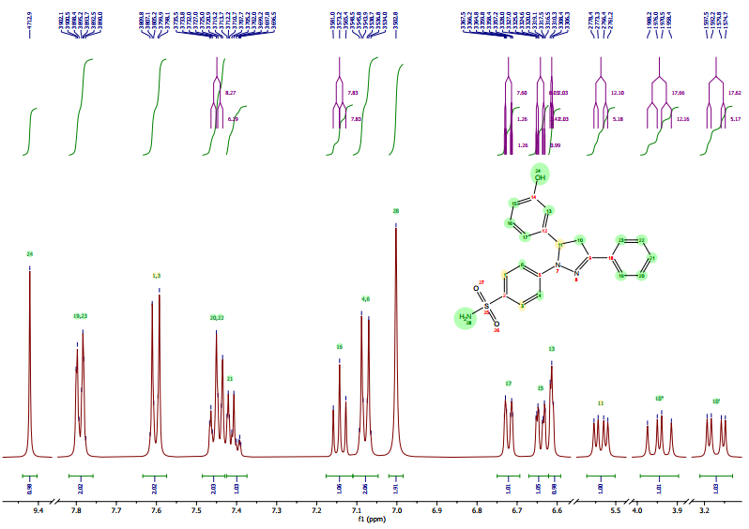

Fig S2. ¹³C NMR Spectrum of compound 1b (DMSO)

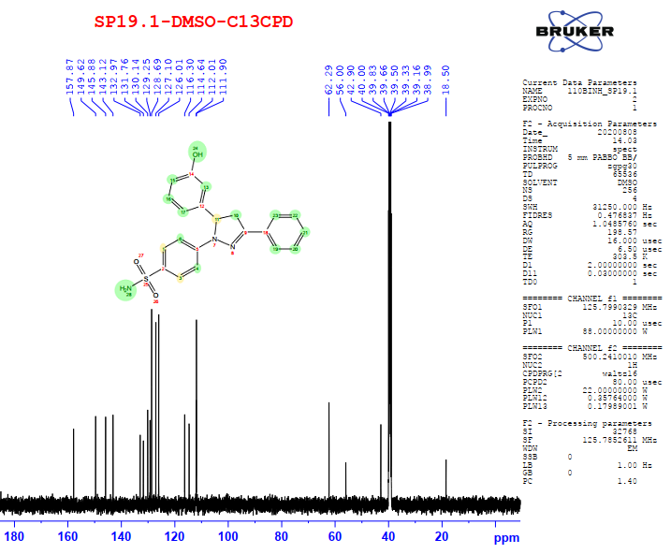

Fig S3. DEPT NMR Spectra of compound 1b (DMSO)
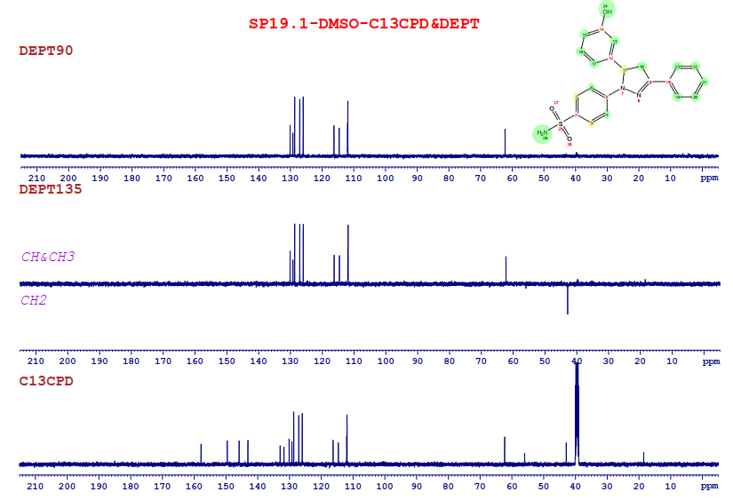

Fig S4. HR-MS spectrum of compound 1b
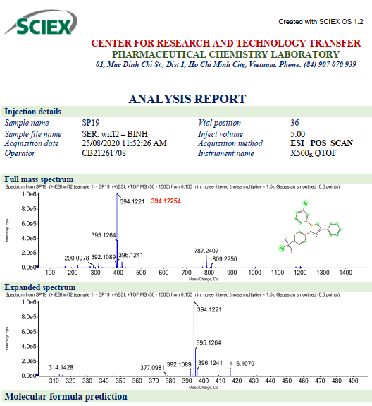

Fig S5. ¹H NMR Spectrum of compound 2b (DMSO)
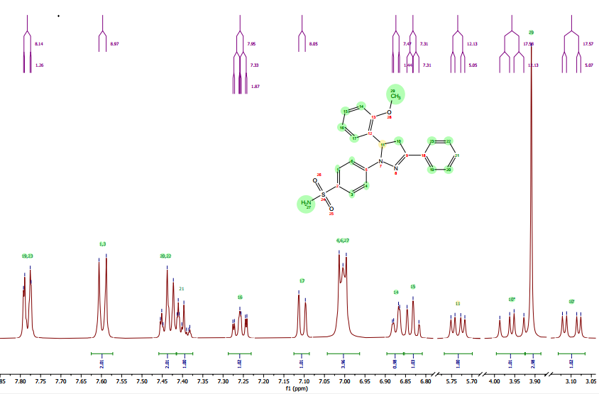

Fig S6. ¹³C NMR Spectrum of compound 2b (DMSO)
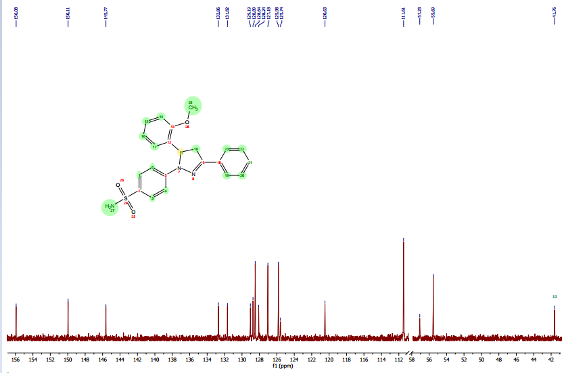

Fig S7. DEPT NMR Spectrum of compound 2b (DMSO)
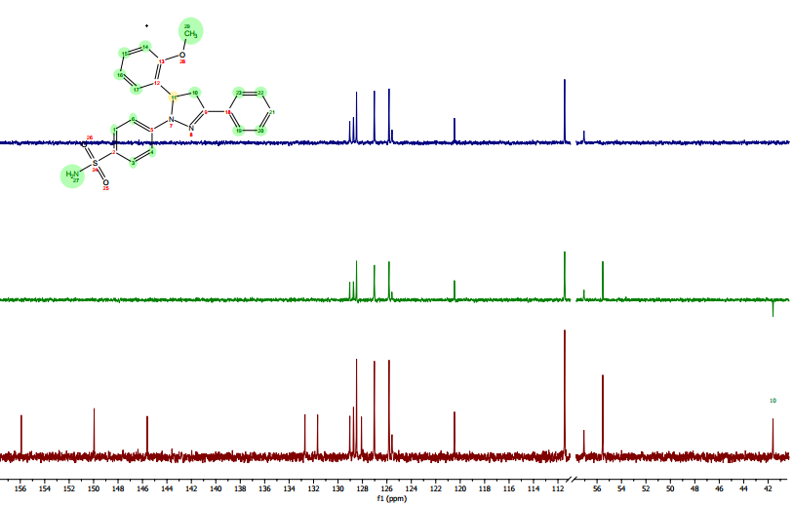

Fig S8. HR-MS Spectrum of compound 2b
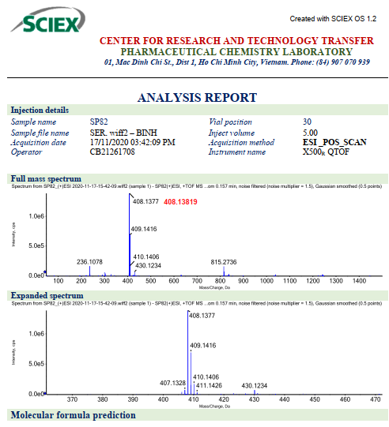

Fig S9. ¹H NMR Spectrum of compound 4b (DMSO)
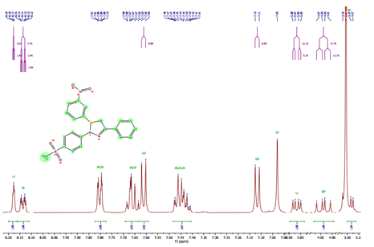

Fig S10. ¹³C NMR Spectrum of compound 4b (DMSO)
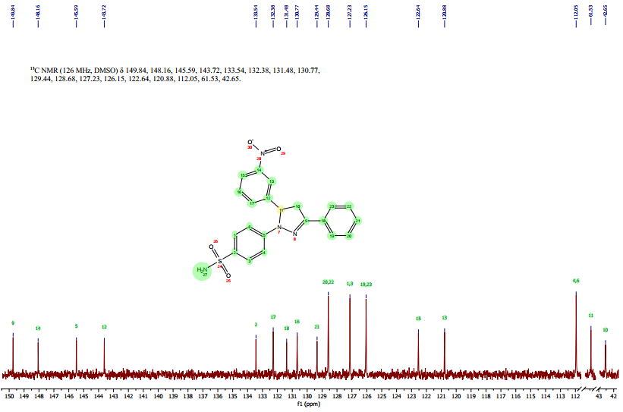

Fig S11. DEPT NMR Spectra of compound 4b (DMSO)
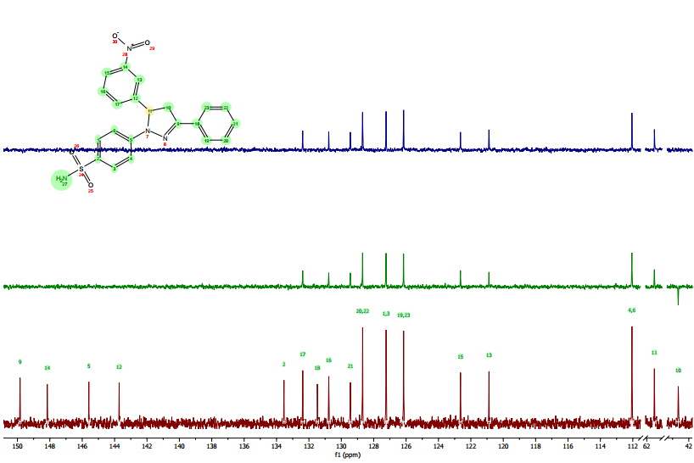

Fig S12. HR-MS spectrum of compound 4b
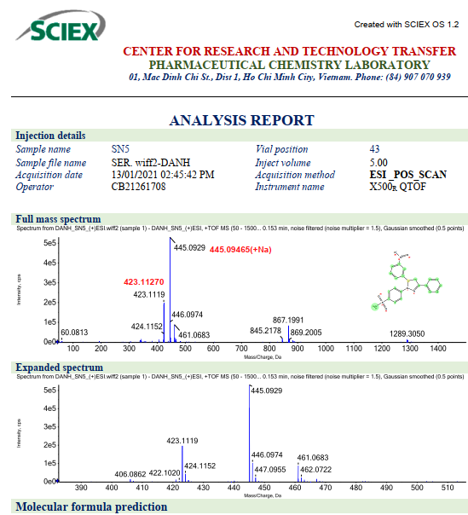

Fig S13. ¹H NMR Spectrum of compound 6b (DMSO)
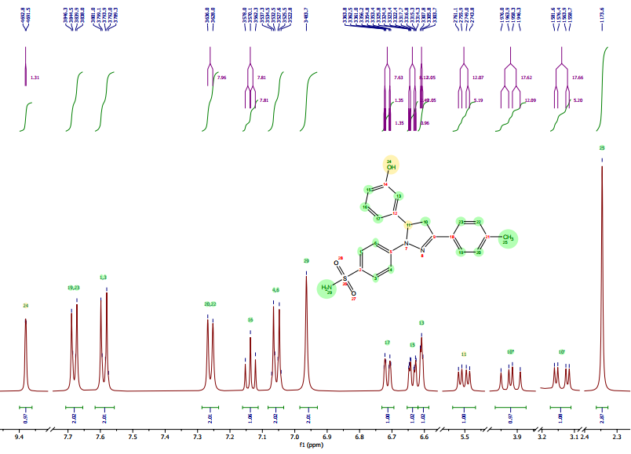

Fig S14. ¹³C NMR Spectrum of compound 6b (DMSO)
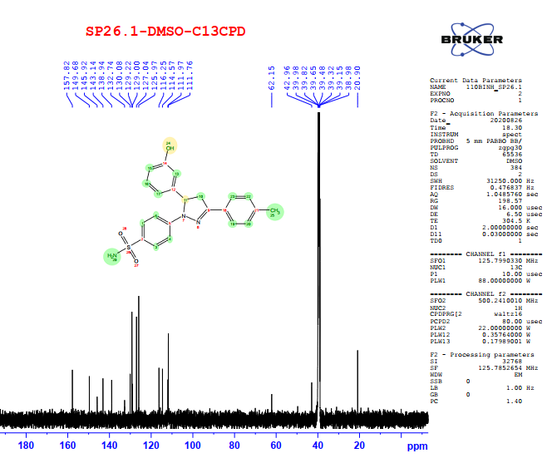

Fig S15. DEPT NMR Spectrum of compound 6b (DMSO)
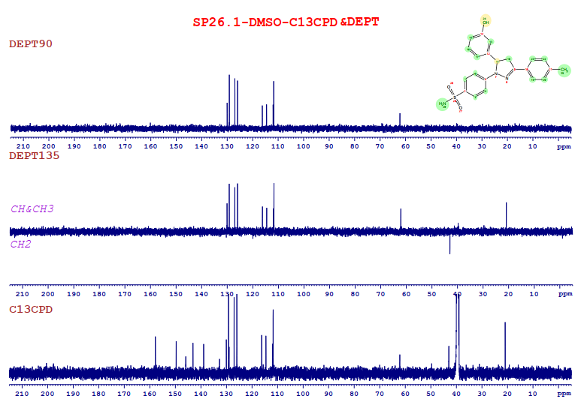

Fig S16. HR-MS spectrum of compound 6b
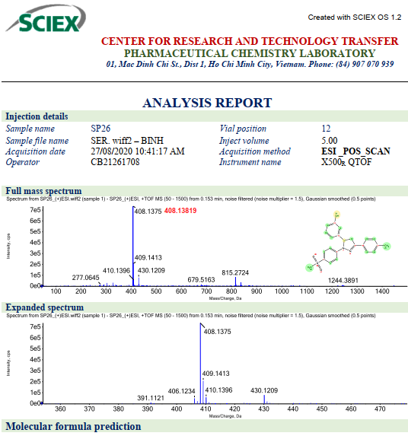

Fig S17. ¹H NMR Spectrum of compound 7b (DMSO)
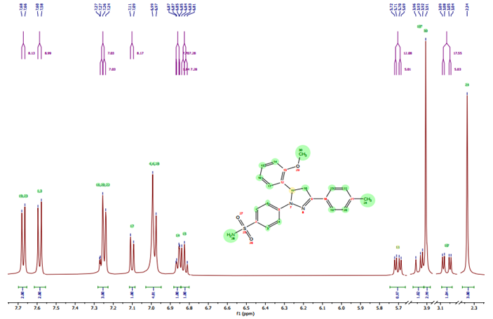

Fig S18. ¹³C NMR Spectrum of compound 7b (DMSO)
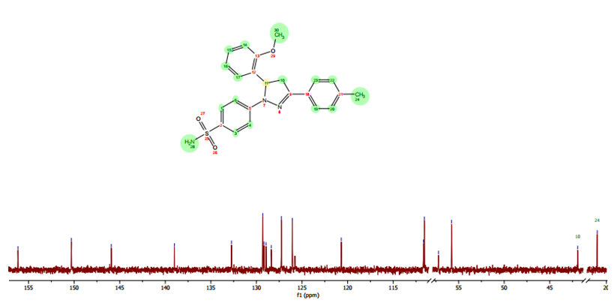

Fig S19. DEPT NMR Spectrum of compound 7b (DMSO)
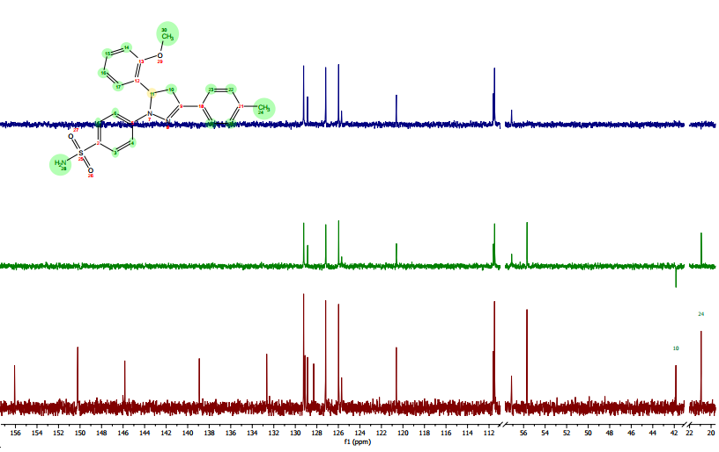

Fig S20. HR-MS Spectrum of compound 7b
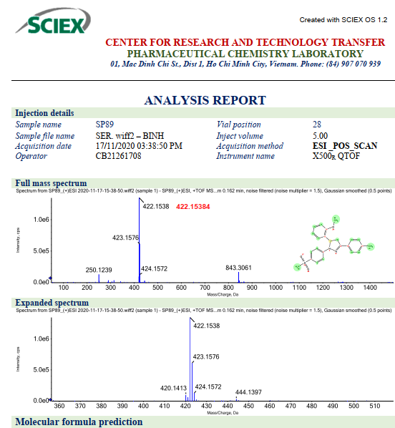

Fig S21. ¹H NMR Spectrum of compound 8b (DMSO)
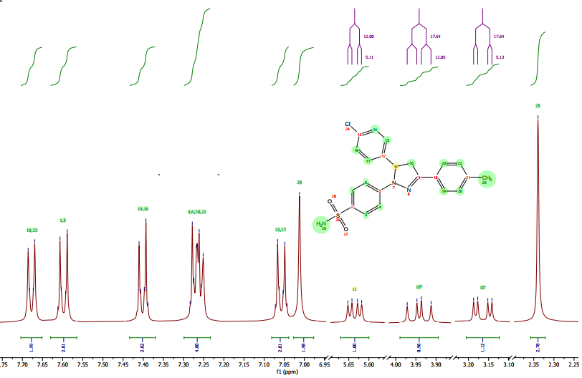

Fig S22. ¹³C NMR Spectrum of compound 8b (DMSO)
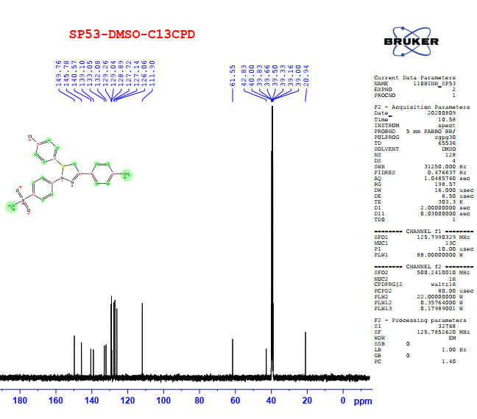

Fig S23. DEPT NMR Spectrum of compound 8b (DMSO)
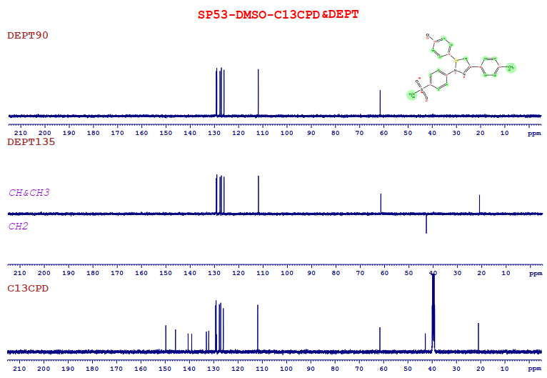

Fig S24. HR-MS spectrum of compound 8b
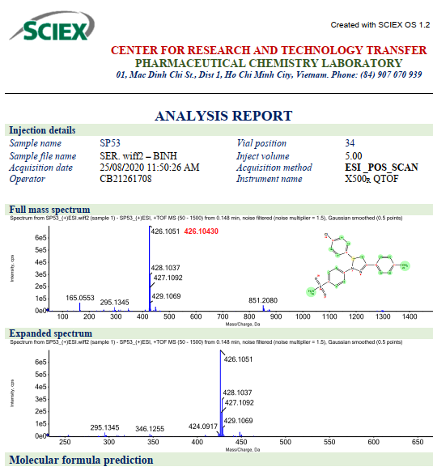

Fig S25. ¹H NMR Spectrum of compound 9b (DMSO)
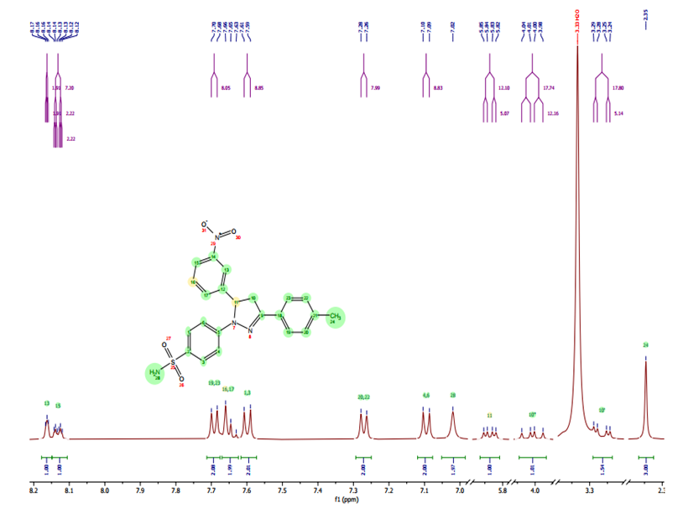

Fig S26. ¹³C NMR Spectrum of compound 9b (DMSO)
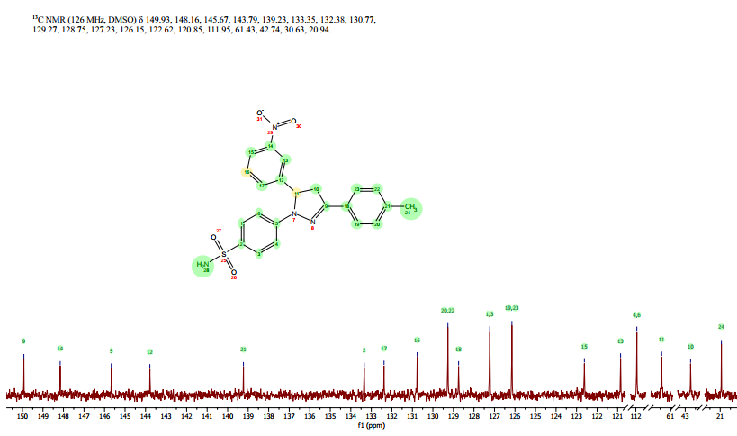

Fig S27. HR-MS spectrum of compound 9b
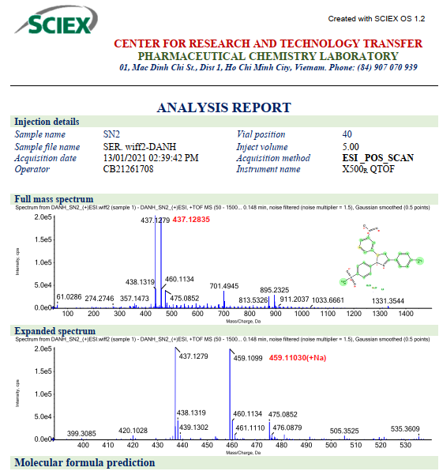

Fig S28. ¹H NMR Spectrum of compound 12b (DMSO)
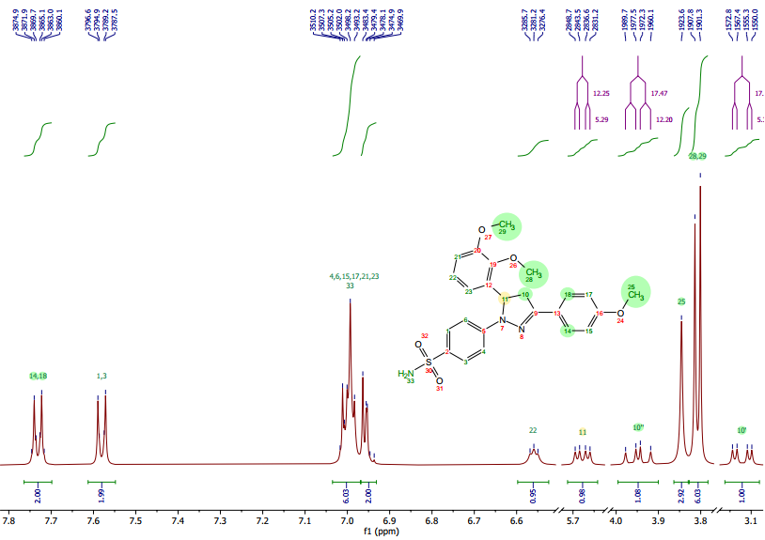

Fig S29. ¹³C NMR Spectrum of compound 12b (DMSO)
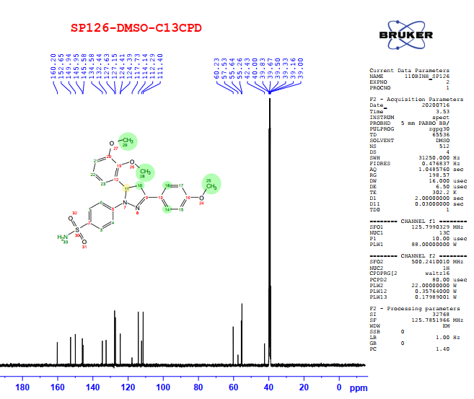

Fig S30. DEPT NMR Spectrum of compound 12b (DMSO)
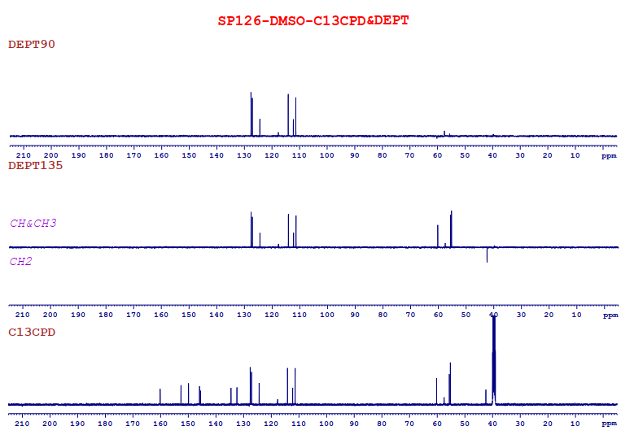

Fig S31. HR-MS spectrum of compound 12b
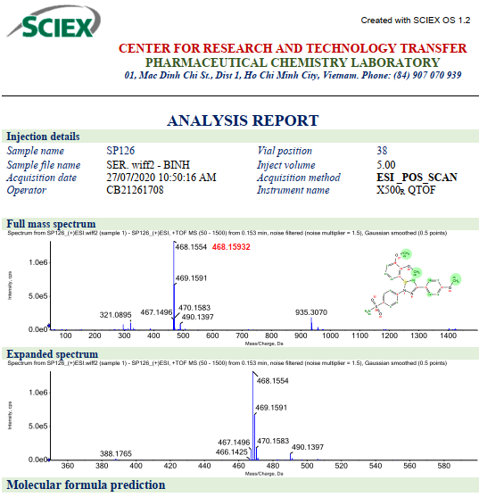

Fig S32. ¹H NMR Spectrum of compound 13b (DMSO)
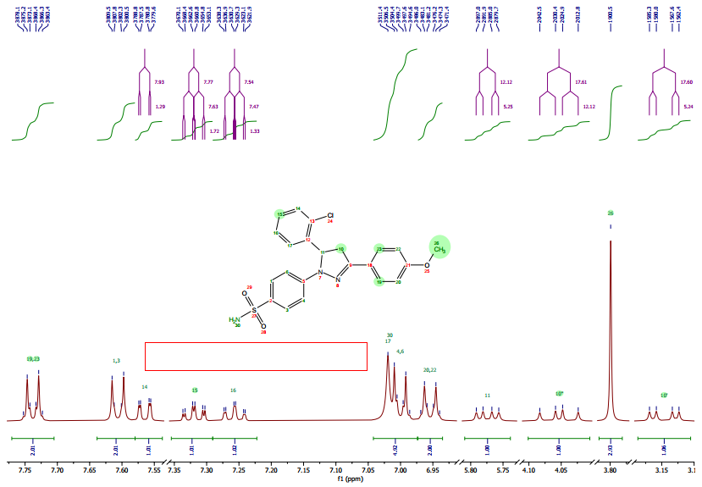

Fig S33. ¹³C NMR Spectrum of compound 13b (DMSO)
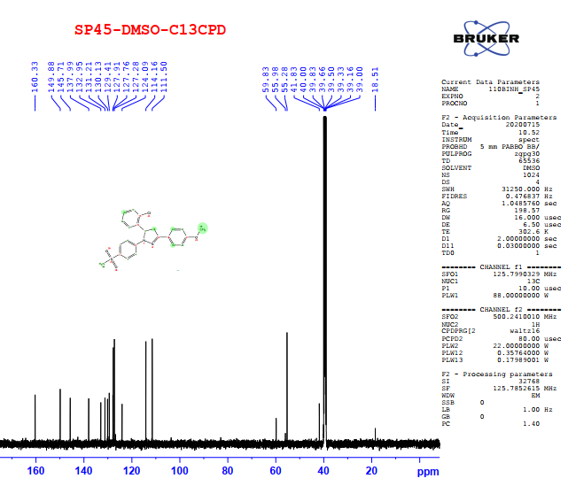

Fig S34. DEPT NMR Spectra of compound 13b (DMSO)
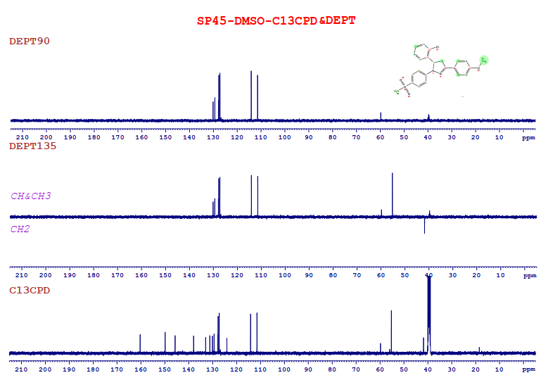

Fig S35. HR-MS spectrum of compound 13b
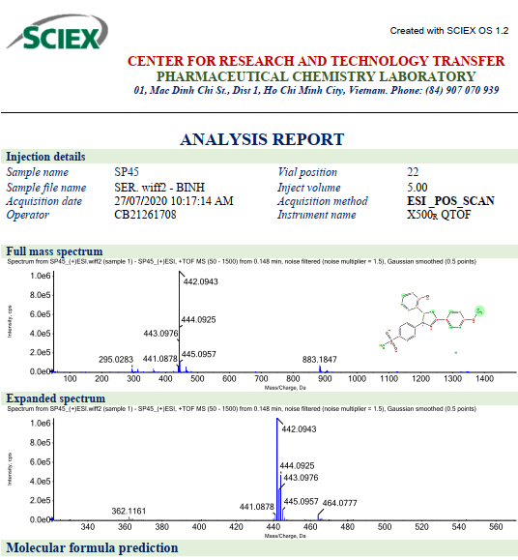

Fig S36. ¹H NMR Spectrum of compound 14b (DMSO)
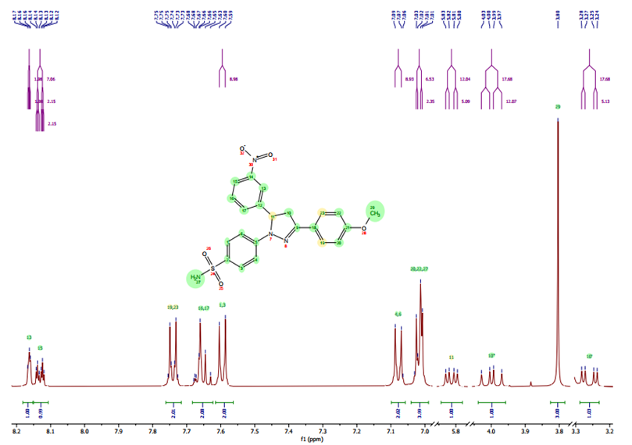

Fig S37. ¹³C NMR Spectrum of compound 14b (DMSO)
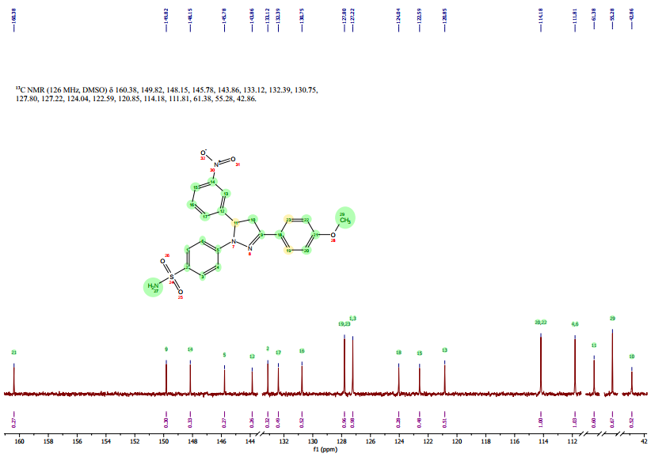

Fig S38. DEPT NMR Spectrum of compound 14b(DMSO)
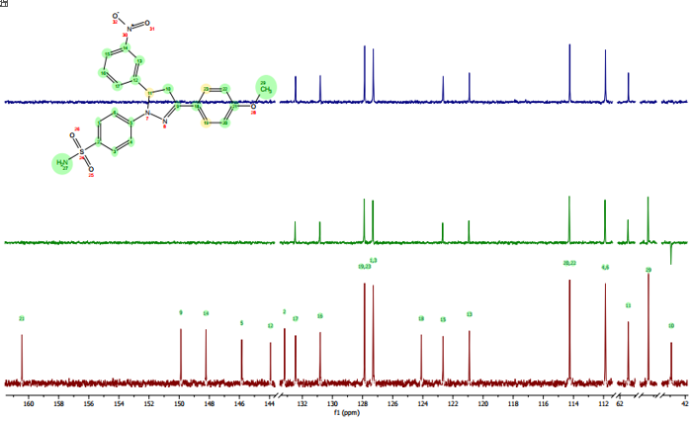

Fig S39. HR-MS spectrum of compound 14b
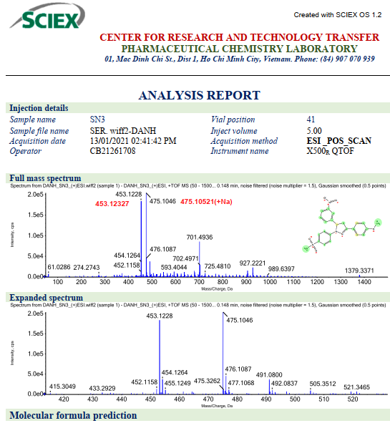

Fig S40. ¹H NMR Spectrum of compound 16b (DMSO)
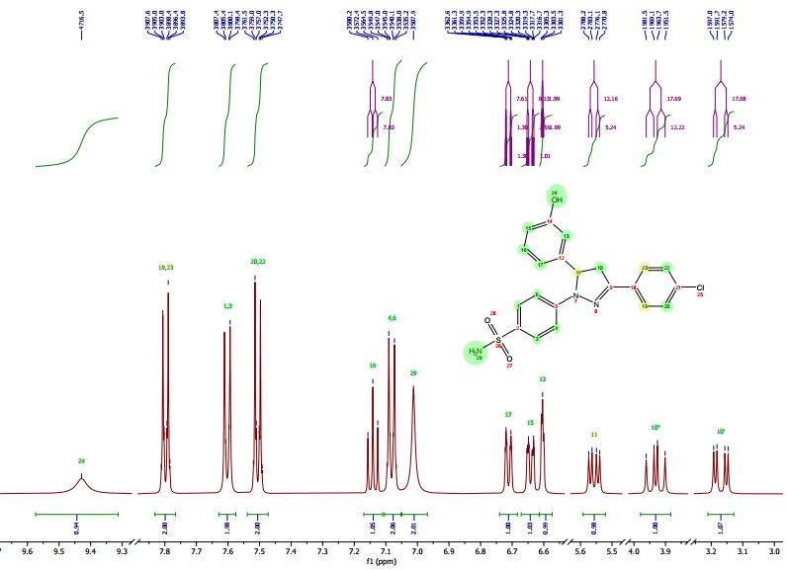

Fig S41. ¹³C NMR Spectrum of compound 16b (DMSO)
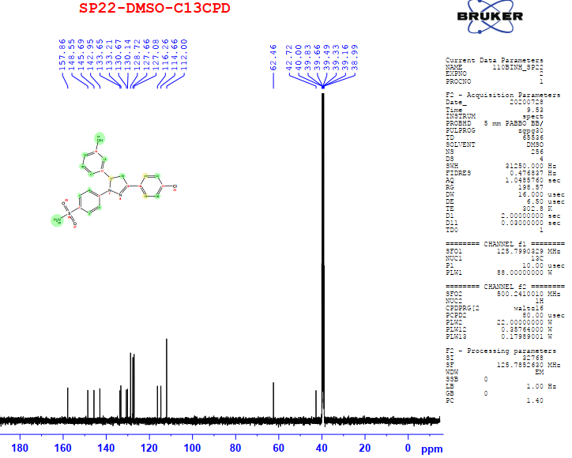

Fig S42. DEPT NMR Spectrum of compound 16b (DMSO)
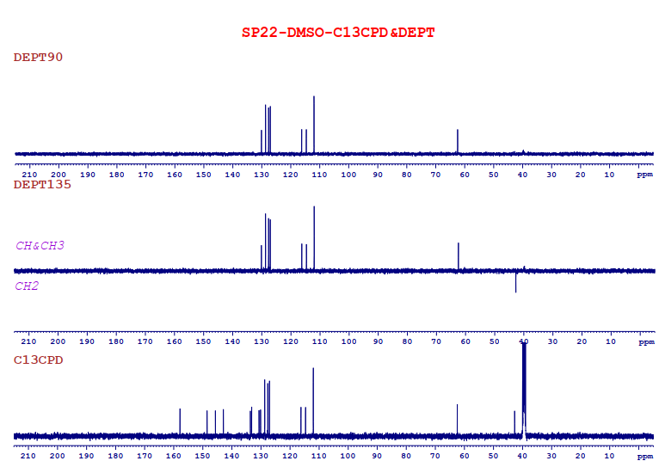

Fig S43. HR-MS spectrum of compound 16b
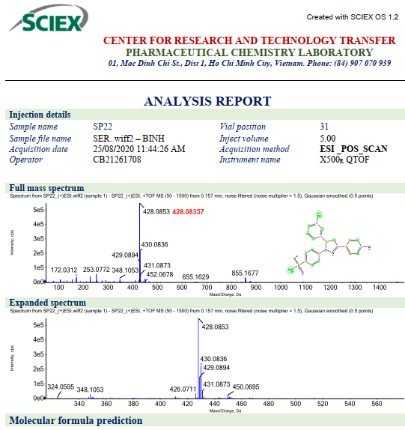

Fig S44. ¹H NMR Spectrum of compound 17b (DMSO)
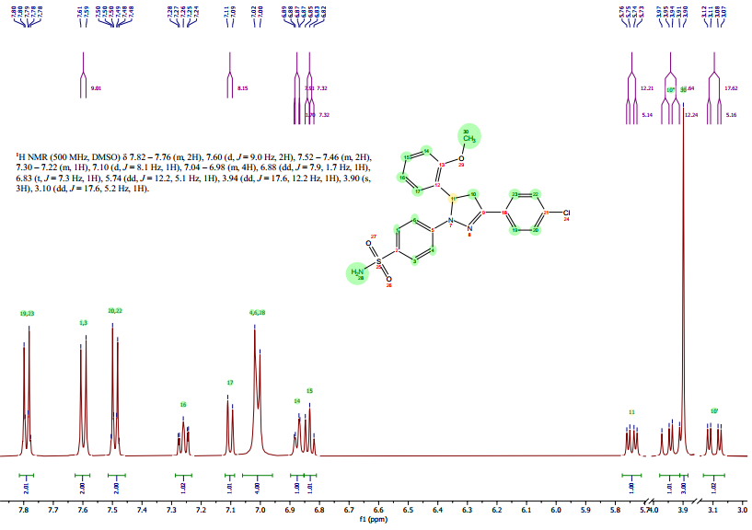

Fig S45. ¹³C NMR Spectrum of compound 17b (DMSO)
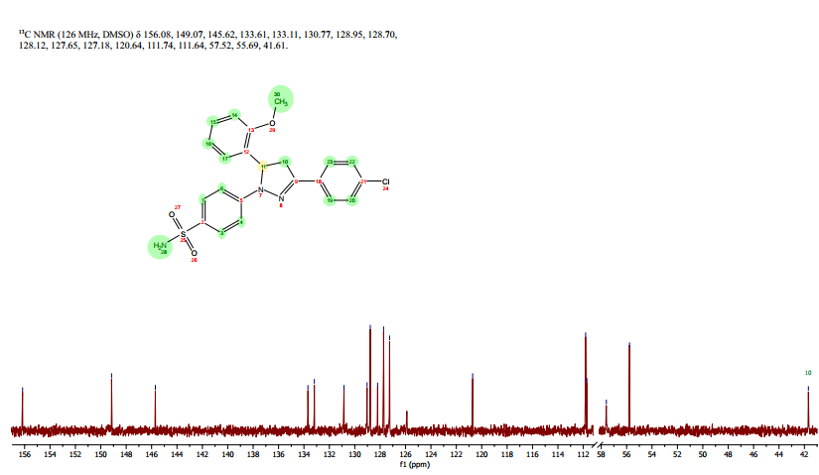

Fig S46. DEPT NMR Spectrum of compound 17b (DMSO)
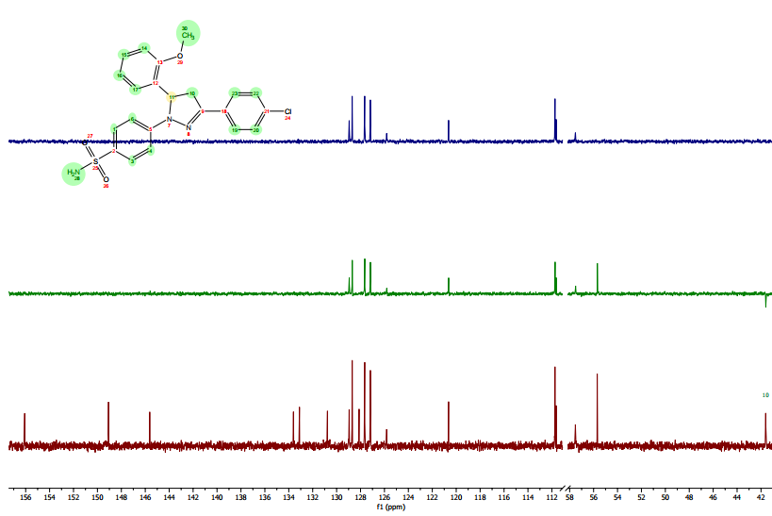

Fig S47. HR-MS Spectrum of compound 17b
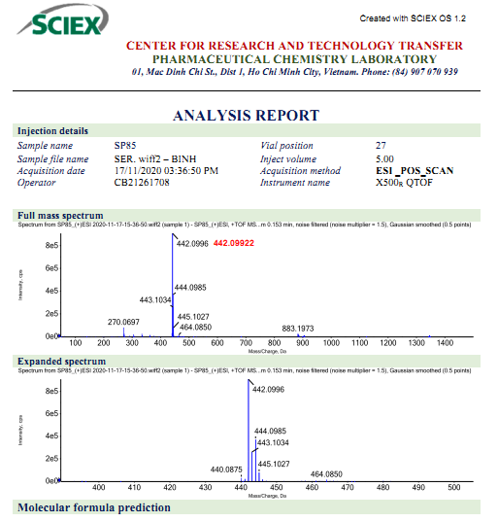

Fig S48. ¹H NMR Spectrum of compound 18b (DMSO)
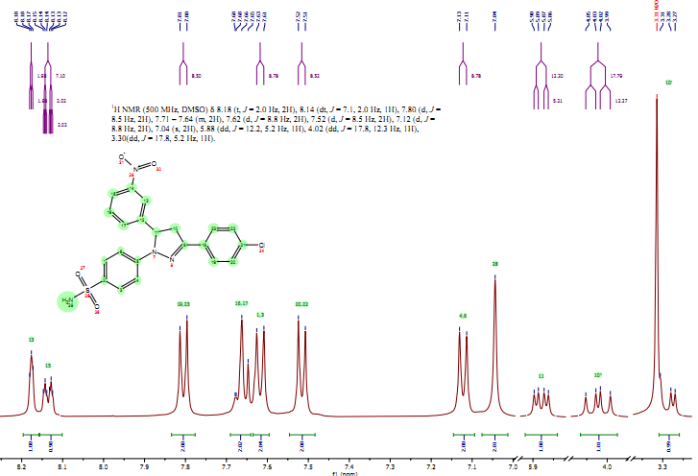

Fig S49. ¹³C NMR Spectrum of compound 18b (DMSO)
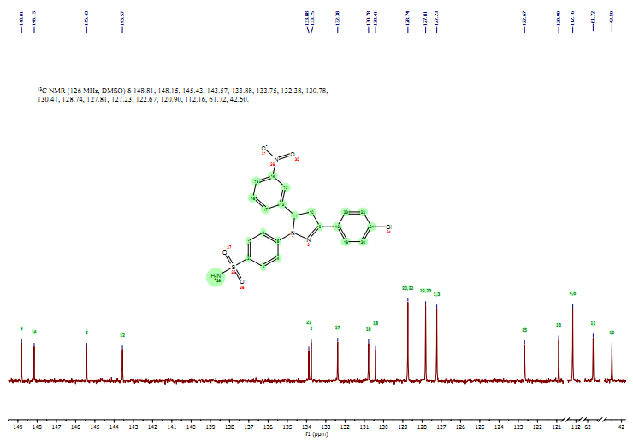

Fig S50. DEPT NMR Spectrum of compound 18b (DMSO)
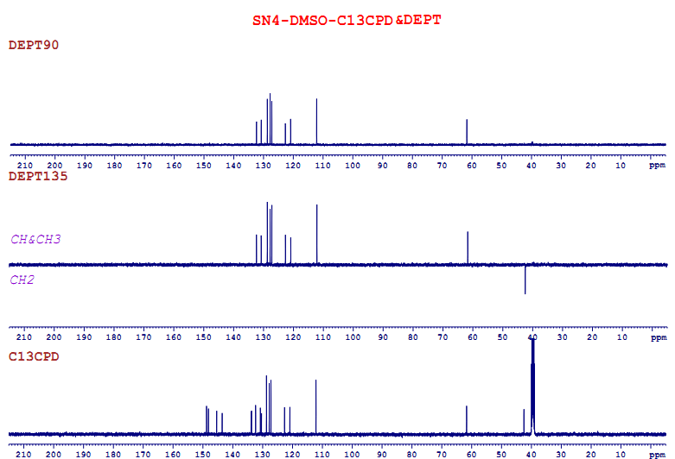

Fig S51. HR-MS spectrum of compound 18b
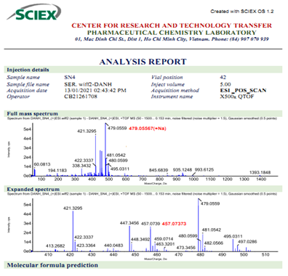

Fig S52. ¹H NMR Spectrum of compound 19b (DMSO)
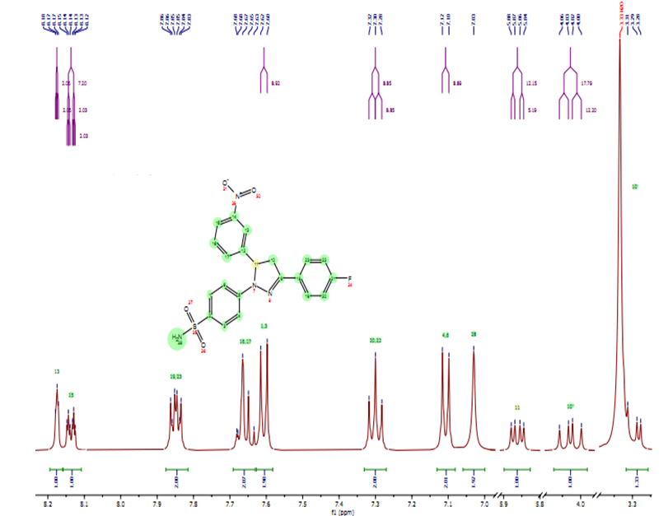

Fig S53. ¹³C Spectrum of compound 19b (DMSO)
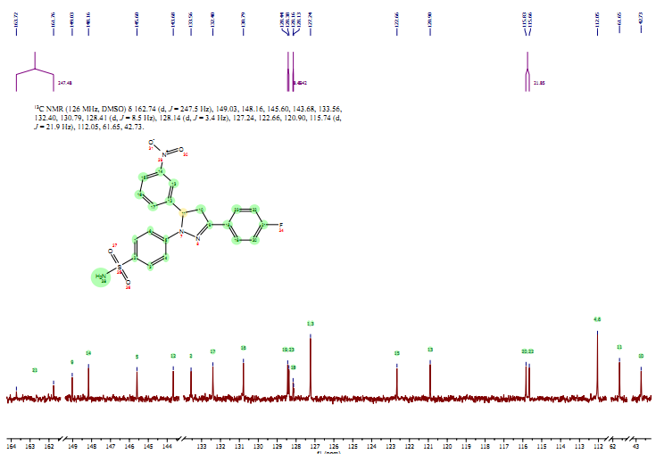

Fig S54. HR-MS spectrum of compound 19b
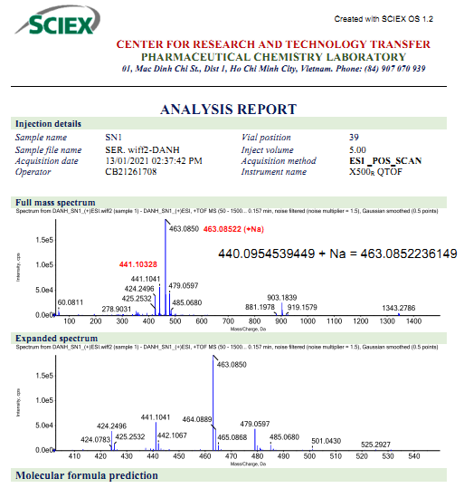

Fig S55. ¹H NMR Spectrum of compound 20b (DMSO)
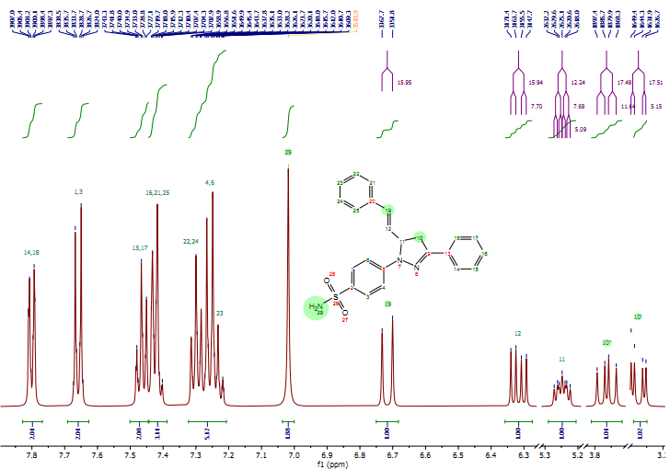

Fig S56. ¹³C NMR Spectrum of compound 20b (DMSO)
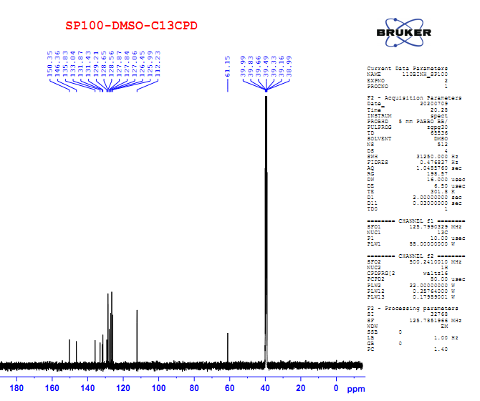

Fig S57. HR-MS spectrum of compound 20b
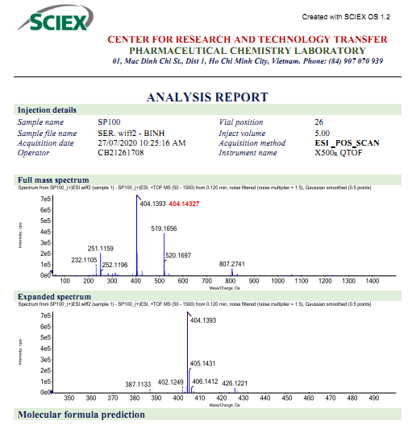

Fig S58. ¹H NMR Spectrum of compound 21b (DMSO)
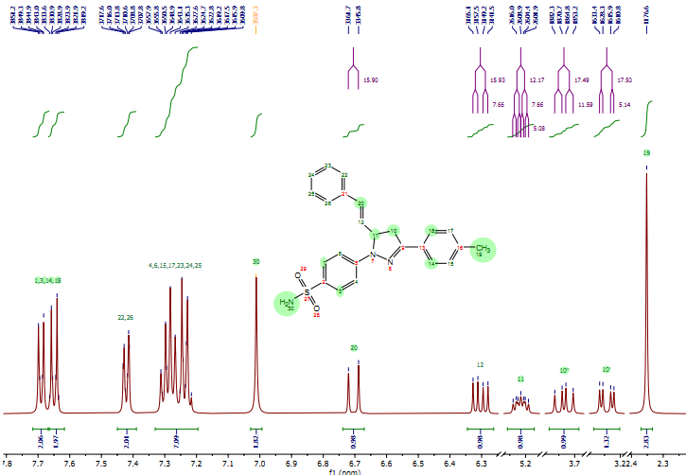

Fig S59. ¹³C NMR Spectrum of compound 21b (DMSO)
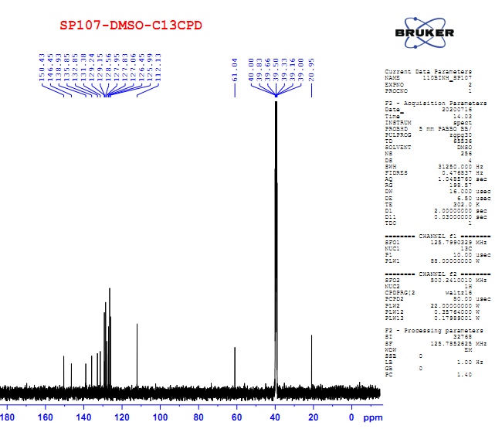

Fig S60. DEPT NMR Spectrum of compound 21b (DMSO)
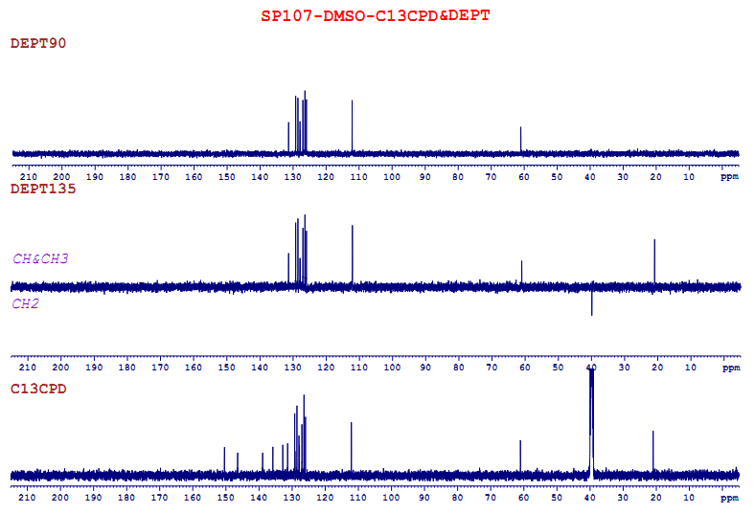

Fig S61. HR-MS spectrum of compound 21b
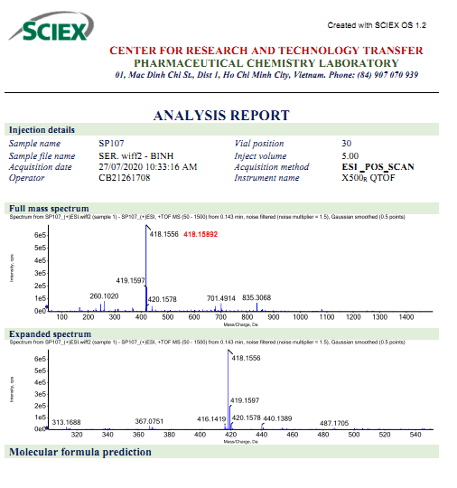

Fig S62. ¹H NMR Spectrum of compound 22b (DMSO)
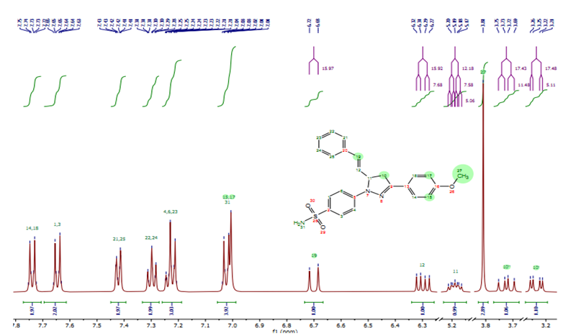

Fig S63. ¹³C NMR Spectrum of compound 22b (DMSO)
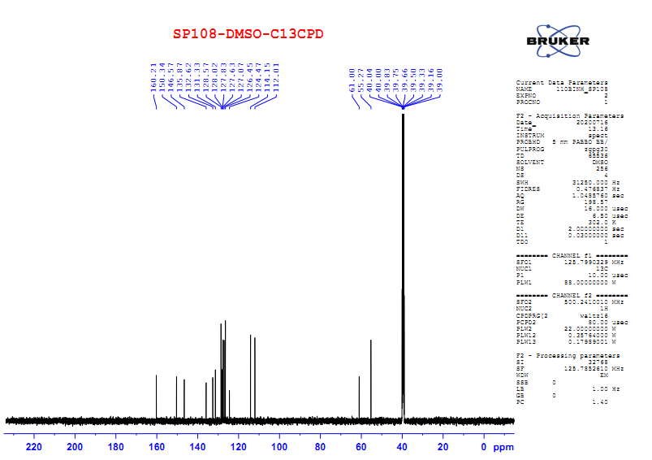

Fig S64. DEPT NMR Spectrum of compound 22b (DMSO)
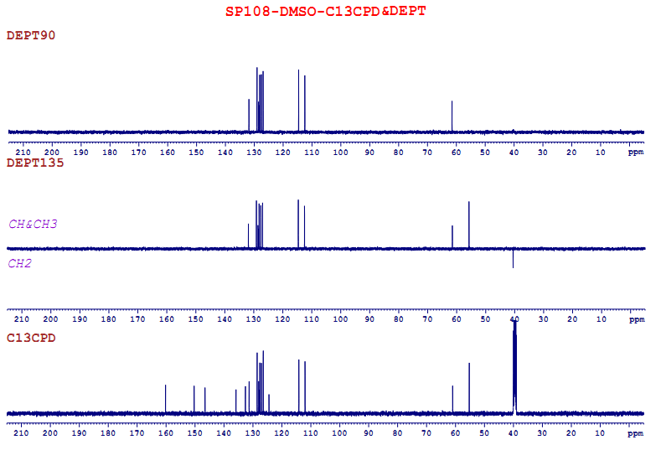

Fig S65. HR-MS spectrum of compound 22b
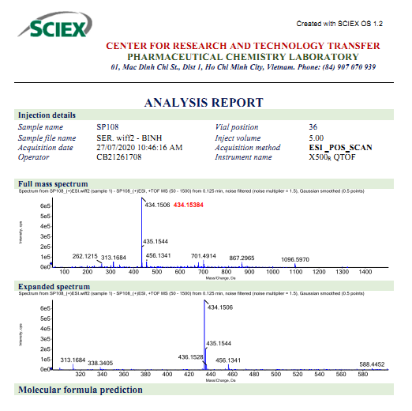

Fig S66. ¹H NMR Spectrum of compound 23b (DMSO)
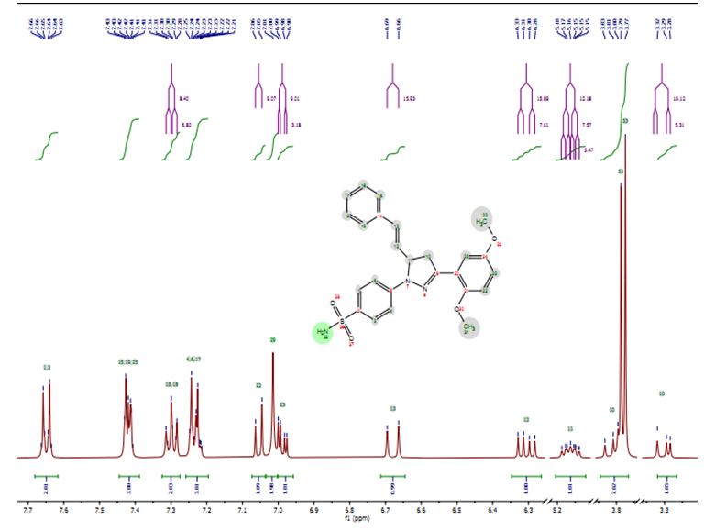

Fig S67. ¹³C NMR Spectrum of compound 23b (DMSO)
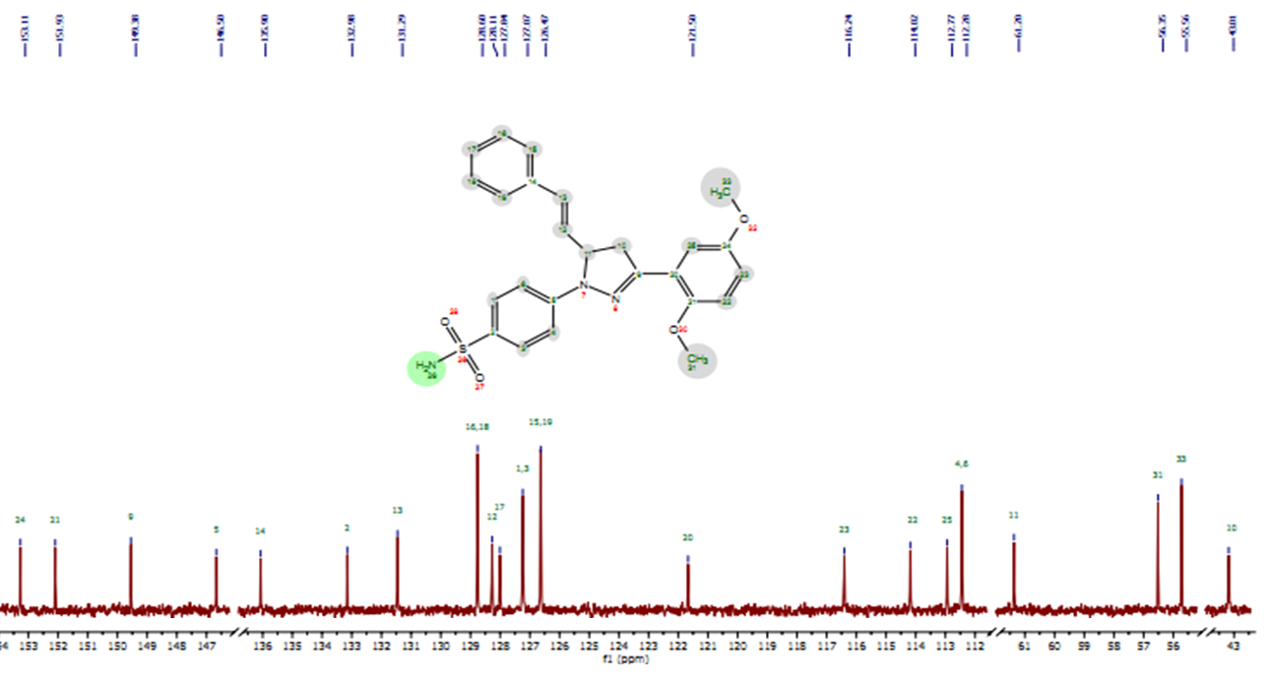

Fig S68. DEPT NMR Spectrum of compound 23b (DMSO)
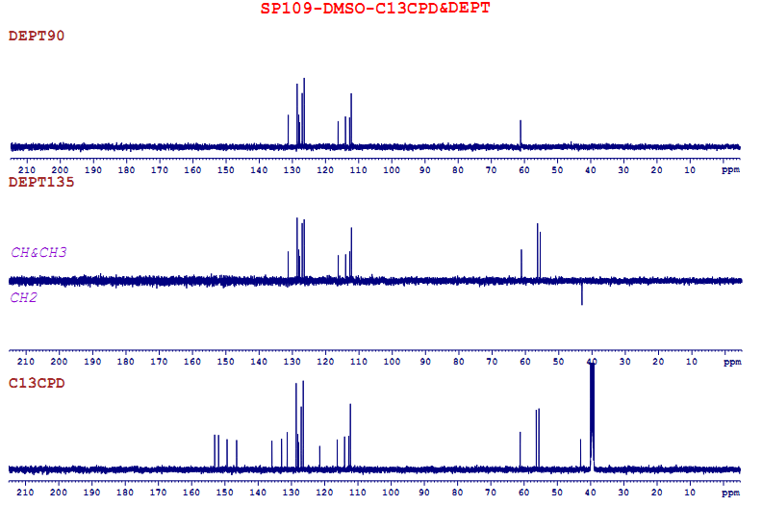

Fig S69. HR-MS spectrum of compound 23b
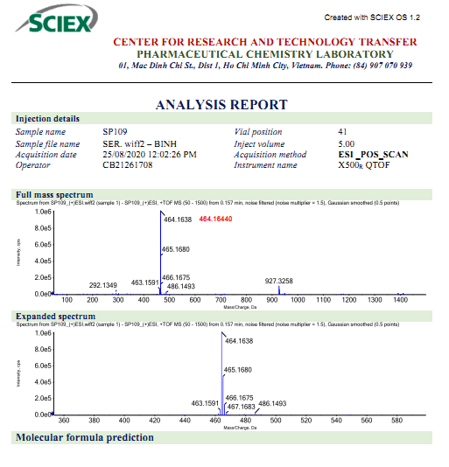

Fig S70. ¹H Spectrum of compound 24b (DMSO)
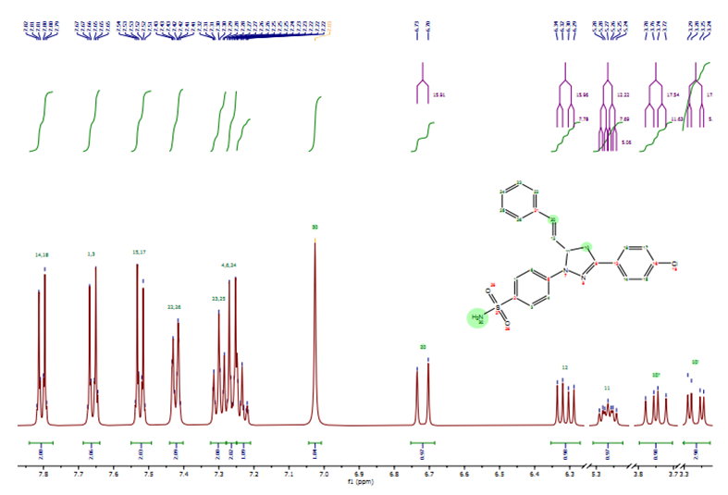

Fig S71. ¹³C NMR Spectrum of compound 24b (DMSO)
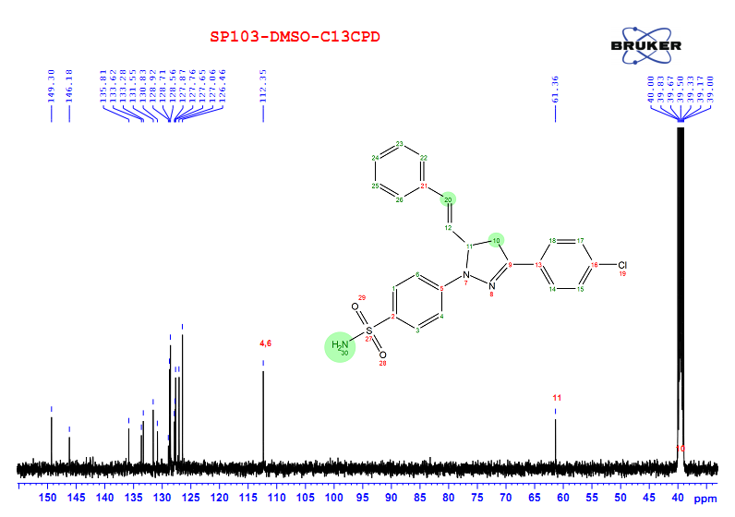

Fig S72. HR-MS spectrum of compound 24b
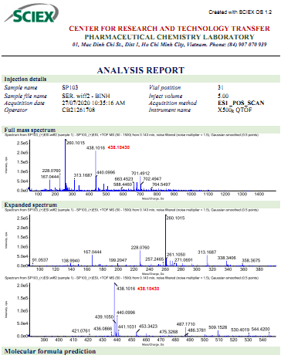

Fig S73. ¹H NMR Spectrum of compound 25b (DMSO)
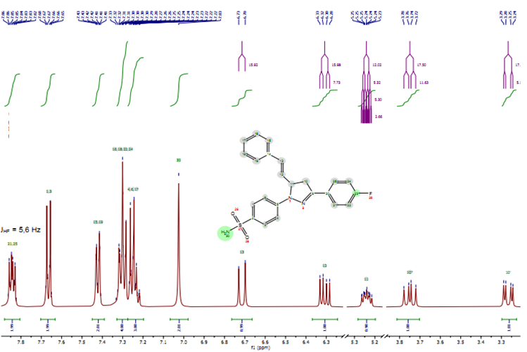

Fig S74. ¹³C NMR Spectrum of compound 25b (DMSO)
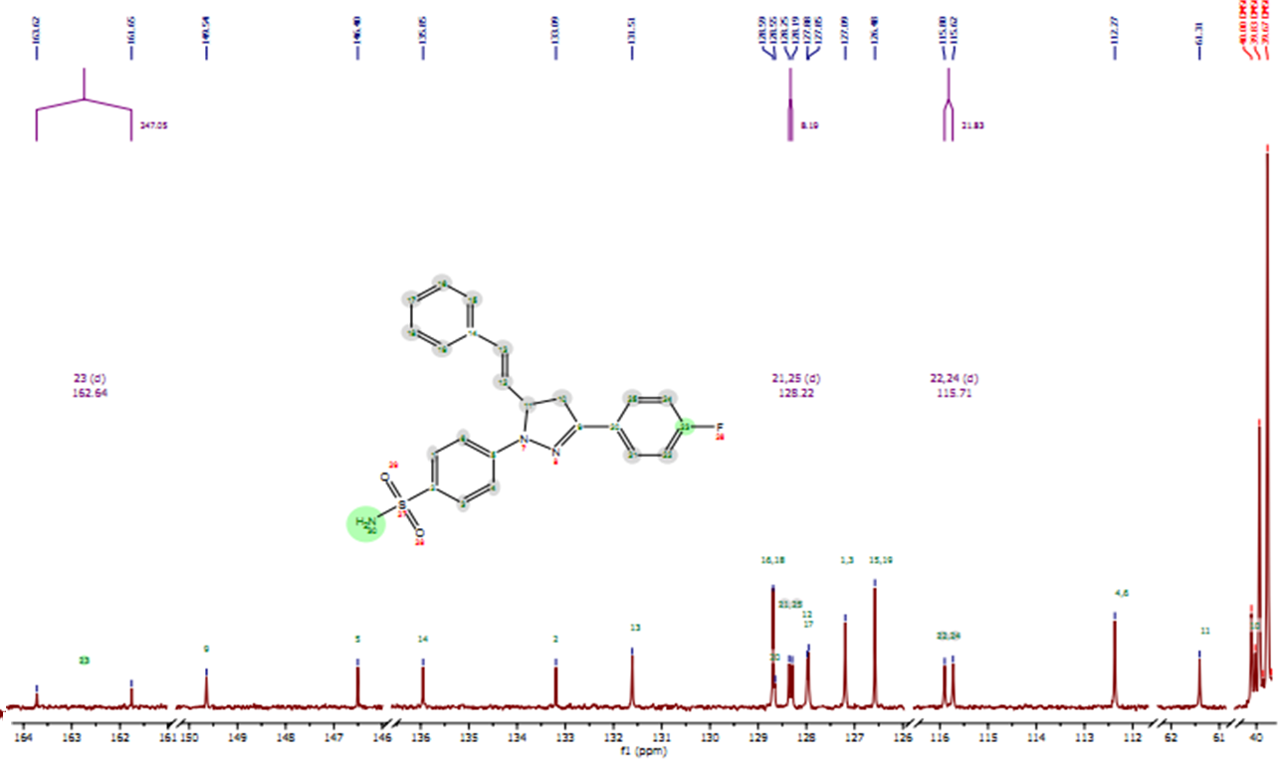

Fig S75. ¹³DEPT NMR Spectrum of compound 25b (DMSO)
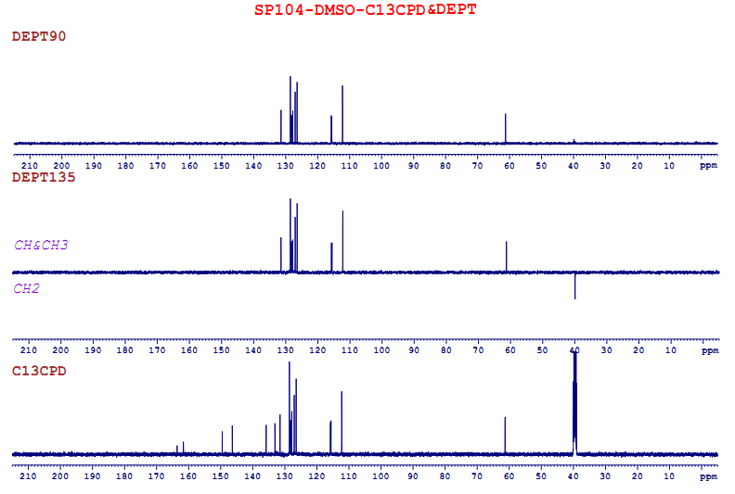

Fig S76. HR-MS spectrum of compound 25b
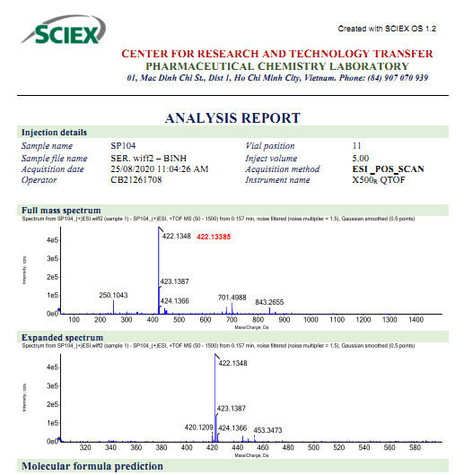

Fig S77. ¹H NMR Spectrum of compound 26b (DMSO)
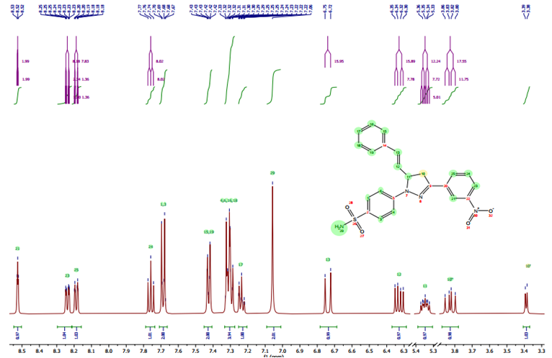

Fig S78. ¹³C NMR Spectrum of compound 26b (DMSO)
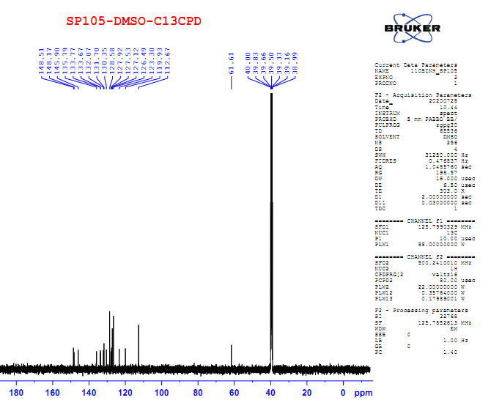

Fig S79. DEPT Spectrum of compound 26b (DMSO)
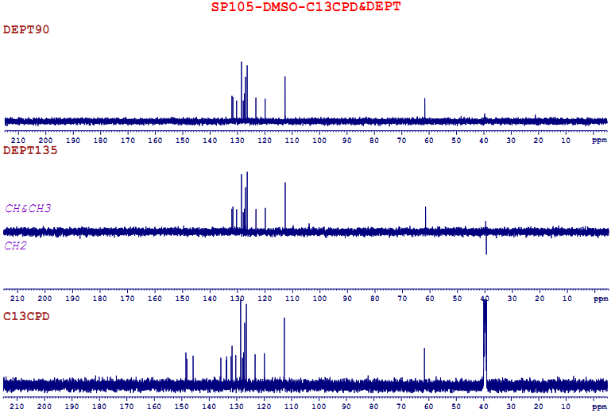

Fig S80. HR-MS spectrum of compound 26b
