Supplementary Information

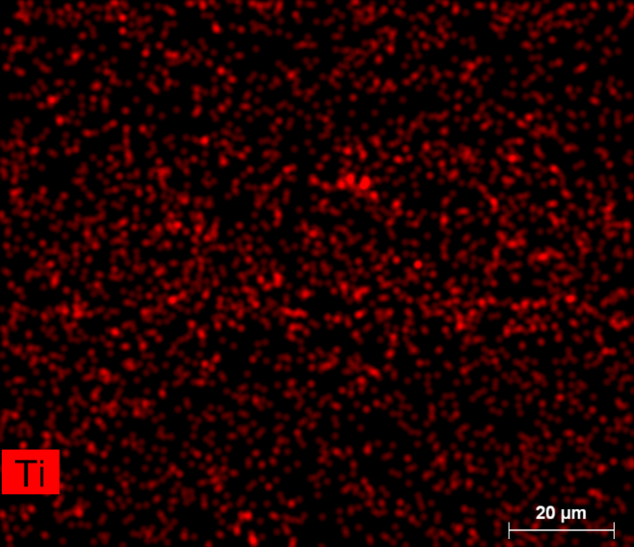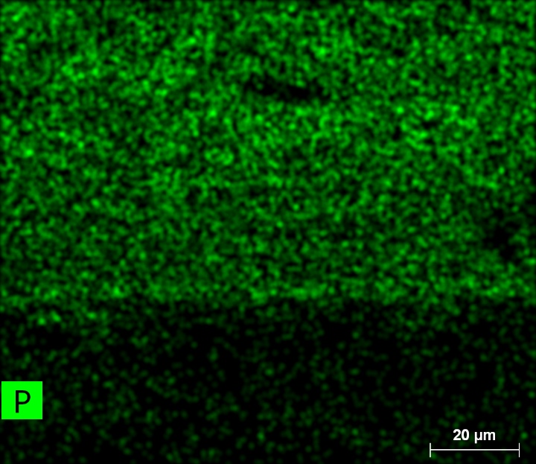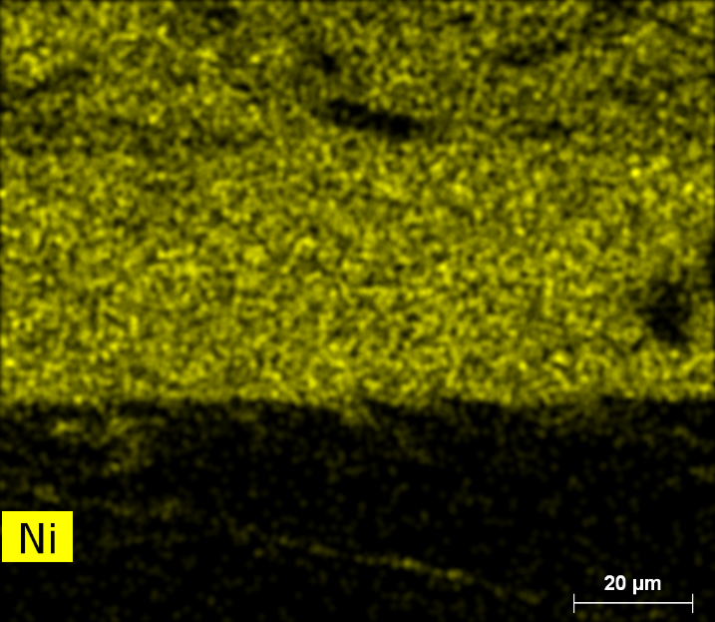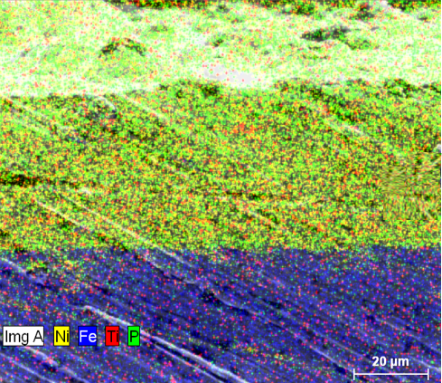

Figure S1: SEM/EDX mapping of the cross-section of the electroless NiP–TiNi nanocomposite coating. The Ti, Ni, and P appear in red, yellow and green, respectively.

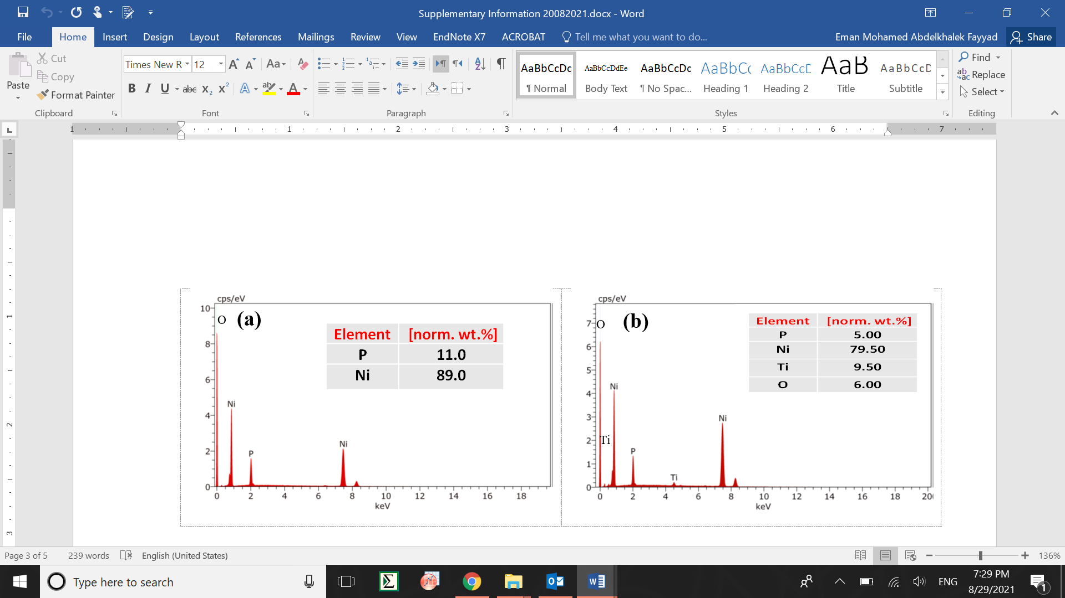

Figure S2. EDX spectra of the electroless NiP and NiP–TiNi nanocomposite coatings.

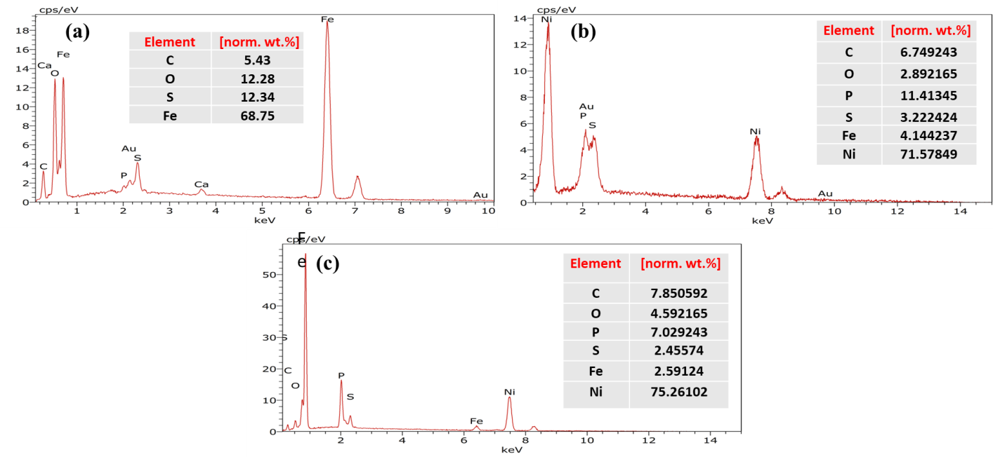

Figure S3: EDX analysis of coupon surfaces incubated with SRB after 28 days of incubation without removal of the corrosion products. (a) CS, (b) NiP and (c) NiP-TiNi.

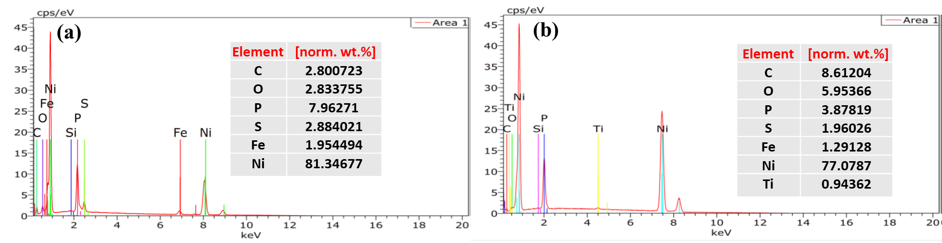

Figure S4. EDS of the coupon surfaces after removing the biofilm and corrosion products. (a) NiP and (b) NiP-TiNi.