**Supplementary: Figures**

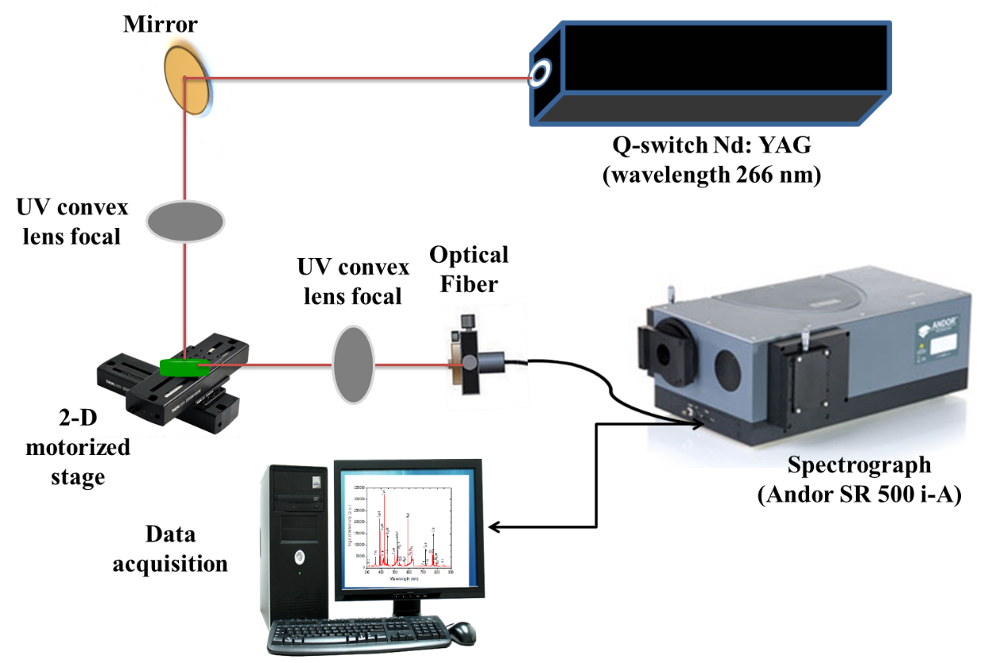

Fig. S1 Schematic representation of the applied LIBS apparatus for the analysis of *Senna* leaves.

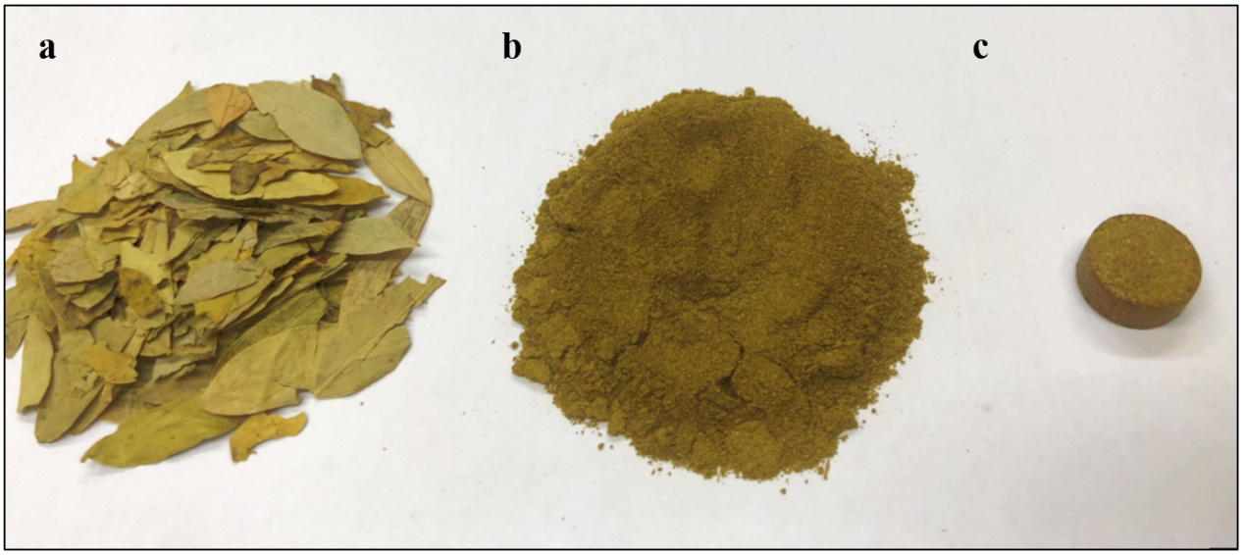

Fig. S2 Preparation of*Senna*leaves samples, a) purchased dried leaves, b) crushed leaves, and c) pelletized powdered leaves.



Fig. S3 Representative time delay influence on LIBS emission line intensities using Ca at 422.6 nm.



Fig. S4 The representative influence of pulse energy on emission line intensities using of Ca lines peaking at 422.6 nm.

**Supplementary: tables**

Table S1. The spectroscopic data of different Ca lines used for the electron temperature (Te) determination.

|  |  |  |  |  |  |  |  |  |  |
| --- | --- | --- | --- | --- | --- | --- | --- | --- | --- |
| **Wavelength**  **(nm)** | **Element** | **Signal Intensity** | **Configurations** | **Statistical weight** | | **Transition probability**  **Aik x10 8(S-1)** | **Energy of the upper**  **level** | | |
| **gi** | **gk** | **Ei**  **(eV)** | **Ek**  **(eV)** | |
| 428.9 | Ca I | 5533 | *3p64s4p* 3Po0  *3p64p2* 3P1 | 1 | 3 | 0.6 | 1.879 | | 4.769 |
| 429.8 | Ca I | 4550 | *3p64s4p* 3Po1  *3p64p2* 3P1 | 3 | 3 | 0.466 | 1.885 | | 4.769 |
| 430.7 | Ca I | 5936 | *3p64s4p* 3Po1  *3p64p2* 3P0 | 3 | 1 | 1.99 | 1.885 | | 4.763 |
| 442.5 | Ca I | 4989 | *3p*6 *4s4p*  3Po0  *3p*6 *4s4d* 3D1 | 1 | 3 | 0.498 | 1.879 | | 4.68 |
| 527.0 | Ca I | 5746 | *3p*6 3d4s 3D3  *3p*6*3d4p* 3Po2 | 7 | 5 | 0.5 | 2.526 | | 4.878 |
| 585.7 | Ca I | 5431 | *3p*6 4s4p 1Po1  *3p*6 *4p2* 1D2 | 3 | 5 | 0.66 | 2.933 | | 5.049 |
| 616.2 | Ca I | 6972 | *3p*6 *4s4p* 3Po2  *3p*6 *4s5s* 3S1 | 5 | 3 | 0.477 | 1.899 | | 3.91 |
| 649.3 | Ca I | 6422 | *3p*6*3d4s*  3D1  *3p*6*3d4p* 3Fo2 | 3 | 5 | 0.44 | 2.521 | | 4.43 |

Table S2. LIBS signal intensities of the viewed spectral transitions for the elemental analytes featuring the dried leaves samples of *Senna* and their concentration results using ICP-OES.

|  |  |  |  |  |  |
| --- | --- | --- | --- | --- | --- |
| **Elements** | **Wavelength**  **(nm)** | **Transition Configuration** | **LIBS Signal Intensity**  **(a.u.)** | | **ICP-OES concentration (mg/kg)** |
| **Ca** | 393.3 | *3p64s* 2S1/2 *3p64p* 2Po3/2 | 10871 | | 26193.35 |
| 396.8 | *3p64s*  2S1/2 *3p64p* 2Po1/2 | 10322 | |
| 422.6 | 3*p*6*4s*2 1S0 3*p*6*4s4p* 1P°1 | 9812 | |
| 445.4 | 3*p*6 *4s4p* 3Po2 3*p*6 *4s4d* 3D3 | 6624 | |
| 527.0 | *3p*6 3d4s 3D3 *3p*6*3d4p* 3Po2 | 5746 | |
| 616.2 | *3p*6 *4s4p* 3Po2 *3p*6 *4s5s* 3S1 | 6972 | |
| 646.2 | *3p*6*3d4s* 3D2 *3p*6*3d4p* 3Fo3 | 6795 | |
| **K** | 404.7 | 3*p*6 4*s* 2S1/2 3*p*6 5*p* 2P°1/2 | 5411 | 9829.17 | |
| 580.1 | 3*p*6 4*p* 2P°1/2 3*p*6 7s2S1/2 | 5305 |
| 766.4 | 3*p*6 4*s* 2S1/2 3*p*6 4*p* 2P°3/2 | 6034 |
| 769.8 | 3*p*6 4*s* 2S1/2 3*p*6 4*p* 2P°1/2 | 5812 |
| **Mg** | 279.5 | 2*p*6 3*s* 2S1/2 2*p*6 3*p* 2P°3/2 | 5068.5 | 3499.54 | |
| 280.2 | 2*p*6 3*s* 2S1/2 2*p*6 3*p* 2P°1/2 | 3856.5 |
| 285.2 | 2*p*6 3*s2* 1S03*s3p* 1P°1 | 5305 |
| 448.1 | 2*p*6 3*d* 2D5/22*p*6 *4f* 2F°7/2 | 652 |
| 518.3 | 3s3*p* 3P23*s4s* 3S1 | 1316 |
| **S** | 543.2 | 3*s*2*3p2(3P) 4s* 4P3/2 3*s*2*3p2(3P) 4p* 4Do5/2 | 2533 | 2311.49 | |
| 545.3 | 3*s*2*3p2(3P) 4s* 4P5/2 3*s*2*3p2(3P) 4p* 4Do7/2 | 2778 |
| 563.9 | 3*s*2*3p2(3P) 4s* 2P3/2 3*s*2*3p2(3P) 4p* 2Do5/2 | 1918 |
| **P** | 253.5 | 3*s*2*3p3* 2Po3/2 3*s*2*3p2(3P) 4s* 2P3/2 | 2576 | 1516.95 | |
| 255.3 | 3*s*2*3p3* 2Po1/2 3*s*2*3p2(3P) 4s* 2P1/2 | 2604 |
| 650.3 | 3*s*2*3p3d* 3Fo3 3*s*2*3p4p* 3D2 | 1546 |
| **Na** | 328.5 | 2*s*2 2*p5 3s* 1Po12*s*2 2*p5 3p* 1D2 | 3334 | 968.37 | |
| 330.1 | 2*s*2 2*p5 3p* 3P12*s*2 2*p5 (*2Po3/2*) 3d* 2[3/2]o2 | 3148 |
| 588.9 | 2*p*6 *3s* 2S1/22*p*6 *3p* 2Po3/2 | 3207 |
| 589.5 | 2*p*6 *3s* 2S1/22*p*6 *3p* 2Po1/2 | 2341 |
| **Al** | 281.6 | 3*s3p* 1Po1 3*s4s* 1S0 | 2414 | 574.85 | |
| 394.4 | 3*s*2*3p* 2Po1/2 3*s*2*4s* 2S1/2 | 2111 |
| 396.1 | Fe3*s*2*3p* 2Po3/2 3*s*2*4s* 2S1/2 | 2686 |
| **Si** | 251.6 | 3*s*2*3p2* 3P2 3*s*2*3p4s* 3Po2 | 2124 | 550.66 | |
| 252.4 | 3*s*2*3p2* 3P1 3*s*2*3p4s* 3Po0 | 2243 |
| 288.1 | 3*s*2*3p2* 1D2 3*s*2*3p4s* 1Po0 | 2629 |
| **Fe** | 248.3 | 3*d*6 *4s*2 5D4 3*d*6*(5D)4s4p* (1Po) 5F°5 | 2544 | 477.72 | |
| 259. 9 | 3*d*6 *(5D) 4s* 6D9/2 3*d*6*(5D) 4p* 6Do9/2 | 2338 |
| 275.5 | 3*d*6 *(5D) 4s* 4D7/2 3*d*6*(5D) 4p* 4Fo9/2 | 2043 |
| 358.1 | 3*d*7 *(4F) 4s* 5F5 3*d*7*(4F) 4p* 5Go6 | 2095 |
| **Sr** | 407.7 | 4*p*6 *5s* 2S1/2 4*p65p* 2Po3/2 | 2054 | 182.63 | |
| 421.5 | 4*p*6 *5s* 2S1/2 4*p65p* 2Po1/2 | 1900 |
| **B** | 249.6 | 2s2 *2p* 2Po1/2 2s2 *3s* 2S1/2 | 893 | 43.56 | |
| 249.7 | 2s2 *2p* 2Po3/2 2s2 *3s* 2S1/2 | 1528 |
| 345.1 | 1s2 *2s2p* 1Po1 1s2 *2p2* 1D2 | 954 |
| **Ba** | 553.5 | 6*s*2 1S0*6s6p* 1Po1 | 1499 | 35.16 | |
| 614.1 | 5d2D5/2*6p* 2Po3/2 | 628 |
| **Mn** | 403.0 | 3*d*5*4s*2 6S5/2 3*d*5*(6S) 4s4p* ( 3P°) 6Po7/2 | 1169 | 34.20 | |
| 257.6 | 3*d*5*(6S)4s* 7S3 3*d*5*(6S) 4p* 7Po4 | 1467 |
| 259.3 | 3*d*5*(6S)4s* 7S3 3*d*5*(6S) 4p* 7Po3 | 930 |
| **Ti** | 334.9 | 3*d*2 *(3F) 4s* 4F9/2 3*d*2*(3F) 4p* 4Go11/2 | 1505 | 21.95 | |
| 336.1 | 3*d*2 *(3F) 4s* 4F7/2 3*d*2*(3F) 4p* 4Go9/2 | 776 |
| 365.3 | 3*d*2*4s*2 3F4 3*d*2*(3F) 4s4p (*1Po*)* 3Go5 | 847 |
| 399.8 | 3*d*2*4s*2 3F4 3*d*2*(3F) 4s4p (*1Po*)* 3Fo4 | 1280 |
| **Zn** | 255.7 | 3*d*10*4p* 2Po3/2 3*d*10 *5s* 2S1/2 | 424 | 9.36 | |
| 334.5 | 3*d*10 *4s4p* 3Po2 3*d*10 *4s4d* 3D3 | 565 |
| **Cr** | 425.4 | 3*d*5 *(6S) 4s* 7S3 3*d*5*(6S) 4p* 7P°4 | 488 | 3.54 | |
| 357.8 | 3*d*5 *(6S) 4s* 7S3 3*d*4*(5D) 4s4p* ( 3P°) 7P°4 | 453 |
| 520.8 | 3*d*5 *(6S) 4s* 5S2 3*d*5*(6S) 4p* 5P°3 | 367 |
| **Cu** | 324.7 | 3*d*10*(1S) 4s* 2S1/2 3*d*10*(1S) 4p* 2P°3/2 | 428 | 3.23 | |
| 327.3 | 3*d*10*(1S) 4s* 2S1/2 3*d*10*(1S) 4p* 2P°1/2 | 564 |
| **Ni** | 341.4 | 3*d*9*(2D) 4s* 3D3 3*d*9*(2D) 4p* 3F°4 | 355 | 1.94 | |
| 352.4 | 3*d*9*(2D) 4s* 3D3 3*d*9*(2D) 4p* 3P°2 | 382 |
| 356.6 | 3*d*9*(2D) 4s* 1D2 3*d*9*(2D) 4p* 1D°2 | 257 |
| **V** | 437.9 | 3*d*4*(5D) 4s* 6D9/2 3*d*4*(5D) 4p* 6F°11/2 | 325 | 1.5 | |
| 440.8 | 3*d*4*(5D) 4s* 6D3/2 3*d*4*(5D) 4p* 6F°3/2 | 250 |
| **As** | --- | --- | ND | ND | |
| **Se** | --- | --- | ND | ND | |
| **Cd** | --- | --- | ND | ND | |
| **Co** | --- | --- | ND | ND | |
| **Pb** | --- | --- | ND | ND | |

ND: Not detected