**Supporting Information**

**for**

**Inhibition of gut bacterial *β*-glucuronidase by chemical components from black tea:** **inhibition interactions and molecular mechanism**

Cheng-Peng Sun a,#, Xiang-Ge Tian a,#, Lei Feng a,b, Chao Wang a, Jing-Xin Li a, Xiao-Kui Huo a,b, Wen-Yu Zhao a, Jing Ning a, Zhen-Long Yu a, Sa Deng a, Bao-Jing Zhang a, Xia Lv a,*,Jie Hou a,*, Xiao-Chi Ma a,b,*

# These authors contributed equally to this work.

*a Dalian Key Laboratory of Metabolic Target Characterization and Traditional Chinese Medicine Intervention, College of Integrative Medicine, College of Pharmacy, Dalian Medical University, Dalian, China.*

*b Second Affiliated Hospital, Dalian Medical University, Dalian, China.*

∗Corresponding author.

E-mail: lvxia@dlnu.edu.cn (Xia Lv), Tel.:+86 411 86116191; houjie@dlmedu.edu.cn (Jie Hou), Tel: +86 411 86110419; maxc1978@163.com (Xiao-Chi Ma), Tel: +86 411 86110414.

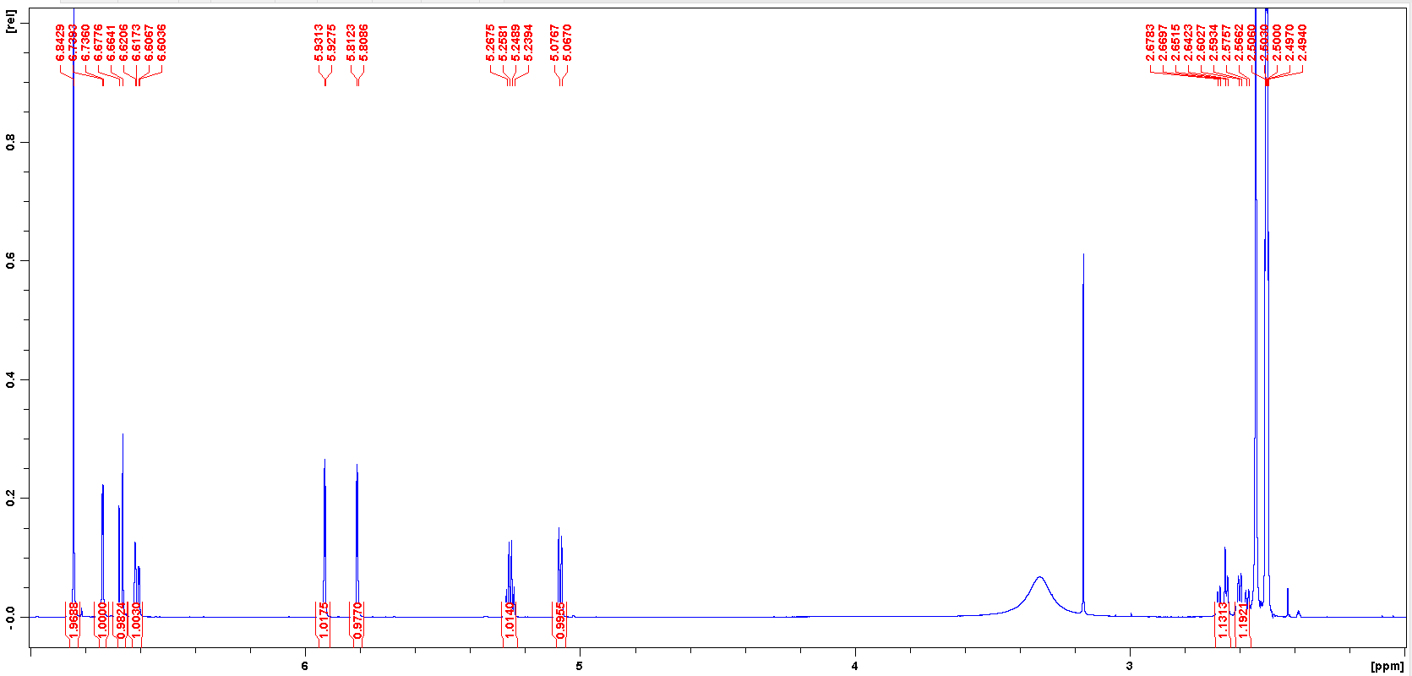

**Figure S1 1H NMR data of CG (600 MHz, DMSO-*d*6)**

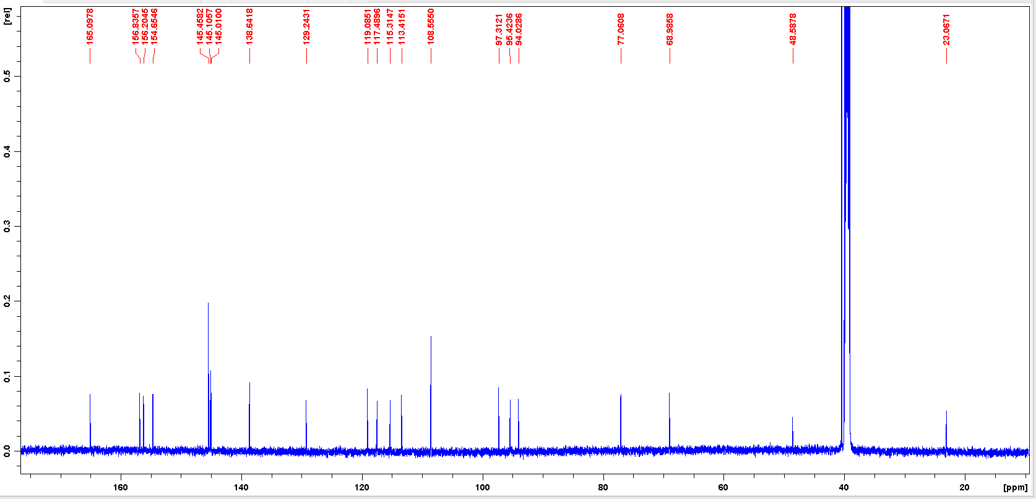

**Figure S2 13C NMR data of CG (150 MHz, DMSO-*d*6)**

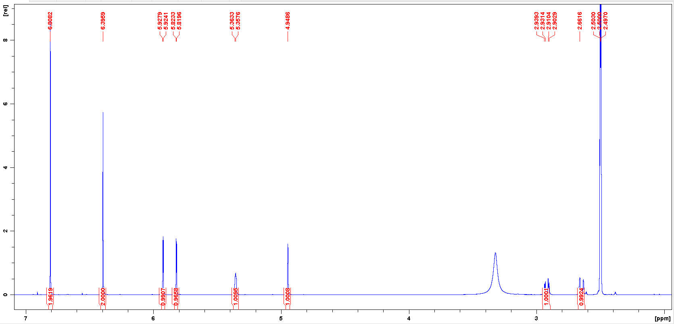

**Figure S3 1H NMR data of EGCG (600 MHz, DMSO-*d*6)**

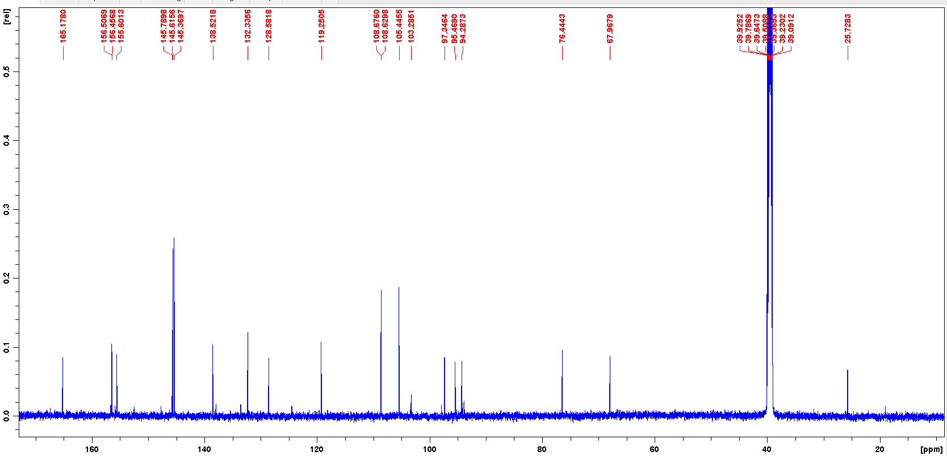

**Figure S4 13C NMR data of EGCG (150 MHz, DMSO-*d*6)**

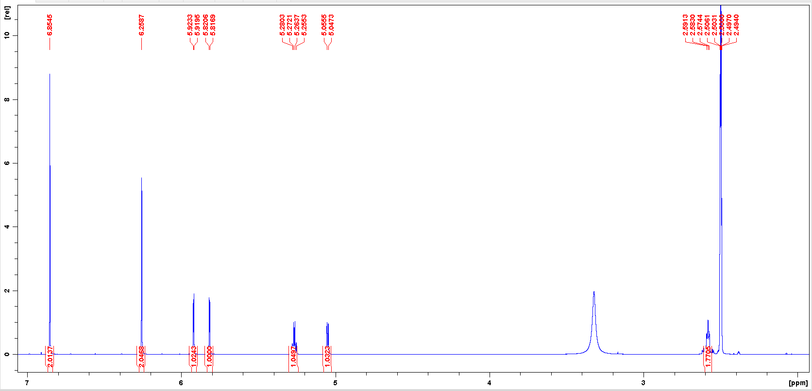

**Figure S5 1H NMR data of GCG (600 MHz, DMSO-*d*6)**

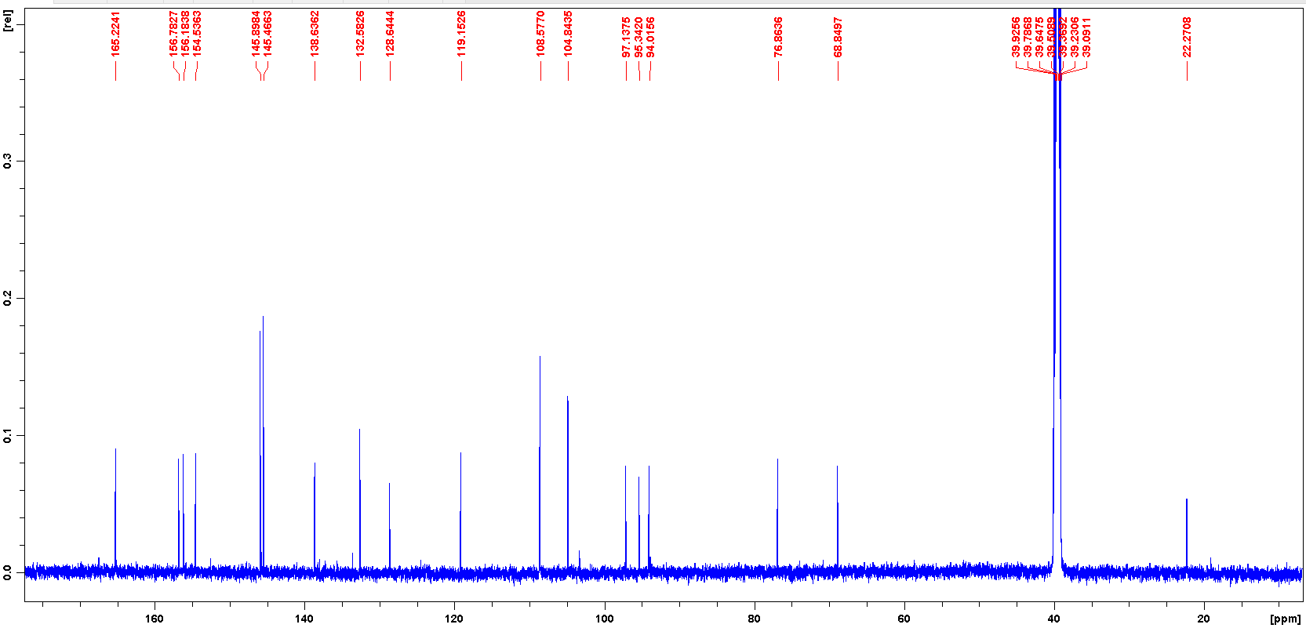

**Figure S6 13C NMR data of GCG (150 MHz, DMSO-*d*6)**

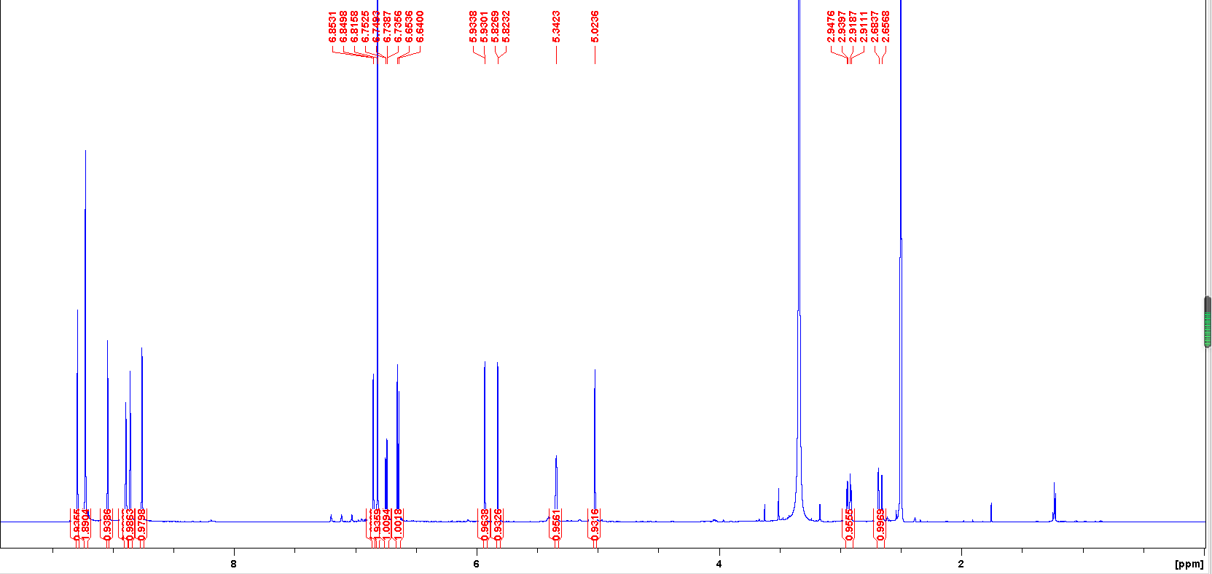

**Figure S7 1H NMR data ECG (600 MHz, DMSO-*d*6)**

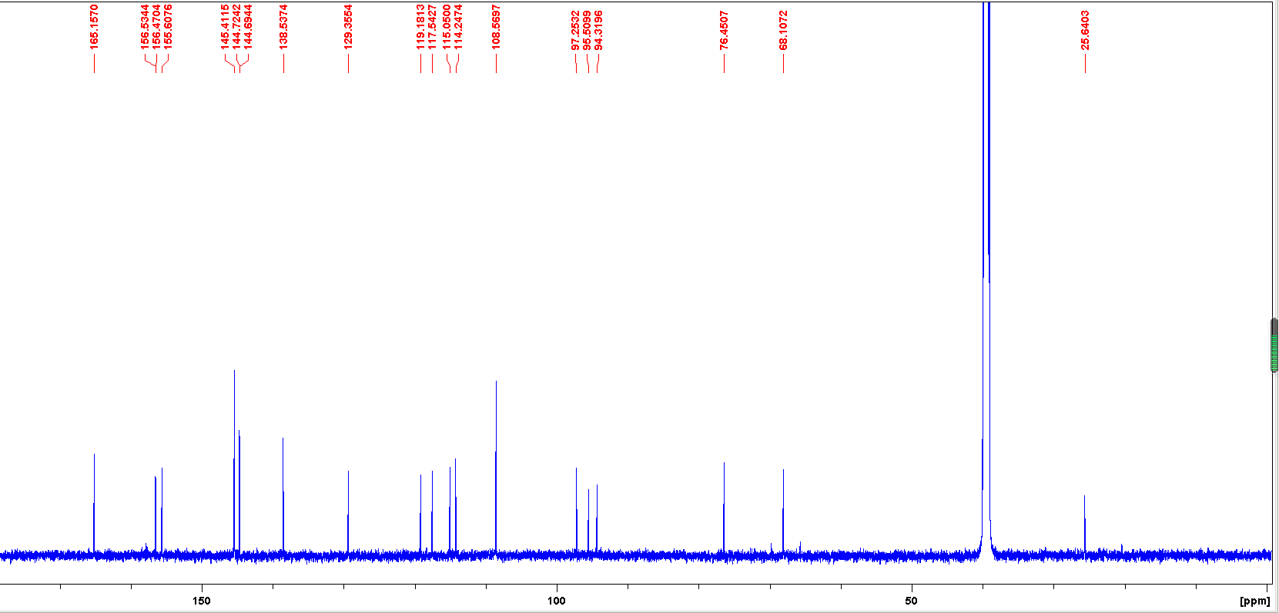

**Figure S8 13C NMR data of ECG (150 MHz, DMSO-*d*6)**

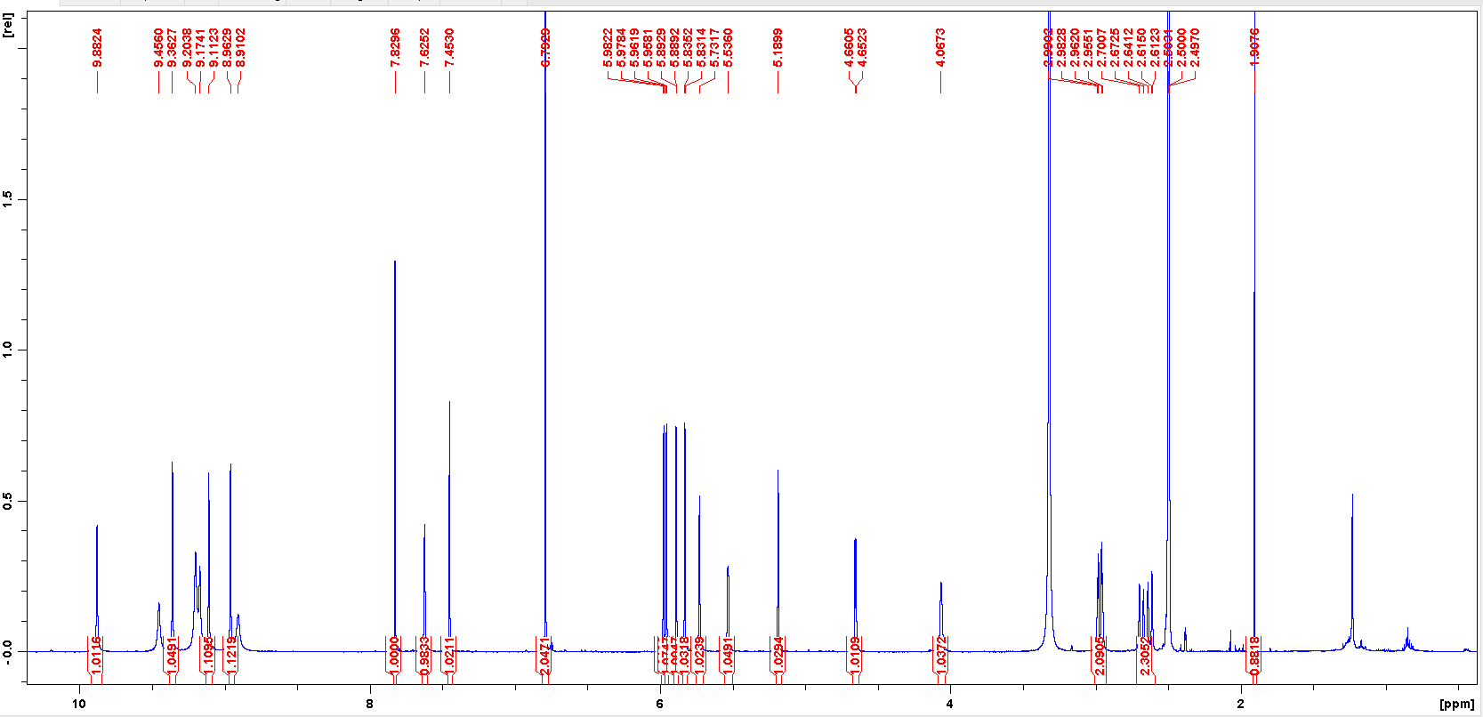

**Figure S9 1H NMR data of TF3G (600 MHz, DMSO-*d*6)**

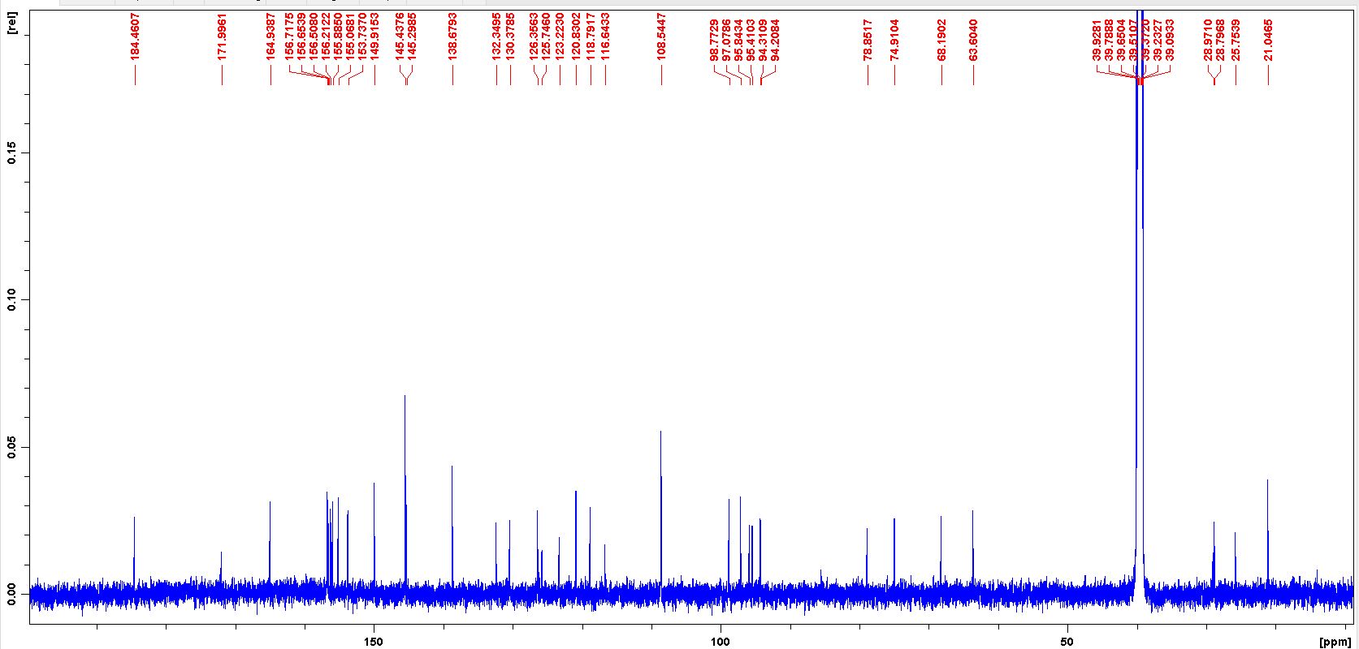

**Figure S10 13C NMR data of TF3G (150 MHz, DMSO-*d*6)**

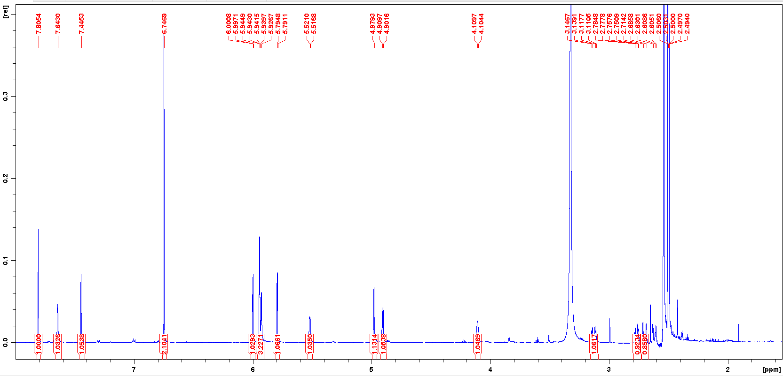

**Figure S11 1H NMR data of TF3’G (600 MHz, DMSO-*d*6)**

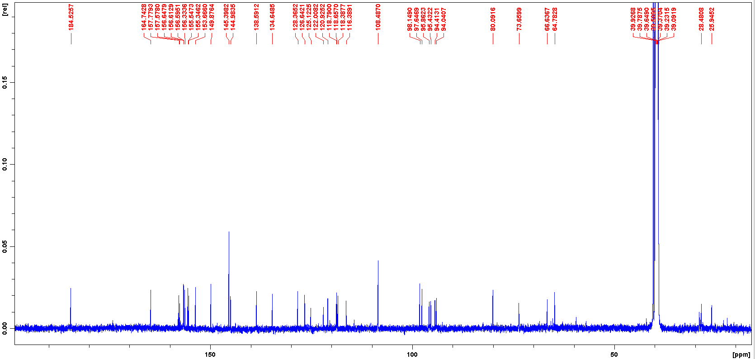

**Figure S12 13C NMR data of TF3’G (150 MHz, DMSO-*d*6)**

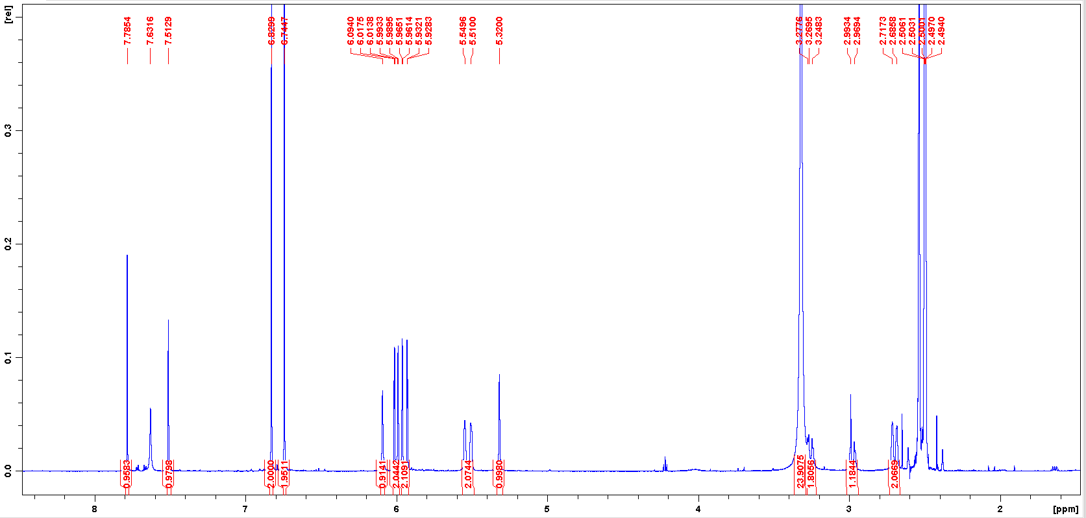

**Figure S13 1H NMR data of TFDG (600 MHz, DMSO-*d*6)**

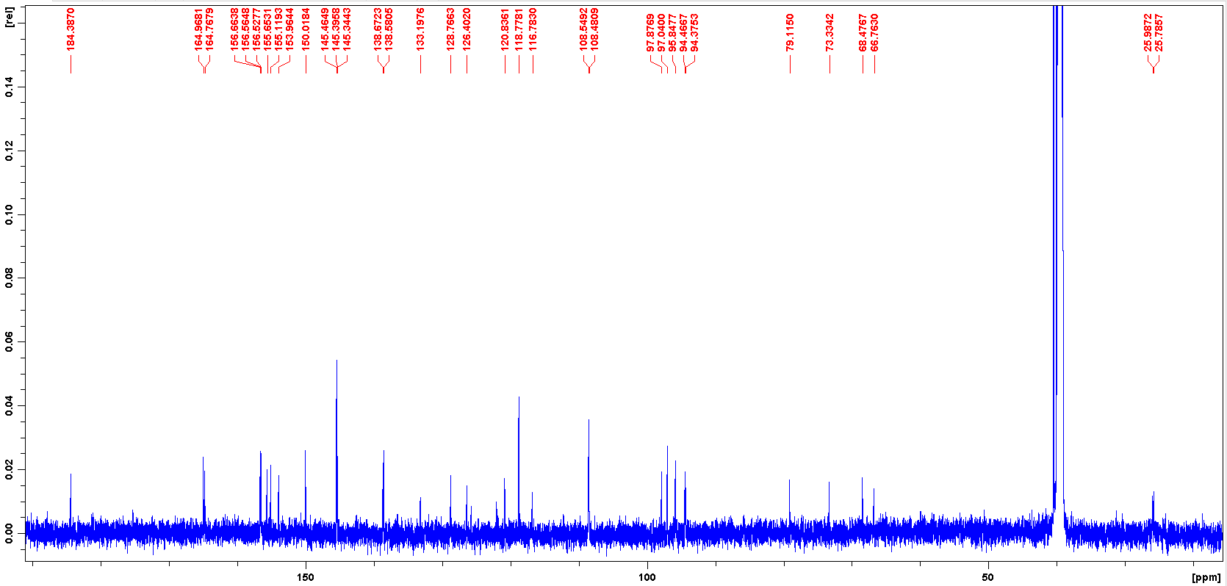

**Figure S14 13C NMR data of TFDG (150 MHz, DMSO-*d*6)**

C:\Users\HP\Desktop\Layout 1.tif

**Figure S15.** Inhibitory effects of the seven bioactive constitutes in black tea against SN-38G hydroxylation in EcGUS. Left: the concentration-dependent inhibition curves of CG (a), GCG (c), ECG (e), EGCG (g), TF-3-G (i), TF-3′-G (k), and TFDG (m). Right: the representative Lineweaver-Burk plots of CG (b), GCG (d), ECG (f), EGCG (h), TF-3-G (j), TF-3′-G (l), and TFDG (n).



**Figure S16.** 2D interaction description of CG ( A), GCG (B), ECG (C), EGCG (D), TF-3-G (E), TF-3′-G (F) and TFDG (G) with EcGUS.