**SUPPLEMENTARY INFORMATION FOR**

**Sudan-I Dye and Fructose chemicals based photogalvanic cells for electrochemical solar energy conversion and storage at low and artificial sun intensity**

*Pooran Koli*, Department of Chemistry, Jai Narain Vyas University, Jodhpur, Rajasthan (India),*

* *Corresponding author,* [*poorankoli@yahoo.com*](mailto:poorankoli@yahoo.com)*; poorankoli@rediffmail.com*

1. **Materials**

The solutions, i.e., M/500 of Sudan-I (Purity > 95.0 %), M/100 of Fructose (99.8 % Assay), M/10 of Sodium lauryl sulfate (SLS; purity 94 % minimum), and 1M of NaOH (98 % Assay) have been used. The liquid phenolphthalein was used in form as obtained from the market. The solvent ethyl alcohol was used for preparation of solution of the hydrophobic Sudan-I dye, and the solvent single distilled water was used to prepare solution of rest chemicals. The stock solutions of all chemicals were stored in amber colored containers to protect them from sunlight.

Sudan-I is not soluble in water, but in alcohol. The alcoholic solution of Sudan-I shows absorbance in UV-Visible range (mainly in 280 nm- 650 nm) as (i) λmax in MeOH (nm) 476 (main band), 418 (Sigma-Aldrich); (ii) Absorption Absorption maxima of Sudan-I in Ethanol, 476 nm (ε 14500 LM-1cm-1) [**ref.S1**], and (iii) Absorption Absorption maxima of Sudan-I in Ethanol, 480 nm (ε 14481 LM-1cm-1), 314 nm (ε 6930 LM-1cm-1), shoulder 419 nm (ε 982 LM-1cm-1); absorbance ~ 1.29, I**t** = 5.128 %, I**a**= 94.87 %, concentration 8.96 x 10-5 M, for quartz cuvettes 10 mm width [**ref. S2,S3**].

**Fig.S1.** UV-Visible absorption spectra of Sudan-I. Absorption maxima in Ethanol, 480 nm (ε 14481 LM-1cm-1), 314 nm (ε 6930 LM-1cm-1), shoulder 419 nm (ε 982 LM-1cm-1) [**ref.S3**].

1. **Method and calculation**

The photogalvanic cell consisting of 0.38 mL of M/500 Sudan-I dye, 1.6 mL of M/100 Fructose, 1.0 mL of M/10 SLS, 3.6 mL of 1M NaOH and 18.42 mL of single distilled water (to make total volume of solution 25 mL) has been studied. The specifications for this cell are [Sudan-I] = 3.04 x 10-5 M, [Fructose] = 6.4x10-4 M, [SLS] = 4 x 10-3 M, pH=13.15, light Intensity=10.4 mW cm-2, Temp. = 310 K, Diffusion Length (DL) = 5.6 cm, and Pt electrode area = 0.4 x 0.2 cm2.

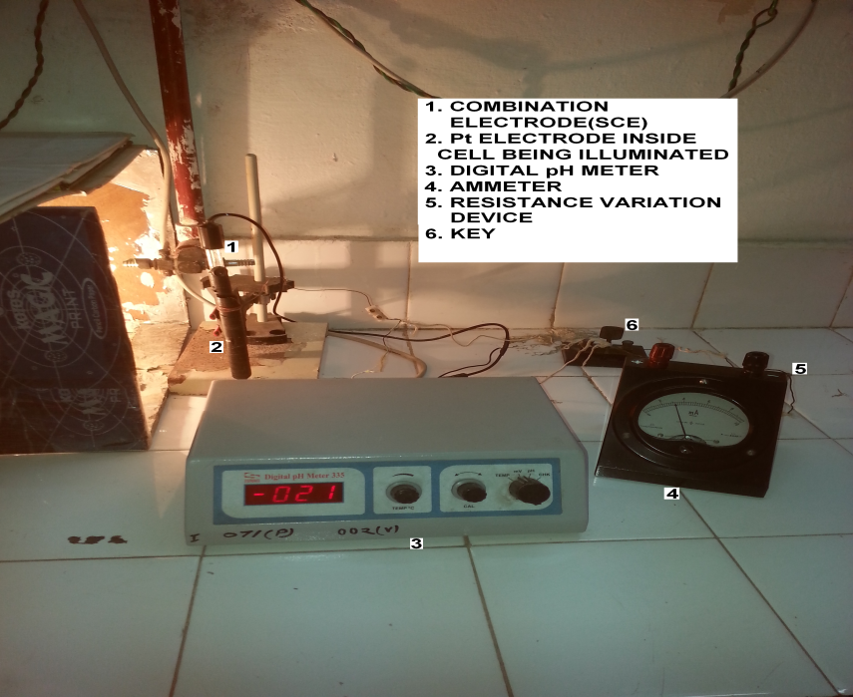

**Fig. S2.** Photo of experimental set-up of photogalvanic cell and the related circuit.

In beginning, the cell is kept in dark to get stable dark potential (Vdark). After it, the illumination of the cell against the Pt electrode is started and the photo-potential is measured at a periodic time interval to get the maximum potential (Vmax) corresponding to a fast irreversible photo-process in beginning which later on leads to the establishment of the equilibrium of photo-process that is shown by the observation of open-circuit potential (Voc). Once the Voc is noted then the cell is considered to be fully charged. At Voc, the current is zero. At zero external loads, the current value obtained immediately on closing the circuit is maximum current (imax), and after some time at equilibrium, the current of circuit is short-circuit current (isc), and the imax is always higher than isc. Then, the i-V characteristic of the cell is studied by varying the circuit resistance to note the photo-potential values for various current values ranging from isc to zero current. The highest product value of the current at power point (ipp) and its corresponding photo-potential at power point (Vpp) in i-V curve is the power at power point (Ppp), i.e., the maximum power extractable at a characteristic external load. The cell is adjusted at power at power point by fixing the circuit resistance equal to characteristics external load (resistance corresponding to the power at power point) of the cell. Thereafter, the illumination is cut-off and the power storage capacity of the cell is studied by noting power (by noting both current and potential) at periodic interval of time. The time period starting from the time at which the illumination of the cell was cut-off to time at which the power of the cell becomes half of the power at power at point is called half change time (t0.5). The t0.5 is the measure of the inherent power storage capacity of the cell (higher value of t0.5 shows the higher power storage capacity of the cell).The size of the open window has not been used for calculating the efficiency as the electrical performance of the cell is found independent of the area of illuminating window. The cell performance is studied in terms of conversion efficiency (CE), half change time (t0.5), and fill factor (FF) in dark. The CE and FF of the cell are calculated from equations (1) and (2), respectively.

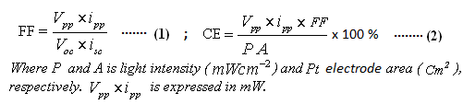

The photogalvanic cell is fabricated by taking solutions of sensitizer, reductant, surfactant, and alkali NaOH in an H-shaped glass tube having Pt as anodic electrode in one arm and saturated calomel electrode (SCE) in another arm. The glass tube is blackened from outside leaving only a small sized window against the Pt electrode for illumination of solution filled in glass tube. The micro-ammeter, a carbon pot log 470 K (Potentiometer 470 K) and a circuit key is connected in series to the terminals of the cell for the purpose of measuring current, varying circuit resistance and external load, and closing/opening of the circuit, respectively. A digital pH meter-Model is connected in parallel fashion to the terminals of the cell for measuring potential [**12, 14**]. The incandescent bulb of 200 wattages has been used as source for 10.4 mWcm-2 illumination intensity (i.e., an artificial and low intensity) (**Fig.1, S2**). The error range in observed values of the current and potential is of the order of ± 10 µA and ±5 mV, respectively. The intensity of illuminating source was determined by the *HTC Instrument LX-101A Light Meter Luxmeter* (accuracy, +5 percent) for the vertical illumination at the illumination window of the cell. The desired intensity is obtainable at ~5.5 cm distance from the illuminating source.

1. **Estimation of efficiency (CE) by power integration method**

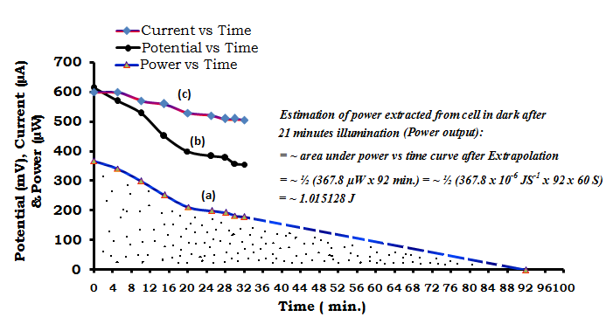**Fig. S3.**Estimation of power extracted from cell in dark after 21 minutes illumination (Power output).

*Estimation of power extracted from cell in dark after 21 minutes illumination (Power output):*

*= ~ area under power vs time curve after Extrapolation*

*= ~ ½ (367.8 µW x 92 min.) = ~ ½ (367.8 x 10-6 JS-1 x 92 x 60 S)*

*= ~ 1.015128 J*

*Estimation of power (sunlight) absorbed through 1cm x 1 cm window by cell in 21 minutes illumination with the 10.4 mWcm-2 at absorbance 1.29 and absorbed intensity 94.87 % for alcoholic solution of Sudan-I (sunlight power absorbed):*

= ~ (illumination intensity) x (illumination time) x (area of cell exposed) x (% of absorbed

Intensity)

= ~ (10.4 mWcm-2) x (21 x 60 S) x (1cm x 1 cm) x (0.9487)

= ~ (10.4 x 10-3 x JS-1cm-2) x (21 x 60 S) x (1cm x 1 cm) x (0.9487)

= ~ 12.43176 J

*Estimation of efficiency (CE):*

*= ~ [(Power output x 100%)/ (power absorbed)] =~ [(*1.015128 J x 100 %)/ (12.43176 J)]

= ~ 8.165 %

*Estimation of charge (Q) & and number of electrons (ne-) extracted from cell in dark in 32 minutes:*

Q = ~ area under curve ‘current *vs* time’ (corresponding to 32 minutes)

Q = ~ 600 µA x 32 min. = ~ (600 x 10-6 A) x (32 x 60 Sec.) = ~ 1.152 Amp. Sec. = ~ 1.152 Coulombs

*ne- = (charge)/(charge on 1 e-) = (*1.152 Coulombs)/(1.6 x 10-19 Coulomb) = ~ 7.2 x 1018 electrons.

Actual power output will be higher than estimated 1.015128 Joule because actual area under power *vs* time will be higher than estimated. Actually, the cell power decay rate is higher in beginning and it slows down with passage of time (**Table 3**). Therefore, the total time taken in discharge of cell completely will be higher than 92 minutes, and accordingly estimated efficiency will be as high as the calculated efficiency ~ 11.49 from the equation 2 (SI). The whole scheme of extensive study on estimation of efficiency by power integration method shall be taken in future research projects. Present estimation of power is limited on the basis of already available research data.

1. Variation of concentration of Sudan-Idye photosensitizer

The effect of variation of Sudan-Idye photosensitizer on cell has been studied by constructing six photogalvanic cells having all factors common except dye concentration. Each cell has total 25 mL solution including dye, Fructose, NaOH, SLS and single distilled water. Each cell has factors-light intensity 10.4 mW cm-2, diffusion length (DL) 5.6 cm, Temp.310 K,Pt electrode area 0.4 x 0.2 cm2, 1.6 mL of M/100 Fructose (resultant concentration 6.4 x 10-4 M),1 mL of SLS (resultant concentration 4 x 10-3 M) and 3.6 mL of 1M NaOH (resultant pH 13.15). The volume of M/500 dye (with its resultant concentration) for six cells is 0.20 mL (1.60 x 10-5 M), 0.26 mL (2.08 x 10-5 M), 0.32 mL (2.56 x 10-5 M), 0.38 mL (3.04 x 10-5 M), 0.44 mL (3.52 x 10-5 M) and 0.50 mL (4.0 x 10-5 M, respectively.

1. Effect of variation of concentration of fructose reductant

The effect of variation of fructose reductant on cell has been studied by constructing six photogalvanic cells having all factors common except fructose concentration. Each cell has total 25 mL solution including solutions of dye, fructose, SLS, NaOH with single distilled water. Each cell has factors - light intensity 10.4 mW cm-2, diffusion length (DL) 5.6 cm, temp.310 K,Pt electrode area 0.4 x 0.2 cm2,0.38 mL of M/500 dye (resultant concentration 3.04 x 10-5 M),1.0 mL of M/10 SLS (resultant concentration 4 x 10-3 M), and 3.6 mL of 1M NaOH (resultant pH 13.15). The volume of M/100 Fructose (with its resultant concentration) for six cells is 1.0 mL (4.0 x 10-4 M),1.2 mL (4.8 x 10-4 M),1.4 mL (5.6 x 10-4M), 1.6 mL (6.4 x 10-4 M), 1.8 mL (7.2 x 10-4 M) and 2.0 mL (8.0 x 10-4 M), respectively.

1. Effect of variation of surfactant (SLS) concentration

The effect of variation of surfactant (SLS) concentration on cell has been studied by constructing six photogalvanic cells having all factors common except SLS. Each cell has total 25 mL solution including solutions of dye, Fructose, SLS and NaOH with single distilled water. Each cell has factors-light intensity 10.4 mWcm-2, diffusion length (DL) 5.6 cm, temp.310 K, Pt electrode area 0.4 x 0.2 cm2, 0.38 mL of M/500 dye (resultant concentration 3.04 x 10-5 M),3.6 mL of NaOH (pH 13.15) and 1.6 mL of M/100 Fructose (resultant concentration 6.4 x 10-4 M). The volume of M/10 SLS (with resultant concentration) for six cells is 0.6 mL (2.4 x 10-3 M), 0.8 mL (3.2 x 10-3 M),1.0 mL (4.0 x 10-3 M),1.2 mL (4.8 x 10-3 M),1.4 mL (5.6x 10-3 M), and 1.6 mL (6.4 x 10-3 M), respectively.

The effect of surfactant can be explained in terms of Critical micelle concentration (CMC). The CMC of a surfactant is its concentration value below which no micelles is formed and above which it forms micelles. All the added amount of surfactant over and above CMC goes to form micelles. Before CMC, the surfactant changes surface tension of the solvent strongly, and above CMC, the change in surface tension remains nearly constant with a lower slope. The CMC value is affected by pressure, temperature, and by also the presence and concentration of other surface active substances and electrolytes. It is a well known fact that the surfactant over its critical micelles concentration (CMC) solubilizes the dye, and this dye solubility increases linearly with rise in surfactant concentration. But, it holds good for moderate concentrations of the majority of the surfactants. It is because of the fact that at very high surfactant concentration the rod like micelles are formed leading to the rise in viscosity The reported CMC value of the SLS for the Sudan-I solubility is of the order of 10-3 M. The surfactant like SLS with a straight alkyl tail gives better solubilization. It is also a reported fact that in absence of any surfactant, the solubility of hydrophobic dye like Sudan-I is almost negligible in the pH interval 3–12, but addition of SLS causes dye solubility in the range of 0.2-0.3 mM. At higher pH over the 12, the increasing pH has positive impact on the dye solubility in inner, hydrophobic part of the micelle [40,41]. It is also a reported fact that once the micelles have grown to a certain size the solubilization of dyes is not further facilitated by the micelles becoming even more extended, ultimately often reaching a worm-like or thread-like structure [42]. On the basis of these characteristics of the surfactants, the effect of SLS on cell performance may be explained. In present study, the used concentration of SLS is of the order of its CMC 10-3 M. Therefore, the use of SLS enhances the solubility of the Sudan-I dye which in turn enhances available numbers of dye sensitizer for photogalvanics leading to an increase in the cell power. The cell power increases with rise in SLS concentration as the dye solubilization increases almost linearly with increasing surfactant concentration beyond the CMC. At very high SLS concentration, the higher viscosity of the electrolyte may be attributed the reasons behind the lowering of the diffusion of ions leading to the decrease in the cell performance. Thus, the lower electrical output may be attributed to the less number of available SLS molecules (at its lower concentration side) for facilitating electron transfer by enhancing solubility and stability of dye molecules. At higher concentration side of the SLS, the increased number of SLS molecules may hinder the diffusion of the dye molecules leading to the decreased cell current and power. The SLS solution alone also shows a potential value ~ (-) 300 mV and current ~ 30 µA in the dark as well as in illuminated state. This nature of contribution of SLS to the current may also be one of the reasons for enhancement of the cell power in presence of the SLS.

1. Effect of variation of initial pH

The effect of variation of initial pH on cell has been studied by constructing six photogalvanic cells having all factors common except pH. Each cell has total 25 mL solution including solutions of dye, Fructose, SLS and NaOH with single distilled water. Each cell has factors - light intensity 10.4 mW cm-2, diffusion length (DL) 5.6 cm, temp.310 K, Pt electrode area 0.4 x 0.2 cm2, 0.38 mL of M/500 dye (resultant concentration 3.04 x 10-5 M),1.0 mL of M/10 SLS (resultant concentration 4 x 10-3 M), and 1.6 mL of M/100 Fructose (resultant concentration 6.4 x 10-4 M). The volume of 1M NaOH (with resultant pH) for six cells is 2.4 mL (12.98), 3.0 mL (13.07), 3.6 mL (13.15), 4.2 mL (13.22), 4.8 mL (13.28), and 5.4 mL (13.33), respectively.

1. Effect of variation of diffusion length

The effect of variation of diffusion length on cell has been studied by constructing six photogalvanic cells having all factors common except diffusion length (separation between the centers of two arms of the H-cell). Each cell has total 25 mL solution including solutions of dye, Fructose, SLS and NaOH with single distilled water. Each cell has factors - light intensity 10.4 mW cm-2, temp.310 K, Pt electrode area 0.4 x 0.2 cm2, 0.38 mL of M/500 dye (resultant concentration 3.04 x 10-5 M), 1.0 mL of M/10 SLS (resultant concentration 4 x 10-3 M), 3.6 mL of 1M NaOH (resultant pH 13.15) and1.6 mL of M/100 Fructose (resultant concentration 6.4 x 10-4 M). The diffusion length (cm) for six cells is 4.5, 4.8, 5.2, 5.6, 6.3, and 6.8, respectively.

**Table S1. Effect of variation of Diffusion Length (DL)\***

|  |  |  |  |  |  |  |
| --- | --- | --- | --- | --- | --- | --- |
| Cell Parameters | Diffusion Length (cm) | | | | | |
| 4.5 | 4.8 | 5.2 | 5.6 | 6.3 | 6.8 |
| Vdark (mV) | 627 | 612 | 596 | 578 | 590 | 567 |
| Vmax(mV) | 1060 | 1053 | 1020 | 1021 | 997 | 990 |
| Voc (mV) | 1054 | 1042 | 1014 | 1009 | 990 | 987 |
| ∆V(mV) | 433 | 441 | 424 | 443 | 407 | 423 |
| t (min.) | 25 | 17 | 21 | 29 | 45 | 57 |
| imax (μA) | 1530 | 1290 | 1800 | 1490 | 1610 | 1460 |
| isc (μA) | 1180 | 1270 | 1350 | 1370 | 1380 | 1380 |
| i (μA) | 1180 | 1270 | 1350 | 1370 | 1380 | 1380 |
| Ppp (μW ) | 352.4 | 353.2 | 367.8 | 344.8 | 314.8 | 299.3 |
| Vpp (mV) | 691 | 609 | 613 | 605 | 594 | 611 |
| ipp (μA) | 510 | 580 | 600 | 570 | 530 | 490 |
| t0.5 (min.) | 31 | 23 | 30 | 17 | 48 | 39 |
| vt0.5 (mV) | 451 | 419 | 358 | 391 | 383 | 453 |
| it0.5 (μA) | 390 | 420 | 510 | 440 | 410 | 330 |
| CE (%) | 11.84 | 11.02 | 10.97 | 9.93 | 8.69 | 7.53 |
| FF | 0.28 | 0.26 | 0.26 | 0.24 | 0.23 | 0.21 |
| ∆i/∆t (μA min.-1) | 3.8 | 8.2 | 3.0 | 7. 6 | 2.5 | 4.1 |

*\*At [Fructose] = 6.4 x 10-4 M, [SLS] = 4 x 10-3 M, Temp. = 310 K, Pt electrode area = 0.4 x 0.2 cm2, light intensity = 10.4mWcm-2, pH=13.15, [SLS] = 3.04 x 10-5M.*

In all, the six photogalvanic cells were constructed for the study of effect of variation of diffusion lengthon the cell performance. As explained previously, the photogalvanic cells are diffusion controlled cell devices in which the molecules including the dye carry the current inside the cell solution. The excited dye molecule must reach within its life time to Pt for electron transfer from the dye to the Pt. At higher diffusion length, the excited dye molecules are not able to reach the Pt within their life time leading to the reduced current. At higher diffusion length, the increased concentration gradient also diminishes the potential difference between the two electrodes leading to the reduced photo-potential. At lower diffusion length, the favorable conditions exist for excited dye molecules for reaching the Pt within life time, but in totality the number of such dye molecules will be less in number as there will be less volume of the solution between the electrodes, leading to the reduced current.

1. Effect of variation of temperature

The effect of variation of temperature on cell has been studied by constructing five photogalvanic cells having all factors common except temperature. Each cell has total 25 mL solution including solutions of dye, Fructose, SLS and NaOH with single distilled water. Each cell has factors - light intensity 10.4 mWcm-2, diffusion length (DL) 5.6 cm, Pt electrode area 0.4 x 0.2 cm2, 0.38 mL of M/500 dye (resultant concentration 3.04 x 10-5 M), 1.0 mL of M/10 SLS (resultant concentration 4 x 10-3 M), 3.6 mL of 1M NaOH (resultant pH 13.15), and 1.6 mL of M/100 Fructose (resultant concentration 6.4 x 10-4 M). The temperature (K) for five cells is 300, 305, 310, 315, and 320, respectively. In all, the six photogalvanic cells were constructed for the study of effect of variation of temperatureon the cell performance.The optimum cell performance in terms of the isc, Ppp, ipp and CE was observed at an optimal temperature (Table S2). The temperature rise favors the photocurrent (imax) as a result of increased diffusion, and disfavors the photo-potential (Voc)as a result of disturbance in the double layer at electrode. The potential change is much higher than the current change. The rise in temperature (temperature range under observation) invariably leads to slight rise in the power output irrespective of the fall in photopotential. The effect of temperature may be explained on the basis of certain reported and observed facts. It is a reported fact that the rise in temperature increases the solubility of hydrophobic dye like Sudan-I in the presence of the ionic surfactants due to increased (i) thermal agitation in the system, (ii) available space for solubilization in the micelle, and (iii) enthalpy term [43, 44]. From this fact, it is also clear that increased temperature will also increase the diffusion of dye molecules leading to the increased electrical performance of the diffusion controlled PG cell. The temperature behavior of the dye based PG cells can be understood with the help of the dye sensitized solar cells (DSSC). It is reported that the efficiency of the DSSC remains highest in the temperature range 30 °C - 40 °C, and lowering in efficiency above this temperature [45]. In the PG cell, the stock solutions which are used are stored at room temperature (~25 °C to 30 °C). On illumination of the cell with illuminating source (incandescent 200 Wattage tungsten bulbs), the average 8 °C to 20 °C rise in the temperature of the electrolyte is observed. The magnitude of the rise in temperature depends on the duration of illumination (7 °C rise in about seven minutes and 20 °C rise in about 60 minutes). In sun, the rise in temperatures is very low (~3 °C in 10 minutes). In the case of PG cells, temperature effect on efficiency is not expected adverse at high temperature range as highest achievable temperature of the cell electrolyte is 50 °C. But, there is loss of water and that can be tackled by safe sealing. The temperature behavior of the dye based PG cells can also be understood with the help of the dye sensitized solar cells (DSSC). It is reported that the efficiency of the DSSC remains highest in the temperature range 30 °C - 40 °C, and lowering in efficiency above this temperature. It is reported that the recombination kinetics in the cell is the same between -7 °C and 40 °C leading to the virtually constant efficiency and small differences in the FF associated with changes in the series resistance. Further rise in the temperature above 40 °C favors recombination kinetics lowering photo-potential and cell performance [45].

Table S2. Effect of variation of Temperature*

|  |  |  |  |  |  |
| --- | --- | --- | --- | --- | --- |
| Cell Parameters | Temperature (K) | | | | |
| 300 | 305 | 310 | 315 | 320 |
| Vdark (mV) | 609 | 590 | 596 | 582 | 570 |
| Vmax(mV) | 1037 | 1030 | 1020 | 1008 | 1002 |
| Voc (mV) | 1032 | 1024 | 1014 | 1006 | 1000 |
| ∆V(mV) | 428 | 440 | 424 | 426 | 432 |
| t (min.) | 41 | 26 | 21 | 19 | 15 |
| imax (μA) | 1170 | 1560 | 1800 | 1730 | 1850 |
| isc (μA) | 1100 | 1290 | 1350 | 1360 | 1410 |
| i (μA) | 1100 | 1290 | 1350 | 1360 | 1410 |
| Ppp (μW) | 300.8 | 346.0 | 367.8 | 370.2 | 377.3 |
| Vpp (mV) | 640 | 618 | 613 | 607 | 599 |
| ipp (μA) | 470 | 560 | 600 | 610 | 630 |
| t0.5 (min.) | 19 | 34 | 30 | 32 | 47 |
| vt0.5 (mV) | 455 | 453 | 358 | 440 | 400 |
| it0.5 (μA) | 330 | 380 | 510 | 420 | 470 |
| CE (%) | 9.38 | 10.79 | 10.97 | 11.93 | 11.72 |
| FF | 0.26 | 0.26 | 0.26 | 0.27 | 0.26 |
| ∆i/∆t (μA min.-1) | 7.3 | 5.2 | 3.0 | 5.9 | 3.4 |

*\*At [Fructose] = 6.4 x 10-4 M, [SLS] = 4 x 10-3 M, [Dye] = 3.04 x 10-5 M, Pt electrode area = 0.4x 0.2 cm2, light intensity=10.4mWcm-2, diffusion length (DL) = 5.6 cm, pH = 13.15.*

1. Effect of variation of Pt electrode area

The effect of variation of Pt electrode area on cell has been studied by constructing five photogalvanic cells having all factors common except Pt electrode area. Each cell has total 25 mL solution including solutions of dye, Fructose, SLS and NaOH with single distilled water. Each cell has factors - light intensity 10.4 mW cm-2, diffusion length (DL) 5.6 cm, temp.310 K, 0.38 mL of M/500 dye (resultant concentration 3.04 x 10-5 M), 1.0 mL of M/10 SLS (resultant concentration 4 x 10-3 M), 3.6 mL of 1M NaOH (resultant pH 13.15), and 1.6 mL of M/100 Fructose (resultant concentration 6.4 x 10-4 M). The Pt electrode area (cm2) for five cells is 0.40 x 0.15, 0.30 x 0.25, 0.40 x 0.20, 0.60 x 0.80, and 1.00 x 1.00, respectively.

In all, the five photogalvanic cells were constructed for the study of effect of variation of Pt electrodeon the cell performance. Under the observed effect of electrode area, the optimum cell performance in terms of the isc, Ppp, ipp and CE was observed at 0.30 cm x 0.25 cm (Table S3). For the observed effect of electrode area, the small Pt electrodes favors higher cell performance owing to relatively less hindrance to the diffusion of ions. Thus, we see that cell performance is found to be affected by variables like dye concentration, reductant concentration, pH, diffusion length, temperature, light intensity, electrode area, etc. The optimum performance of the cell can only be obtained by carefully selecting the best values for all these variables.

Table S3. Effect of variation of electrode area

|  |  |  |  |  |  |
| --- | --- | --- | --- | --- | --- |
| Cell Parameters | Pt electrode area (cm2) | | | | |
| 0.45 x 0.15 | 0.30 x 0.25 | 0.40 x 0.20 | 0.60 x 0.80 | 1.00 x 1.00 |
| Vdark (mV) | 509 | 548 | 596 | 611 | 670 |
| Vmax(mV) | 1007 | 1024 | 1020 | 1036 | 1053 |
| Voc (mV) | 1003 | 1011 | 1014 | 1033 | 1048 |
| ∆V(mV) | 498 | 476 | 424 | 425 | 383 |
| t (min.) | 45 | 28 | 21 | 36 | 09 |
| imax (μA) | 1270 | 1870 | 1800 | 1390 | 1260 |
| isc (μA) | 1120 | 1380 | 1350 | 1210 | 970 |
| i (μA) | 1120 | 1380 | 1350 | 1210 | 970 |
| Ppp (μW) | 331.7 | 370.2 | 367.8 | 351.0 | 258.7 |
| Vpp (mV) | 572 | 617 | 613 | 650 | 528 |
| ipp (μA) | 580 | 600 | 600 | 540 | 490 |
| t0.5 (min.) | 43 | 17 | 30 | 59 | 77 |
| vt0.5 (mV) | 405 | 429 | 358 | 438 | 367 |
| it0.5 (μA) | 410 | 430 | 510 | 400 | 350 |
| CE (%) | 13.7 | 12.32 | 10.97 | 1.96 | 0.60 |
| FF | 0.29 | 0.26 | 0.26 | 0.28 | 0.25 |
| ∆i/∆t (μA min.-1) | 3.9 | 10.0 | 3.0 | 2.3 | 1.8 |

*\*At [Fructose] = 6.4 x 10-4 M, [SLS] = 4 x 10-3 M, [Dye] = 3.04 x 10-5 M, Temp. = 310 K, light intensity = 10.4mWcm-2, diffusion length (DL) = 5.6 cm, pH = 13.15.*

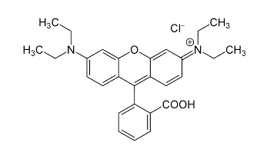

**Scheme-I (SI).** Chemical structure of the Rhodamine-B (M.W. 479.02, M.P. 210 to 211 °C, λmax  543 nm).

***References for supplementary information***

**[S1]** [M. Taniguchi](https://onlinelibrary.wiley.com/action/doSearch?ContribAuthorStored=Taniguchi%2C+Masahiko), [J. S. Lindsey](https://onlinelibrary.wiley.com/action/doSearch?ContribAuthorStored=Lindsey%2C+Jonathan+S), Database of Absorption and Fluorescence Spectra of >300 Common Compounds for use in PhotochemCAD, Photochemistry and photobiology, [94 (2](https://onlinelibrary.wiley.com/toc/17511097/2018/94/2)018), p. 290.

**[S2]** G. R. Ferreira, H. C. Garcia, M. R. C. Couri, H.F. D. Santos, L.F.C. de Oliveira, On the Azo/Hydrazo Equilibrium in Sudan I Azo Dye Derivatives, Journal of Physical Chemistry A, 117 (2013), p.642.

**[S3]** Source: <http://www.photochemcad.com/compounds/J07_Sudan_I.htm>., retrieved on 14 Nov.2020.