Supplementary data
Improved self-healing performance of polymeric nanocomposites reinforced with talc nanoparticles (TNPs) and urea-formaldehyde microcapsules (UFMCs)
Sehrish Habib¹, Eman Fayyed¹, Abdul Shakoor^{1*}, Ramazan Kahraman², Aboubakr Abdullah¹
¹Center for Advanced Materials (CAM), Qatar University, 2713 Doha, Qatar.
²Department of Chemical Engineering, Qatar University, 2713 Doha, Qatar.

* Corresponding Authors: shakoor@qu.edu.qa Tel: +974–44036867, 974-6612-5107.

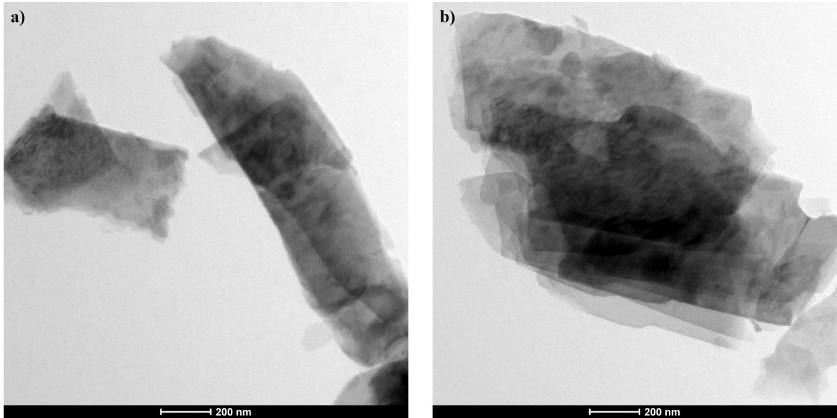
Fig S1: TEM analysis of a) as received TNPs and TNPs loaded with NaNO₃

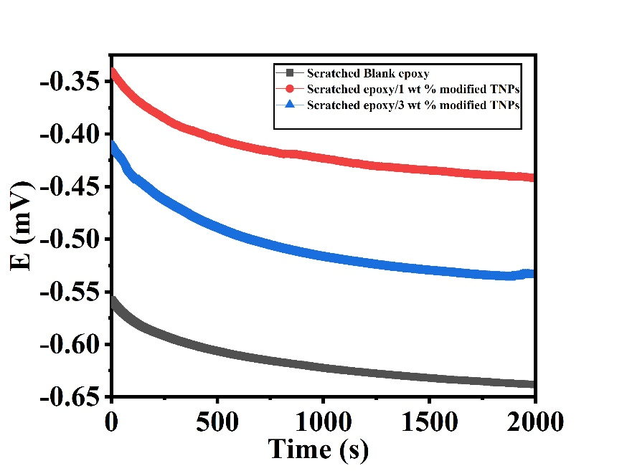
Fig S2: Open circuit potential, E_{OCP} vs. time, for steel substrate immersed in 3.5 wt % NaCl solution for blank epoxy and modified polymeric nanocomposite coatings 25°C.
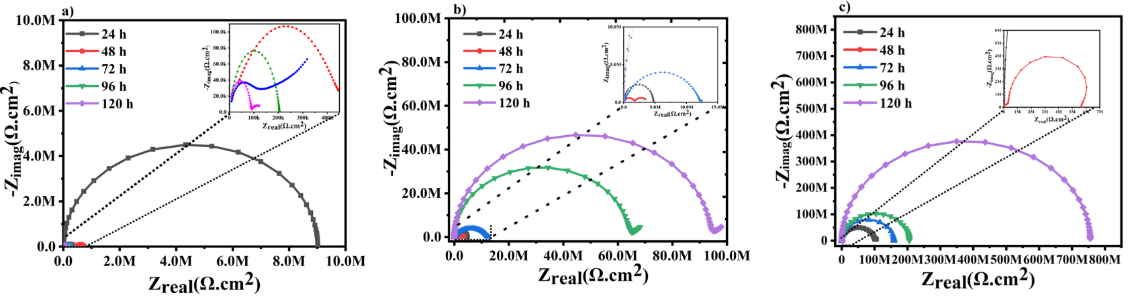
Fig S3: Nyquist plots for a) blank epoxy coatings, b) polymeric nanocomposite coatings containing 1 wt.% TNPs and c) polymeric nanocomposite coatings containing 3 wt.% TNPs
Table S1. The obtained fitted electrochemical values of the EIS data for the blank epoxy and the developed polymeric nanocomposites immersed in 3.5 wt % NaCl for different immersion times at room temperature.
Coatings | Time  (h) | R_{po}  (MΩ.cm²) | CPE₁  (s^{n} Ω⁻¹cm⁻²) | n₁ | R_{ct}  (MΩ.cm²) | CPE₂  (s^{n} Ω⁻¹ cm⁻²) | n₂ | R_{s}  (Ohms) | W  (s^{n} Ω⁻¹ cm⁻²) | IE  (%) | Goodness of fit
Scratched Blank epoxy | 24  48  72  96  120 | 0.27  0.11  0.07  0.05  0.01 | 2.67 x 10⁻⁹  6.01 x 10⁻⁶  1.30 x 10⁻⁵  1.72 x 10⁻⁴  1.45 x 10⁻² | 0.75  0.83  0.82  0.75  0.66 | 0.46  0.20  0.17  0.09  0.01 | 1.94 x 10⁻¹⁰  4.78 x 10⁻¹⁰  8.34 x 10⁻¹⁰  1.07 x 10⁻⁹  1.16 x 10⁻⁶ | 0.71  0.88  0.79  0.81  0.63 | 775.8  770.3  778.4  756.2  750.8 | -  -  -  -  - | - | 1.03 x 10⁻⁴  1.73 x 10⁻⁴  3.59 x 10⁻⁴  3.33 x 10⁻⁴  6.80 x 10⁻⁴
Scratched epoxy/1 wt % modified TNPs | 24  48  72  96  120 | 4.54  1.44  11.56  60.65  93.45 | 2.82 x 10⁻¹⁰  3.51 x 10⁻⁹  1.53 x 10⁻⁹  3.64 x 10⁻¹⁰  3.14 x 10⁻¹⁰ | 0.94  0.65  0.86  0.83  0.84 | 4.61  1.75  12.14  63.62  93.63 | 7.68 x 10⁻⁷  7.99 x 10⁻⁶  1.43 x 10⁻⁸  6.99 x 10⁻¹¹  1.03 x 10⁻¹¹ | 0.90  0.62  0.84  0.89  0.80 | 796.5  768.9  760.2  766.6  772.8 | 6.90  10.8  16.5  18.3  32.8 | 88.3  99.5 | 4.85 x 10⁻⁴  1.12 x 10⁻⁴  7.12 x 10⁻⁴  1.09 x 10⁻⁶  1.35 x 10⁻⁵
Scratched epoxy/3 wt % modified TNPs | 24  48  72  96  120 | 5.61  3.00  58.58  125.8  204.8 | 1.69 x 10⁻⁹  1.29 x 10⁻⁴  6.63 x 10⁻⁵  6.79 x 10⁻¹⁰  1.91 x 10⁻¹⁰ | 0.83  0.60  0.82  0.73  0.82 | 6.15  3.00  58.58  125.80  755.30 | 2.27 x 10⁻¹⁰  1.79 x 10⁻⁹  4.83 x 10⁻¹⁰  4.75 x 10⁻¹⁰  4.60 x 10⁻¹⁰ | 0.88  0.68  0.76  0.90  0.86 | 752.7  749.5  732.4  724.2  735.8 | 10.50  13.08  19.50  22.20  45.30 | 96.7  99.9 | 3.70 x 10⁻⁴  2.94 x 10⁻⁴  1.38 x 10⁻⁴  3.56 x 10⁻⁴  2.44 x 10⁻⁴

