|  |  |  |
| --- | --- | --- |
| Figure S1 | IR spectra of a) H3L, b) **1**, c) **2** and d) **3**. | S2 |
| Figure S2 | Electronic absorption spectra of a) H3L, b) **1**, c) **2** and d) **3**. | S4 |
| Figure S3 | Thermal analysis charts a) TGA (**1**), b) DTG (**1**), c) TGA (**2**) and d) DTG (**2**). | S6 |
| Figure S4 | The calculated IR spectra of the local minima structures of **1–3**. | S8 |
| Table S1 | Computed electronic transitions and their oscillator strengths (*f*) of the investigated complexes in DMSO using PCM model | S10 |

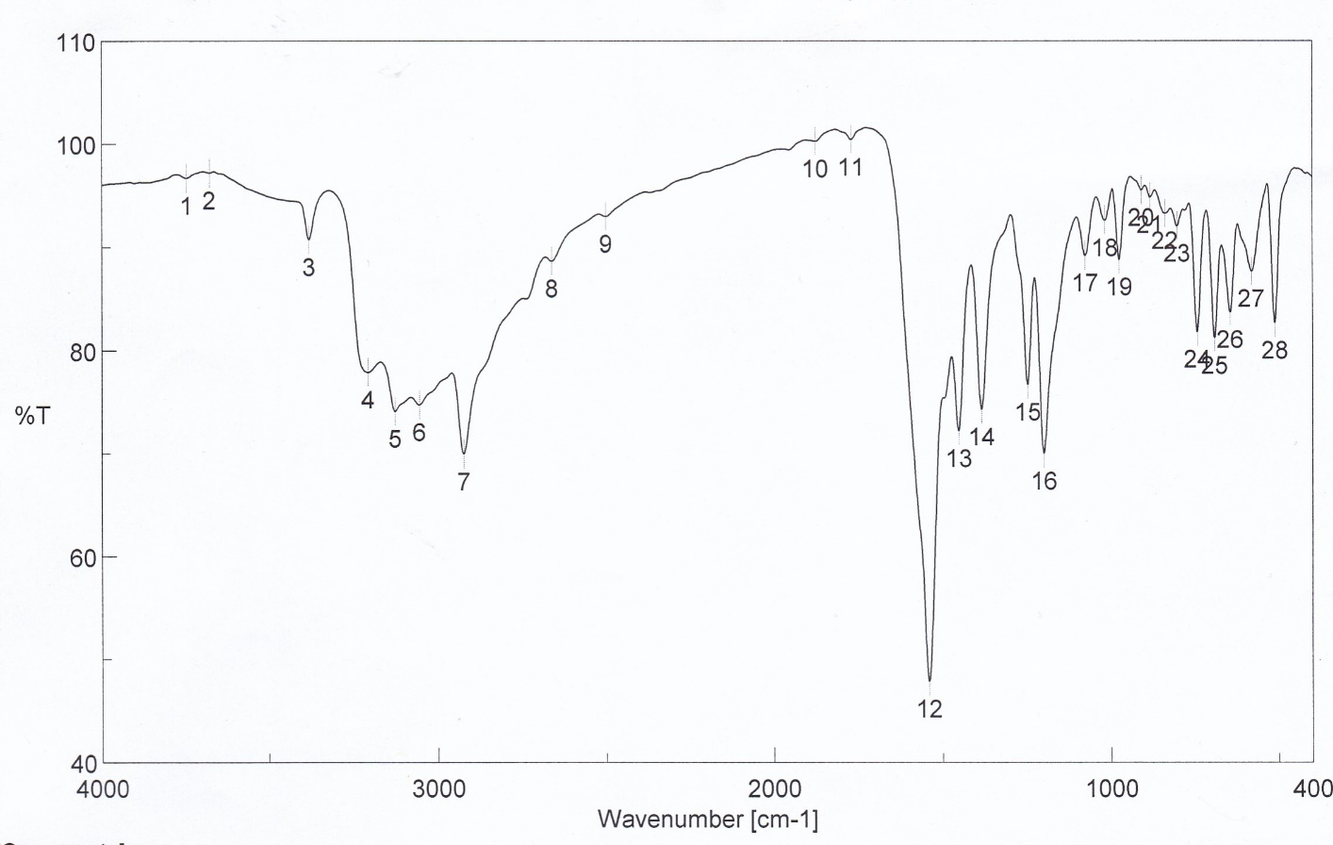

a)

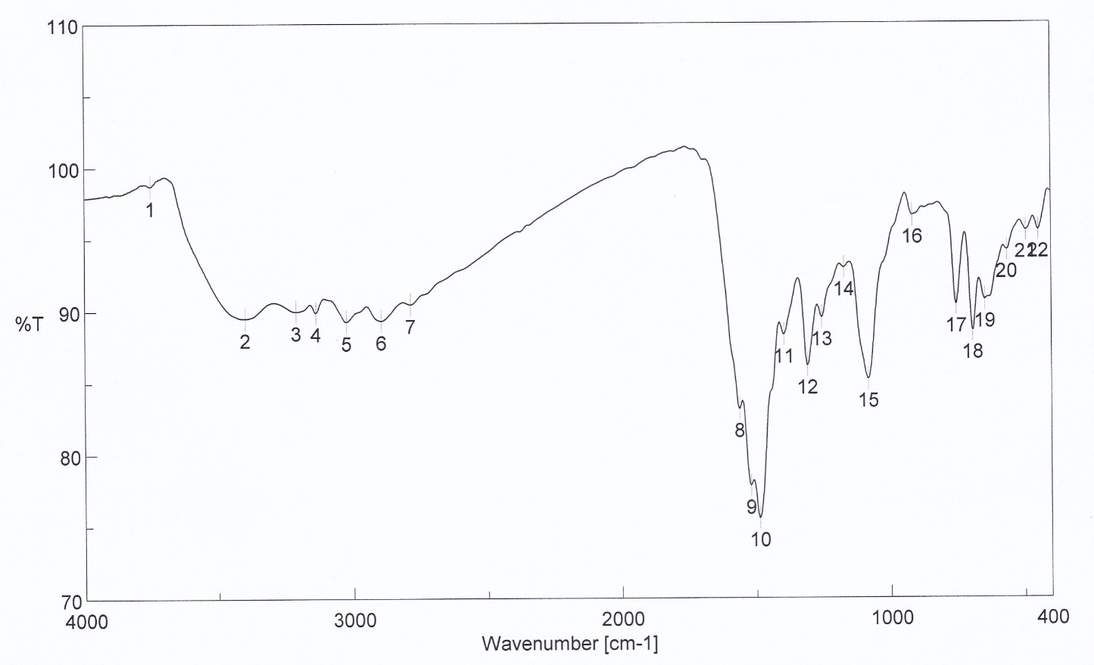

b)

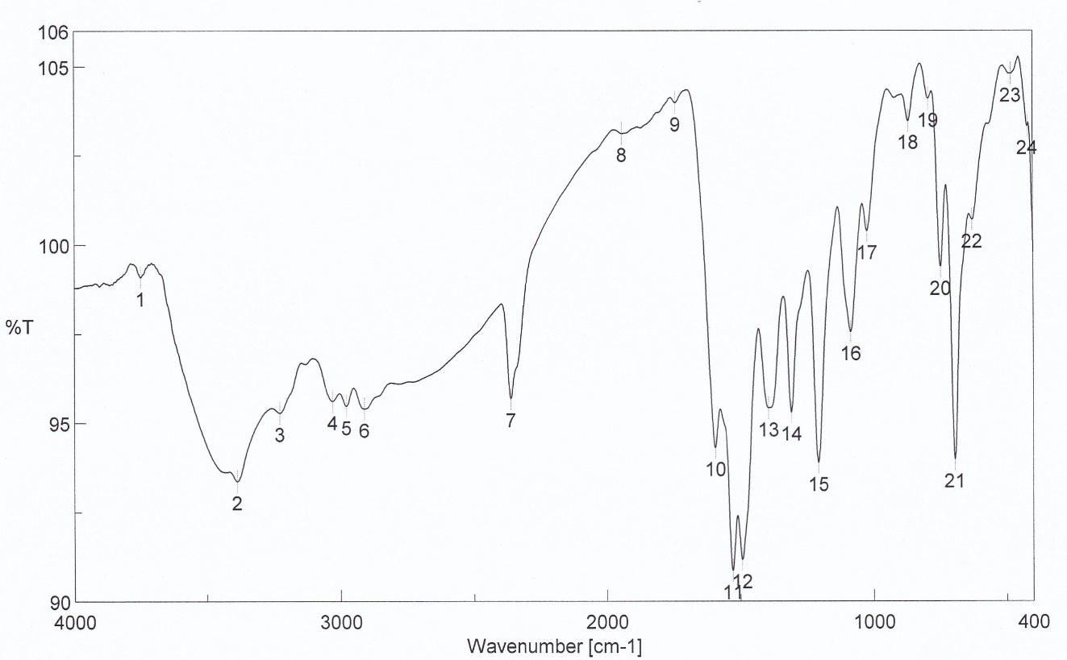

c)

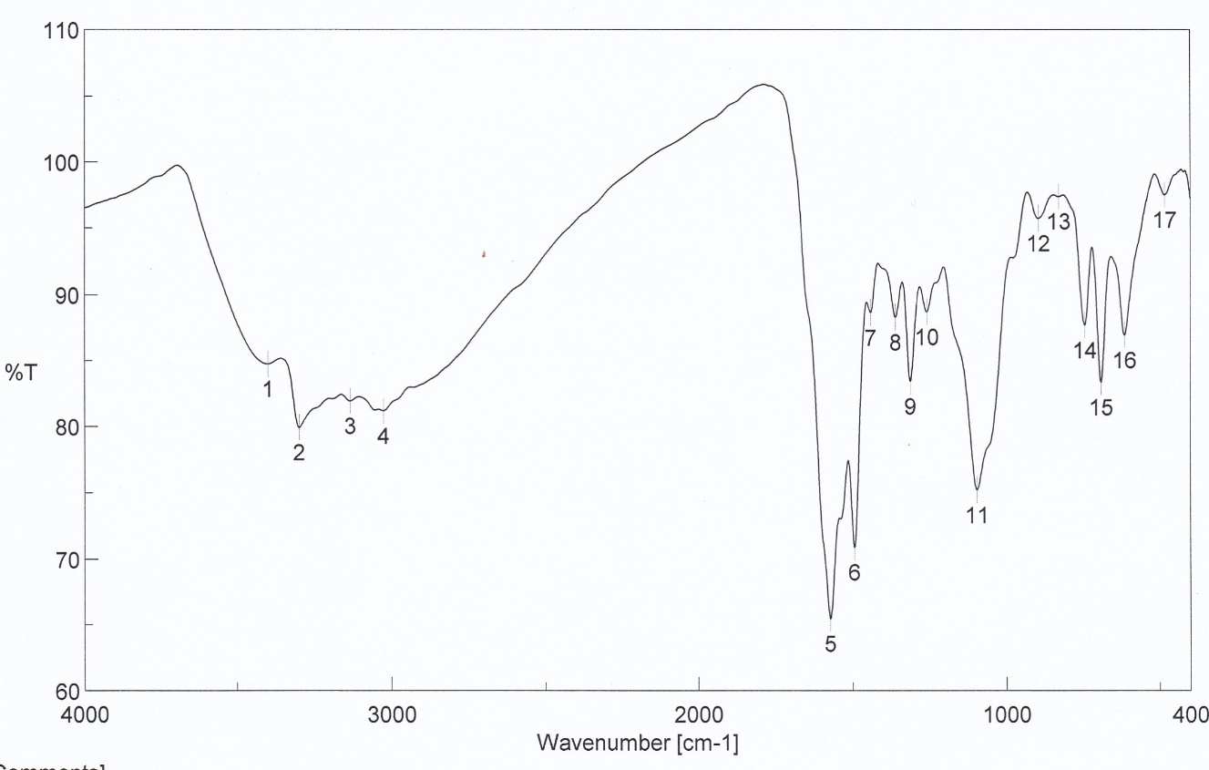

d)

Figure S1 IR spectra of a) H3L, b) **1**, c) **2** and d) **3**.



a)



b)



c)



d)

Figure S2 Electronic absorption spectra of a) H3L, b) **1**, c) **2** and d) **3**. Dilute and very concentrated solutions were used to get the spectra of the complexes. [In the range of 190–400 nm, 5×10-5 M was used, while in the range of 400–800 nm, 10-3 M was used]



a)

b)

c)



d)

Figure S3 Thermal analysis charts a) TGA (**1**), b) DTG (**1**), c) TGA (**2**) and d) DTG (**2**).

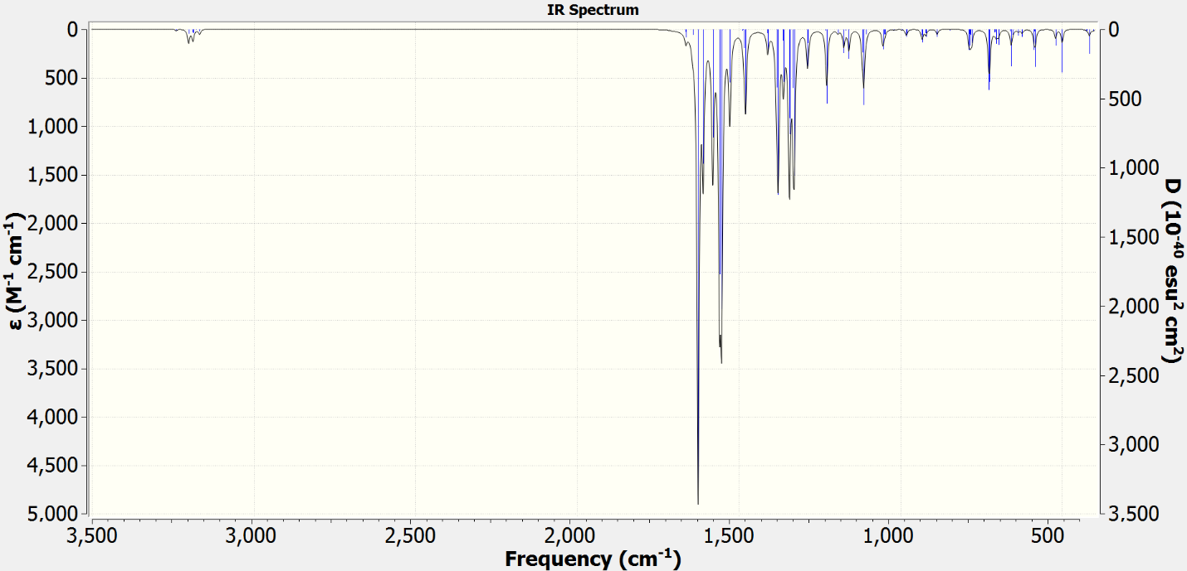

a)

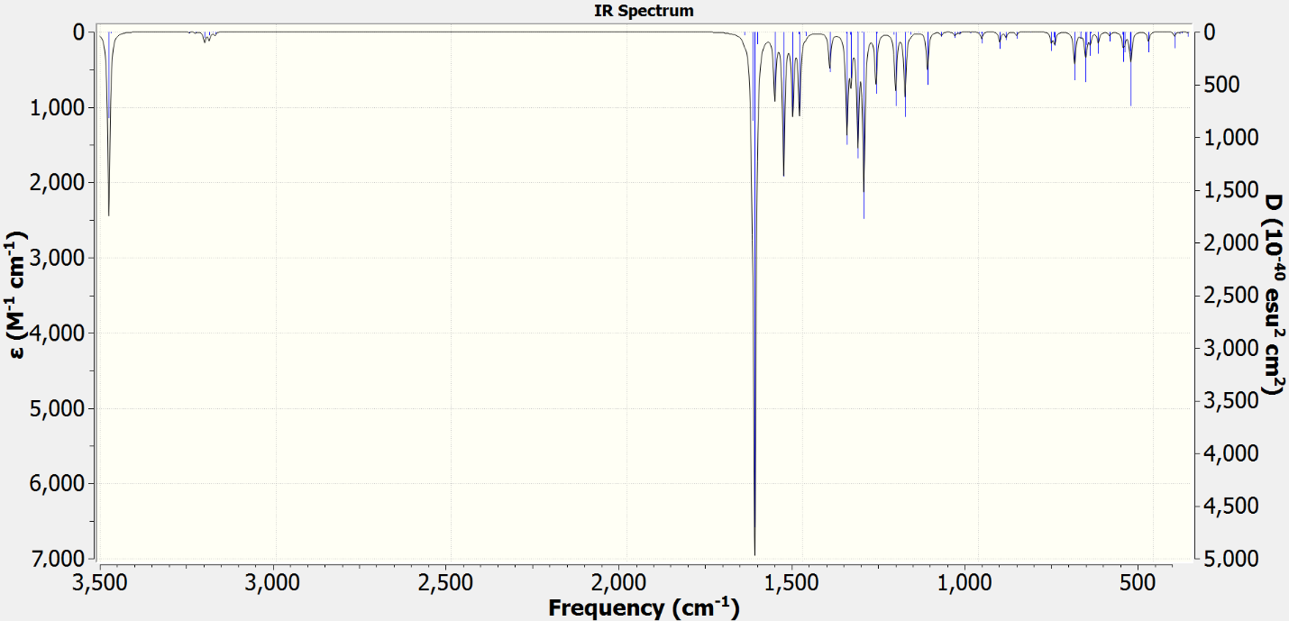

b)

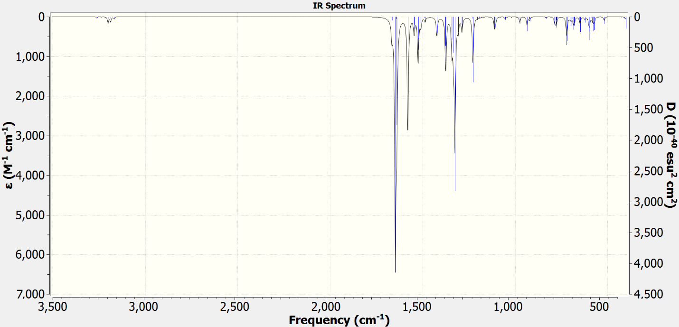

c)

Figure S4 The calculated IR spectra of the local minima structures of **1–3**.

|  |  |  |
| --- | --- | --- |
| Table S1 Computed electronic transitions and their oscillator strengths (*f*) of the investigated complexes in DMSO using PCM model | | |
| **nm** | ***f*** | **Composition** |
| * **1** | | |
| 735 | 0.0001 | HOMO–5(β)→LUMO(β) (17%), HOMO–4(β)→LUMO(β) (20%) |
| 640 | 0.0001 | HOMO(α)→LUMO(α) (23%) |
| 555 | 0.0004 | HOMO–3(α)→LUMO(α) (19%) |
| 547 | 0.0006 | HOMO–5(α) →LUMO(α) (31%), HOMO–2(α)→LUMO(α) (18%) |
| 486 | 0.007 | HOMO–4(α)→LUMO(α) (16%) |
| * **2** | | |
| 387 | 0.0152 | HOMO→LUMO (47%) |
| 333 | 0.0188 | HOMO→L+1 (35%) |
| 328 | 0.0003 | H–5→LUMO (51%) |
| 322 | 0.1753 | HOMO→L+1 (44%) |
| 320 | 0.0036 | HOMO→L+2 (80%) |
| 308 | 0.8843 | H–6→LUMO (45%) |
| 301 | 0.3095 | H–2→L+1 (70%) |
| * **3** | | |
| 398 | 0.0267 | HOMO–2(β)→LUMO(β) (23%), HOMO(β)→LUMO(β) (22%) |
| 381 | 0.0004 | HOMO–3(β)→LUMO(β) (31%), HOMO–1(β)→LUMO(β) (51%) |
| 349 | 0.0277 | HOMO–1(β)→LUMO(β) (21%), HOMO(β)→LUMO(β) (36%) |
| 332 | 0.0074 | HOMO–3(β)→LUMO(β) (32%) |
| 317 | 0.0848 | HOMO–4(β)→LUMO(β) (26%) |
| 310 | 0.0462 | HOMO–7(β)→LUMO(β) (31%), |
| 269 | 1.0977 | HOMO(α)→L+1(α) (23%), HOMO(β)→LUMO+2(β) (22%) |
| 259 | 0.0047 | HOMO–2(α)→LUMO(α) (31%) |
| 255 | 0.1804 | HOMO–10(β)→LUMO(β) (21%), HOMO–7(β)→LUMO(β) (24%) |