**A stereo, regioselective synthesis and discovery of antimycobaterium tuberculosis activity of** ***β*-lactam grafted spirooxindolopyrrolidine hybrid heterocycles**

Natarajan Arumugama,*, Abdulrahman I. Almansoura, Raju Suresh Kumara, Vagolu Siva Krishnab, Dharmarajan Sriramb, Ramanathan Padmanabanc

*aDepartment of Chemistry, College of Science, King Saud University, P.O. Box 2455, Riyadh 11451, Saudi Arabia*

*bMedicinal Chemistry and Antimycobacterial Research Laboratory, Pharmacy Group, Birla Institute of Technology & Science-Pilani, Hyderabad Campus, Jawahar Nagar, Hyderabad 500078, Telangana, India.*

*cDepartment of Chemistry, School of Physical, Chemical & Applied Sciences, Pondicherry University, R.V. Nagar, Kalapet, Puducherry 605 014, India*

_____________________________________________________________________________________

**General Method**

*Chemistry*

1H and 13C NMR spectra were recorded on a Varian Mercury JEOL-400/500 NMR spectrometers in CDCl3 using TMS as internal standard. Chemical shifts are given in parts per million (δ-scale) and coupling constants are given in hertz. Elemental analyses were performed on a Perkin Elmer 2400 Series II Elemental CHNS analyzer.

***Biology***

***In vitro* anti tubercular activity**

Briefly, the *Mycobacterium tuberculosis* H37Rv inoculum was prepared from fresh LJ medium re-suspended in 7H9-S medium (7H9 broth, 0.1% casitone, 0.5% glycerol, supplemented oleic acid, albumin, dextrose, and catalase [OADC]), adjusted to a OD590 1.0, and diluted 1:20; 100 µl was used as inoculum. Each drug stock solution was thawed and diluted in 7H9-S at four-fold the final highest concentration tested. Serial two-fold dilutions of each drug were prepared directly in a sterile 96-well microtiter plate using 100 µl 7H9-S. A growth control containing no antibiotic and a sterile control were also prepared on each plate. Sterile water was added to all perimetre wells to avoid evaporation during the incubation. The plate was covered, sealed in plastic bags and incubated at 37ºC in normal atmosphere. After 7 days incubation, 30 µl of alamar blue solution was added to each well, and the plate was re-incubated overnight. A change in colour from blue (oxidised state) to pink (reduced) indicated the growth of bacteria, and the MIC was defined as the lowest concentration of drug that prevented this change in colour 1,2.

***In vitro* cytotoxicity screening:**

The *in vitro* cytotoxicity of the privileged antitubercular active analogues with lower MIC value were assessed by 3-(4,5- dimethylthiazol-2- yl)-2,5- diphenyltetrazolium bromide (MTT) assay against growth inhibition of RAW 264.7 cells at 50 μg/mL concentration.3 Cell lines were maintained at 37ºC in a humidified 5% CO2 incubator (Thermo scientific). Detached the adhered cells and followed by centrifugation to get cell pellet. Fresh media was added to the pellet to make a cell count using haemocytometer and plate 100μl of media with cells ranging from 5,000 - 6,000 per well in a 96-well plate. The plate was incubated overnight in CO2 incubator for the cells to adhere and regain its shape. After 24hr cells were treated with the test compounds at 50 μg/mL diluted using the media to deduce the percentage inhibition on normal cells. The cells were incubated for 48 hr to assay the effect of the test compounds on different cell lines. Zero hour reading was noted down with untreated cells and also control with 1% DMSO to subtract further from the 48hr reading. After 48 hr incubation, cells were treated by MTT (4, 5-dimethylthiazol- 2-yl)- 2, 5-diphenyltetrazolium bromide) dissolved in PBS (5mg/ml) and incubated for 3-4 hr at 37ºC. The formazan crystals thus formed were dissolved in 100μl of DMSO and the viability was measured at 540nm on a multimode reader (Spectra max). The values were further calculated for percentage inhibition which in turn helps us to know the cytotoxicity of the test compounds.

1. L.A. Collins, S.G. Franzblau, Antimicrob. Agents Chemother. 41 (1997), 1004-1009.
2. V.S. Krishna, S. Zheng, E. M. Rekha, L. W. Guddat, D. Sriram, Discovery and evaluation of novel Mycobacterium tuberculosis ketol-acid reductoisomerase inhibitors as therapeutic drug leads. J. Comput. Aided Mol. Des., 33 (2019) 357.
3. J. Van Meerloo, G.J. Kaspers, J. Cloos, Cell sensitivity assays: the MTT assay. Methods Mol. Biol 731 (2011) 237-245.

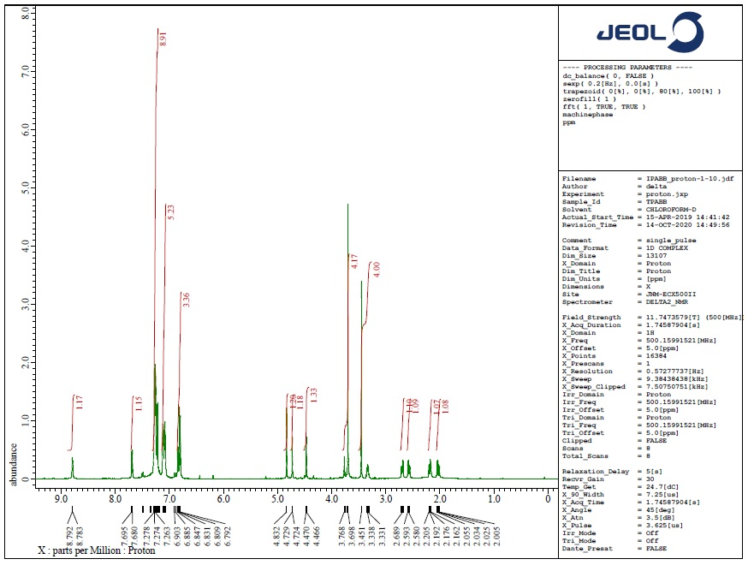

**Figure S1**. 1H NMR spectrum of **6a**

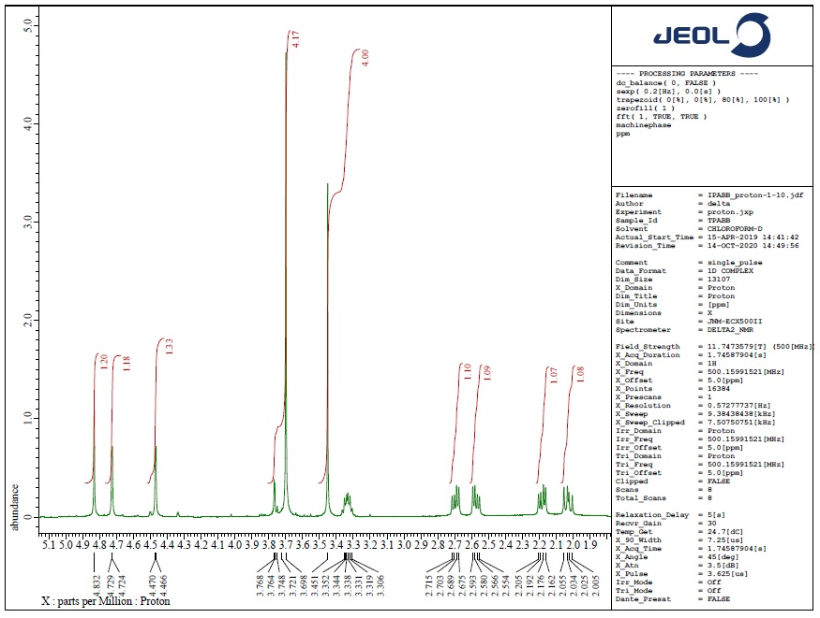

**Figure S2**. Expanded 1H NMR spectrum of **6a**

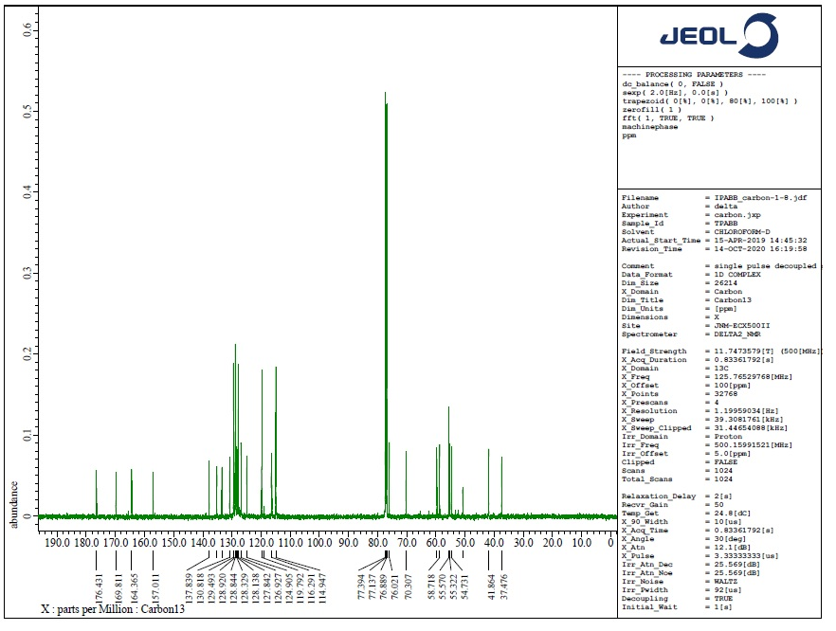

**Figure S3**. 13C NMR spectrum of **6a**

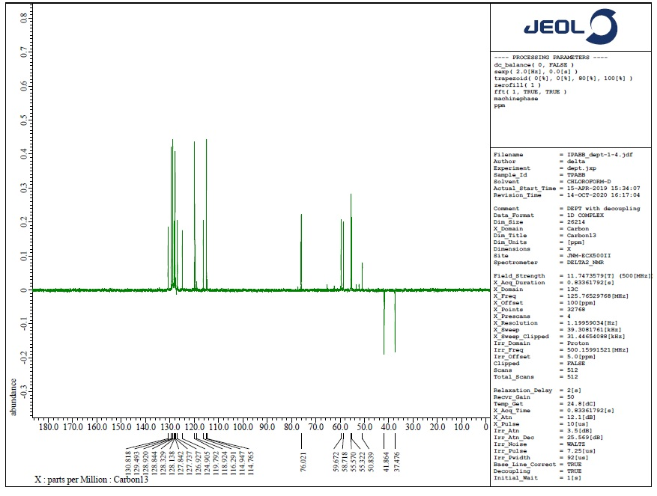

**Figure S4**. DEPT-135spectrum of **6a**

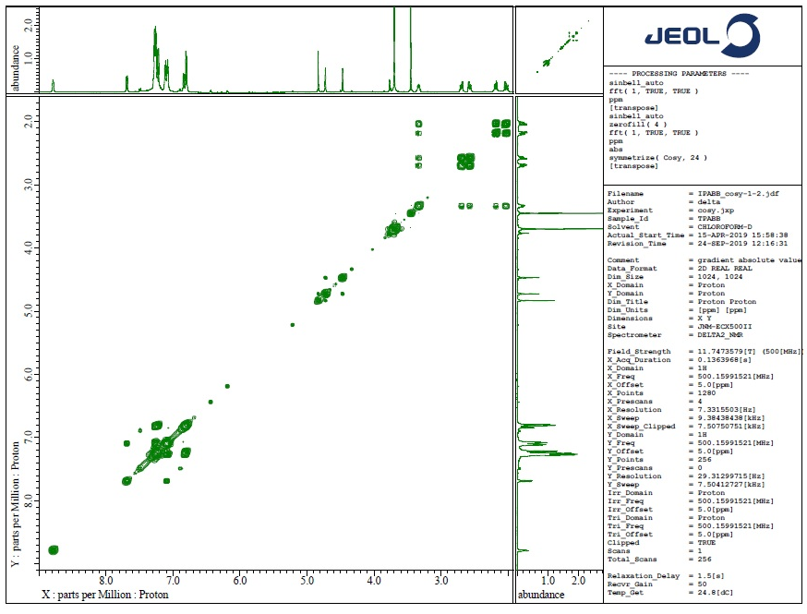

**Figure S5**. 1H, 1H-COSY spectrum of **6a**

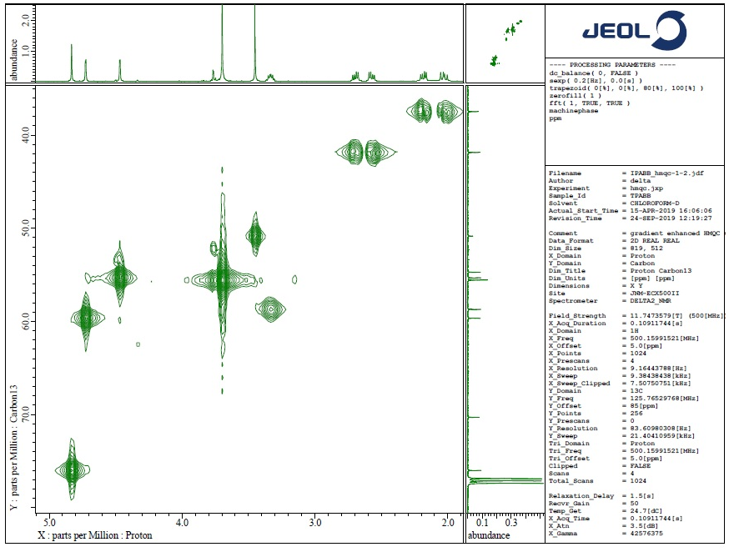

**Figure S6**. Expanded 1H, 1H-COSY spectrum of **6a**

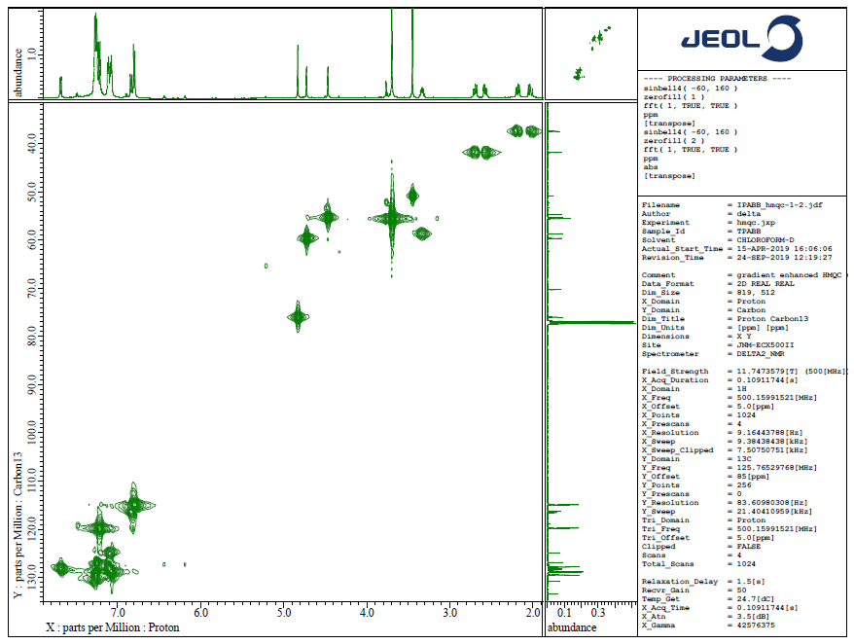

**Figure S7**. 13C, 1H-COSY spectrum of **6a**

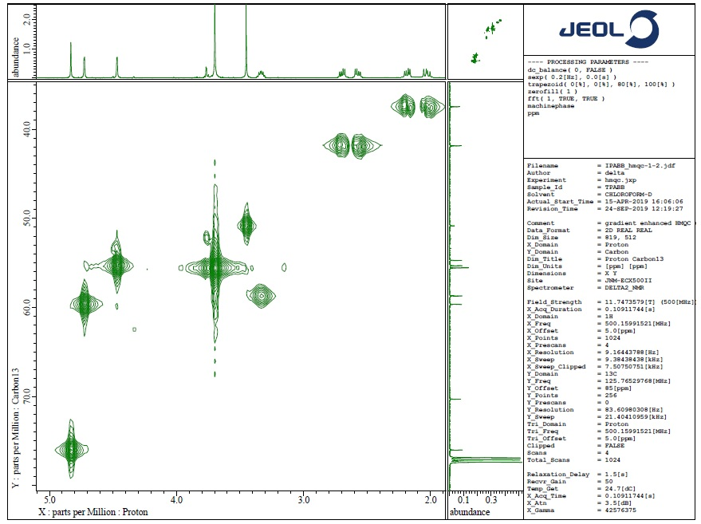

**Figure S8**. Expanded 13C, 1H-COSY spectrum of **6a**

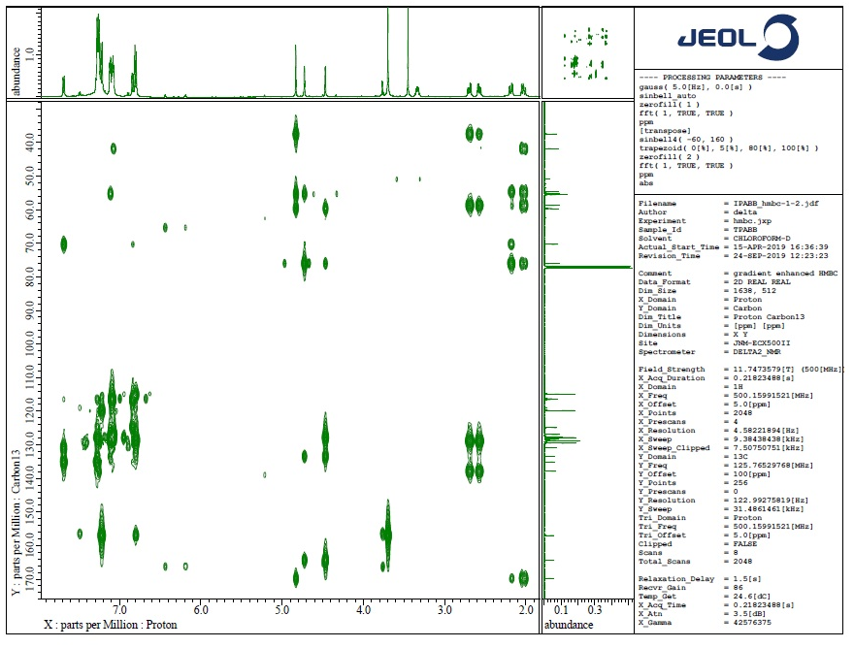

**Figure S9**. HMQC spectrum of **6a**

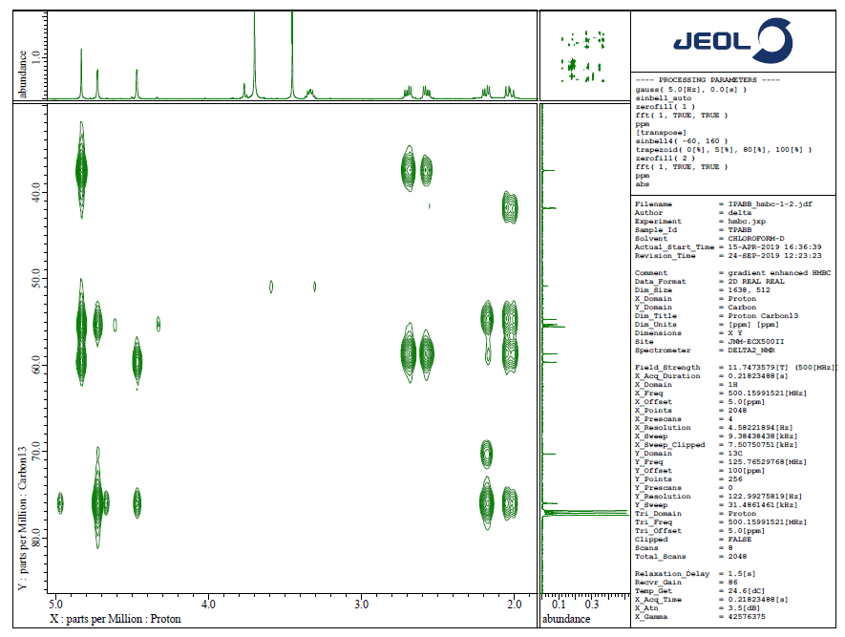

**Figure S10**. Expanded HMQC spectrum of **6a**

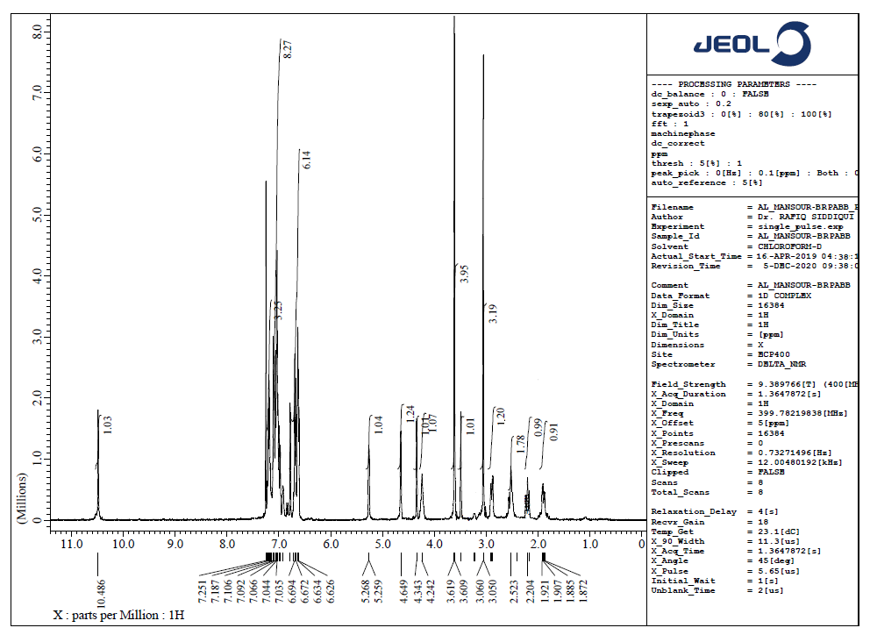

**Figure S11**. 1H NMR spectrum of **6b**

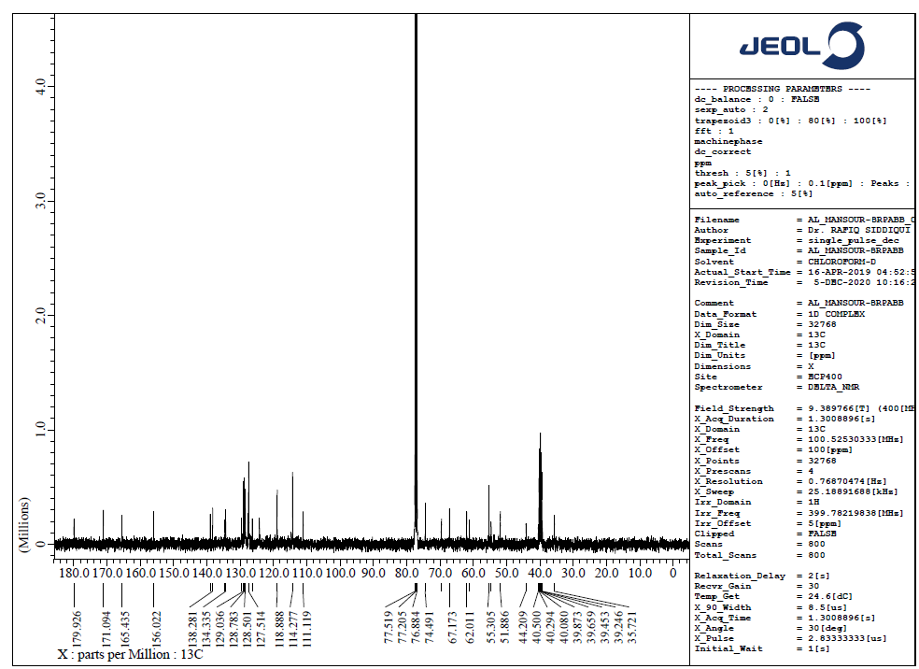

**Figure S12**. 13C NMR spectrum of **6b**

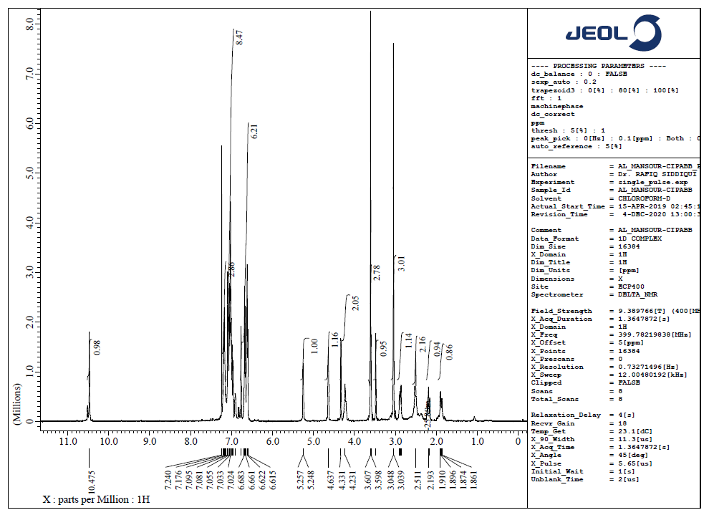

**Figure S13**. 1H NMR spectrum of **6c**

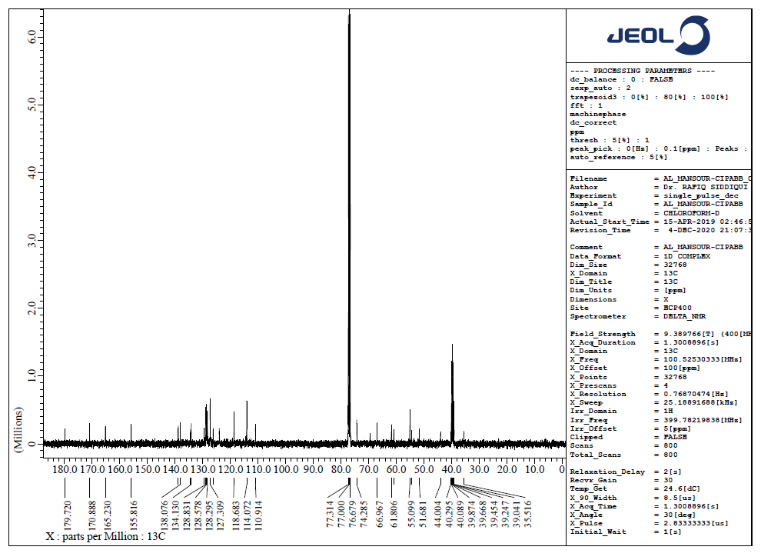

**Figure S14**. 13C NMR spectrum of **6c**

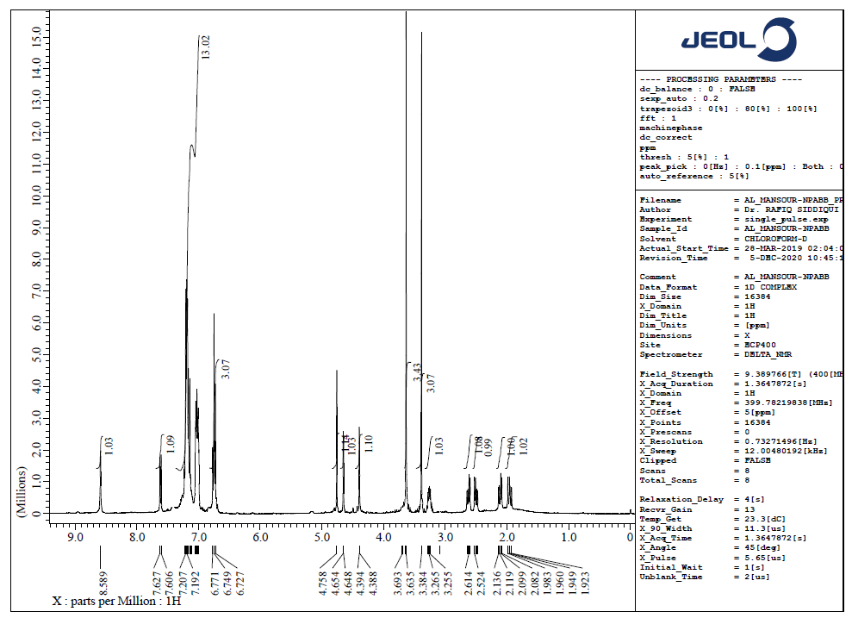

**Figure S15**. 1H NMR spectrum of **6d**

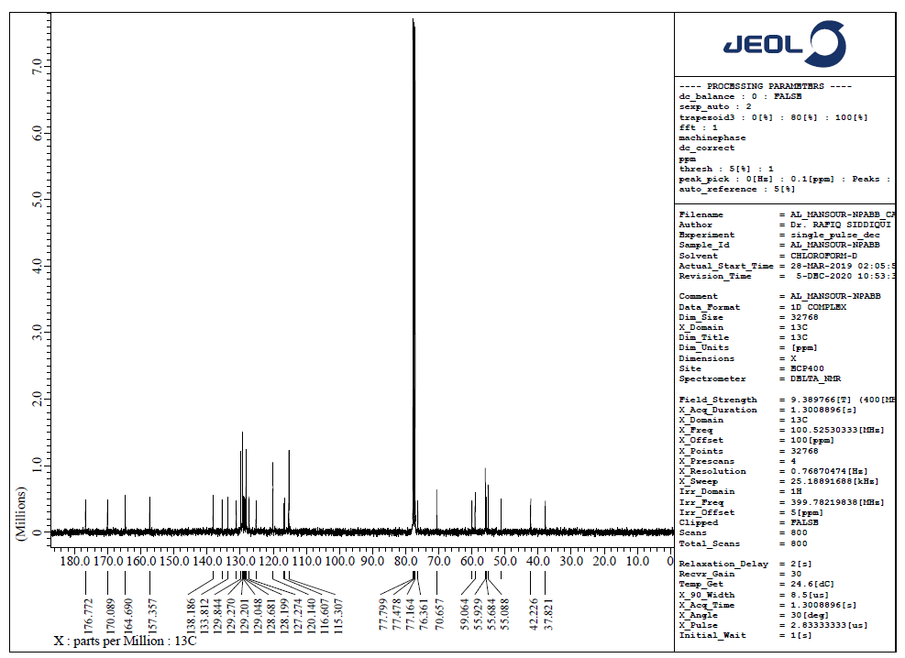

**Figure S16**. 13C NMR spectrum of **6d**

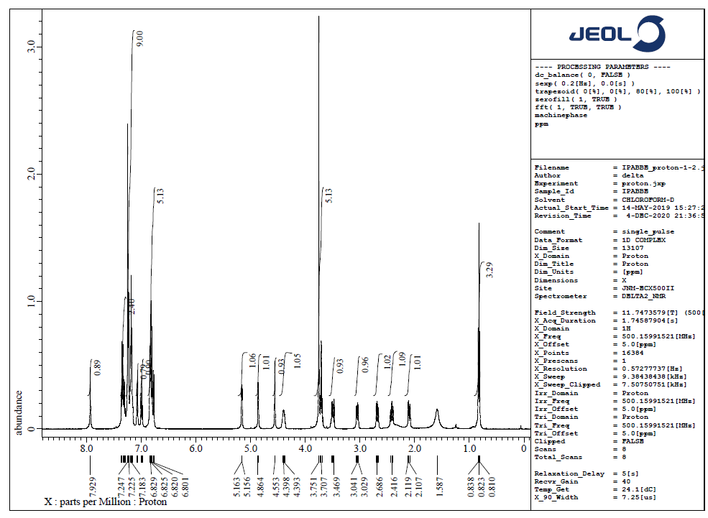

**Figure S17**. 1H NMR spectrum of **6e**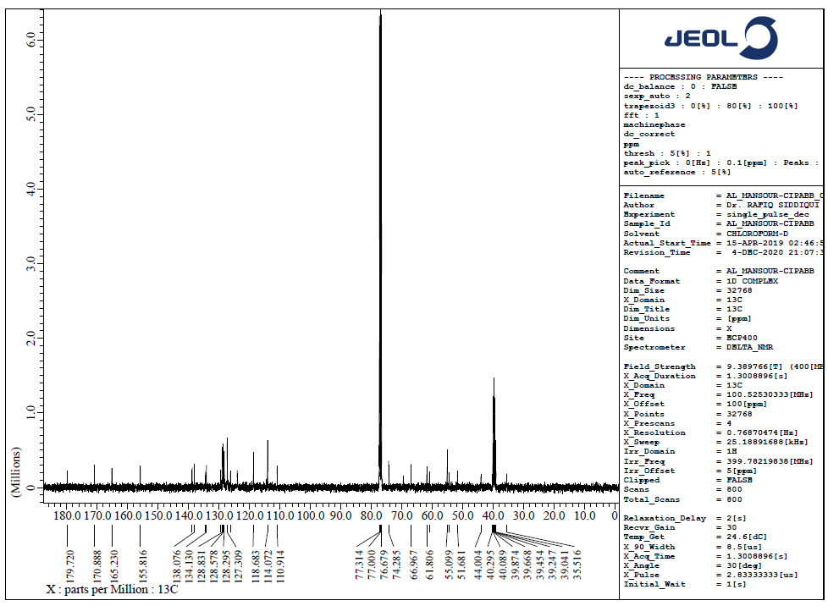

**Figure S18**. 13C NMR spectrum of **6e**

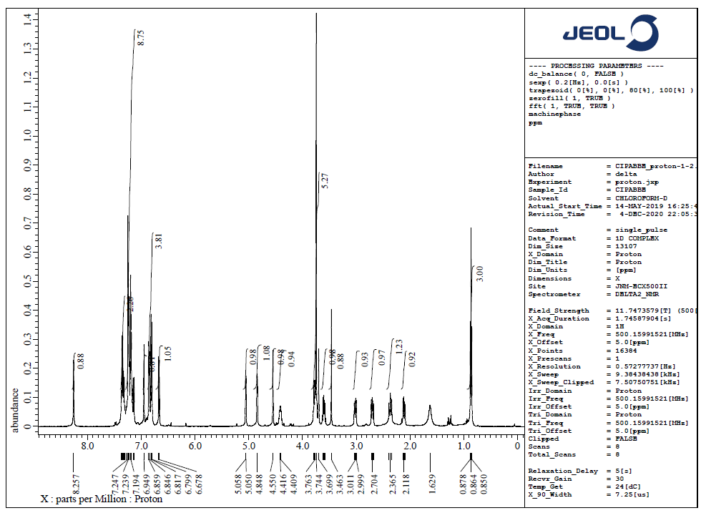

**Figure S19**. 1H NMR spectrum of **6f**

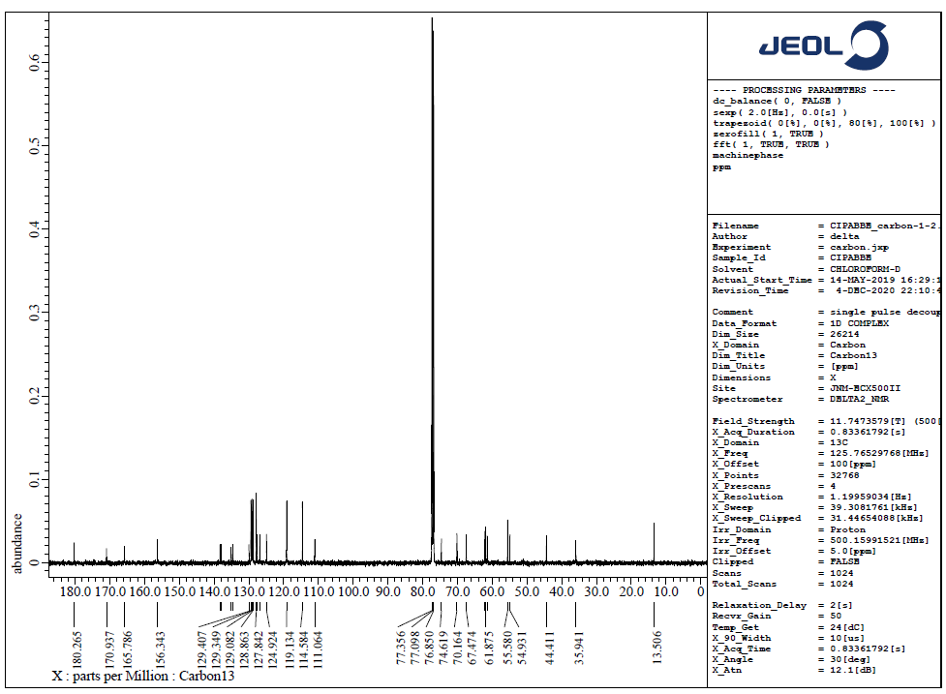

**Figure S20**. 13C NMR spectrum of **6f**

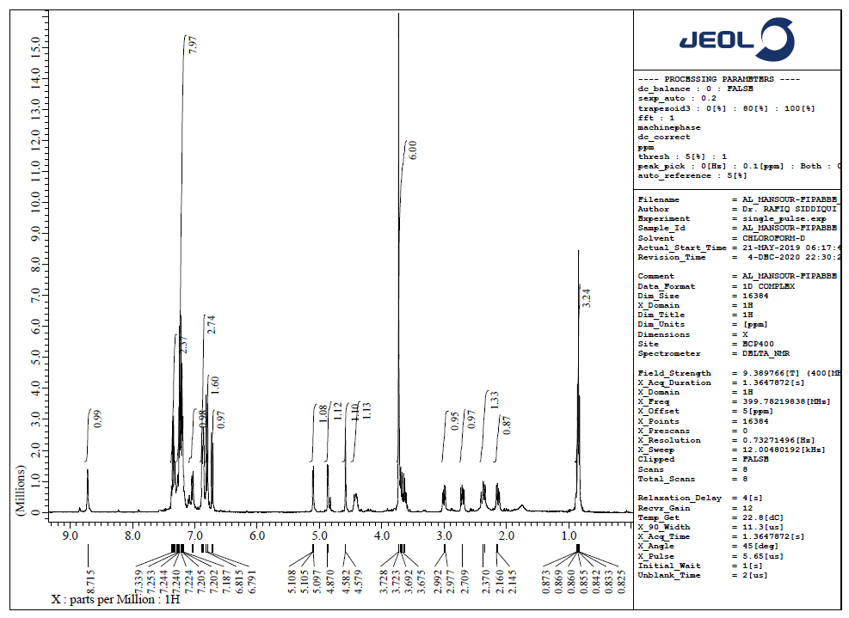

**Figure S21**. 1H NMR spectrum of **6g**

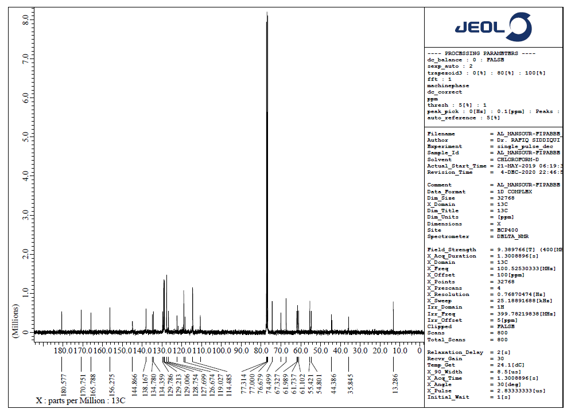

**Figure S22**. 13C NMR spectrum of **6g**

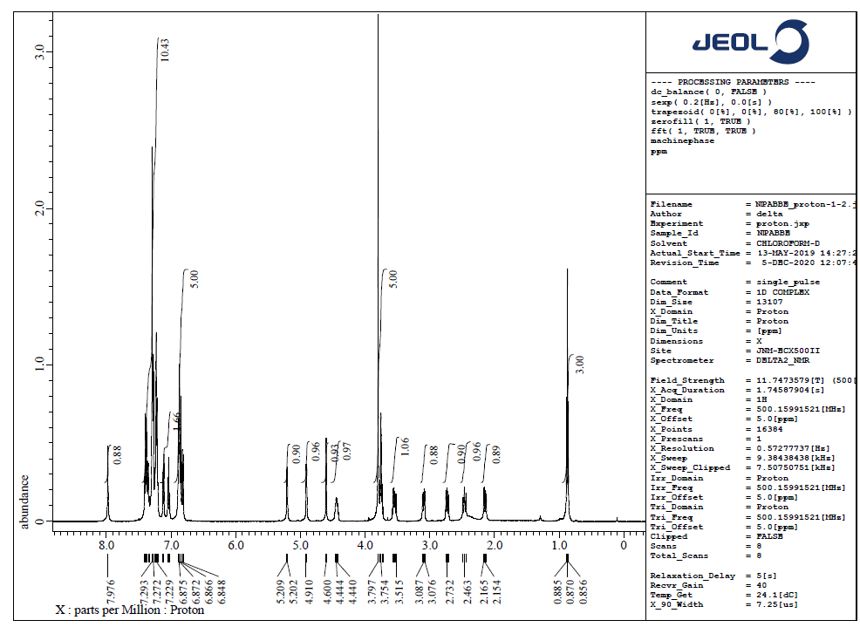

**Figure S23**. 1H NMR spectrum of **6h**

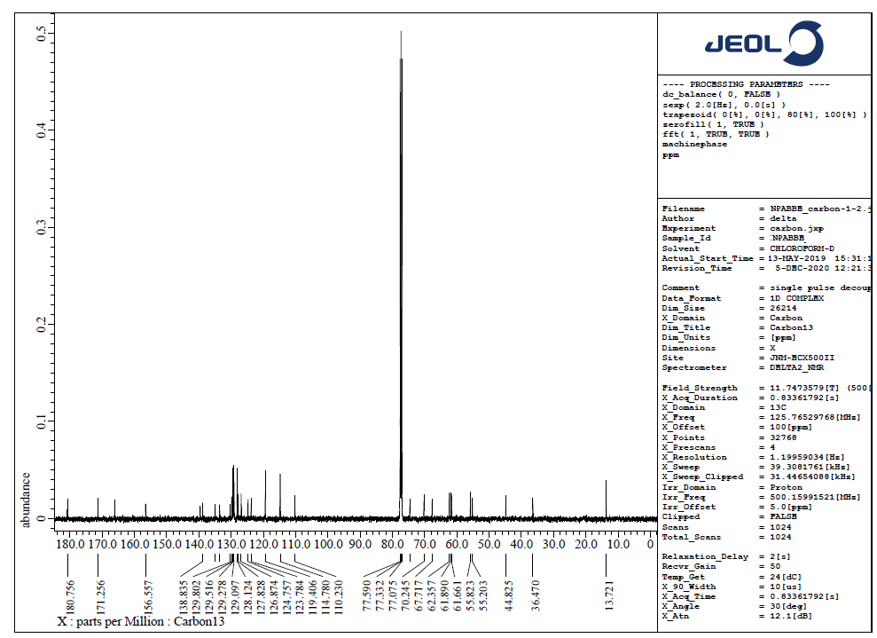

**Figure S24**. 13C NMR spectrum of **6h**