**A study on highly active Cu-Zn-Al-K catalyst for CO2 hydrogenation to methanol**

Nagaraju Pasupulety*, Abdurahim A. Al-Zahrani, Muhammad A. Daous, Seetharamulu Podila and Hafedh Driss

*Chemical & Materials Engineering Department, College of Engineering, King Abdulaziz University, P.O. Box 80204 Jeddah 21589*

**Supplementary data**

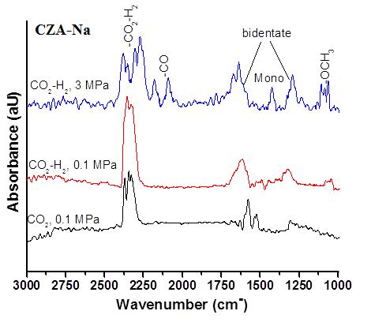

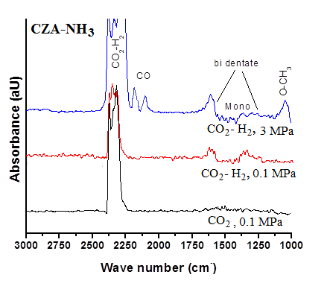

**CZA**

**S1:** Transient DRIFTs spectra of CZA-Na and CZA samples at 240 oC.

**S2:** XPS analysis of calcined CZA samples.



**S3:** EPR spectrum results for CZA-K.

The CZA-K EPR spectrum data revealed gII as 2.30 and g┴ as 2.09 with AII equals to 15 mT, which suggests the existence of isolated copper(II) ions in these samples. The trend of gII > g┴ > 2.00 emphasizes the unpaired electron was localized in dх2-y2orbital of the copper(II) ion and the spectral features were characteristic of axially elongated tetragonal geometry. Essentially, similar relative intensity of Cu(II) ions in calcined and spent sample under identical EPR conditions suggests limited copper species sintering in 100h of CZA-K used sample.



**S4:** TGA of spent CZA samples.