***In-situ* Activation of NiMo Catalyst Based on Support Surface-Bound Thiols: A Green Approach to Catalyst Sulfidation and Improved Activity**

Abdulkadir Tanimua, Saheed A. Ganiyua, Ivan Kozhevnikovb, Khalid Alhooshania*

aDepartment of Chemistry, King Fahd University of Petroleum and Minerals, Dhahran

31261, Saudi Arabia.

bDepartment of Chemistry, University of Liverpool, Liverpool, L69 7ZD, United Kingdom.

*Corresponding author

Email: [hooshani@kfupm.edu.sa](mailto:hooshani@kfupm.edu.sa)

Phone: +966 13 860 3065

Fax: +966 13 860 4277

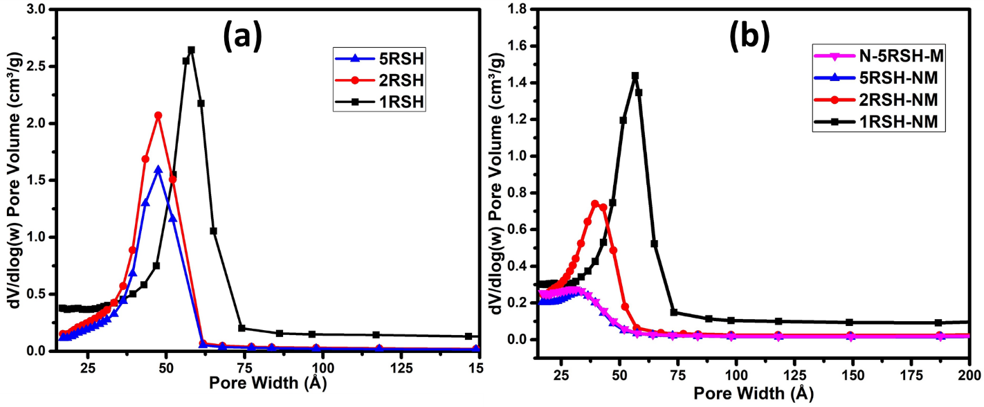

Figure SI-1: Pore size distribution plots for (a) thiol functionalized SBA-15 supports and (b) activated catalysts.

**Table S-1:** Atomic percent of chemical states of elements observed in the catalysts.

|  |  |  |  |  |  |  |  |
| --- | --- | --- | --- | --- | --- | --- | --- |
| States | C1s | C1s | C1s | Ni2p | Ni2p | Mo4+(3d5/2) | Mo6+(3d5/2) |
| BE (eV) | **282.9** | **284.3** | **285.6** | **854.9** | **860.1** | **229.1** | **232.8** |
| 1RSH-NM | 15.66 | 8.95 | 4.52 | 0.09 | 0.05 | 0.25 | 0.47 |
| 2RSH-NM | 16.18 | 8.27 | - | 0.13 | 0.08 | 0.33 | 0.52 |
| 5RSH-NM | 22.64 | 10.15 | - | 0.20 | 0.13 | 1.10 | 0.67 |
| N-5RSH-M | 22.22 | 10.22 | - | 0.19 | 0.13 | 1.09 | 0.70 |

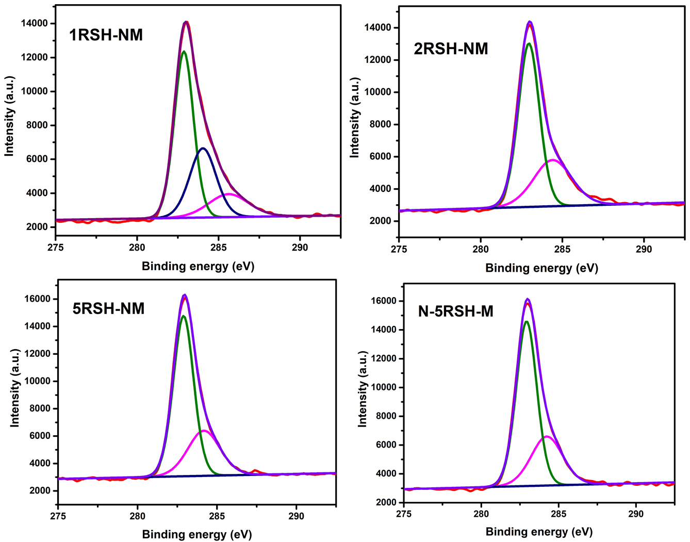

Figure SI-2: XPS spectra of activated catalysts showing the peaks of C1s chemical states.

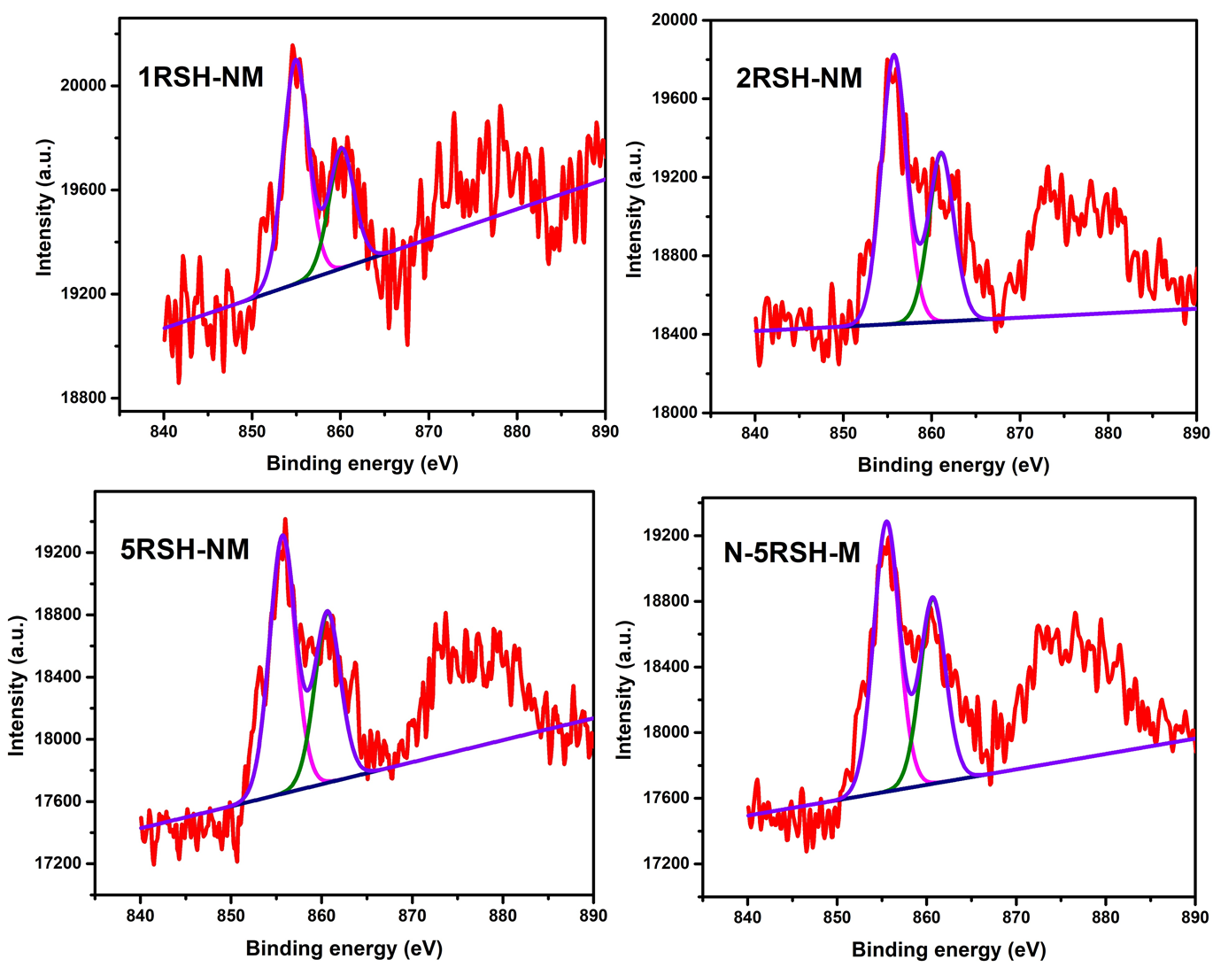

Figure SI-3: XPS spectra of activated catalysts showing the peaks of Ni2p chemical states.

**Table S-2:** Catalyst performance results: percentage of DBT removal (process conditions: 350 oC, 5 MPa, 1000 ppm DBT, 4 h reaction time).

|  |  |  |  |  |  |
| --- | --- | --- | --- | --- | --- |
| Catalysts | DBT Removal (%) | | | | |
| **0 h** | **1 h** | **2 h** | **3 h** | **4 h** |
| 1RSH-NM | 31 | 40 | 47 | 60 | 72 |
| 2RSH-NM | 40 | 47 | 52 | 65 | 70 |
| 5RSH-NM | 40 | 48 | 57 | 64 | 74 |
| N-5RSH-M | 42 | 52 | 68 | 81 | 91 |
| Reference | 20 | 35 | 52 | 67 | 82 |

**Table S-3:** Catalyst performance results: product distribution and first order rate constants (process conditions: 350 oC, 5 MPa, 1000 ppm DBT).

|  |  |  |  |  |
| --- | --- | --- | --- | --- |
| Catalyst | Product distribution (%) | | Pseudo-first-order rate constant after 1 h | Pseudo-first-order rate constant after 4 h |
| **CHB** | **BP** | **kHDS x 103 (min-1)** | **kHDS x 103 (min-1)** |
| 1RSH-NM | - | 100 | 8.5 | 5.2 |
| 2RSH-NM | - | 100 | 10.4 | 5.1 |
| 5RSH-NM | - | 100 | 10.8 | 5.6 |
| N-5RSH-M | - | 100 | 12.2 | 10.2 |
| Reference | 5.5 | 94.5 | 6.9 | 7.3 |