**Supplementary data**



Fig. S1 Fluorescence spectra of thecomplexes in ethanol solutions with varied concentrations. (a) Tb(oct-ala)3•H2O;(b)Tb(oct-phe)3•H2O; (c) Tb(oct-ser)3•3H2O; and (d) powder samples of thethree terbium complexes



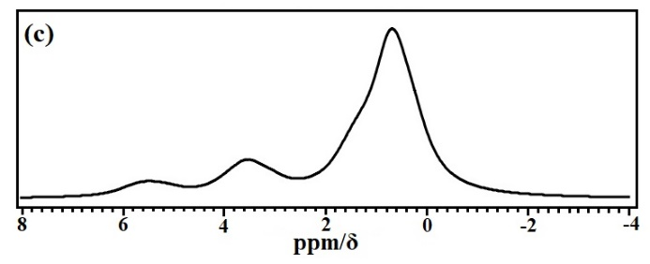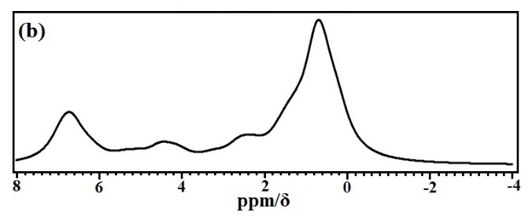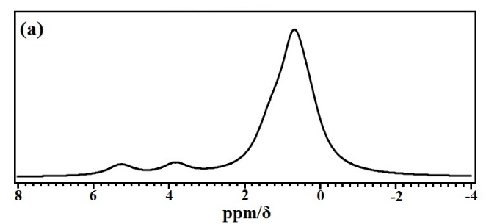Fig. S2 Calculated FT-IR spectra of the terbium complexes.

Fig. S3 1H NMR calculations of the terbium complexes.

(a) Tb(oct-ala)3•H2O, (b) Tb(oct-phe)3•H2O, and (c) Tb(oct-ser)3•3H2O