**Editor-in-Chief**,

Arabian Journal of Chemistry

**Ms. Ref. No.:** ARABJC-D-20-00955R1

**Title:** Promotional Effect of Transition Metals (Cu, Ni, Co, Fe, Zn)–Supported Dolomite on Hydrogenolysis of Glycerol into 1,2-propanediol

**Supporting documents**

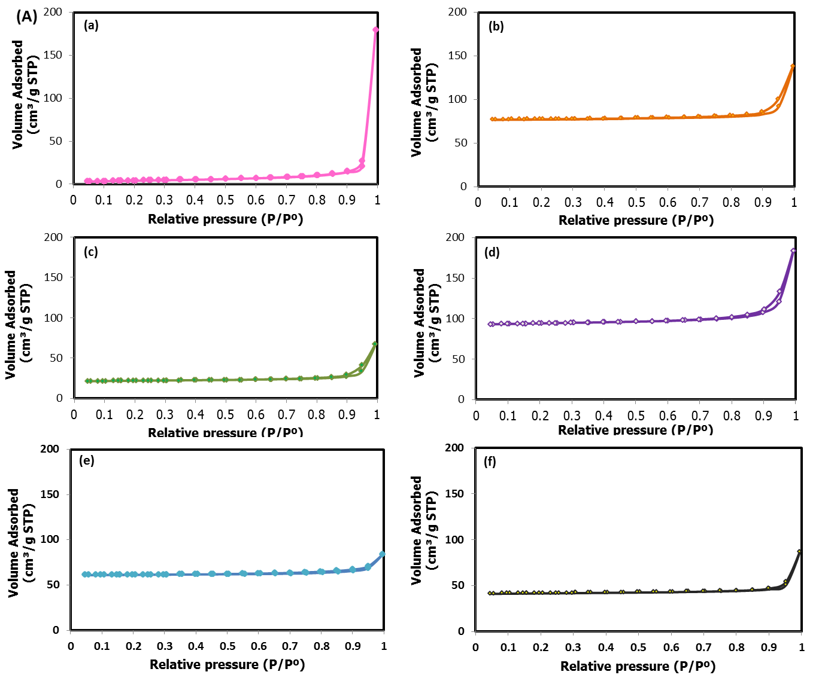

**Figure S1:** N2-physisorption of (a) Dolomite, (b) Cu/Dol, (c) Ni/Dol, (d) Co/Dol, (e) Fe/Dol and (f) Zn/Dol.

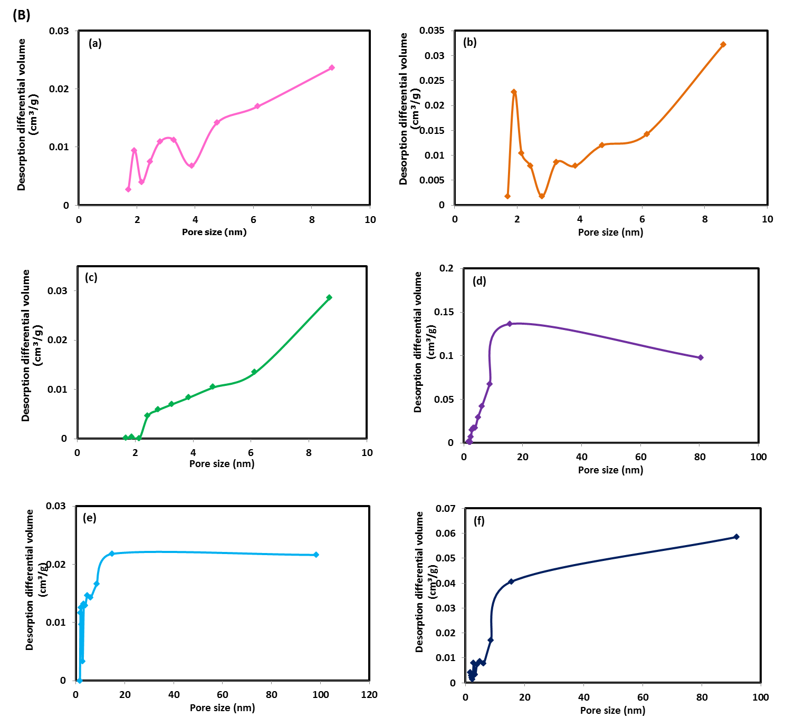

**Figure S2:** Pore size distribution of (a) Dolomite, (b) Cu/Dol, (c) Ni/Dol, (d) Co/Dol, (e) Fe/Dol and (f) Zn/Dol.



**TGA and DTG curves of (a) uncalcined dolomite**

**Figure S3:** TGA and DTG curves of dolomite catalyst.