**SUPPLEMENTARY FILE**

**Synthesis, characterization and biological evaluation of N-Mannich base derivatives of 2-phenyl-2-imidazoline as potential antioxidants, enzyme inhibitors, antimicrobials, cytotoxic and anti-inflammatory agents.**

Samra Farooq1a, Ihsan-Ul-Haq1b, Naseem Ullah*1

1 Department of Pharmacy, Faculty of Biological Sciences, Quaid-I-Azam University, Islamabad 45320, Pakistan

a[samrafarooq@bs.qau.edu.pk](mailto:samrafarooq@bs.qau.edu.pk); b [ihaq@qau.edu.pk](mailto:ihaq@qau.edu.pk)

**\*** Author to whom correspondence should be addressed.

Email: [nullah@qau.edu.pk](mailto:nullah@qau.edu.pk)

1. 1H NMR (400 MHz, CDCl3) of SP1



1. 13C NMR (101 MHz, CDCl3) of SP1

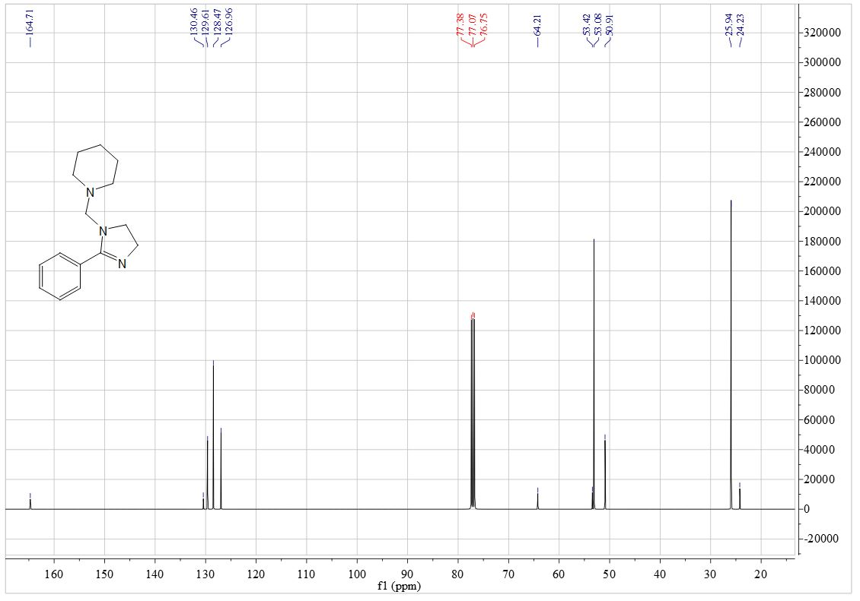

1. 1H NMR (400 MHz, CDCl3) of SP2



1. 13C NMR (101 MHz, CDCl3) of SP2

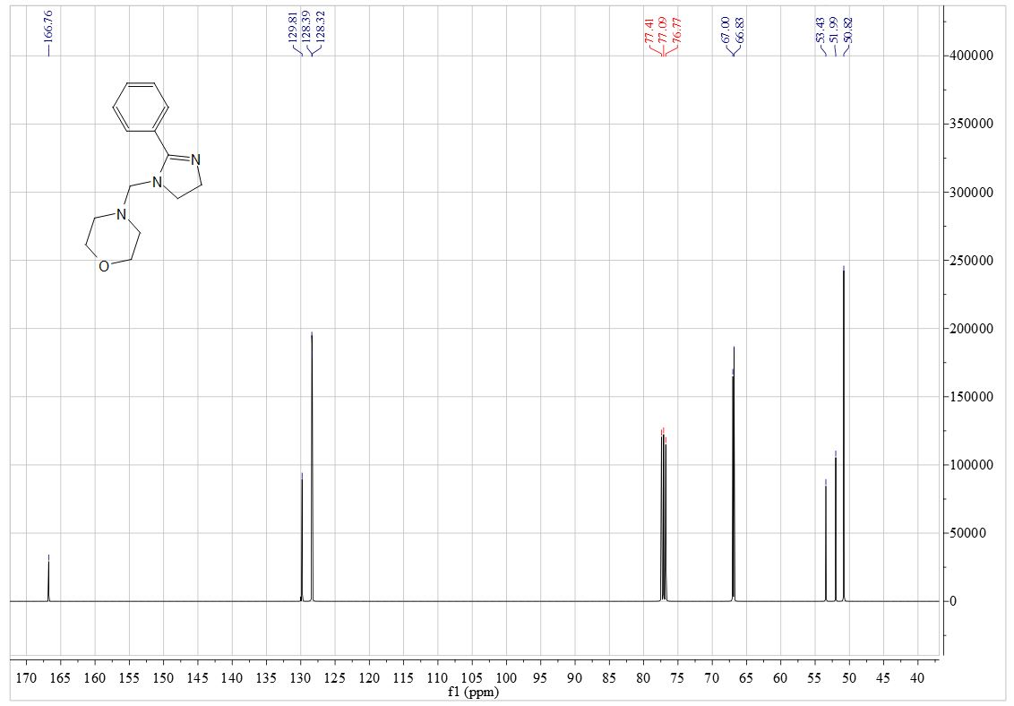

1. 1H NMR (400 MHz, CDCl3) of SP3



1. 13C NMR (101 MHz, CDCl3) of SP3

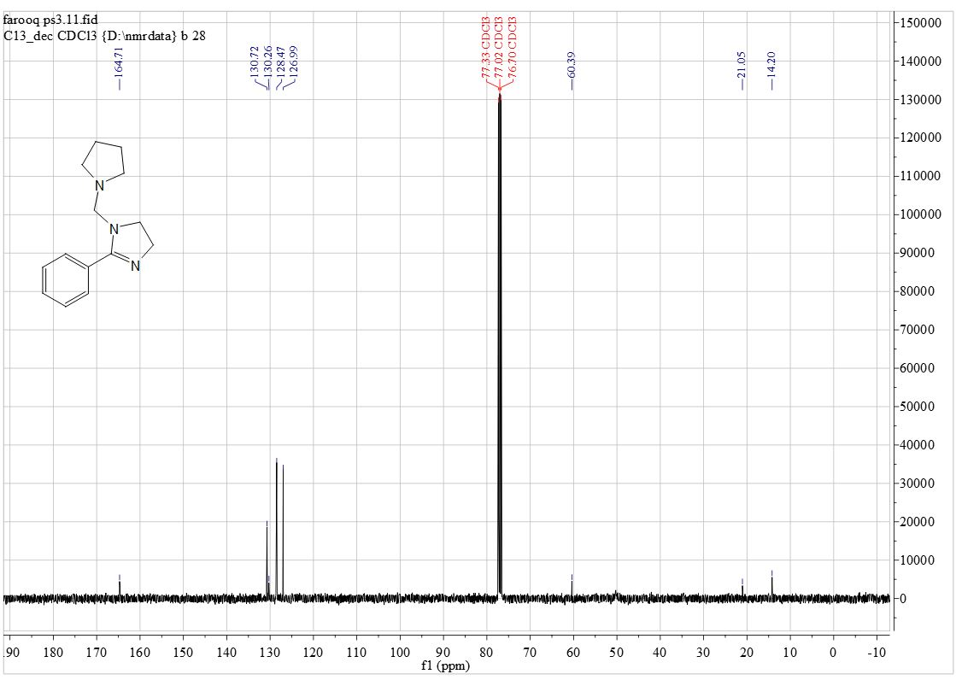

1. 1H NMR (400 MHz, CDCl3) of SP4



1. 13C NMR (101 MHz, CDCl3) of SP4

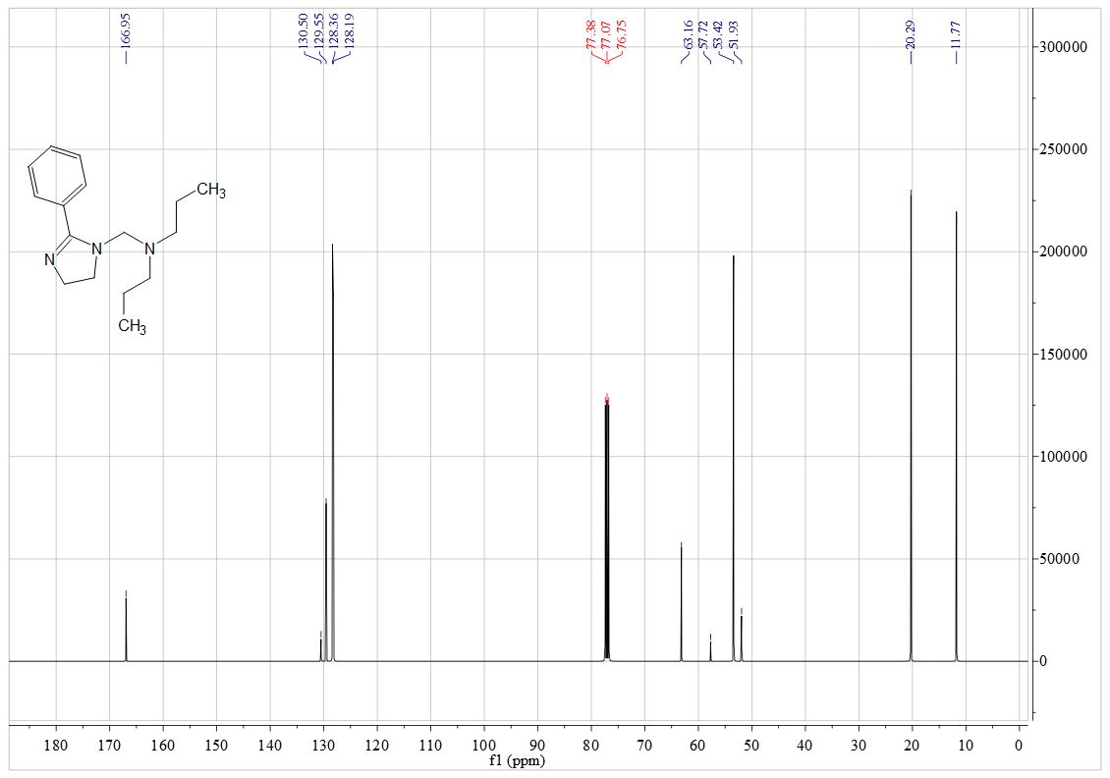

1. 1H NMR (600 MHz, CDCl3) of SP5



1. 13C NMR (151 MHz, CDCl3) of SP5

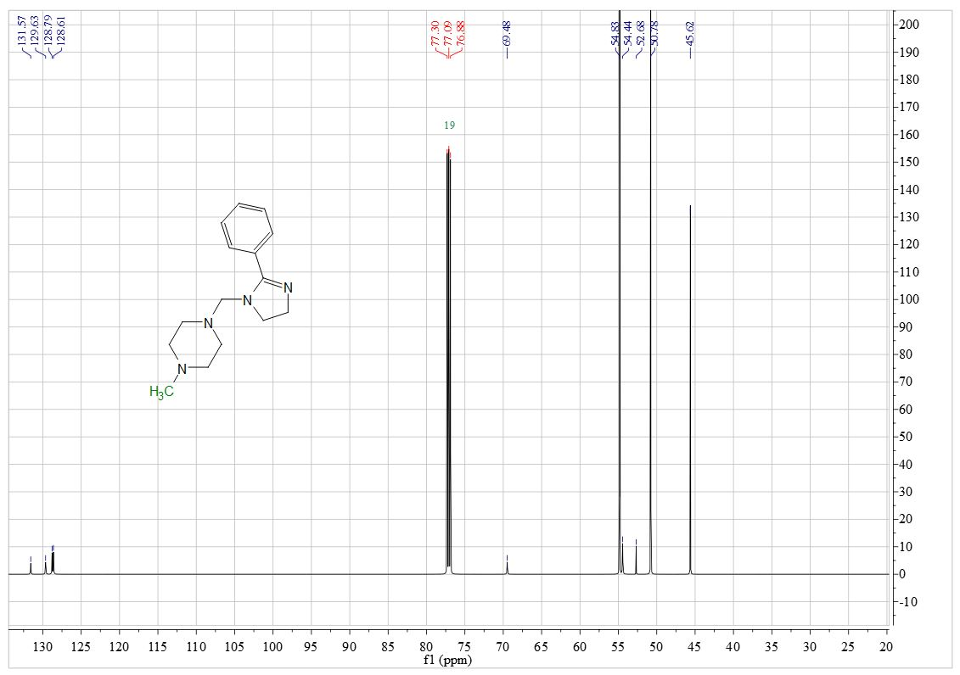

1. 1H NMR (400 MHz, CDCl3) of SP6



1. 13C NMR (101 MHz, CDCl3) of SP6

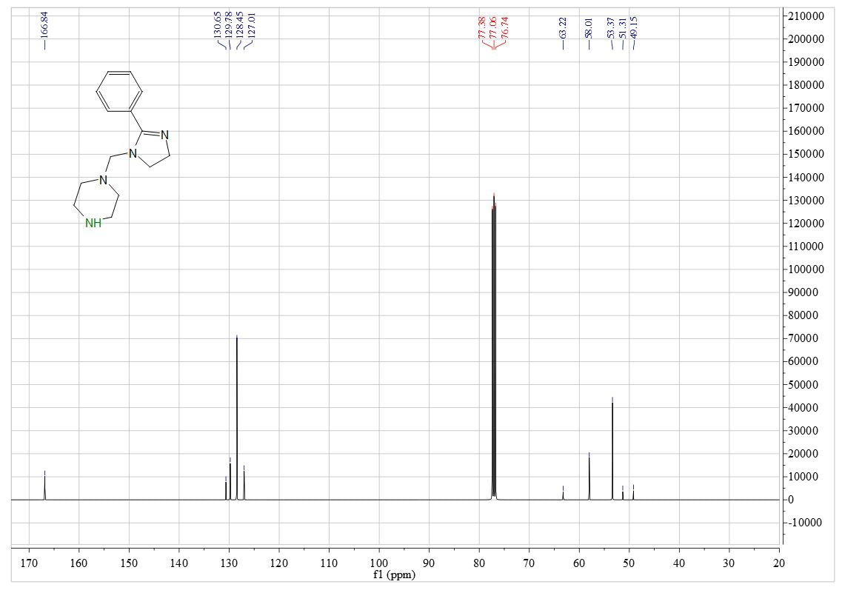

1. 1H NMR (400 MHz, CDCl3) of SP7



1. 13C NMR (101 MHz, CDCl3) of SP7

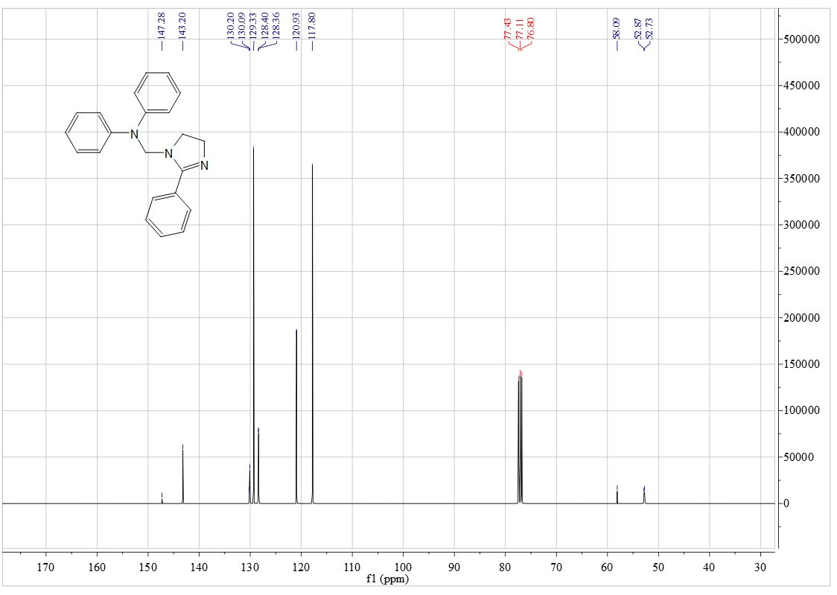

1. 1H NMR (600 MHz, CDCl3) of SP8



1. 13C NMR (151 MHz, CDCl3) of SP8

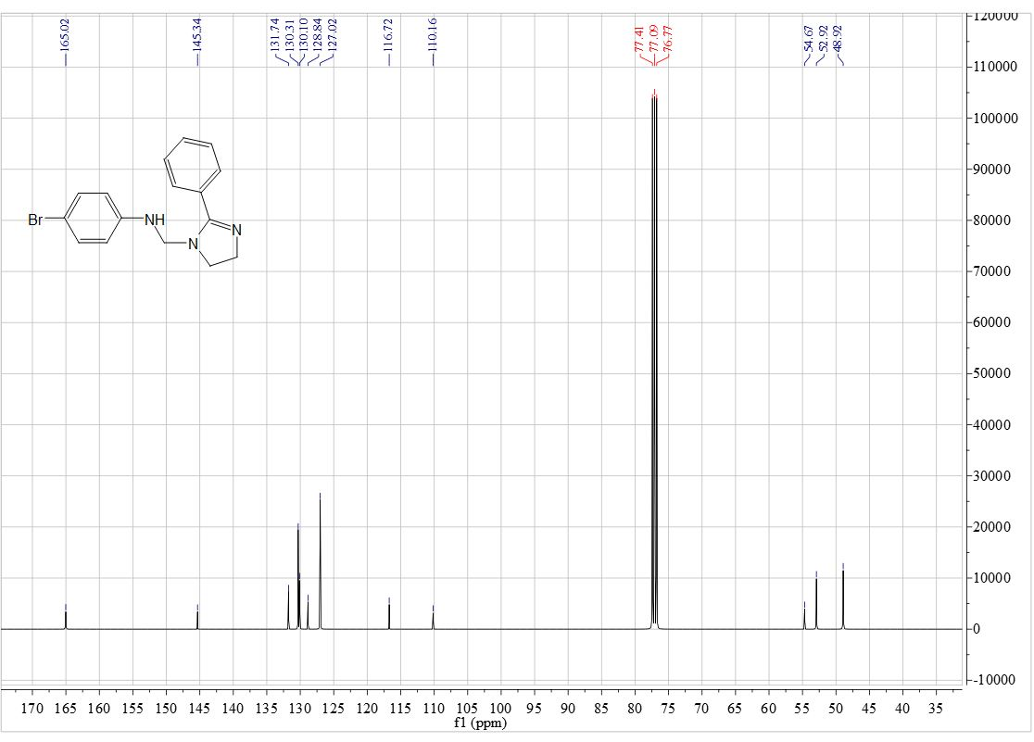

1. 1H NMR (400 MHz, CDCl3) of SP9



1. 13C NMR (101 MHz, CDCl3) of SP9

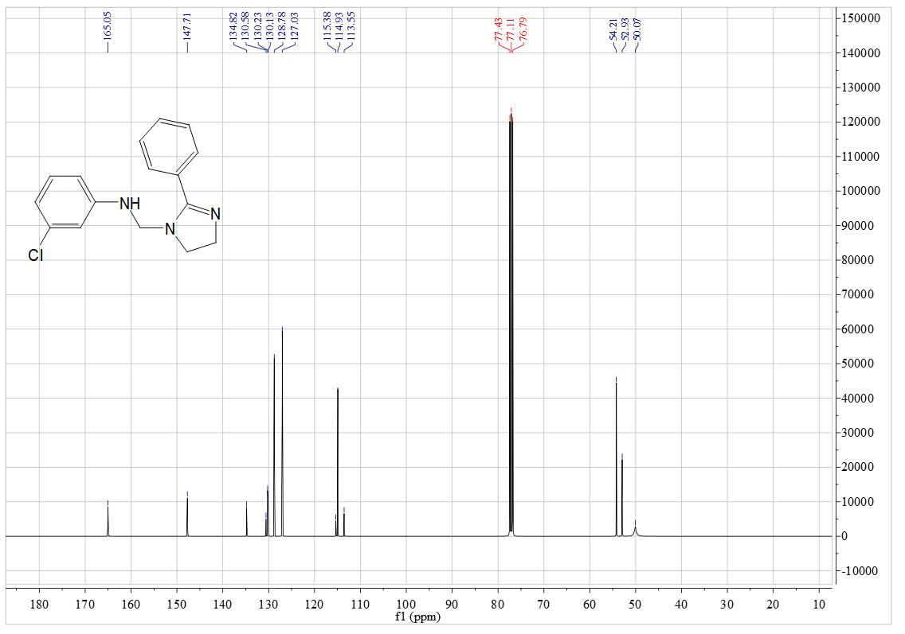

1. 1H NMR (400 MHz, CDCl3) of SP10



1. 13C NMR (101 MHz, CDCl3) of SP10

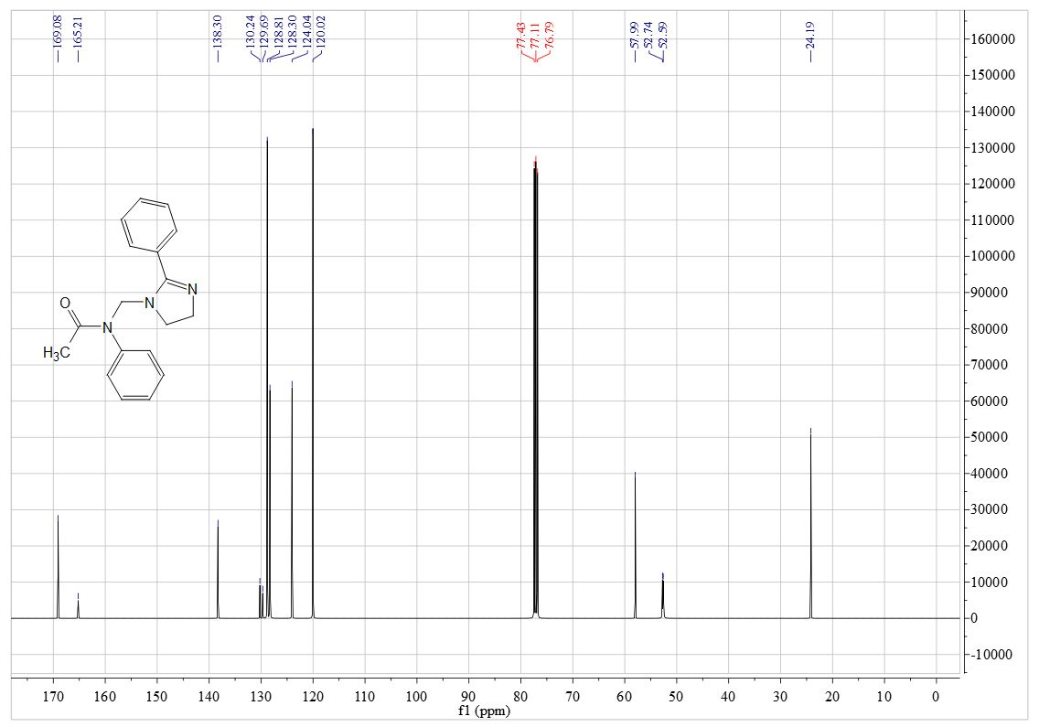

1. 1H NMR (600 MHz, CDCl3) of SP11



1. 13C NMR (151 MHz, CDCl3) of SP11



1. 1H NMR (600 MHz, CDCl3) of SP12



1. 13C NMR (151 MHz, CDCl3) of SP12

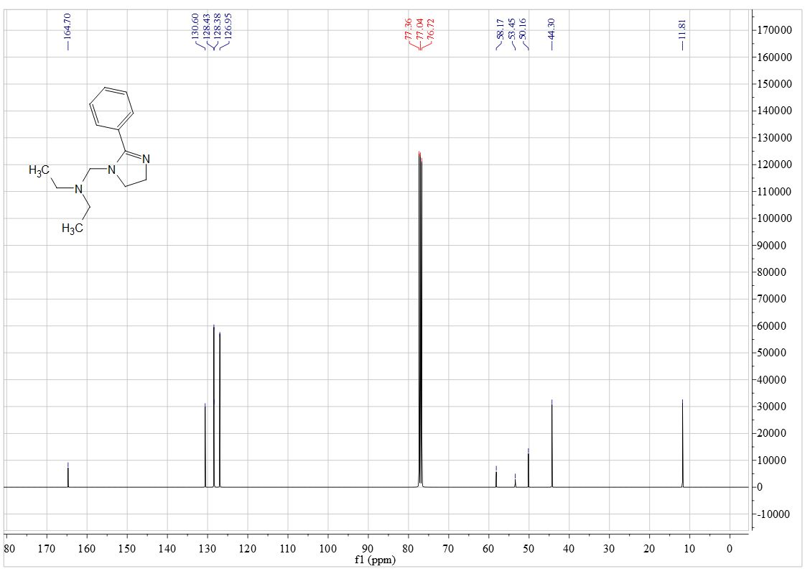

1. 1H NMR (600 MHz, CDCl3) of SP13



1. 13C NMR (151 MHz, CDCl3) of SP13

