**Supplementary Information**

**Cytoprotective organoselenium compounds for oligodendrocytes**

Saad Shaaban,a,b[1]Amira Zarrouk,c,d Dominique Vervandier-Fasseur,e Yasair S.Al-Faiyz,a Hany El-Sawy,a,f Ismail Althagafi,g Pierre Andreoletti,c and Mustapha Cherkaoui-Malkic**

*a Department of Chemistry, College of Science, King Faisal University, P.O. Box 380 Al-Ahsa, 31982 Saudi Arabia*

*bOrganic Chemistry Division, Department of Chemistry, Faculty of Science, Mansoura University, Egypt*

*cUniv. Bourgogne-Franche Comté, Laboratoire BioPeroxIL (Biochimie du Peroxysome, Inflammation et Métabolisme Lipidique), Dijon, France*

*dFaculté de Médecine, Laboratoire de Nutrition-Aliments Fonctionnels et Santé Vasculaire (LR12ES05), Monastir &Faculté de Médecine, Université de Monastir, Sousse, Tunisia*

*eInstitut de ChimieMoléculaire de l'Université de Bourgogne, UMR6302, CNRS, Université Bourgogne Franche-Comté, Dijon, France*

*fBiochemistry division,**Department of Chemistry, Faculty of Science, Tanta University, Tanta, Egypt*

g*Chemistry Department, Faculty of applied science, Umm Al-Qura University, Makkah, Saudi Arabia*

**Content of supporting information**

|  |  |  |
| --- | --- | --- |
| **1** | **Docking patterns (panel A) and surface maps (panel B) for compounds 4c, 12 and 15 against 3C1L protein** | **.** |
| **2** | **S 2. Docking patterns (panel A) and surface maps (panel B) for compounds 4c, 12, and 15 conformers against 2F8A protein** |  |
| **3** | **Copies of HRMS, 1H and 13C NMR spectra of new compounds** |  |

|  |  |
| --- | --- |
| **S1. Docking patterns (panel A) and surface maps (panel B) for selected conformers of compounds 4c, 12, and 15 against 3C1L protein** | |
| **A** | **B** |
| **4c** |  |
| **12** |  |
| **15** |  |

|  |  |
| --- | --- |
| **S 2. Docking patterns (panel A) and surface maps (panel B) for selected conformers of compounds 4c, 12, and 15 against 2F8A protein** | |
| **A** | **B** | **B** |
| **4c** |  |
| 12 |  |
| **15** |  |

**S3. Copies of HRMS, 1H and 13C NMR spectra of new compounds**

***N-((1-(tert-butyl)-1H-tetrazol-5-yl)methyl)-4-((2,2-diethoxyethyl)selanyl)aniline (5)***



HRMS of compound 5

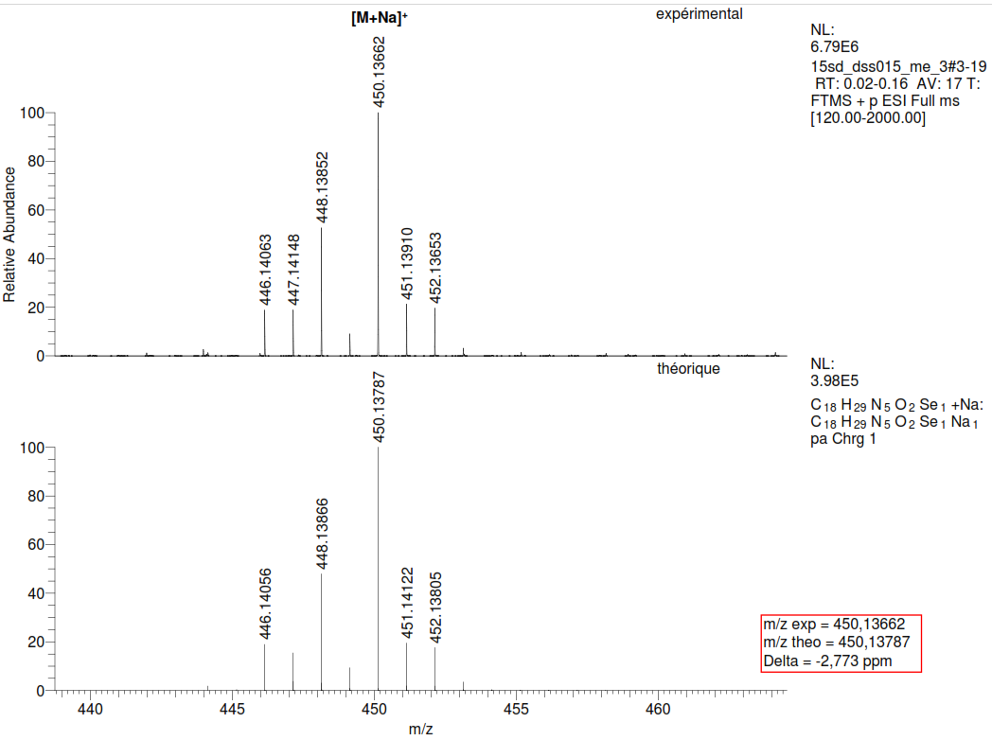

1HNMR of compound 5

13CNMR of compound 5

***N-((1-(tert-butyl)-1H-tetrazol-5-yl)(4-chlorophenyl)methyl)-4-((2,2-diethoxyethyl)selanyl)aniline*** *(****6****)*



HRMS of compound 6

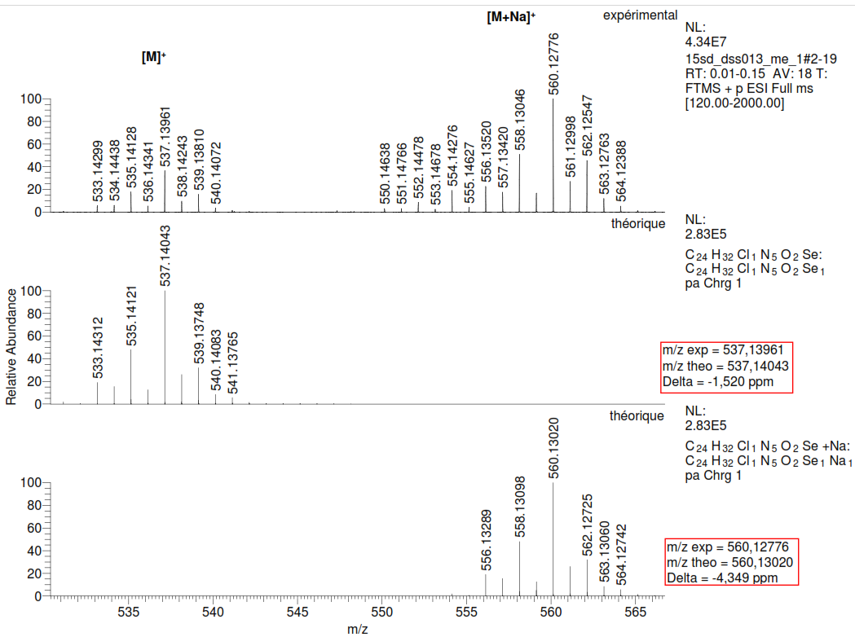

1HNMR of compound 6

13CNMR of compound 6

***N-((1-(tert-butyl)-1H-tetrazol-5-yl)(4-methoxyphenyl)methyl)-4-((2,2-diethoxyethyl)selanyl)aniline (7)***



HRMS of compound 7

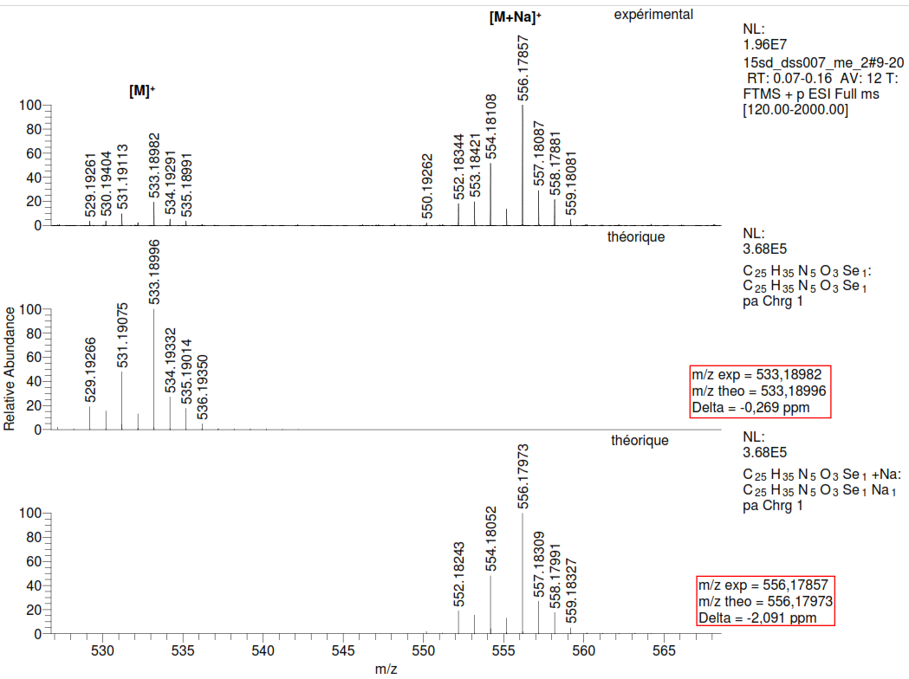

1HNMR of compound 7

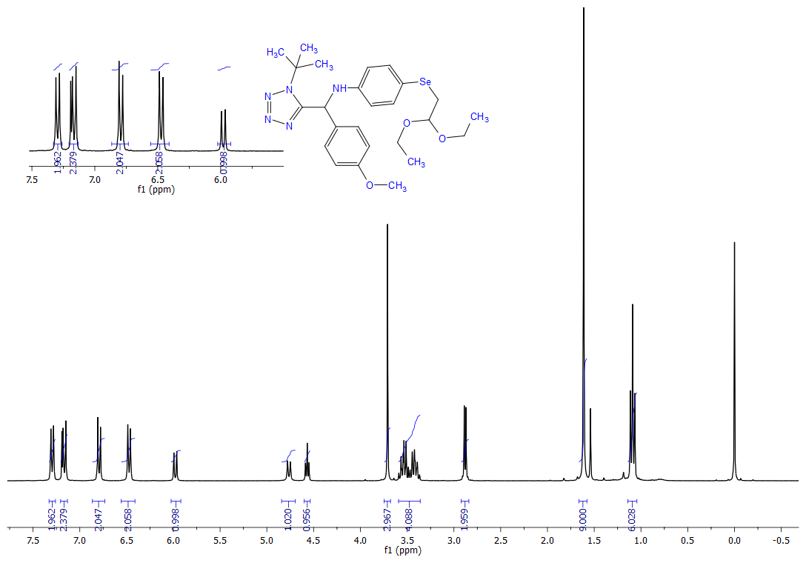

13CNMR of compound 7

***4-((4-bromobenzyl)selanyl)-N-((1-(tert-butyl)-1H-tetrazol-5-yl)methyl)aniline (8)***



HRMS of compound 8

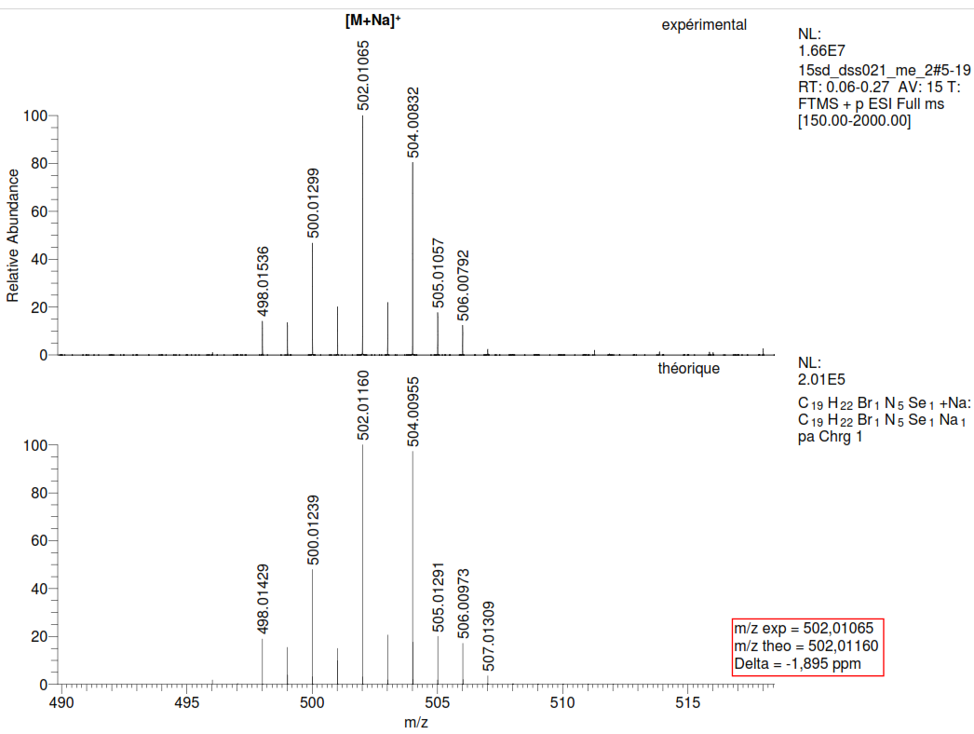

1HNMR of compound 8

13CNMR of compound 8

***4-((4-bromobenzyl)selanyl)-N-((1-(tert-butyl)-1H-tetrazol-5-yl)(4-chlorophenyl)methyl)aniline (9)***



HRMS of compound 9

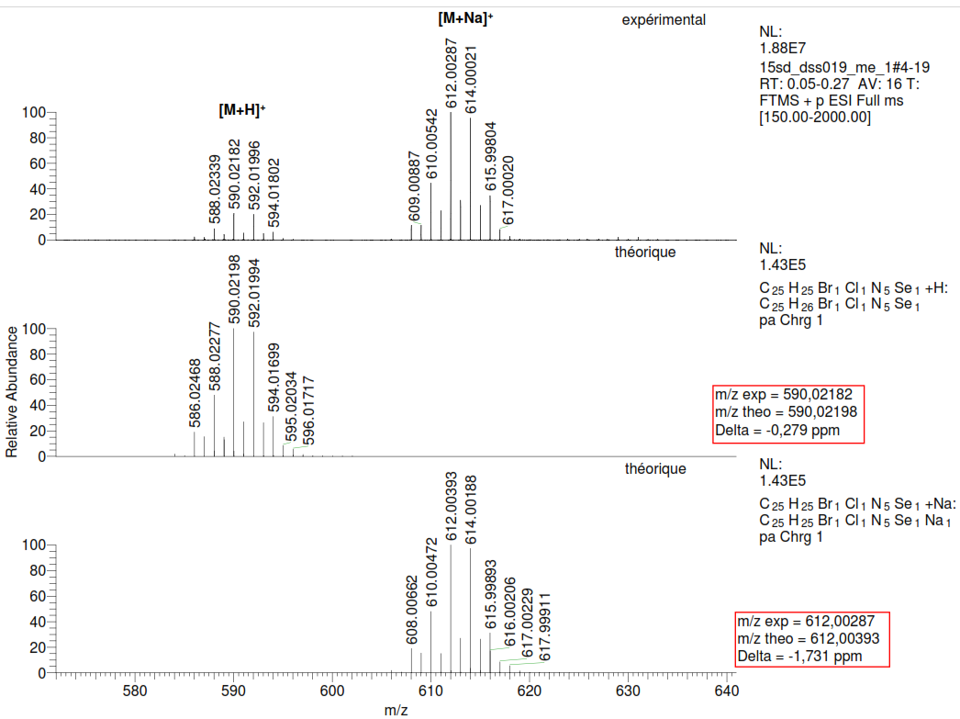

1HNMR of compound 9

13CNMR of compound 9

***4-((4-bromobenzyl)selanyl)-N-((1-(tert-butyl)-1H-tetrazol-5-yl)(4-methoxyphenyl)methyl)aniline (10)***



HRMS of compound 10

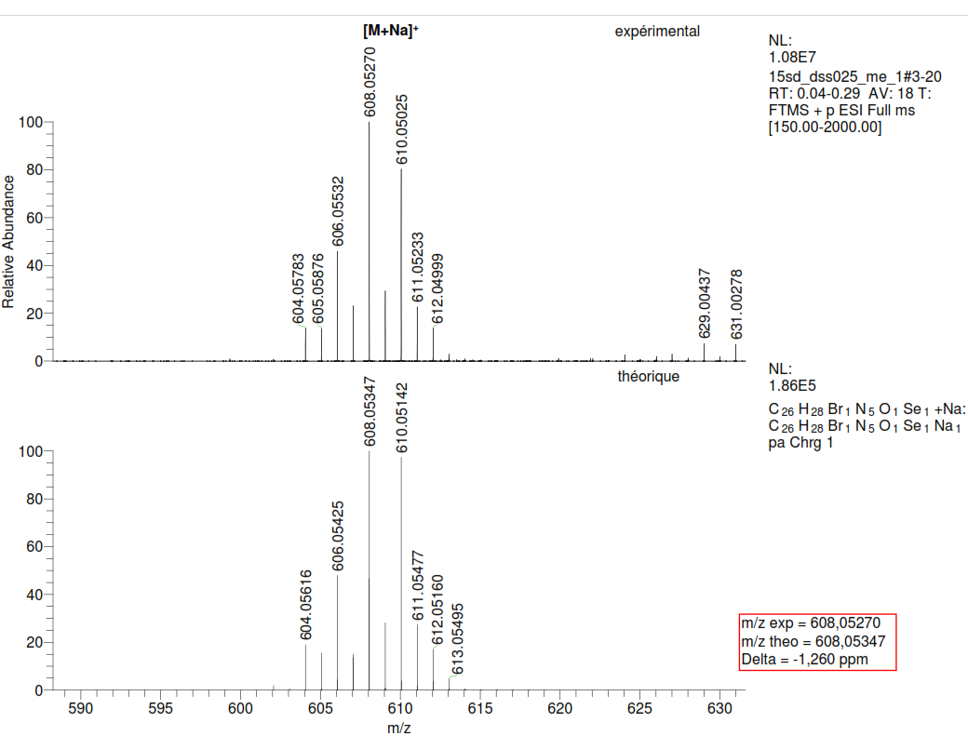

1HNMR of compound 10

13CNMR of compound 10

***N-(tert-butyl)-2-(N-(4-((2,2-diethoxyethyl)selanyl)phenyl)acetamido)acetamide (11)***



HRMS of compound 11

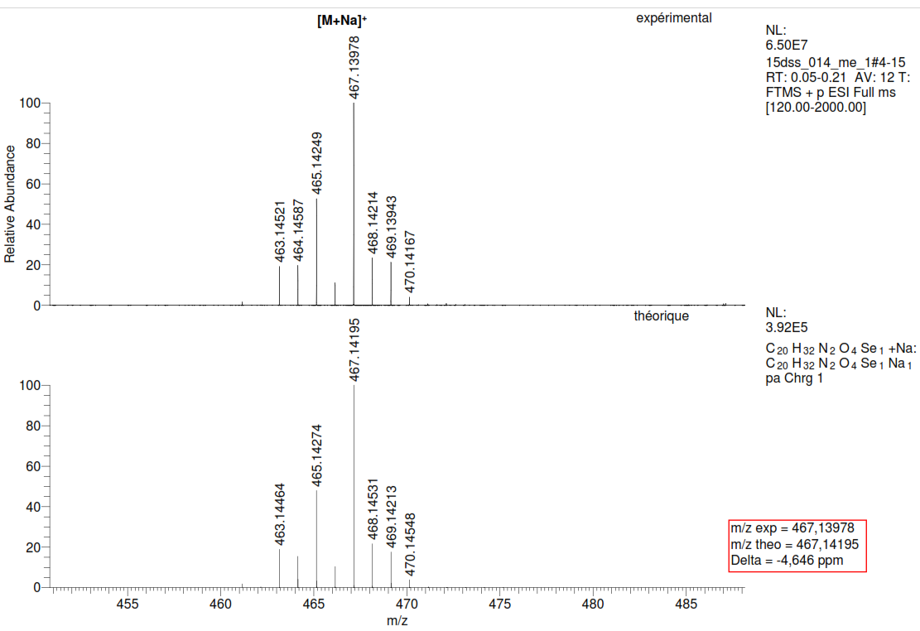

1HNMR of compound 11

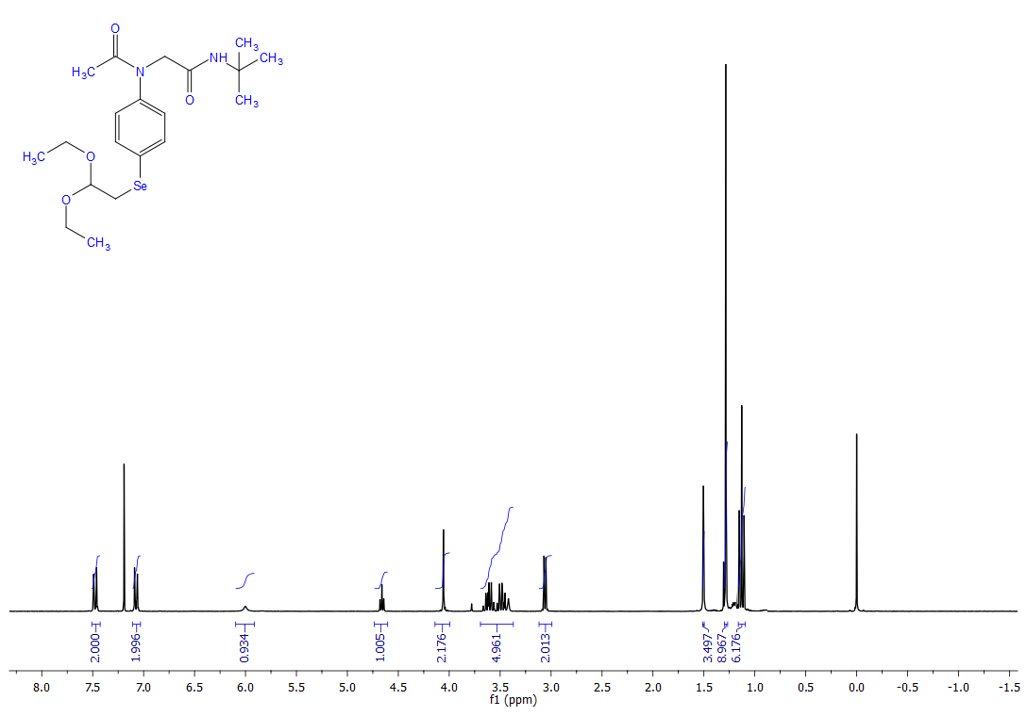

13CNMR of compound 11

***N-(tert-butyl)-2-(4-chlorophenyl)-2-(N-(4-((2,2-diethoxyethyl)selanyl)phenyl)acetamido)acetamide (12)***



HRMS of compound 12

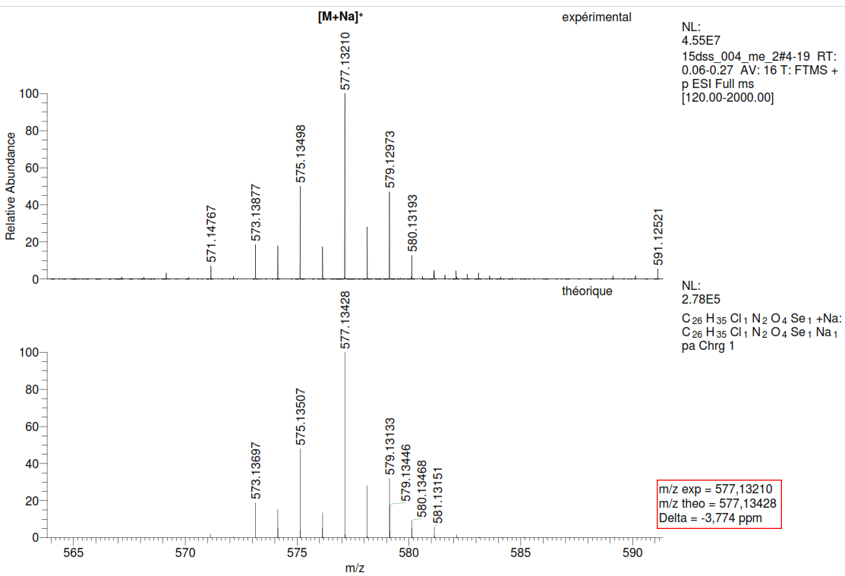

1HNMR of compound 12

13CNMR of compound 12

***N-(tert-butyl)-2-(N-(4-((2,2-diethoxyethyl)selanyl)phenyl)acetamido)-2-(4-hydroxyphenyl)acetamide (13)***



HRMS of compound 13

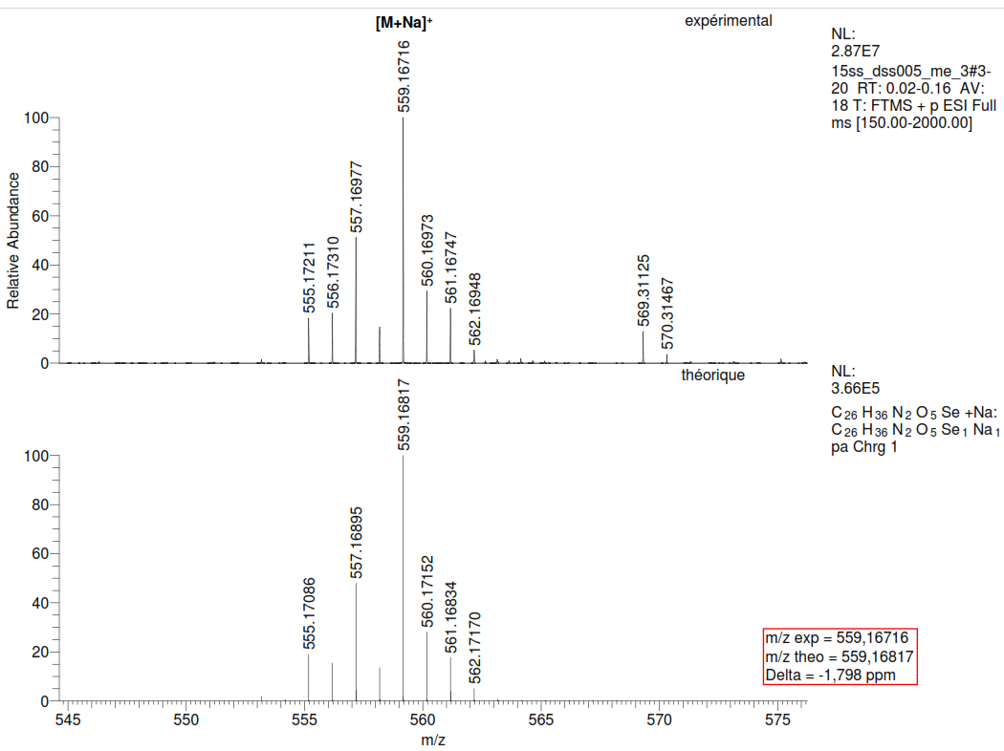

1HNMR of compound 13

13CNMR of compound 13

***N-(tert-butyl)-2-(N-(4-((2,2-diethoxyethyl)selanyl)phenyl)acetamido)-2-(4-methoxyphenyl)acetamide (14)***



HRMS of compound 14

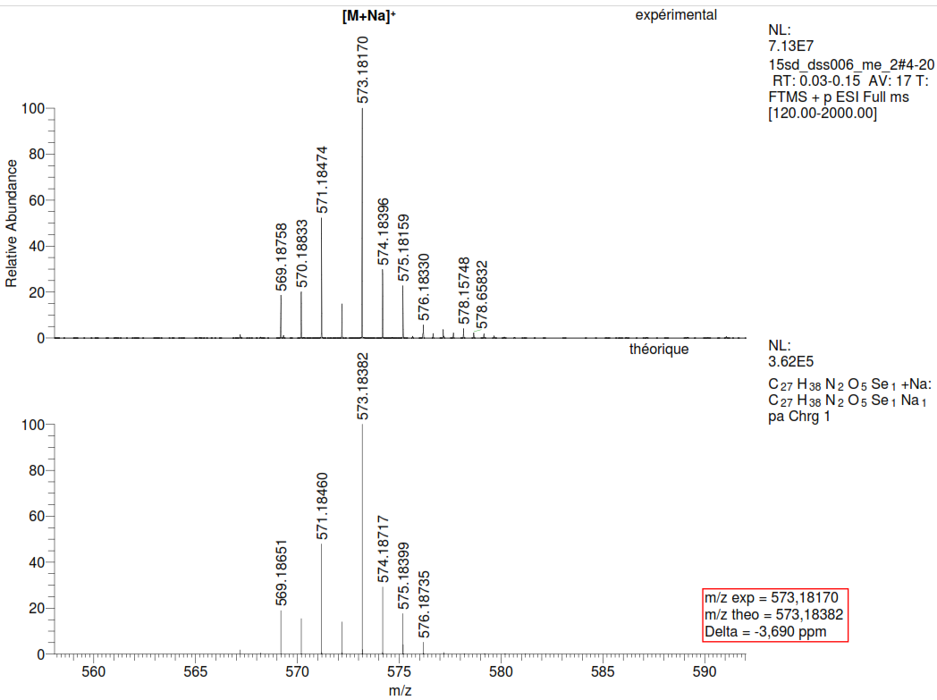

1HNMR of compound 14

13CNMR of compound 14

***N-(4-((4-bromobenzyl)selanyl)phenyl)-N-(2-(tert-butylamino)-2-oxoethyl)acetamide (15)***



HRMS of compound 15

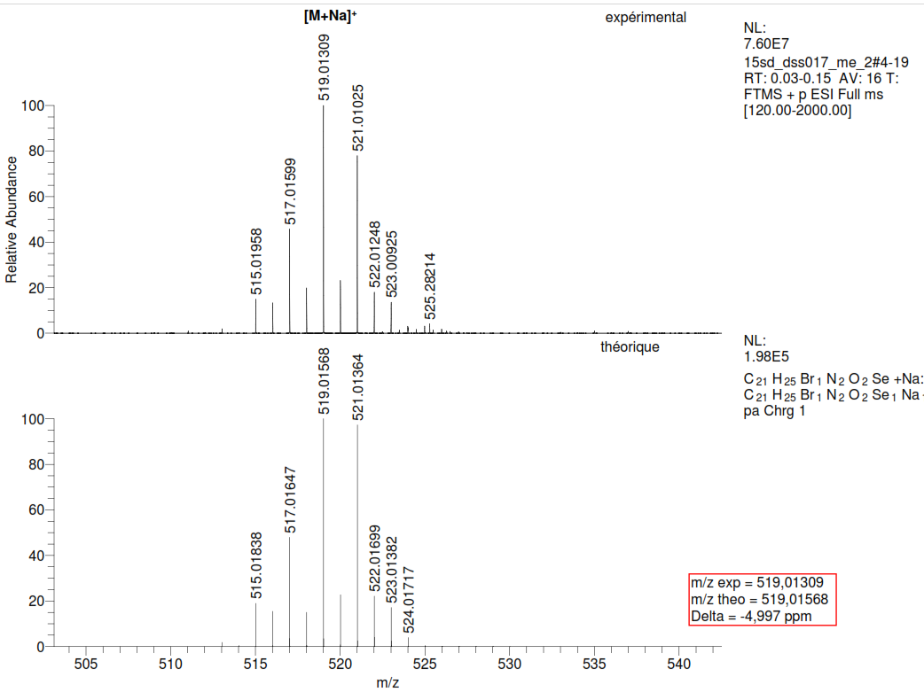

1HNMR of compound 15

13CNMR of compound 15

***2-(N-(4-((4-bromobenzyl)selanyl)phenyl)acetamido)-N-(tert-butyl)-2-(4-chlorophenyl)acetamide (16)***



HRMS of compound 16

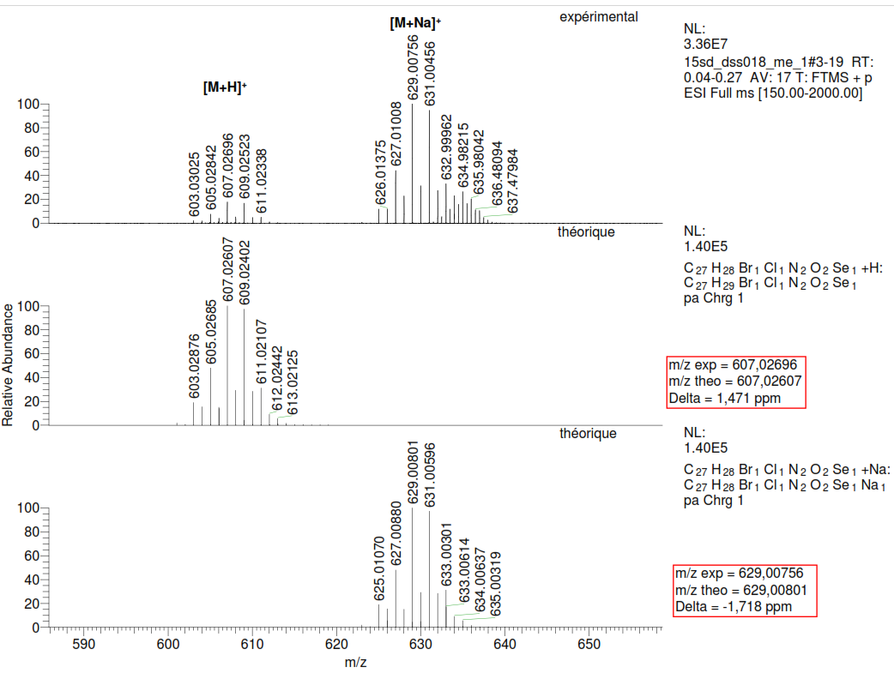

1HNMR of compound 16

13CNMR of compound 16

***2-(N-(4-((4-bromobenzyl)selanyl)phenyl)acetamido)-N-(tert-butyl)-2-(4-methoxyphenyl)acetamide (17)***



HRMS of compound 17

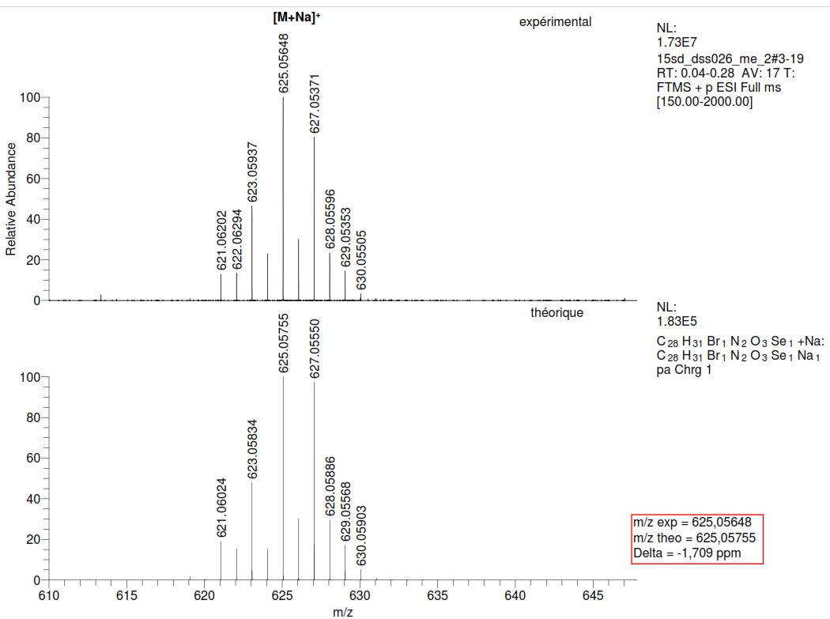

1HNMR of compound 17

13CNMR of compound 17

***(E)-2-((4-((4-chlorobenzylidene)amino)phenyl)selanyl)-3-methylnaphthalene-1,4-dione (18)***



HRMS of compound 18

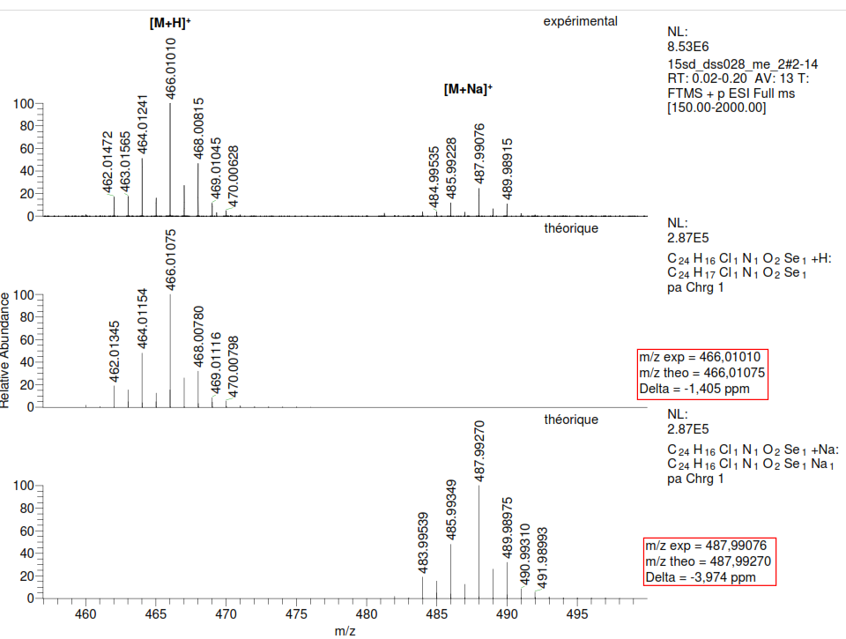

1HNMR of compound 18

13CNMR of compound 18

***(E)-2-((4-((4-methoxybenzylidene)amino)phenyl)selanyl)-3-methylnaphthalene-1,4-dione (19)***



HRMS of compound 19

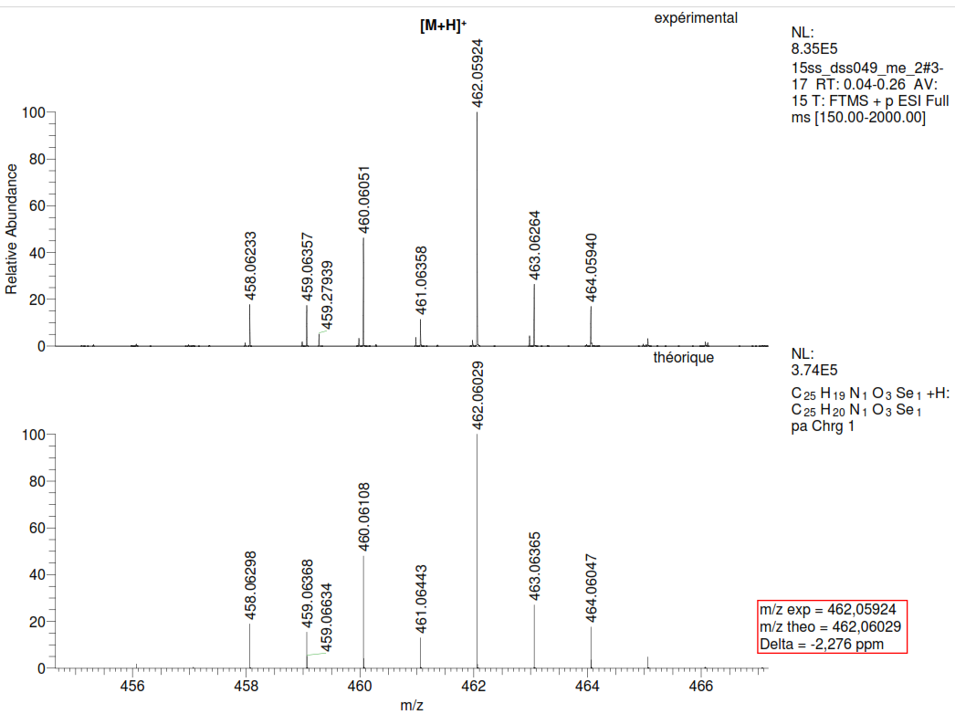

1HNMR of compound 19

13CNMR of compound 19

1. *Corresponding author: Saad Shaaban Tel.: +966551821475; E-mail address:* [*sibrahim@kfu.edu.sa*](mailto:sibrahim@kfu.edu.sa)*;* [*dr_saad_chem@mans.edu.eg*](mailto:dr_saad_chem@mans.edu.eg)

   \*\**Corresponding author*: *Mustapha Cherkaoui-Malki, Laboratoire BioPeroxIL EA7270, Univ. Bourgogne-Franche Comté, Faculté des Sciences Gabriel, 6 Bd Gabriel, 21000 Dijon, France. Tel.: 33380396205;* [*malki@u-bourgogne.fr*](mailto:malki@u-bourgogne.fr)