**Fermented whey as natural descaling agent: Electrochemical and microscopical analysis**

Aisholpan Kaziullayeva, Kayode Olaifa, Enrico Marsili*

*School of Engineering and Digital Sciences, Nazarbayev University, 53 Kabanbay Batyr Avenue, Nur-Sultan 010000, Kazakhstan*

**Supplementary material**

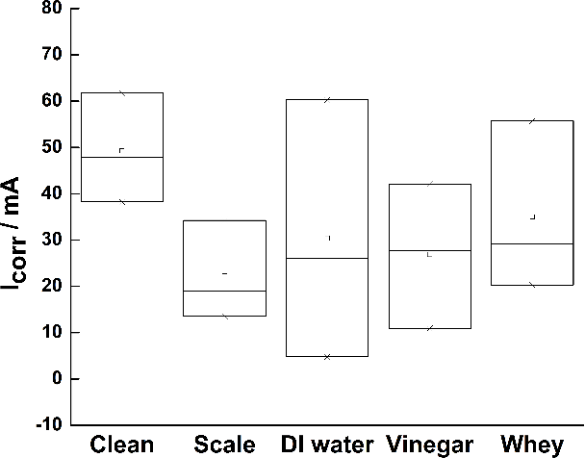

**Figure S1: $I_{corr}$**  of mild steel coupons: clean, scaled and cleaned with DI water, vinegar, and whey (pH ~ 2.8).

**Table S1:** Effective capacitance $Q_{eff}$ of clean, scaled, and descaled mild steel coupons calculated from equivalent circuit. Clean electrodes are significantly different from scaled and descaled coupons. N = number of independent replicates; a = non-ideality constant of the non-ideal capacitance.

|  |  |  |  |
| --- | --- | --- | --- |
| Electrode | N total | (mF cm-2) | a |
| Clean | 3 | 2.88±1.17 | 0.72±0.12 |
| Scaled (no treatment) | 4 | 41.44±12.90 | 0.77±0.12 |
| Scaled (whey treated) | 4 | 13.42±13.35 | 0.74±0.11 |

**Table S2:** ANOVA for $Q_{eff}$ of clean, scaled, and descaled mild steel coupons. Null hypothesis: no difference in the mean of clean, scaled, and descaled mild steel coupons. Alternate hypothesis: there is difference in the mean interfacial capacitance of clean, scaled, and descaled mild steel coupons. As F>Fcrit, we accept the alternate hypothesis; there is a significant difference between the mean effective capacitance of clean, scaled, and descaled mild steel coupons.

|  |  |  |  |  |  |  |
| --- | --- | --- | --- | --- | --- | --- |
| Source of variation | Sum of squares | Degrees of freedom | Mean square | Mean square ratio (F) | P-value | Fcrit |
| Between groups | 2884.81 | 2 | 1442.4 | **11.1** | 0.0048 | **4.6** |
| Within groups | 1036.4 | 8 | 129.5 |  |  |  |
| Total | 3921.2 | 10 |  |  |  |  |