**1. Spectral characterization of IS1-5**

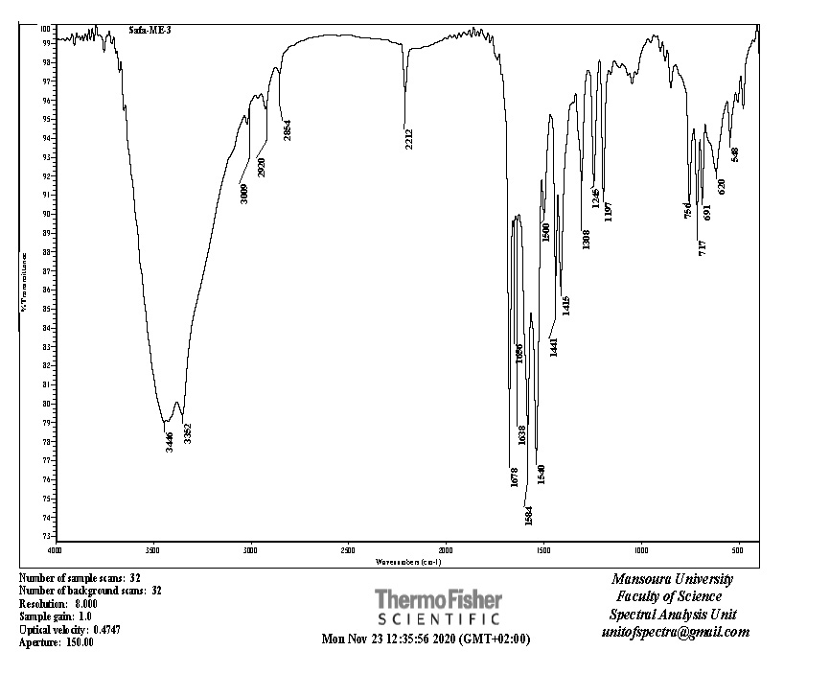



**Figure (1): IR spectrum of compound IS-1**

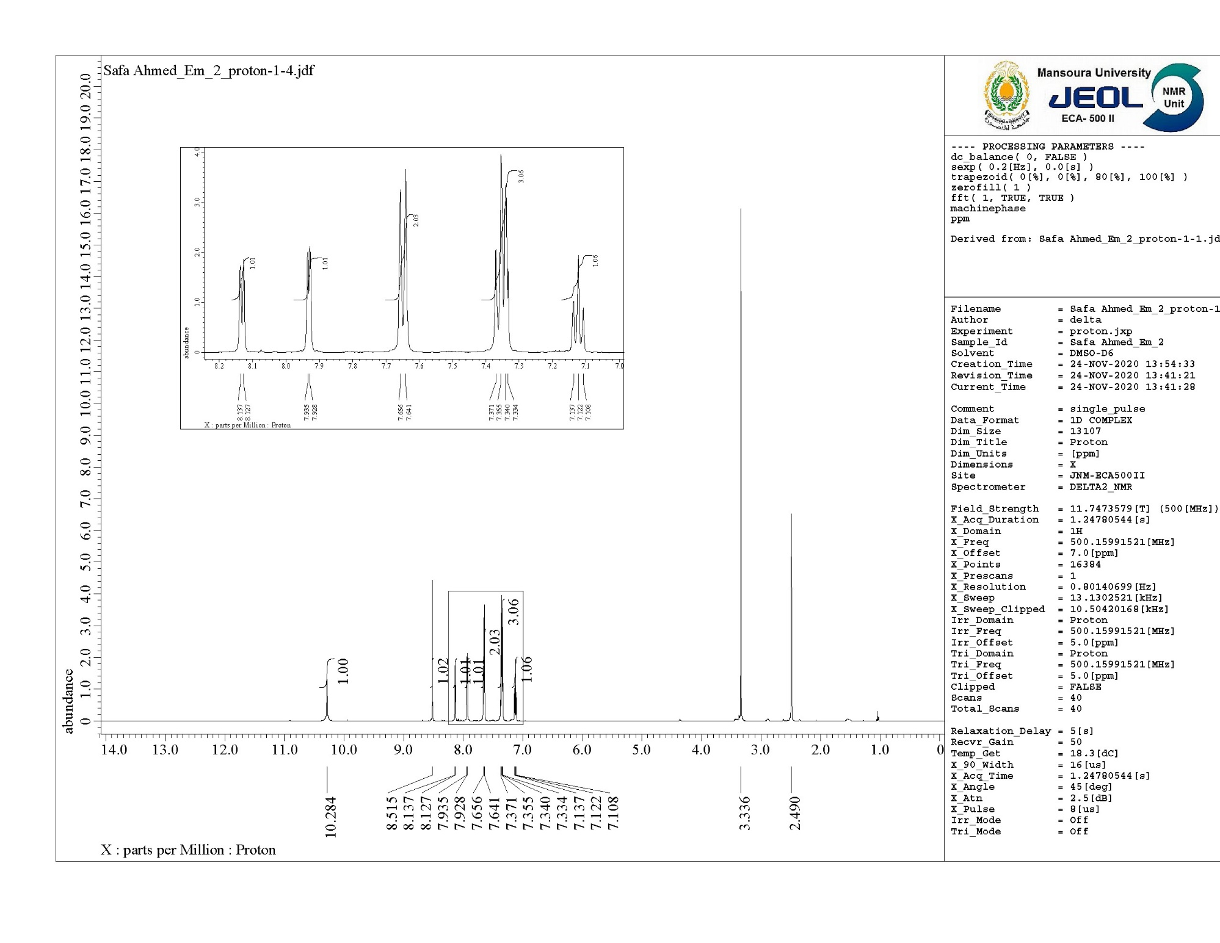



**Figure (2): 1H NMR spectrum of compound IS-1**

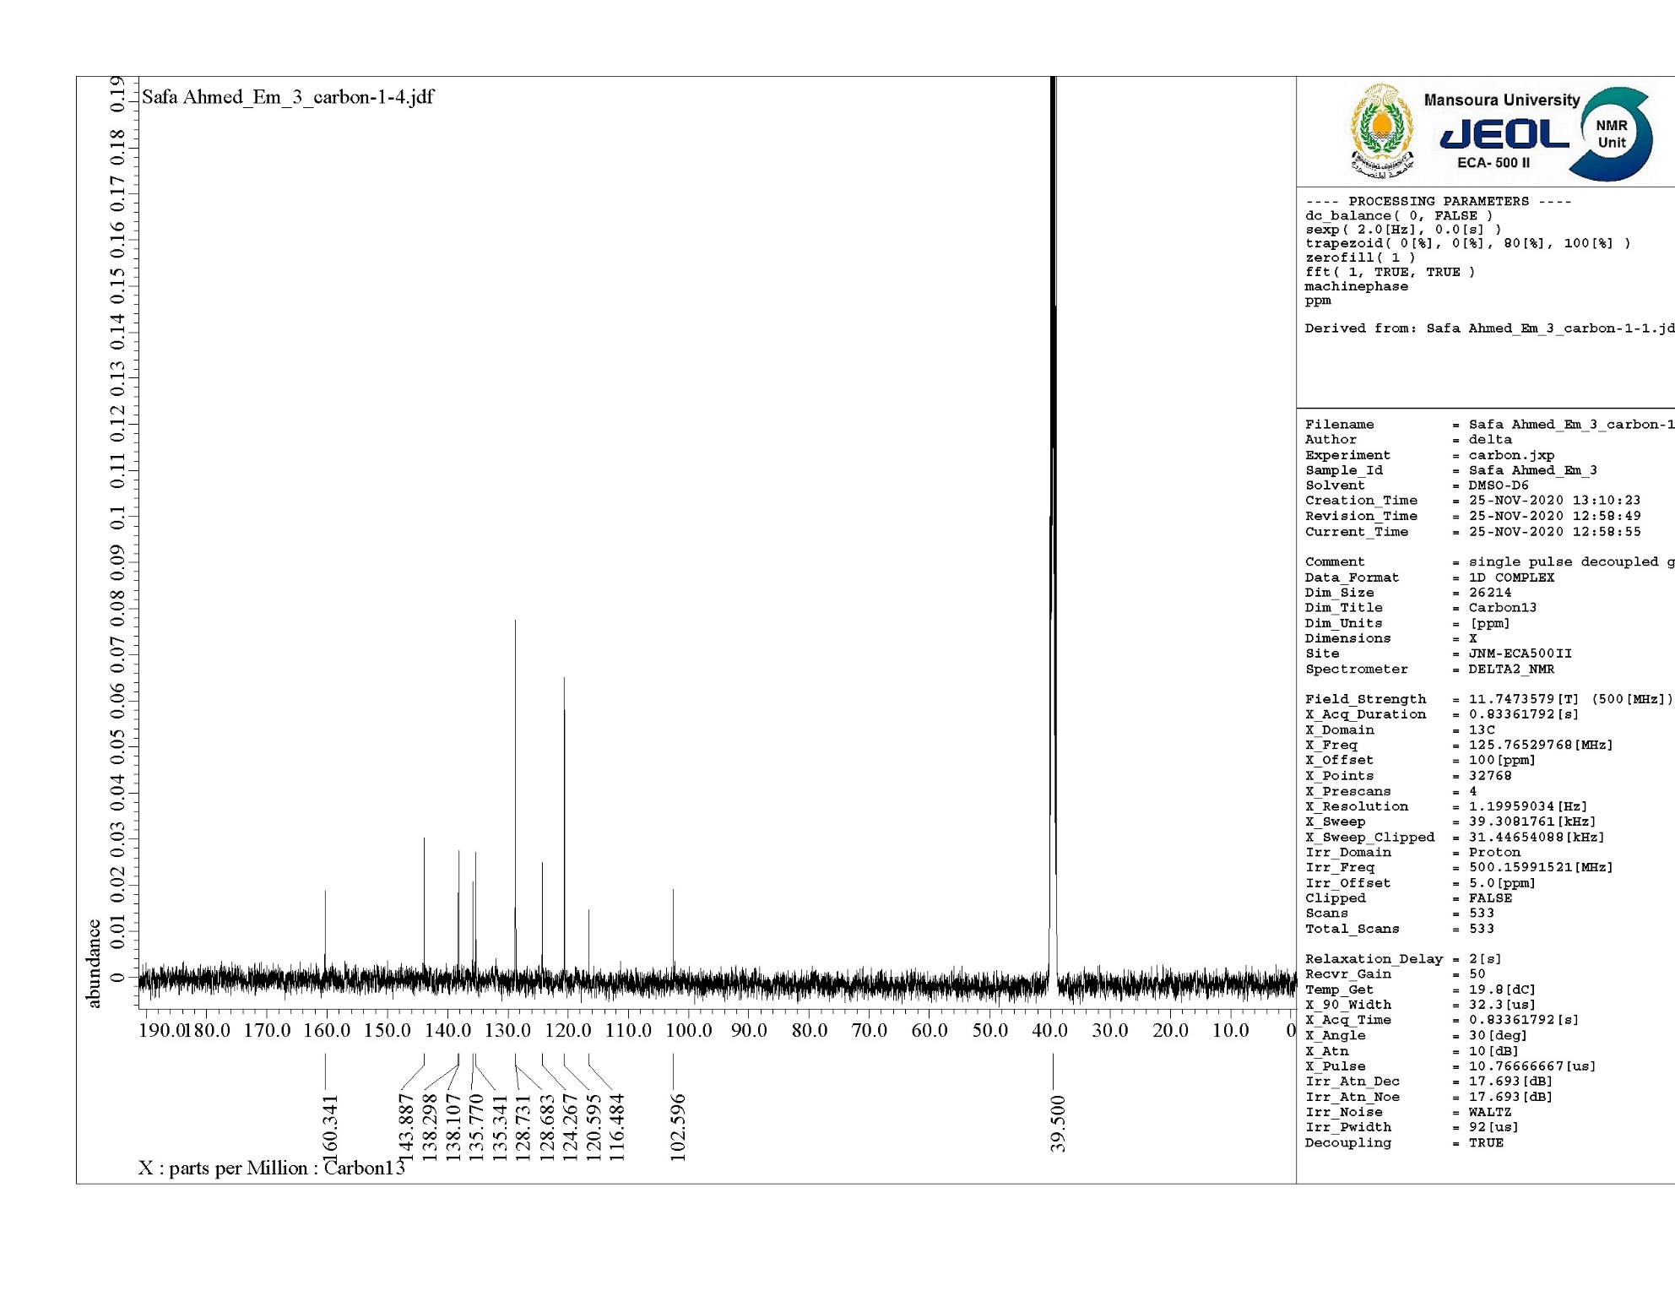



**Figure (3): 13C NMR spectrum of compound IS-1**



**Figure (4): Mass analysis of compound IS-1**

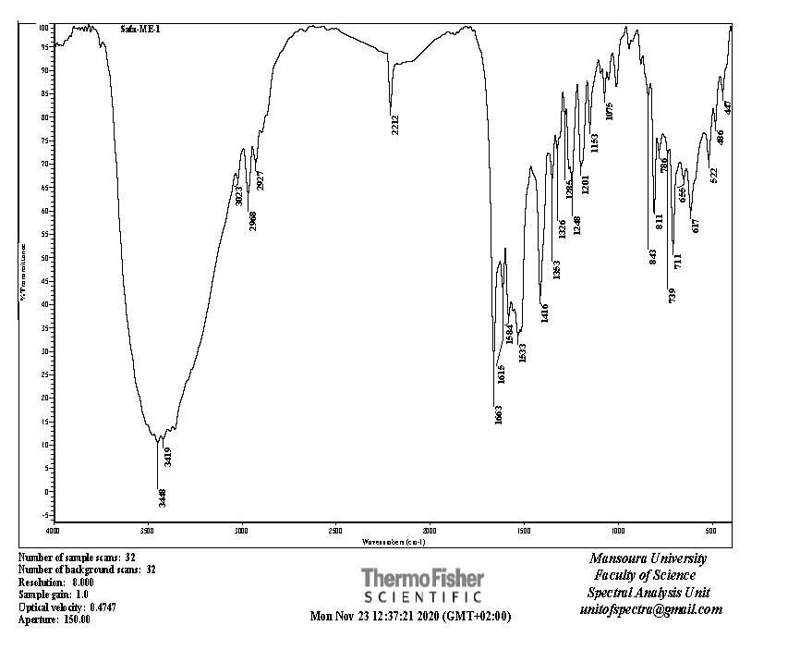



**Figure (5): IR spectrum of compound IS-2**

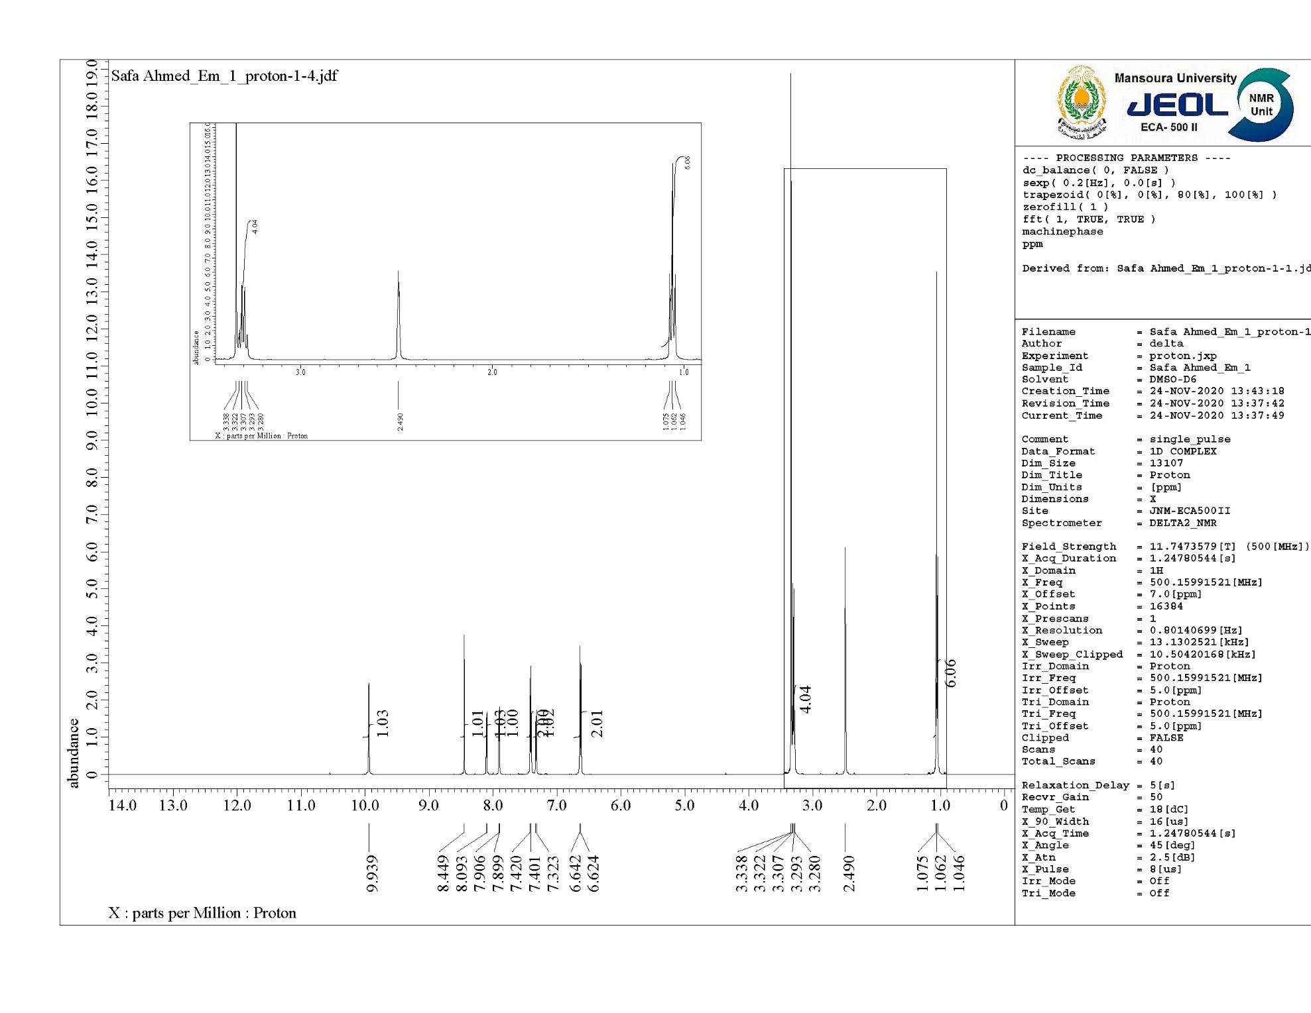



**Figure (6): 1H NMR spectrum of compound IS-2**

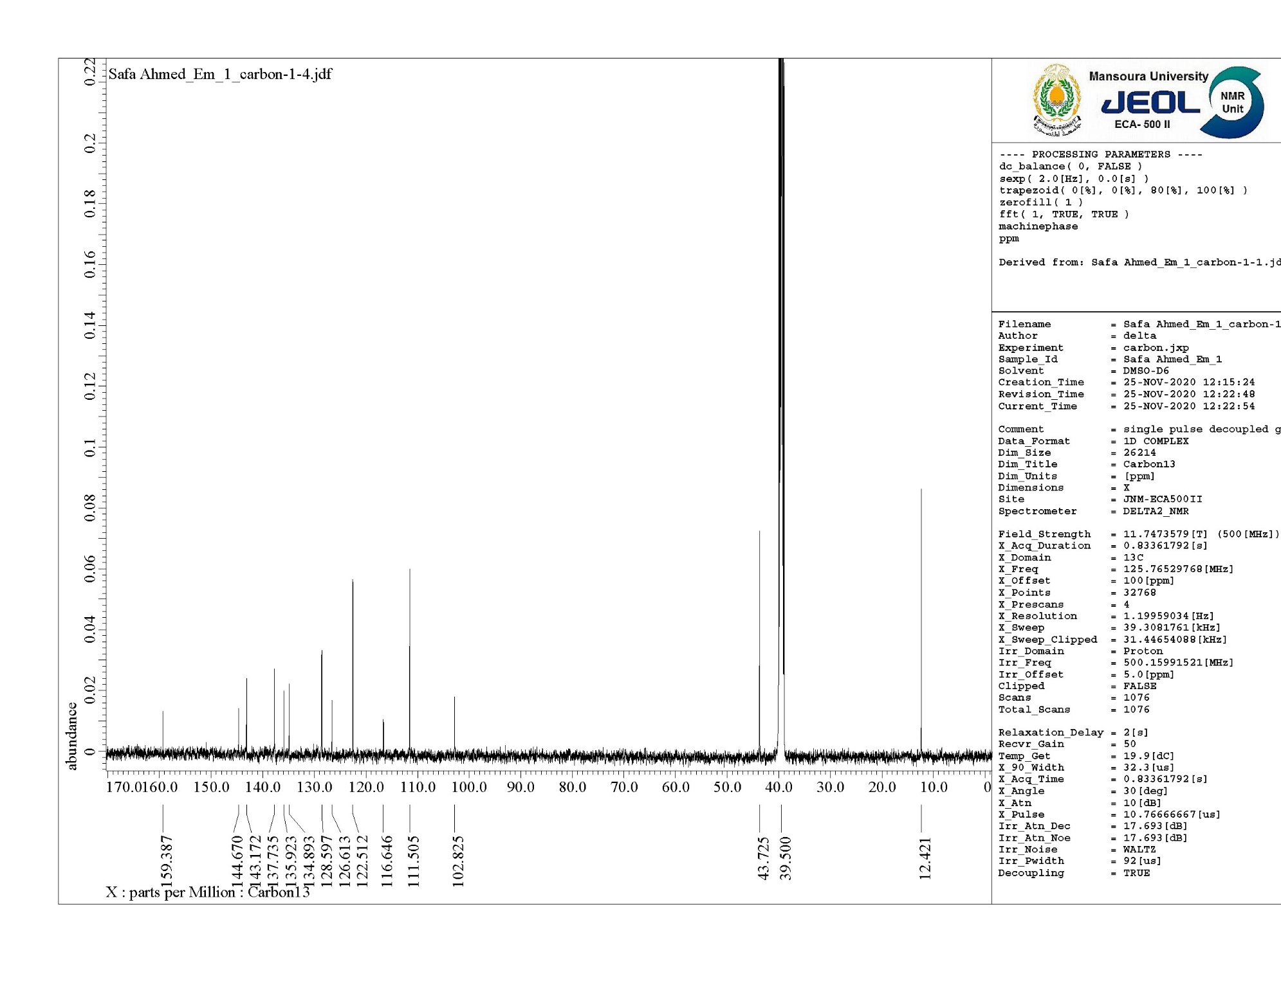



**Figure (7): 13C NMR spectrum of compound IS-2**



**Figure (8): Mass analysis of compound IS-2**

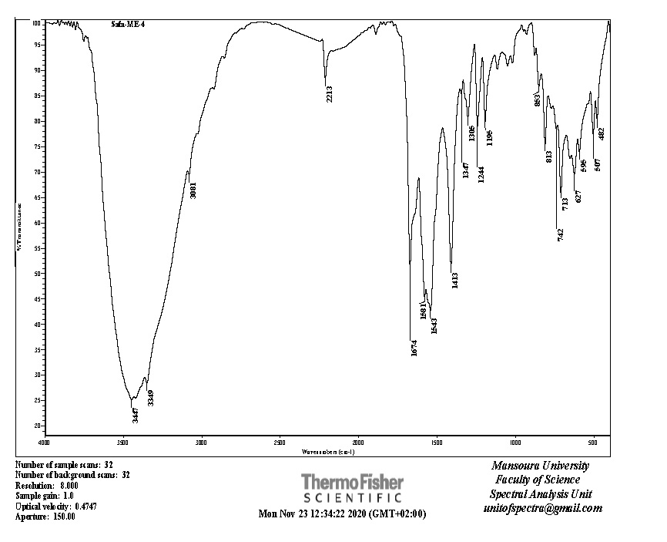



**Figure (9): IR spectrum of compound IS-3**

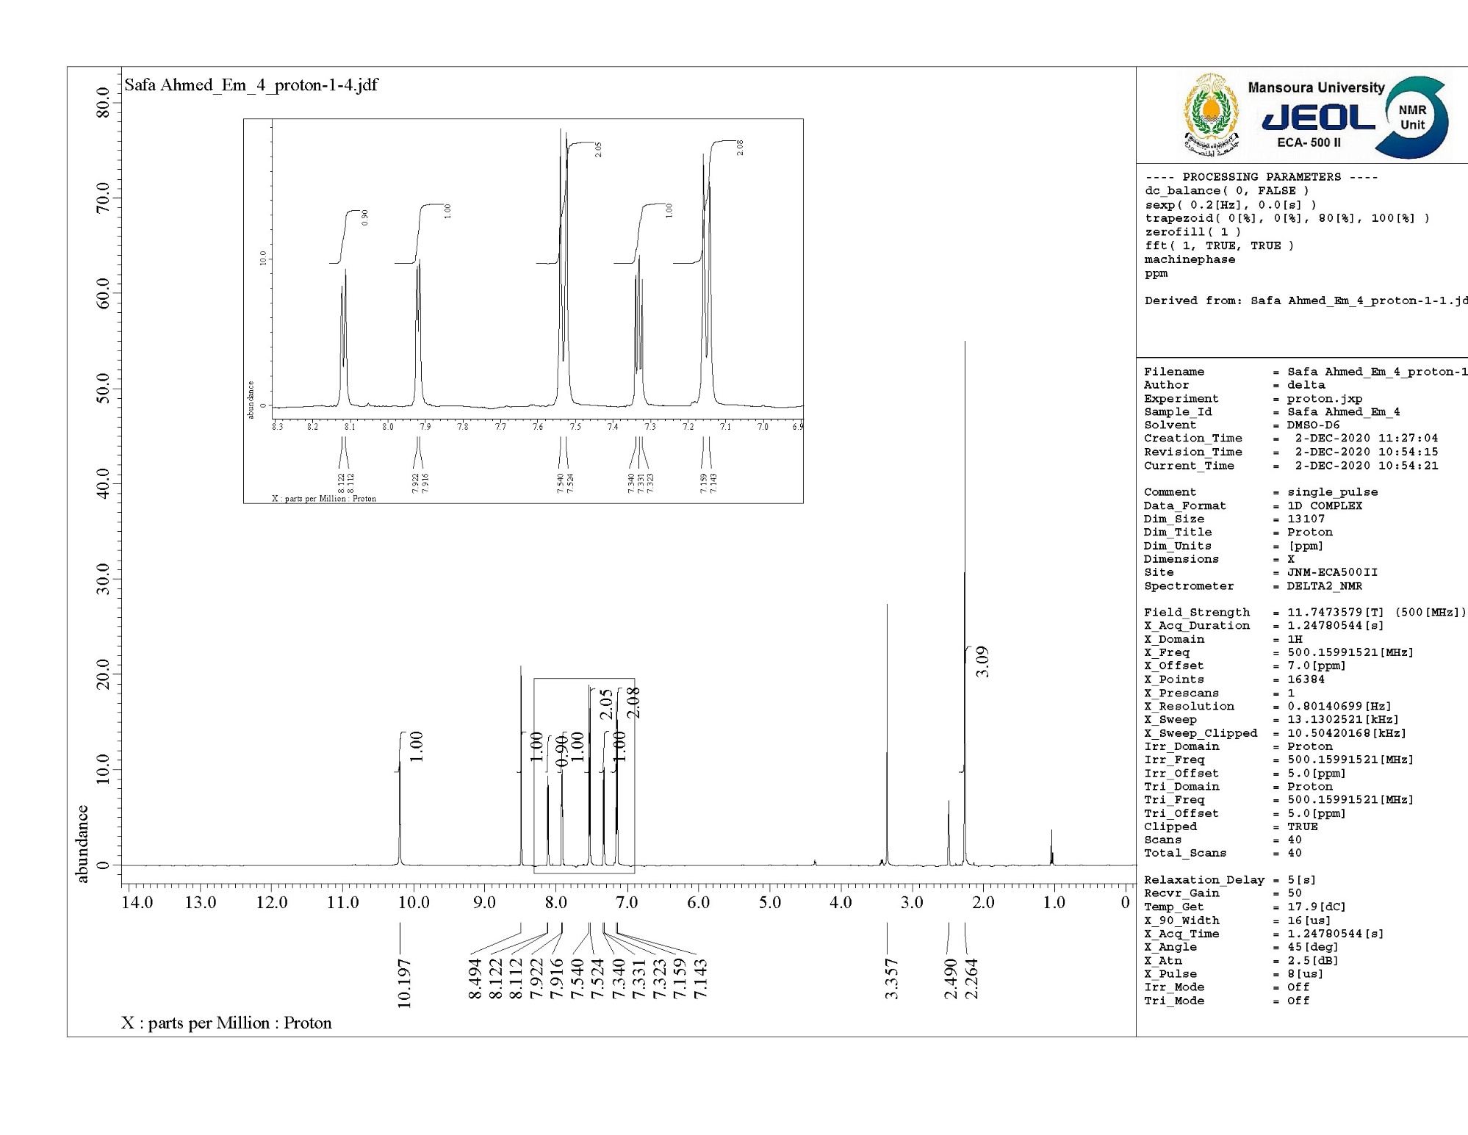



**Figure (10): 1H NMR spectrum of compound IS-3**

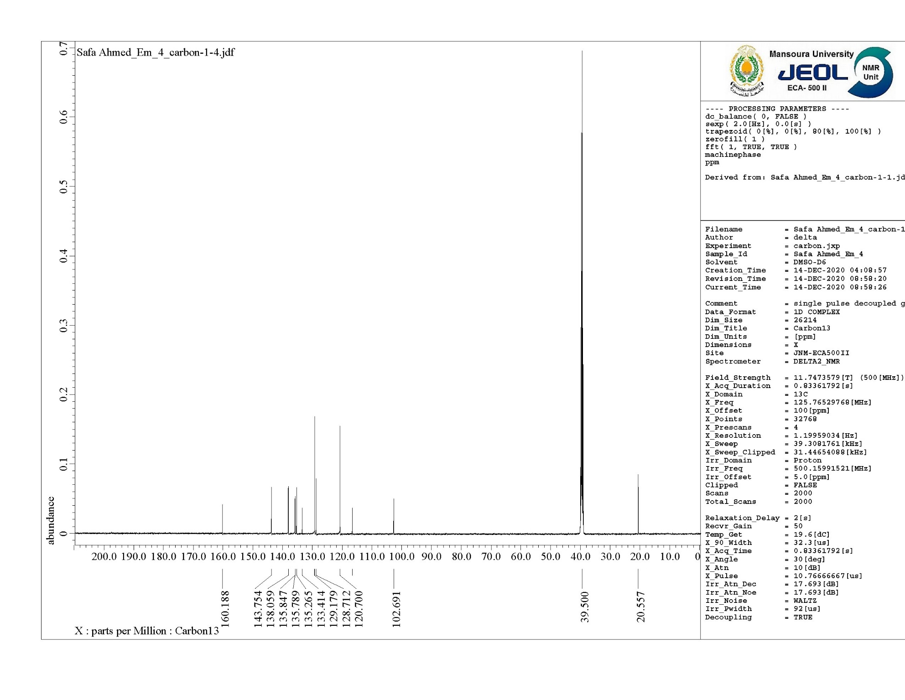



**Figure (11): 13C NMR spectrum of compound IS-3**



**Figure (12): Mass analysis of compound IS-3**

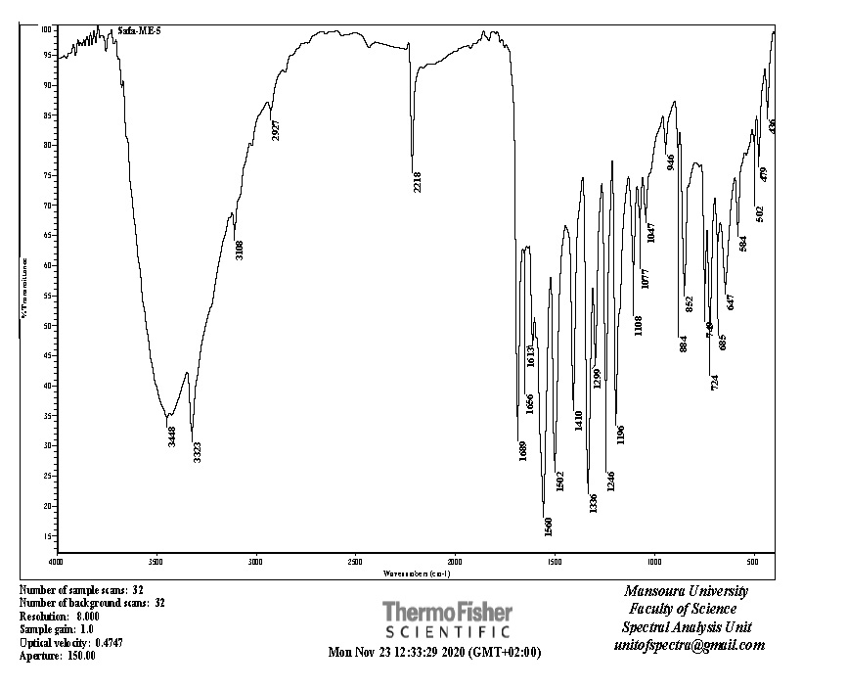



**Figure (13): IR spectrum of compound IS-4**

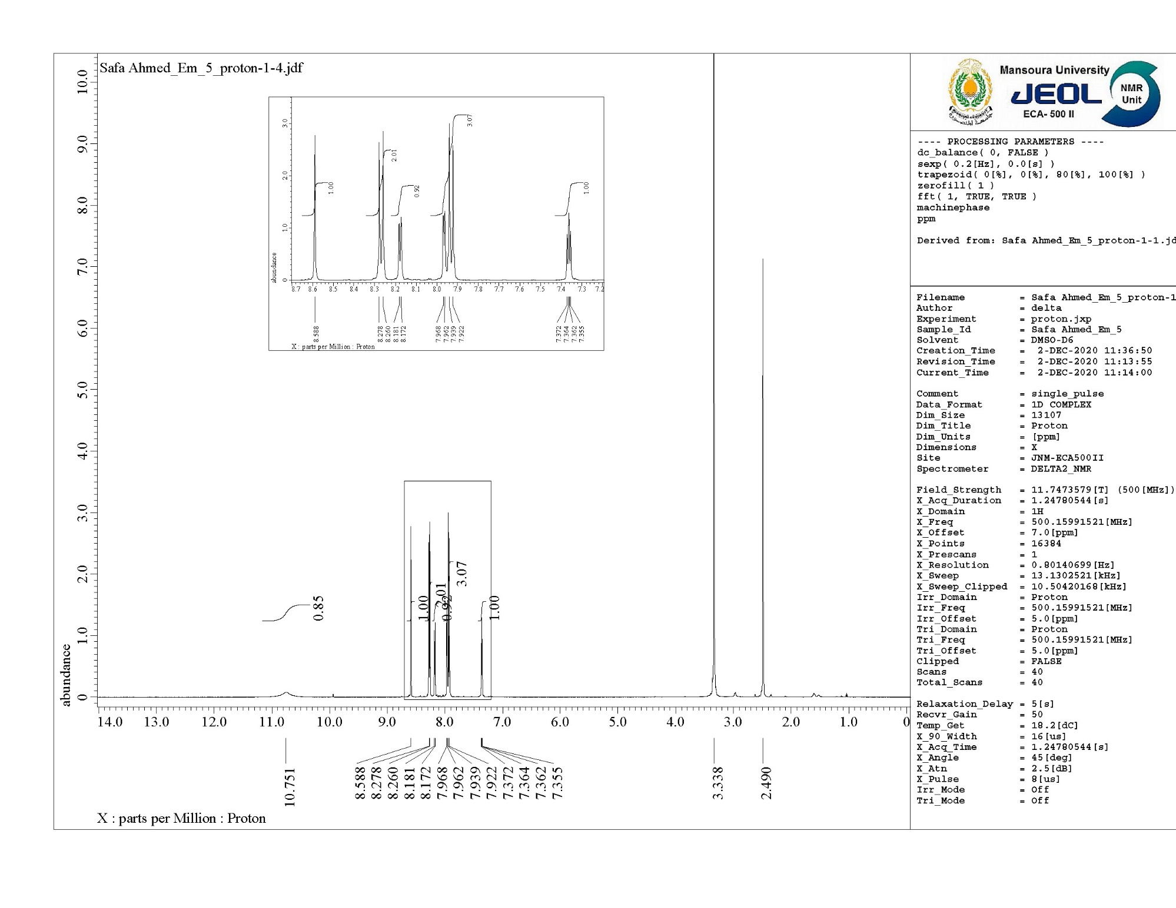



**Figure (14): 1H NMR spectrum of compound IS-4**

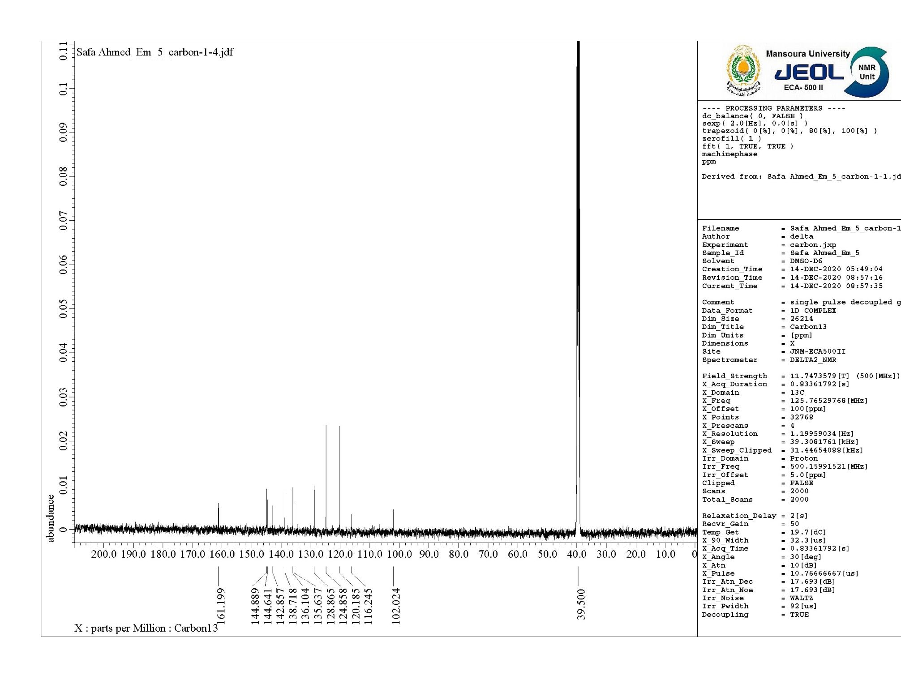



**Figure (15): 13C NMR spectrum of compound IS-4**



**Figure (16): Mass analysis of compound IS-4**

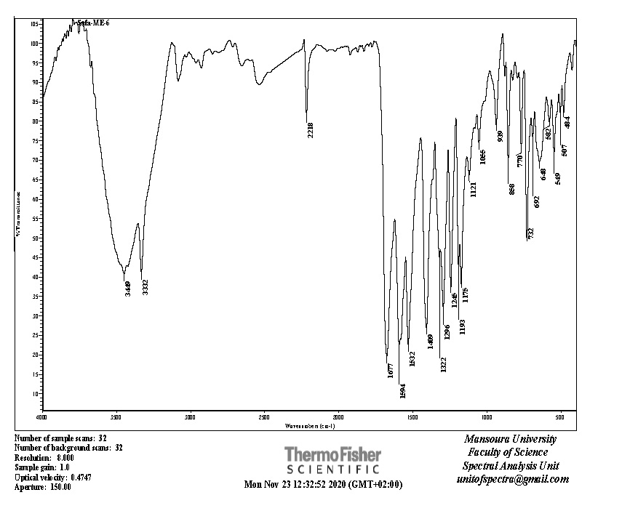



**Figure (17): IR spectrum of compound IS-5**

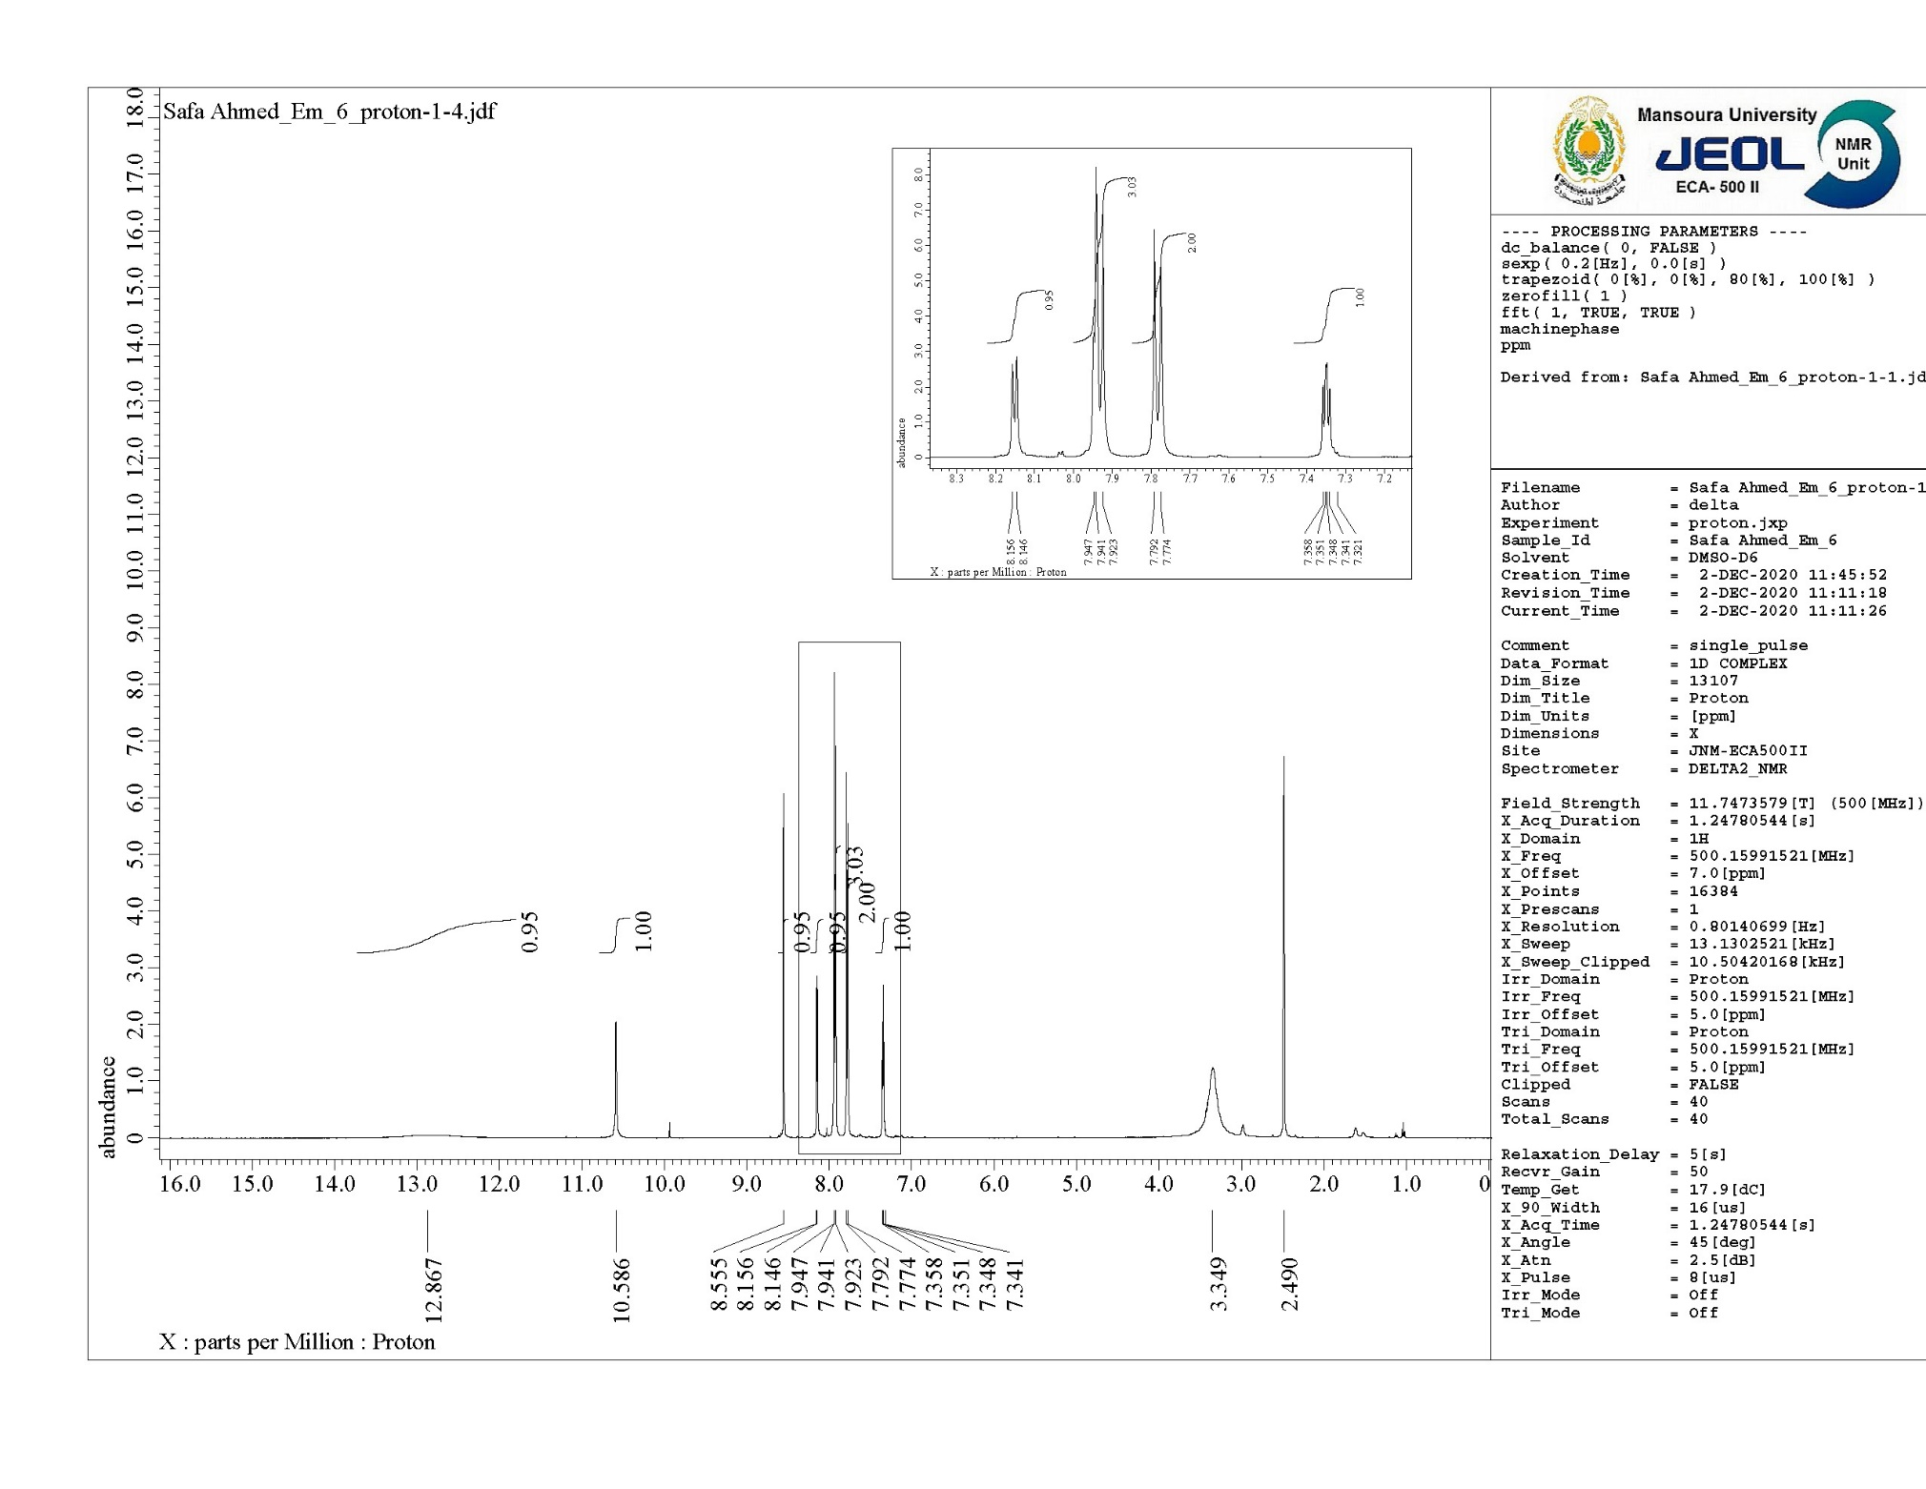



**Figure (18): 1H NMR spectrum of compound IS-5**

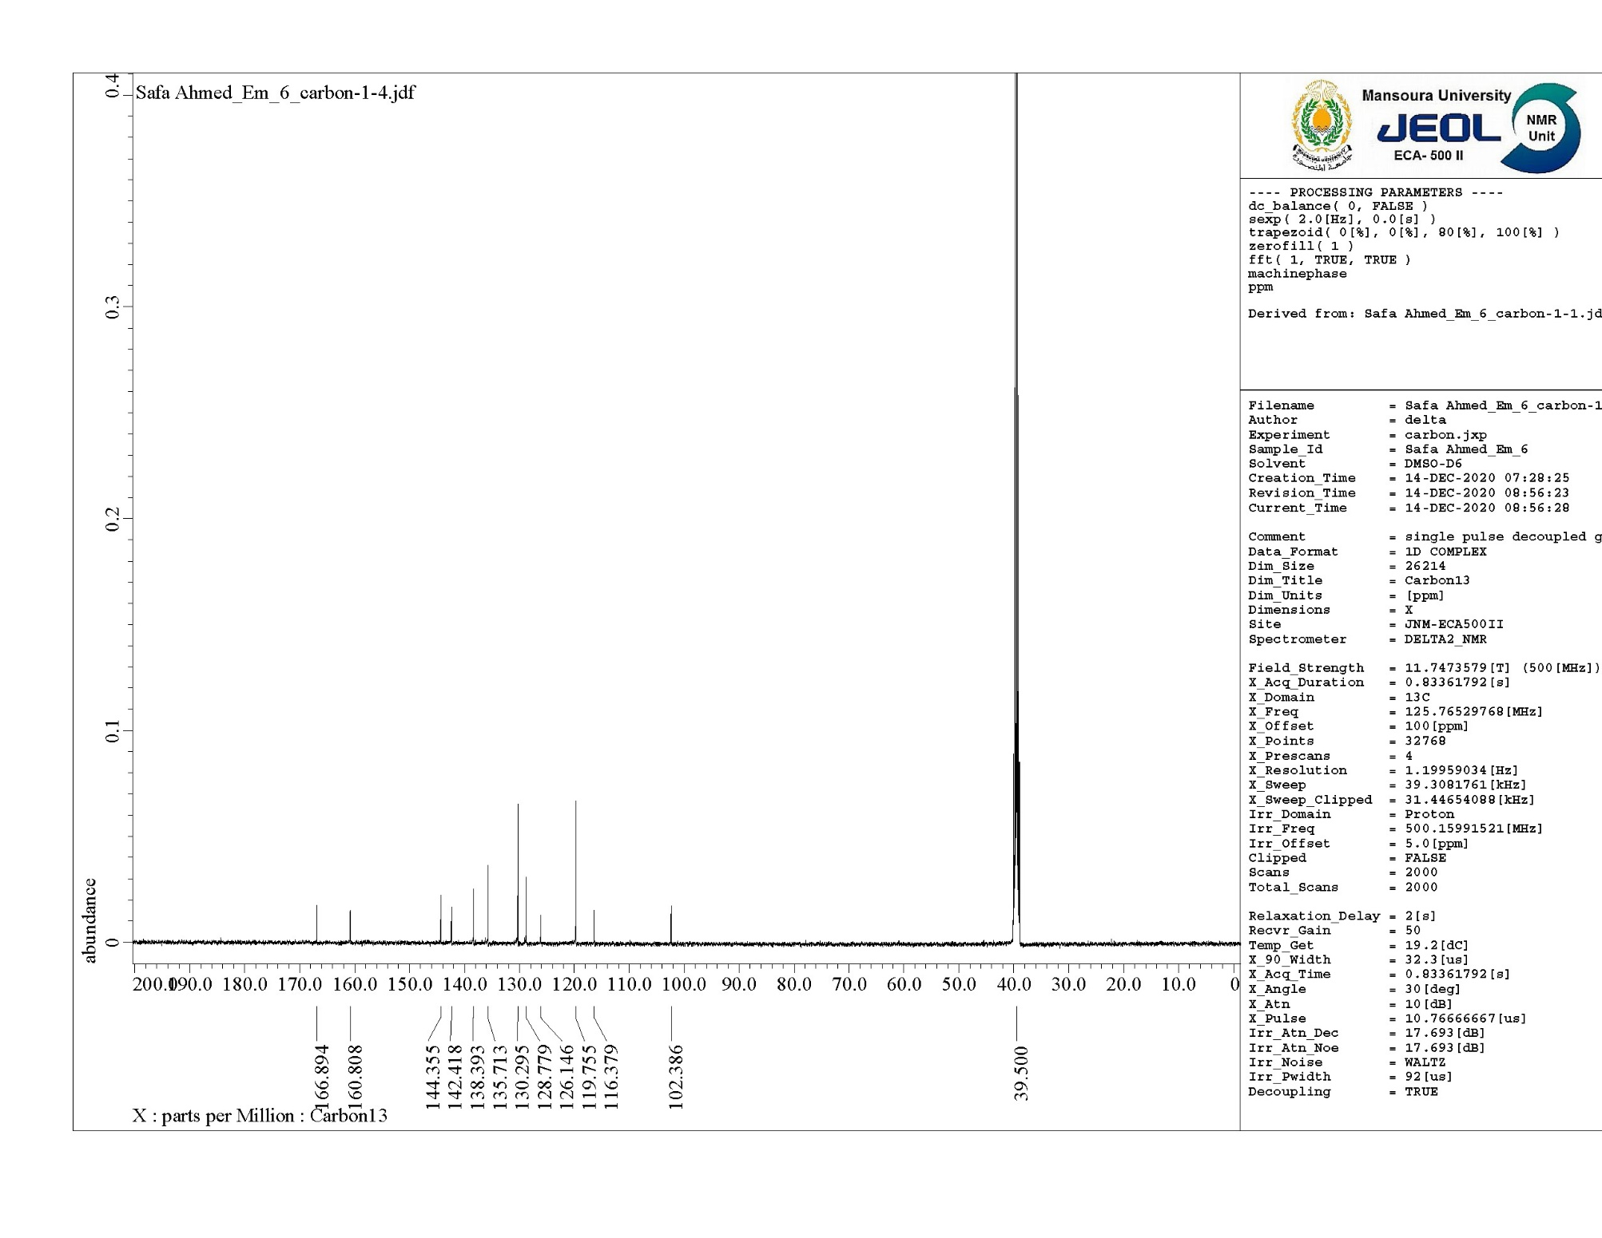



**Figure (19): 13C NMR spectrum of compound IS-5**



**Figure (20): Mass analysis of compound IS-5**

**2. Cell preparations and photovoltaic characterizations**

2.1. TiO2 electrode preparation

A double-layer TiO2 photoelectrode (10 + 5) μm in thickness with a 10 μm thick nanoporous layer and a 5 μm thick scattering layer (area: 0.25 cm2) was prepared using a reported method. Fluorine-doped tin oxide (FTO) coated glasses with a sheet resistance of 8-10 ohm-2 and an optical transmission of greater than 80% in the visible range were screen printed using anatase TiO2 colloids (particle size ∼ 13 nm) obtained from commercial sources (Ti-Nanoxide D/SP, Solaronix). Nanocrystalline TiO2 thin films were deposited onto the conducting glass by screen-printing, which was then sintered at 500 °C for 1 h. The film thickness was measured with a Surfcom 1400A surface profiler (Tokyo Seimitsu Co. Ltd.). The electrodes were impregnated with a 0.05 M titanium tetrachloride solution and sintered at 500 °C. The films were further treated with 0.1 M HCl(aq) before examination.

The dye solutions of the main sensitizer N-719 (0.2 mM) were prepared in 1:1:1 mixture of acetonitrile, tert-butyl alcohol and dimethyl sulfoxide (DMSO). For co-sensitization, of IS1-5 with **N-719** (0.2 mM of each IS1-5 + 0.2 mM **N-719**) were dissolver in 1:1:1 mixtures of the same solvent used later. Deoxycholic acid was added to the dye solution as a coadsorbent at a concentration of 20 mM. The electrodes were immersed in the dye solutions and then kept at 25 ° C for 20 h to adsorb the dye onto the TiO2 surface.

For preparing the counter electrode, pre-cut TCO glasses were washed with water followed by 0.1M HCl in EtOH, and sonication in acetone bath for 10 min. These washed TCO were then dried at 400 °C for 15 min. Thin layer of Pt-paste (Solaronix, Platisol T/SP) on TCO was printed and the printed electrodes were then cured at 450 °C for 10 min.

2.2. Fabrication of dye-sensitized solar cell

Photovoltaic measurements were made on sandwich cells, which were prepared using TiO2 coated working electrodes and platinum coated counter electrodes and were sealed using a 40 μm Syrlyn spacer through heating of the polymer frame. The redox electrolyte (Solaronix, Iodolyte HI-30) consisted of a solution of 0.6 M DMPII, 0.05 M I2, 0.1 M LiI and 0.5 M TBP in acetonitrile.

2.3. Photovoltaic measurements

Photovoltaic measurements of sealed cells were made by illuminating the cell through the conducting glass from the anode side with a solar simulator (WXS-155S-10) at AM 1.5 illuminations (light intensity: 100 mW cm−2).

2.4. Electrochemical impedance spectroscopy (EIS)

The electrochemical impedance spectra were measured with an impedance analyzer potentiostat (Bio-Logic SP-150) under illumination using a solar simulator (SOL3A, Oriel) equipped with a 450 W xenon lamp (91160, Oriel). EIS spectra were recorded over a frequency range of 100 mHz to 200 kHz at room temperature. The applied bias voltage was set at the *VOC* of the DSSCs, with AC amplitude set at 10 mV. The electrical impedance spectra were fitted using Z-Fit software (Bio-Logic).

2.5. Cyclic voltammetry

Cyclic voltammetry (CV) was performed in DMF with the electrolyte 0.1 M [TBA][PF6] at a scan rate of 50 mV s−1. The working electrode used is the Glassy carbon, Pt wire represented the counter electrode and the reference electrode is Ag/Ag+ in ACN. Fc/Fc+ was introduced as internal reference.

**3. Molecular Modeling**

Equilibrium molecular geometries of **IS1-5** calculated using the Becke's three parameter hybrid functional, Lee–Yang–Parr's gradient corrected correlation functional (B3LYP) and (6-311g (d, p)) [1, 2, 3, 4]. The geometry optimization calculations were followed by energy calculations using time-dependent density functional theory (TD-DFT) utilizing the energy, functional B3lyp and the basis set 6-311 g (d, p). The solvent (DMF) effect was accounted for by using the conductor-like polarizable continuum model (C-PCM), implemented in Gaussian 09.

**References**

[1] G. Melikian, F. Rouessac, C. Alexandre, Synth Commun. 1993, 23, 2631

[2] A. D. Becke, Phys. Rev. A **1988**, 38, 3098.

[3] C. T. Lee, W.T. Yang, R.G. Parr, Phys. Rev. B. **1988**, 37, 785

[4] N. Godbout, D.R. Salahub, J. Andzelm, E. Wimmer, Optimization of Gaussian-type basis-sets for local spin-density functional calculations .1. Boron through neon, optimization technique and validation. Can. J. Chem.-Rev. Can. Chim. **1992**, 70, 560-571.