**Supporting Information**

**Ultrasound-assisted extraction of four groups of *Osmanthus fragrans* fruit: optimization, UPLC-Orbitrap-MS/MS characterization and anti-inflammatory activity evaluation**

Weizhuo Tanga*, Shuang Lia, Miaomiao Wanga, Bin Wangb,

*aCollege of Biological and Environmental Engineering, Changsha University, Changsha 410022, P.R. China*

*bTCM and Ethnomedicine Innovation & Development International Laboratory, School of Pharmacy, Hunan University of Chinese Medicine, Changsha 410208, P. R. China*

*Corresponding author Tel/fax: +86 731 84261421;

Email address: tweizhuo@126.com

**Contents**

**Figure S1.** Normal probability plot for the reduced quadratic models for four types of OF fruits: a: OFM; b: OFN; c: OFA; d: OFS;

**Figure S2.** Total ion chromatogram in positive and negative ion mode of OFA fruit extract.

**Figure S3.** UPLC/MS/MS spectrum of compound **1**.

**Figure S4.** UPLC/MS/MS spectrum of compounds **2** and **3**.

**Figure S5.** UPLC/MS/MS spectrum of compounds **4**, **5**, and **8**.

**Figure S6.** UPLC/MS/MS spectrum of compounds **6**, **9**, and **11**.

**Figure S7.** UPLC/MS/MS spectrum of compounds **7** and **10**.

**Figure S8.** UPLC/MS/MS spectrum of compounds **12** and **13**.

**Figure S9.** ESIMS/MS fragment ions (m/z) of iridoid glucosides identified from the OFA fruit.

**Figure S10.** HPLC-DAD chromatography of OFA fruit by ultrasound-assisted extraction. A: The chromatogram of mixed nine standards; B: The chromatogram of sample.

**Table S1.** Single-factor experiment results for extraction time of ultrasound-assisted extraction of OFA fruit

**Table S2.** Single-factor experiment results for ethanol concentration of ultrasound-assisted extraction of OFA fruit

**Table S3.** Single-factor experiment results for liquid-to- solid ratio of ultrasound-assisted extraction of OFA fruit.

**Table S4.**  Quantitative analysis of nine compounds in OFA fruit

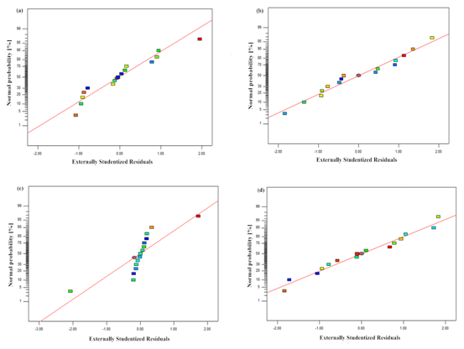

**Figure S1.** Normal probability plot for the reduced quadratic models for four types of OF fruits: a: OFM; b: OFN; c: OFA; d: OFS.

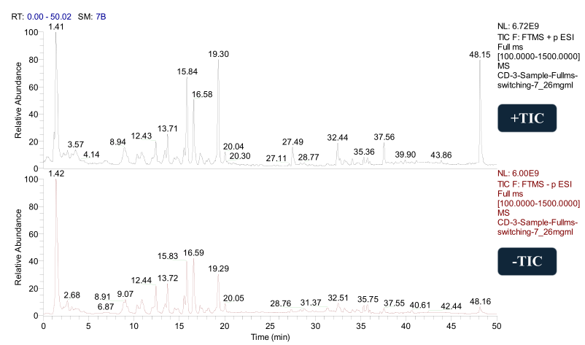

**Figure S2.** Total ion chromatogram in positive and negative ion mode of OFA fruit extract.

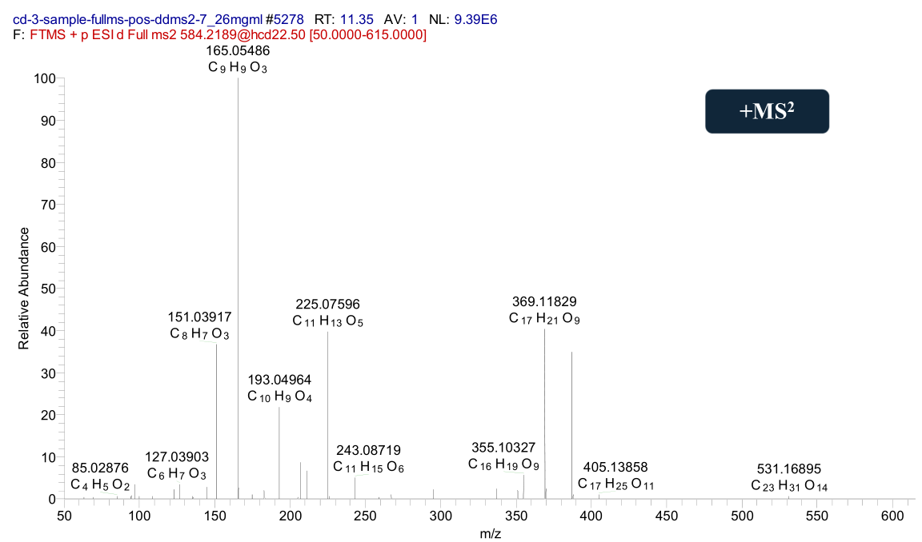

**Figure S3.** UPLC/MS/MS spectrum of compound **1**.

**Figure S4.** UPLC/MS/MS spectrum of compounds **2** and **3**.

**Figure S5.** UPLC/MS/MS spectrum of compounds **4**, **5**, and **8**.

**Figure S6.** UPLC/MS/MS spectrum of compounds **6**, **9**, and **11**.

**Figure S7.** UPLC/MS/MS spectrum of compounds **7** and **10**.

**Figure S8.** UPLC/MS/MS spectrum of compounds **12** and **13**.

**Figure S9.** ESIMS/MS fragment ions (m/z) of iridoid glucosides identified from the OFA fruit.

**Figure S10.** HPLC-DAD chromatography of OFA fruit by ultrasound-assisted extraction.

A: The chromatogram of mixed nine standards; B: The chromatogram of sample. 1: Salidroside; 2: Acteoside; 3: Neonuezhenide; 4: Nuezhenide; 5: Isoacteoside; 6: G13; 7: Quercetin; 8: Apigenin; 9: Kaempferol. All samples were detected at 210 nm.

**Table S1.** Single-factor experiment results for extraction time of ultrasound-assisted extraction of OFA fruit.

|  |  |  |  |  |
| --- | --- | --- | --- | --- |
| Runs | Ultrasonic time  (*X1*, min) | Ethanol concentration (*X2*, %) | Liquid-to- solid ratio (*X3*, mL/g) | Extraction  yield |
|  |
| 1 | 10 | 75 | 1:15 | 3.77 |
| 2 | 30 | 75 | 1:15 | 8.33 |
| 3 | 50 | 75 | 1:15 | 12.24 |
| 4 | 70 | 75 | 1:15 | 11.15 |
| 5 | 90 | 75 | 1:15 | 10.55 |

**Table S2.** Single-factor experiment results for ethanol concentration of ultrasound-assisted extraction of OFA fruit.

|  |  |  |  |  |
| --- | --- | --- | --- | --- |
| Runs | Ultrasonic time  (*X1*, min) | Ethanol concentration (*X2*, %) | Liquid-to- solid ratio (*X3*, mL/g) | Extraction  yield |
|  |
| 1 | 50 | 55 | 1:15 | 10.24 |
| 2 | 50 | 65 | 1:15 | 9.65 |
| 3 | 50 | 75 | 1:15 | 10.17 |
| 4 | 50 | 85 | 1:15 | 9.95 |
| 5 | 50 | 95 | 1:15 | 10.24 |

**Table S3.** Single-factor experiment results for liquid-to- solid ratio of ultrasound-assisted extraction of OFA fruit.

|  |  |  |  |  |
| --- | --- | --- | --- | --- |
| Runs | Ultrasonic time  (*X1*, min) | Ethanol concentration (*X2*, %) | Liquid-to- solid ratio (*X3*, mL/g) | Extraction  yield |
|  |
| 1 | 50 | 75 | 1:5 | 9.58 |
| 2 | 50 | 75 | 1:10 | 14.27 |
| 3 | 50 | 75 | 1:15 | 13.88 |
| 4 | 50 | 75 | 1:20 | 13.02 |
| 5 | 50 | 75 | 1:25 | 12.82 |

**Table S4**. Quantitative analysis of nine compounds in OFA fruit

|  |  |  |  |  |  |  |  |  |  |
| --- | --- | --- | --- | --- | --- | --- | --- | --- | --- |
| Compound | Salidroside | Acteoside | Isoacteoside | Neonuezhenide | nuezhenide | G13 | Quercetin | Apigenin | Kaempferol |
| Contents (mg/g) | 12.883 | 0.674 | 2.133 | 3.180 | 24.262 | 51.333 | 0.023 | 0.001 | 0.008 |