**(Supporting Information)**

**Tailoring crystal size distributions for product performance, compaction of Paracetamol**

Leila Keshavarz1,†, Mahboubeh Pishnamazi1,†,*, U. B. Rao Khandavilli1, Saeed Shirazian1,2, Maurice N. Collins3,4, Gavin M. Walker1, and Patrick J. Frawley1

1 Synthesis and Solid State Pharmaceutical Centre (SSPC),Bernal Institute, University of Limerick, Limerick, Ireland

2 Laboratory of Computational Modeling of Drugs, South Ural State University, 76 Lenin prospekt, 454080 Chelyabinsk, Russia

3 Stokes Laboratories, Bernal Institute, University of Limerick, Limerick, Ireland

4 Health Research Institute, University of Limerick, Limerick, Ireland.

†LK and MP contributed equally.

* Corresponding author; E-mail: seyedeh.pishnamazi@ul.ie

**Solubility Measurement**

The pressurized synthetic method was applied for measuring the solubility of phenacetin in the presence of two different solvents (2-propanol and methanol). This method was used and validated in our previous work and the same protocol and procedure was used in the current work [1]. The rate of temperature change was 0.05 K/min and stirring rate of 450 rpm was adopted in the experiments. The results of the pressurized-synthetic data for phenacetin (measured in different alcohols) are shown in Fig. S1. Table S1 shows the data set of pressurized-synthetic results in g solute/kg solvent at the measured saturation temperature under a pressure of 2 bar (g) and the values of the Apelblat parameters for each solvent summarized in Table S2.

The solubility of PA was compared with the solubility of CA and Phen and the result is shown in Fig. S2. It shows the solubility of CA and Phen are almost similar in the temperature range of 290-330K, after which the solubility of Phen rapidly increased and exceeded the solubility of PA. Therefore, it is assumed that Phen does not have a considerable effect on the solubility of PA in the same way that CA has no significant effect on the solubility of PA [2].

Fig. S3 clearly indicates that the crystallizing solvent influences the crystal habit. This might be due to the solute-solvent interactions at various crystal–solution interfaces, which leads to altered roundness of the interfaces, changes in crystal growth kinetics and enhancement or inhibition of growth at certain crystal faces. The polarity of the solvent and the interaction that leads to its preferential adsorption at selected faces of the solute are critical factors for shape of crystal [3].

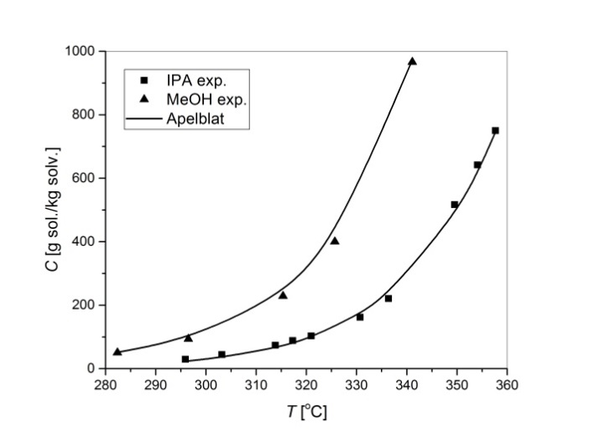

Figure S1. Solubility of phenacetin versus temperature T for IPA (■) and MeOH (▲). Data was fitted using the Apelblat model.

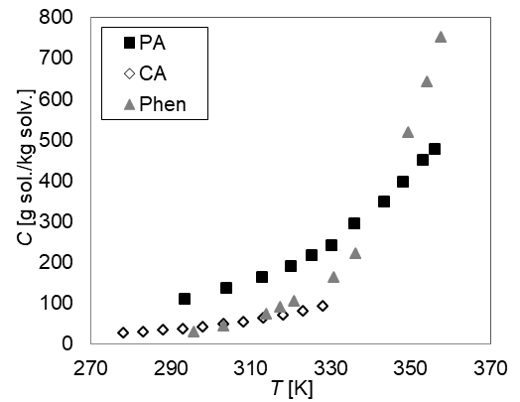

Figure S2. Comparison of solubility of PA (■) [1], CA [2] (♦) and Phen (▲) versus temperature T in 2-propanol.

|  |  |
| --- | --- |
|  |  |

Figure S3. SEM images of recrystallized phenacetin with 2-propanol (a) and methanol (b).

Table S1. Pressurized-Synthetic Solubility and Calculated Solubility of Phenacetin as Calculated Using Apelblat

|  |  |  |  |  |  |
| --- | --- | --- | --- | --- | --- |
| *T* (K) | | *C*exp (g/kg) | | *C*cal (g/kg) | |
|  | | IPA | |  | |
| 295.92 | | 29.43 | | 23.14 | |
| 303.19 | | 44.12 | | 35.57 | |
| 313.81 | | 73.53 | | 65.97 | |
| 317.29 | | 88.23 | | 80.56 | |
| 320.98 | | 102.94 | | 99.42 | |
| 330.72 | | 161.76 | | 172.05 | |
| 336.37 | | 220.59 | | 235.42 | |
| 349.54 | | 516.67 | | 482.83 | |
| 354.11 | | 641.67 | | 617.41 | |
| 357.68 | | 750.23 | | 746.18 | |
| *T* (K) | *C*exp (g/kg) | | *C*cal (g/kg) | |
|  | MeOH | |  | |
| 282.38 | 50.32 | | 51.86 | |
| 296.50 | 93.75 | | 92.63 | |
| 315.34 | 229.01 | | 231.13 | |
| 325.68 | 400.11 | | 403.16 | |
| 341.10 | 966.25 | | 973.11 | |

Table S2. Apelblat formula values for Methanol and 2-Propanol models

|  |  |  |  |  |
| --- | --- | --- | --- | --- |
| solvent | Apelblat parameters | | | van’t Hoff Enthalpy of Solution (kJ mol−1) |
| *a* | *b* | *C* |
| Methanol | -433.1 | 16060 | 67.37 | -37.98 |
| 2-Propanol | -149.9 | 2334 | 25.51 | -43.64 |

Powder X-ray diffraction was utilized (Fig. S4 and S6) to confirm the crystal structure of the paracetamol crystallized in presence of two additives and compared with the pure paracetamol form I (Fig. S4). X-ray diffraction was utilized to investigate the polymorphic transformation during the experiments. Powder diffraction data were collected on a Philips X’Pert-MPD PRO diffractometer (PW3064 sample spinner) with nickel-filtered Cu Kα radiation (λ = 1.5418 Å) run at 40 kV and 35 mA, 2θ = 5−40°, with a step size of 0.02° 2θ and a scan speed of 0.02° s−1. Analysis of the spectra from two samples indicated no polymorphic transformation for both samples of paracetamol.

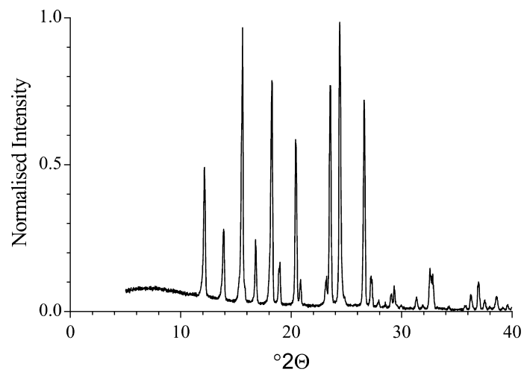

Figure S4. Powder X-ray diffraction pattern for monoclinic paracetamol (form I) [37].

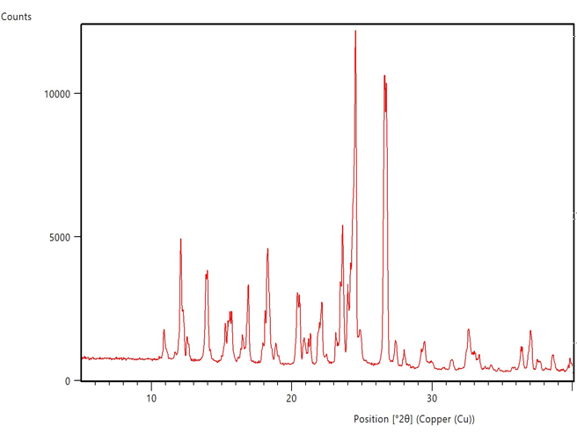Figure S5. Experimental powder X-ray diffraction pattern for paracetamol crystallized in presence of 2.2 mol% phenacetine.

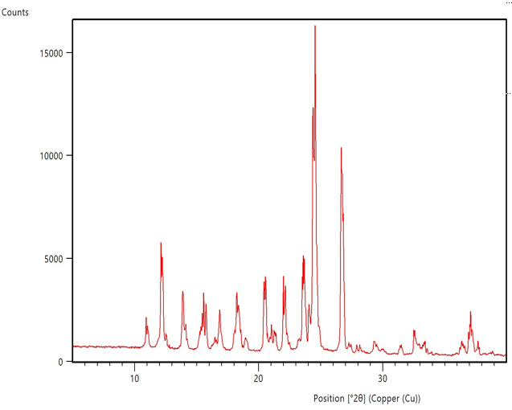

Figure S6. Experimental powder X-ray diffraction pattern for paracetamol crystallized in presence of 2mol% of 4- chloroacetanalide.

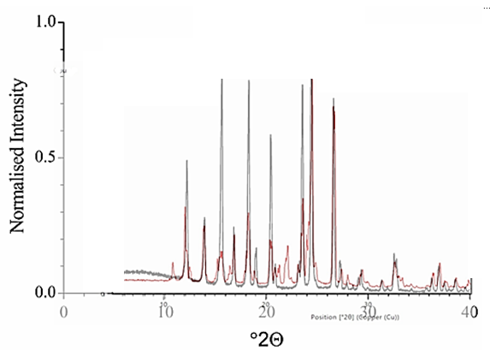

Figure S7. Overlay the powder X-ray diffraction pattern for pure paracetamol form I (black line) and paracetamol crystallized in presence of 2.2 mol% phenacetine (red line).

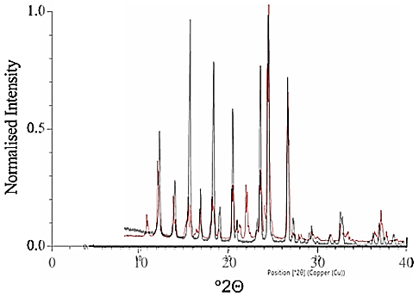

Figure S8. Overlay the powder X-ray diffraction pattern for pure paracetamol form I (black line) and paracetamol crystallized in presence of 2 mol% 4- chloroacetanalide (red line).

The ratio of PA to CA was determined using a high-pressure liquid chromatography (HPLC) methodology based on previous studies [2,4,5,7]. The data of table shows that combination of fast cooling and seeding led to the lower purity of paracetamol crystals. The addition of seed crystals leads to a large crystal surface area across the bulk solution and a rapid depletion of supersaturation which may favour the incorporation of the CA into the solid phase of PA. Without seed crystals, crystallization proceeds locally through primary nucleation followed by a slow depletion of supersaturation, possibly favouring the crystal growth of PA over CA [2].

Table S3. Experimental design matrix of selected crystallization experiments for PA in the presence of 2 mol% CA, with the PA percentage in the solid phase as output.

|  |  |  |  |  |  |  |
| --- | --- | --- | --- | --- | --- | --- |
| No. | Cooling method | | Cooling rate [K/min] | Stirring rate [rpm] | Seeding | PA [%] |
| 1 | Linear | 0.9 | | 300 | No | **99.28** |
| 2 | T-cycle | 0.9 | | 300 | No | **99.22** |
| 3 | Linear | 0.1 | | 300 | No | **99.43** |
| 4 | Linear | 0.9 | | 400 | No | **99.27** |
| 5 | T-cycle | 0.9 | | 400 | No | **99.26** |
| 6 | Linear | 0.1 | | 400 | No | **99.26** |
| 7 | T-cycle | 0.1 | | 400 | No | **99.37** |
| 8 | Linear | 0.9 | | 300 | Yes | **99.11** |
| 9 | T-cycle | 0.1 | | 300 | Yes | **99.31** |
| 10 | Linear | 0.9 | | 400 | Yes | **98.92** |
| 11 | T-cycle | 0.9 | | 400 | Yes | **98.84** |
| 12 | Linear | 0.1 | | 400 | Yes | **99.58** |
| 13 | T-cycle | 0.1 | | 400 | Yes | **98.78** |

**References**

[1] B. De Souza, L. Keshavarz, G. Cogoni, P.J. Frawley, Pressurized-synthetic methodology for solubility determination at elevated temperatures with application to paracetamol in pure solvents, Pharm. Discov. Dev. Manuf. Forum 2017 - Core Program. Area 2017 AIChE Annu. Meet. 2017-Octob (2017) 72–83. https://doi.org/10.1021/acs.jced.7b00118.

[2] L. Keshavarz, R.R.E. Steendam, M.A.R. Blijlevens, M. Pishnamazi, P.J. Frawley, Influence of Impurities on the Solubility, Nucleation, Crystallization, and Compressibility of Paracetamol, Cryst. Growth Des. 19 (2019) 4193–4201. https://doi.org/10.1021/acs.cgd.9b00490.

[3] D.M. Croker, D.M. Kelly, D.E. Horgan, B.K. Hodnett, S.E. Lawrence, H.A. Moynihan, Å.C. Rasmuson, Demonstrating the Influence of Solvent Choice and Crystallization Conditions on Phenacetin Crystal Habit and Particle Size Distribution, Org. Process Res. Dev. 19 (2015) 1826–1836. https://doi.org/10.1021/op500308x.

[4] R.R.E. Steendam, L. Keshavarz, B. de Souza, P.J. Frawley, Thermodynamic properties of paracetamol impurities 4-nitrophenol and 4″-chloroacetanilide and the impact of such impurities on the crystallisation of paracetamol from solution, J. Chem. Thermodyn. 133 (2019) 85–92. https://doi.org/10.1016/j.jct.2019.02.004.

[5] L. Keshavarz, R.R.E. Steendam, P.J. Frawley, Impact of Mother Liquor Recycle on the Impurity Buildup in Crystallization Processes, Org. Process Res. Dev. 22 (2018) 1541–1547. https://doi.org/10.1021/acs.oprd.8b00308.

[6] R.R.E. Steendam, L. Keshavarz, M.A.R. Blijlevens, B. De Souza, D.M. Croker, P.J. Frawley, Effects of Scale-Up on the Mechanism and Kinetics of Crystal Nucleation, Cryst. Growth Des. Eff. 18 (2018) 5547–5555. https://doi.org/10.1021/acs.cgd.8b00857.

[7] L. Keshavarz, The Importance of Impurity on Pharmaceutical Processes, University of Limerick, 2019.