**Biosynthesis of metallic nanoparticles from waste *Passiflora edulis* peels for their antibacterial effect and catalytic activity.**

**Supplementary Data**

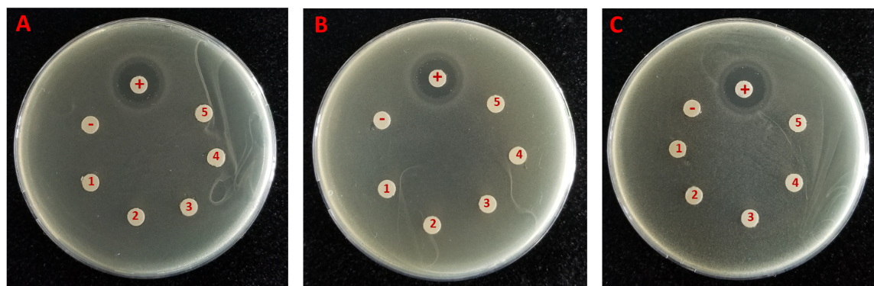

**Figure S1.** Antibacterial activity at the varied concentrations of PEP extract against *E. coli* (A)*, B. subtilis* (B)and *S. aureus* (C) at various ratio of PEP extract volume to water volume (v/v): 6:4 (1), 7:3 (2), 8:2 (3), 9:1 (4) and 10:0 (5).

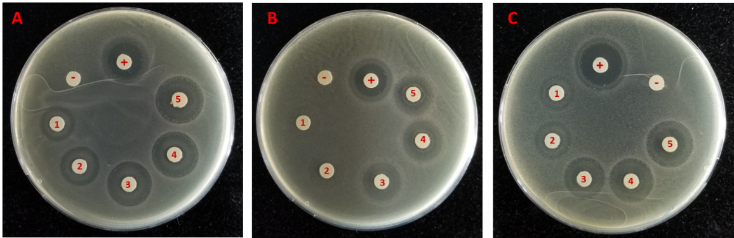

**Figure S2.** Antibacterial activity at the varied concentrations of PEP-AgNPs against *E. coli* (A)*, B. subtilis* (B)and *S. aureus* (C) at various concentrations: 0.25 mM (1), 0.5 mM (2), 1.0 mM (3), 1.5 mM (4) and 2.0 mM (5).

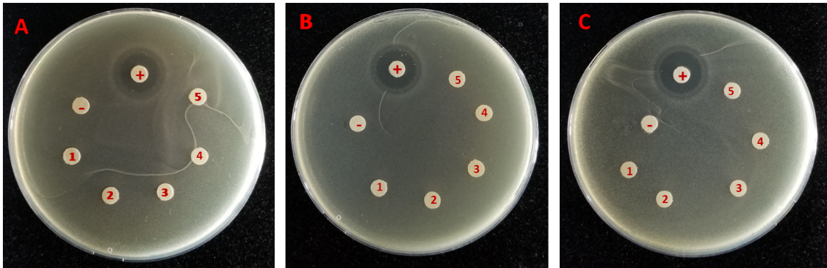

**Figure S3.** Antibacterial activity at the varied concentrations of PEP-AuNPs against *E. coli* (A)*, B. subtilis* (B)and *S. aureus* (C) at various concentrations: 0.68 mM (1), 0.79 mM (2), 0.90 mM (3), 1.01 mM (4) and 1.13 mM (5).