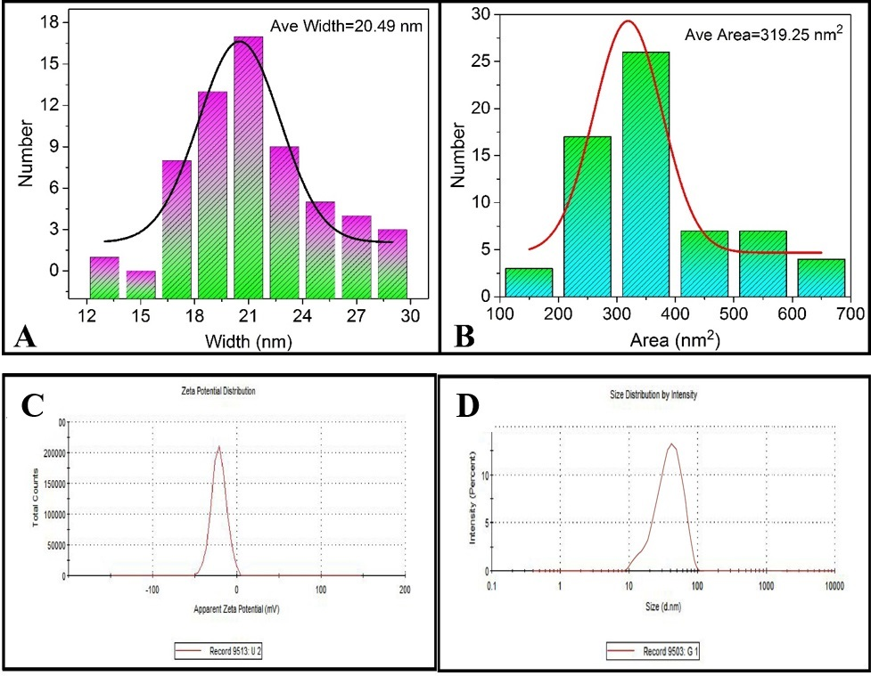

**Figure No. S1:** (A) Particle size distribution and average size; (B) Average area; (C) Zeta potential and (D) Zeta size of AgNPs.

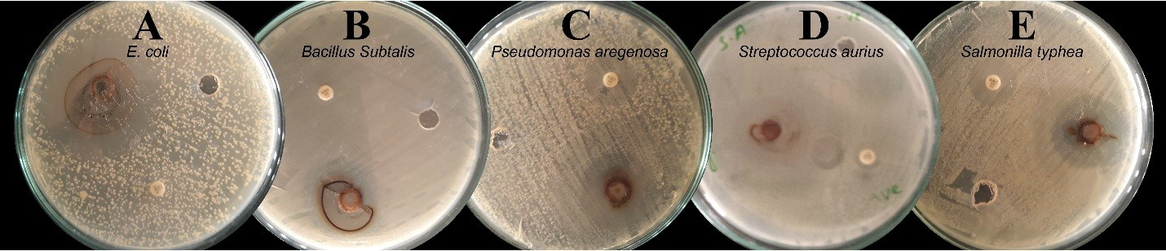

**Figure No. S2:** Antibacterial activities of AgNPs against selected bacterial strains

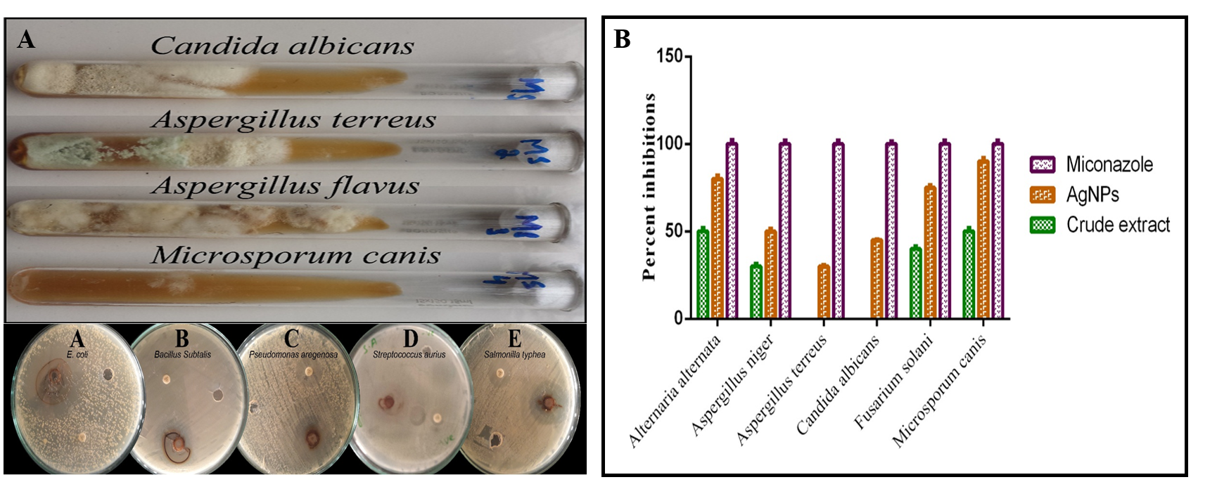

**Figure No. S3:** (A) Antifungal activities of AgNPs against selected fungi; (B) comparison between percent inhibition of miconazole, crude extract and AgNPs.