**Supporting Information**

C:\Users\user\Desktop\Untitled-1.tif

**Figure S1** (a) XPS survey of NGTs, (b) Raman spectra of NGTs, and (c) Specific peak currents of NGTs-based PIB half-cells.

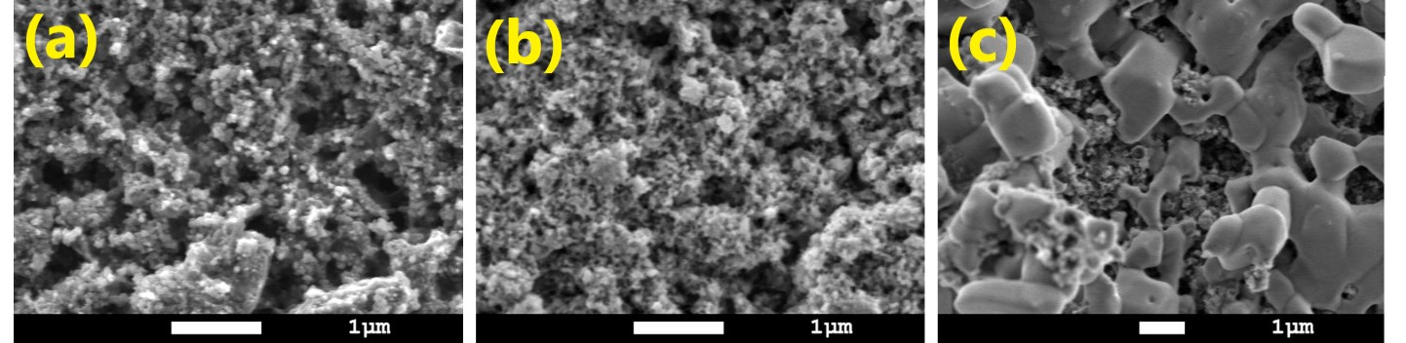**Figure S2** Surface morphology of NGTs electrodes (a) Before cycling, (b) Charged state, and (c) Charged state magnified image.



**Figure S3** Equivalent circuit for Nyquist plots.

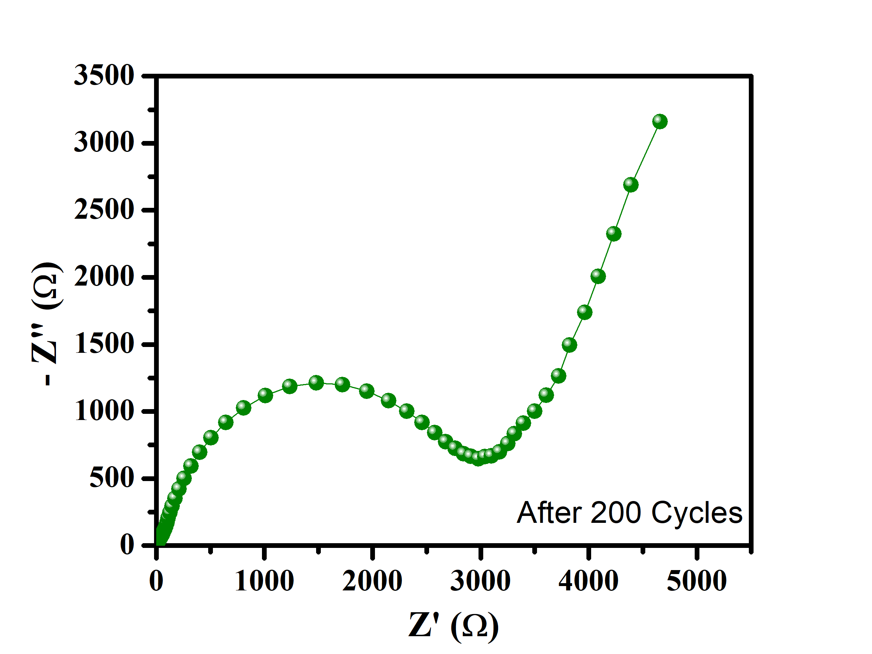

**Figure S4** Nyquist plot of KIBs after 200 cycles.