Supplementary Information - Figures

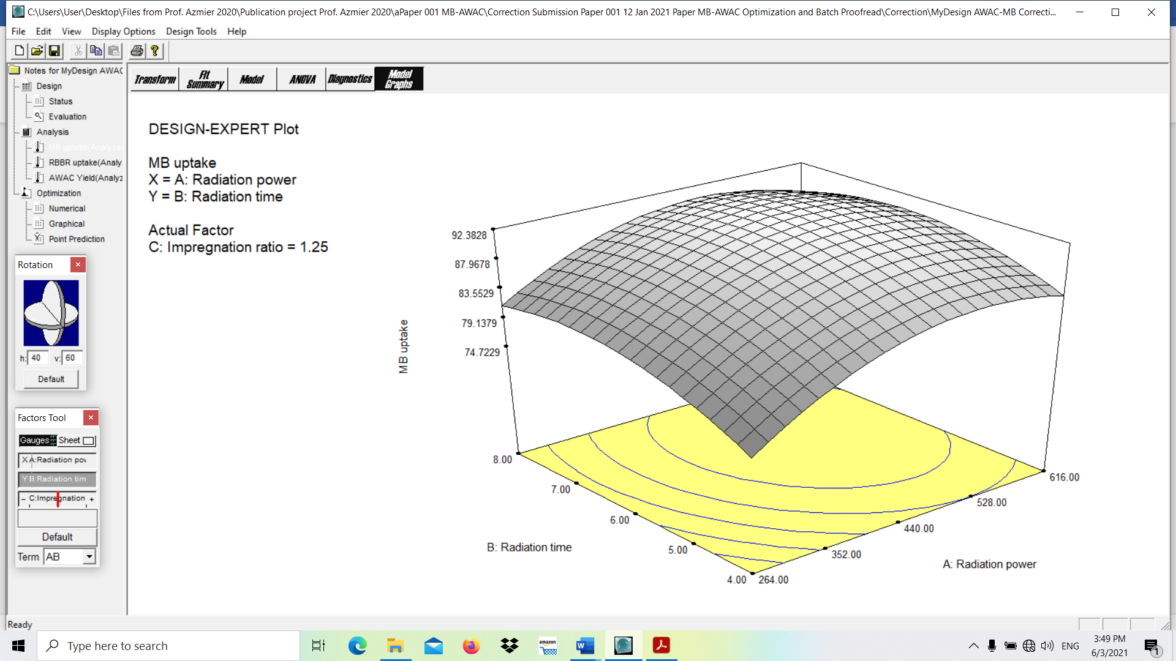  (a) | 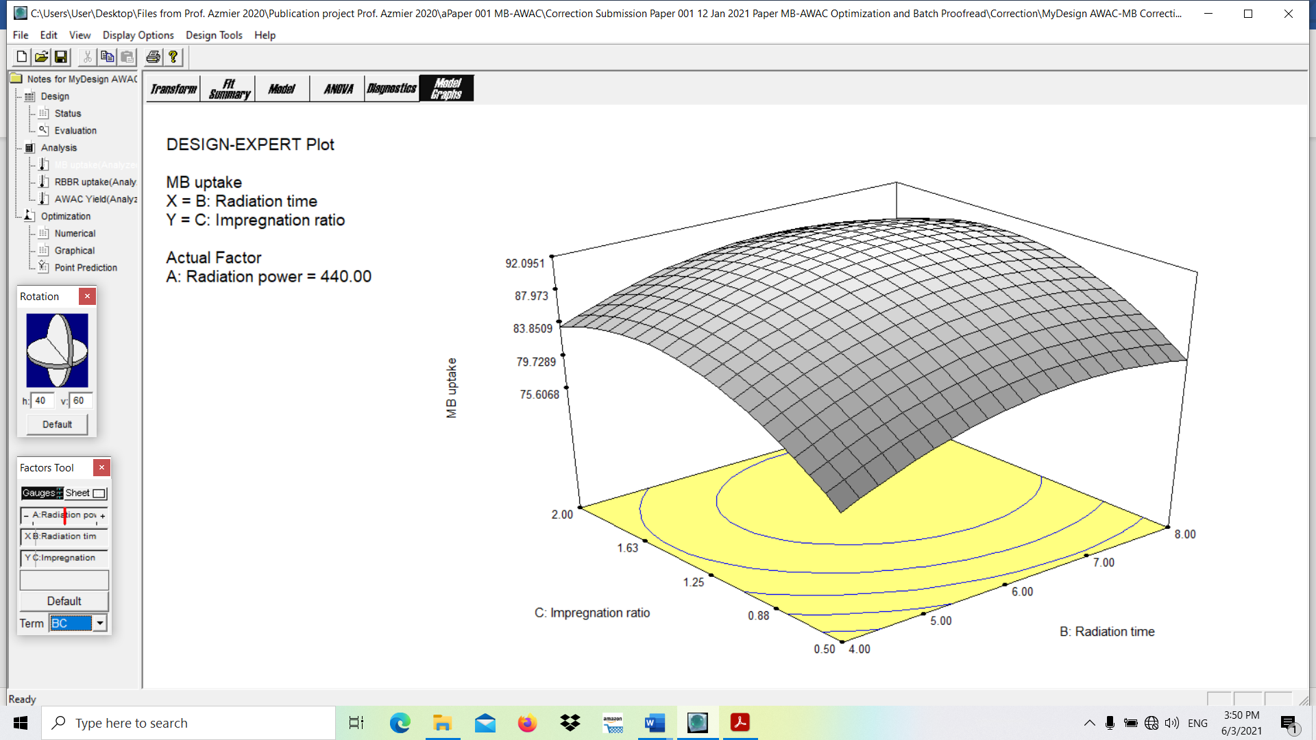  (b)
Fig. 1 3D surface plot of MB removal response for (a) effect of radiation power and radiation time and (b) effect of radiation time and IR

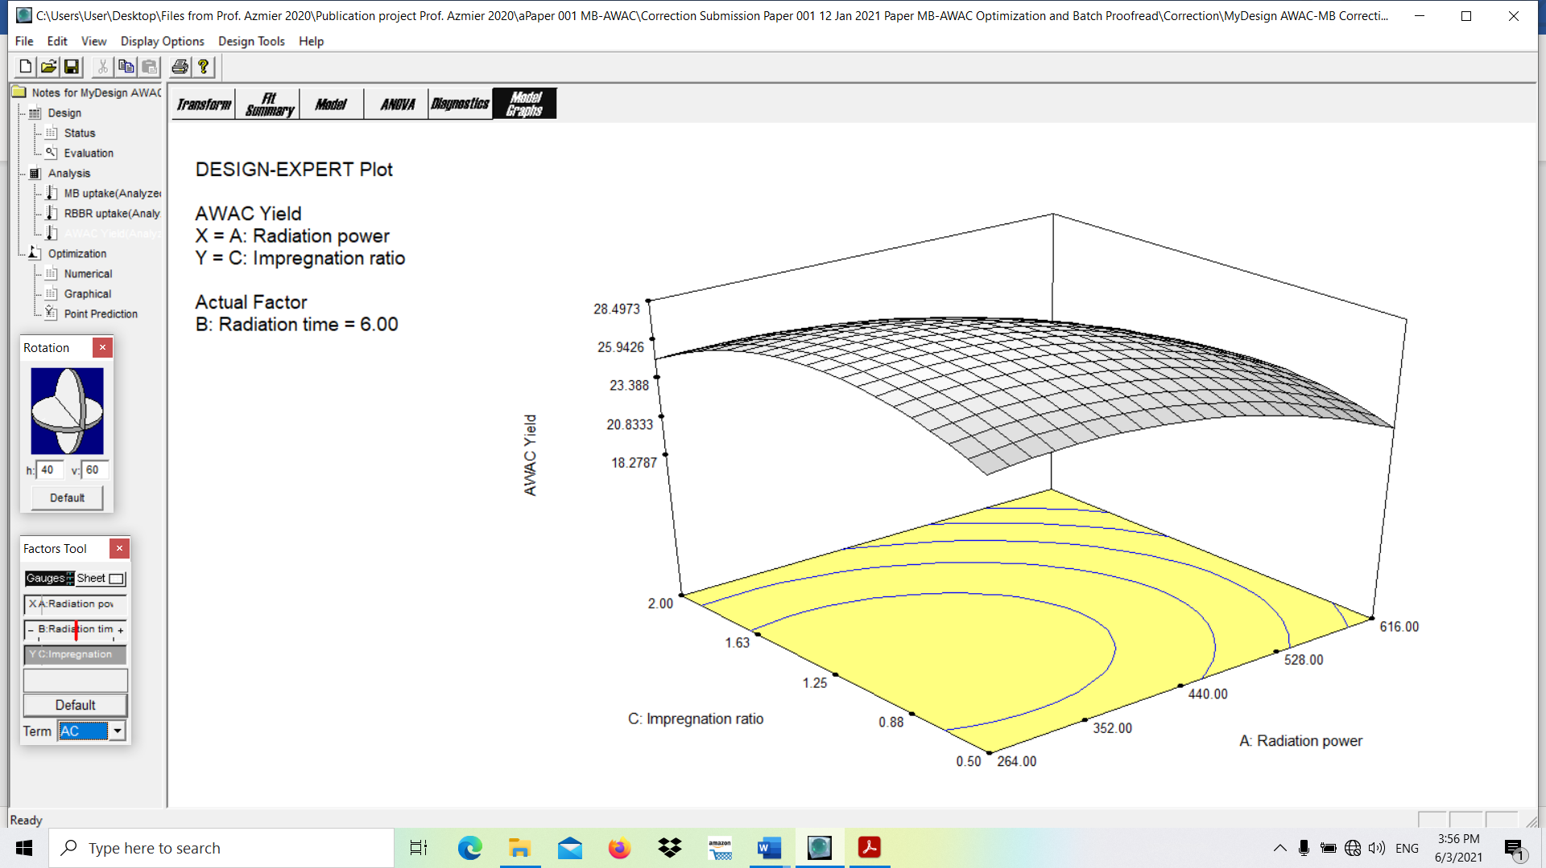  (a) | 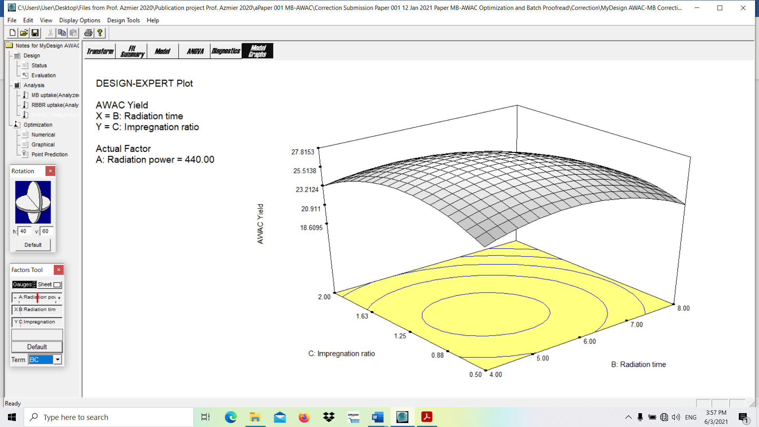  (b)
Fig. 2 3D surface plot of AWAC’s yield response for (a) effect of radiation power and IR and (b) effect of radiation time and IR

Supplementary Information - Equations in manuscript

$$IR= \frac{W_{KOH}}{W_{char}} (1)$$
where W_{KOH} is the weight of KOH pellet and W_{CHAR} is the weight of the char.

$$Yield= \frac{W_{f}}{W_{i}}ⵝ 100\% (2)$$
where W_{f} and W_{i} are dried weight of AWAC and dried weight of precursor, respectively.

$$Y= \left(b_{o}+ ε\right)+ \sum_{i=1}^{3}{b_{i}x_{i}+ \sum_{i=1}^{3}{b_{ii}x_{i}^{2}+\sum_{i=1}^{3}{\sum_{j=i+1}^{3}{b_{ij}x_{i}x_{j}}}}+e_{i} (3)}$$
where Y is the predicted response, b₀, b_{i}, b_{ij} and b_{ii} are the constant coefficient, linear coefficient, interaction coefficient and quadratic coefficient, respectively, x_{i} and x_{j} are the coded values of the AWAC preparation variables and e_{i} is the error.

$$q_{e}= \frac{\left(C_{o}-C_{e}\right)V}{W} (4)$$

$$\% Removal= \frac{C_{o}-C_{e}}{C_{o}} ⵝ 100\% (5)$$
where C_{o} and C_{e} are the concentration of MB dye initially and at equilibrium, respectively; V is the volume of solution (L), and W is the weight of AWAC used (g).

Langmuir (Langmuir, 1918):
$$q_{e}= \frac{Q_{m}K_{L}C_{e}}{1+ K_{L}C_{e}} (6)$$

Freundlich (Freundlich, 1906):
$$q_{e}= K_{F}C_{e}^{1/{n_{F}}} (7)$$

Temkin (Temkin and Pyzhev):
$$q_{e}=\frac{RT}{B}ln⁡(AC_{e}) (8)$$

Dubinin-Radushkevich (Redlich and Peterson, 1959):
$$q_{e}=q_{DR}exp\left[\frac{{\left(RT\ln\left(1+ 1/{C_{e}}\right)\right)}^{2}}{-2ε^{2}}\right] (9)$$
where Q_{m} is maximum adsorption capacity; K_{L} is the constant of Langmuir; K_{F} and n_{F} are constants of Freundlich; B and A are constants of Temkin, q_{DR} is the adsorption capacity, R is the universal gas constant, T is temperature and ɛ is free energy.

Pseudo-first order (PFO) (Lagergren, 1898):
$$q_{t}= q_{e}\left[1-exp\left({-k}_{1}t\right)\right] (10)$$

Pseudo-second order (PSO) (Ho and McKay, 1999)
$$q_{t}= \frac{k_{2}q_{e}^{2}t}{1+ k_{2}q_{e}t} (11)$$

Elovich (Aeenjan and Javanbakht 2017):
$$q_{t}= \frac{1}{β}ln \left(αβ\right) + \frac{1}{β}ln t (12)$$

Intraparticle diffusion (Boopathy et al. 2013):
$$q_{t}= k_{t,i}t^{\frac{1}{2}} (13)$$

Boyd plot (Islam et al. 2017):
$$B_{t}=-0.4977-ln \left(1-\frac{q_{t}}{q_{e}}\right) (14)$$
where k₁ is rate constant for PFO, k₂ is rate constant for PSO, α is sorption constant of adsorbate, β is constant of desorption, k_{t,i} is rate constant for intraparticle diffusion.

$$Error (\%)= \left|\frac{q_{e,exp}-q_{e,cal}}{q_{e,exp}}\right|×100\% (15)$$
where q_{e,cal} is the calculated MB uptake and q_{e,exp} is the experimental MB uptake.

$$ln K_{c}= \frac{ΔS°}{R} - \frac{ΔH°}{RT} (16)$$

$$∆G°= -RT ln K_{c} (17)$$

$$ln k_{2}=ln A- \frac{E_{a}}{RT} (18)$$
where ΔH° is the enthalpy change (kJ mol⁻¹), ΔS° is the entropy change (kJ mol⁻¹ K⁻¹), ΔG° is the Gibbs free energy (kJ mol⁻¹).

$$K_{c}= \frac{1000\frac{mg}{g} ×K_{L} ×molecular weight of adsorbate × {\left[adsorbate\right]}^{°}}{γ} (19)$$
where [adsorbate]° and ϒ are the standard concentration of the adsorbate, which concentration by definition is 1 mol/L at standard conditions and coefficient of activity of the adsorbate (dimensionless), respectively.

$$Y_{1}=91.33+4.21X_{1}+2.31X_{2}+3.29X_{3}-5.53X_{1}^{2}-3.72X_{2}^{2}-5.79X_{3}^{2}-0.83X_{1}X_{2}-1.02X_{1}X_{3}-0.61X_{2}X_{3} (20)$$

$Y_{2}=27.48-2.73X_{1}-1.63X_{2}-1.14X_{3}-1.93X_{1}^{2}-2.49X_{2}^{2}-2.92X_{3}^{2}+0.39X_{1}X_{2}-0.48X_{1}X_{3}-0.70X_{2}X_{3} (21)$

