Development of larvicide nanoemulsion from the essential oil of *Aeollanthus suaveolens* Mart. ex Spreng against *Aedes aegypti*, and its toxicity in non-target organism

**Supplementary Data**

**Fig. S1.** Chromatogram of the essential oil of *Aeollanthus suaveolens*.

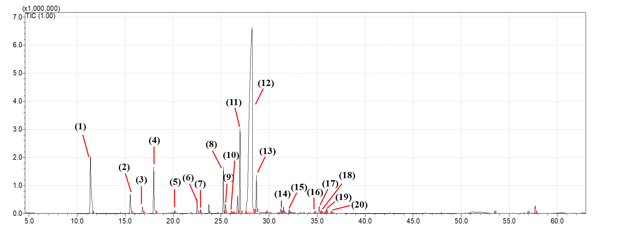

1- Linalol

12- Massoialactone

13- δ- Decalactone

14- Nerolidol <(E)->

15- Germacrene D-4-ol

16- Muurolol<epi-α->

17- Cadinol<α ->

18- Pentadecen-2-one<6Z

19- Bisabolol<epi-β>

20- Massoia Dodecalactone

2- α- Terpineol

3- Nerol

4- Geraniol

5- Carvacrol

6- Eugenol

7- Neryl Acetate

8- 2,5-Dimethoxy-p-Cymene

9- α-Santalene

10- (E)-α-Bergamotene

11- (E)-β-Farnesene

**Fig. S2.** Spectrum of mass from essential *Aeollanthus suaveolens* oil, obtained by GC-MS in comparison with equipment library spectrum.

**Substance (1)** - Linalool (tR = 11.400 min.)



Library Mass spectrum (ADAMS, 2017)

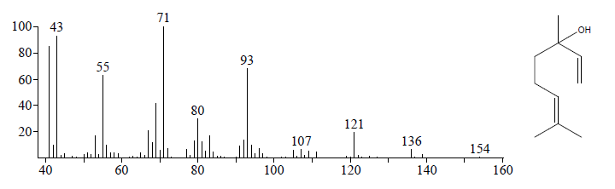

**Substance (2) -** α- Terpineol(tR = 15.542 min.)



Library Mass spectrum (ADAMS, 2017)

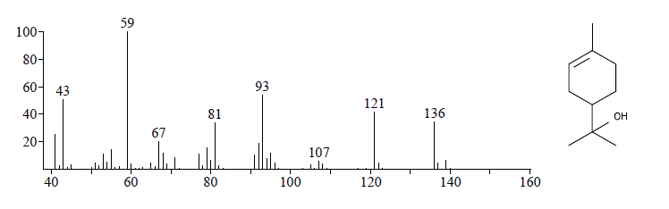

**Substance (3) -** Nerol(tR = 16.808 min.)



Library Mass spectrum (ADAMS, 2017)

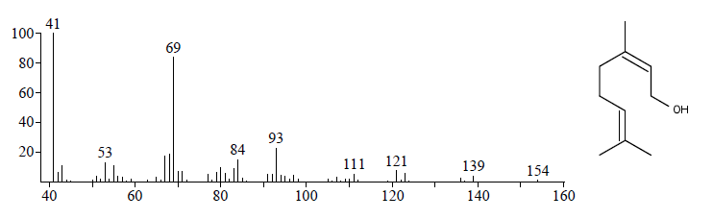

**Substance (4) -** Geraniol(tR = 17.983 min.)



Library Mass spectrum (ADAMS, 2017)

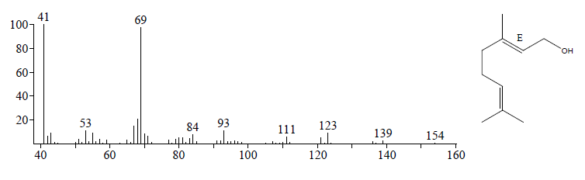

**Substance (5) -** Carvacrol(tR = 20.142 min.)



Library Mass spectrum (ADAMS, 2017)

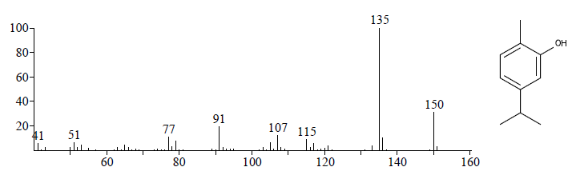

**Substance (6) -** Eugenol(tR = 22.492 min.)



Library Mass spectrum (ADAMS, 2017)

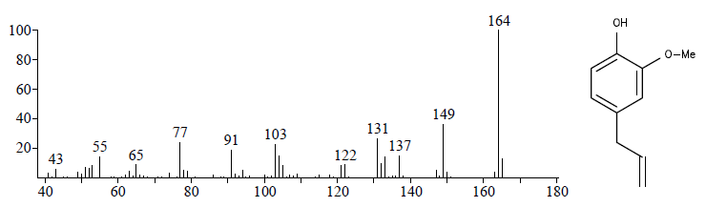

**Substance (7) -** Neryl acetate(tR = 22.850 min.)



Library Mass spectrum (ADAMS, 2017)

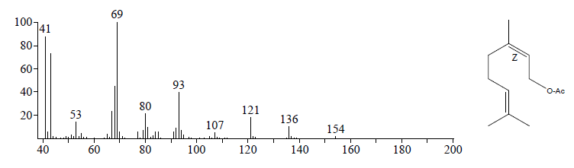

**Substance (8) -** 2,5-Dimethoxy-p-Cymene (tR = 25.233 min.)

Library Mass spectrum (ADAMS, 2017)

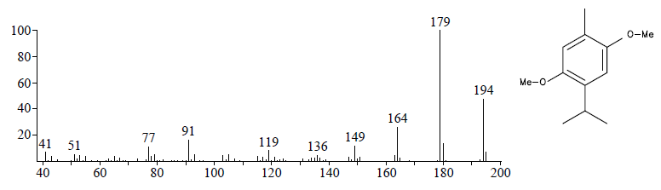

**Substance (9) -** α-Santalene (tR = 25.458 min.)



Library Mass spectrum (ADAMS, 2017)

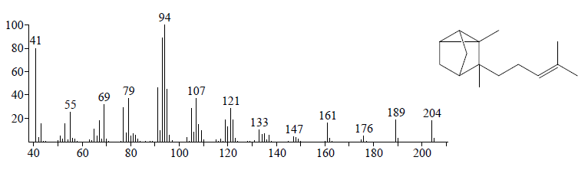

**Substance (10) -** (E)-α-Bergamotene (tR = 26.058 min.)



Library Mass spectrum (ADAMS, 2017)

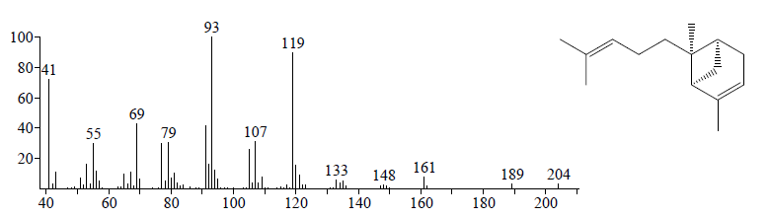

**Substance (11) -** (E)-β-Farnesene (tR = 26.967 min.)



Library Mass spectrum (ADAMS, 2017)

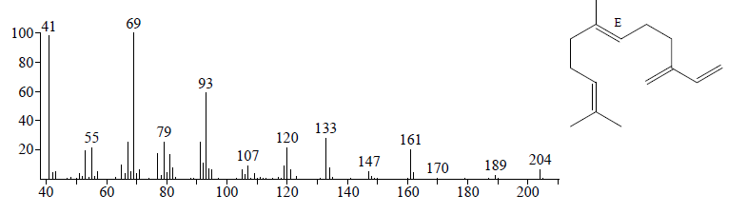

**Substance (12) -** Massoia lactone (tR = 28.225 min.)



Library Mass spectrum (ADAMS, 2017)

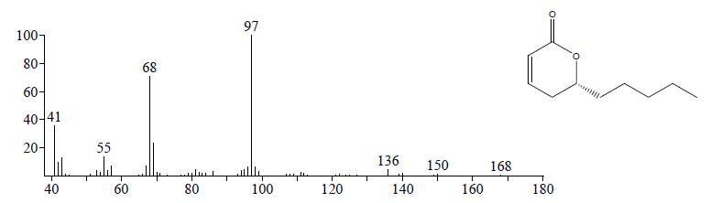

**Substance (13) -** δ- decalactone (tR = 28.683 min.)



Library Mass spectrum (ADAMS, 2017)

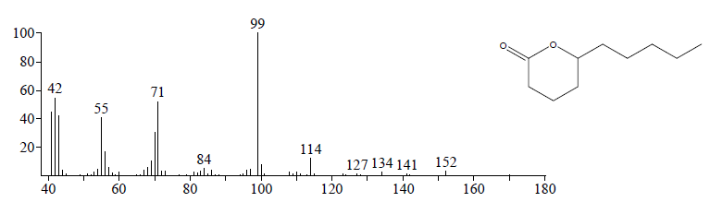

**Substance (14)-** Nerolidol <(E)-> (tR = 31.492 min.)



Library Mass spectrum (ADAMS, 2017)

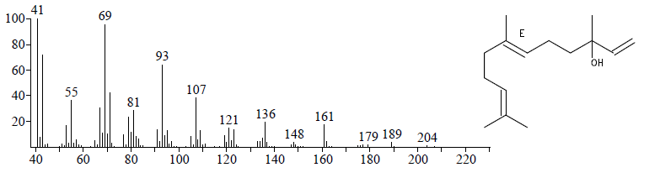

**Substance (15)-** Germacrene D-4-ol (tR = 32.075 min.)



Library Mass spectrum (ADAMS, 2017)

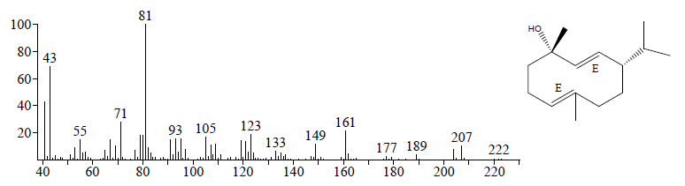

**Substance (16)-** Muurolol<epi- α -> (tR = 34.725 min.)



Library Mass spectrum (ADAMS, 2017)

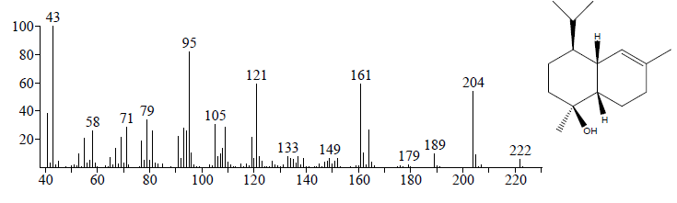

**Substance (17)-** Cadinol< α -> (tR = 35.208 min.)



Library Mass spectrum (ADAMS, 2017)

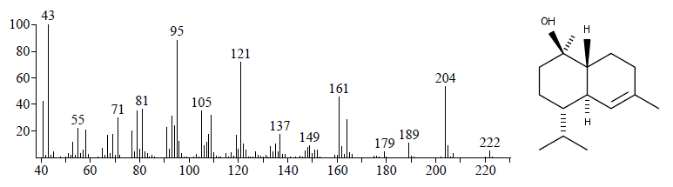

**Substance (18)-** Pentadecen-2-one<6Z-> (tR = 35.458 min.)



Library Mass spectrum (ADAMS, 2017)

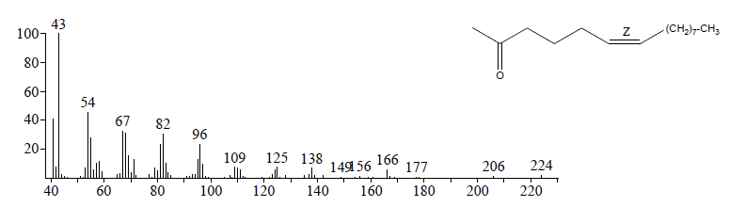

**Substance (19)-** Bisabolol<epi- β- -> (tR = 35.800 min.)



Library Mass spectrum (ADAMS, 2017)

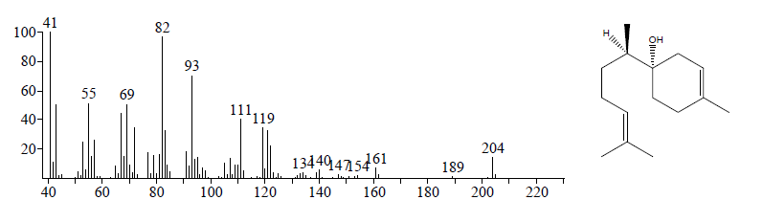

**Substance (20)-** Massoia dodecalactone (tR = 36.458 min.)



Library Mass spectrum (ADAMS, 2017)

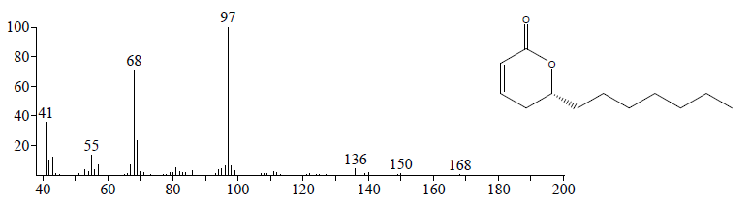

Table S1 Average particle size, polydispersity index and zeta potential during the preparation of nanoemulsions at different HBL values of *A. suaveolens* essential oil.

|  |  |  |  |  |  |  |  |  |  |  |  |  |
| --- | --- | --- | --- | --- | --- | --- | --- | --- | --- | --- | --- | --- |
| HBL | Day 1 | | | Day 7 | | | Day 14 | | | Day 21 | | |
|  | Size (nm) | Pdi | Zeta potential (mV) | Size (nm) | Pdi | Zeta potential (mV) | Size (nm) | Pdi | Zeta potential (mV) | Size (nm) | Pdi | Zeta potential (mV) |
| 10 | 177.7 ± 1.49 | 0.215 ± 0.01 | -34.8 ± 0.5 | 180.4 ± 0.80 | 0.190 ± 0.00 | -25.2 ± 0.41 | 180 ± 0.35 | 0.188 ± 0.01 | -28.3 ± 0.52 | 181.6 ± 0.95 | 0.181 ± 0.00 | -27.8 ± 0.2 |
| 11 | 133.7 ± 0.83 | 0.130 ± 0.00 | -27.3  ± 0.11 | 140.4 ± 0.20 | 0.112 ± 0.01 | -21 ± 0.7 | 141.5 ± 1.50 | 0.101 ± 0.01 | -22.6 ± 0.14 | 142.1 ± 0.20 | 0.100 ± 0.01 | -20.1 ± 0.7 |
| 12 | 115.1 ± 0.45 | 0.138 ± 0.00 | -14.8 ± 0.77 | 125 ± 0.72 | 0.093 ± 0.01 | -16.5 ± 0.05 | 123.1 ± 0.63 | 0.089 ± 0.00 | -14.2 ± 0.51 | 124.5 ± 1.15 | 0.093 ± 0.02 | -16.4 ± 0.32 |
| 13 | 115.3 ± 0.66 | 0.154 ± 0.01 | - 13 ± 0.6 | 131.9 ± 0.55 | 0.102 ± 0.00 | -13.7 ± 0.63 | 128.9 ± 0.43 | 0.073 ± 0.00 | -12 ± 0.1 | 129.4 ± 0.36 | 0.082 ± 0.02 | -13.4 ± 0.17 |
| 14 | 131.1 ± 0.60 | 0.154 ± 0.00 | -20.6 ± 0.4 | 151.1 ± 0.80 | 0.111 ± 0.00 | -10.3 ± 0.26 | 146.5 ± 0.95 | 0.125 ± 0.00 | -9.7 ± 0.9 | 146.3 ± 0.15 | 0.099 ± 0.01 | -10.16 ± 0.2 |
| 14.5 | 102.4 ± 0.3 | 0.158 ± 0.00 | - 40.9 ± 0.56 | 129.3 ± 0.83 | 0.079 ± 0.00 | -10.02 ± 0.95 | 118.1 ± 0.66 | 0.101 ± 0.01 | -7.49 ± 0.3 | 127.9 ± 0.85 | 0.091 ± 0.00 | -10.5 ± 0.5 |
| 15 | 104.83 ± 0.47 | 0.156 ± 0.01 | -13.63 ± 0.83 | 129.53 ± 0.40 | 0.120 ± 0.01 | -10.32 ± 0.53 | 113.26 ± 0.23 | 0.143 ± 0.02 | -10.23 ± 0.66 | 126.73 ± 0.20 | 0.125 ± 0.01 | -16.25 ± 1.48 |
| 15.5 | 153.2 ±1.01 | 0.124 ± 0.01 | -13.2 ± 0.3 | 170.7 ± 0.70 | 0.095 ± 0.02 | 11.4 ± 0.26 | 158.9 ± 0.21 | 0.089 ± 0.01 | -6.76 ± 0.55 | 172.3 ± 0.83 | 0.087± 0.01 | -11.3 ± .1.2 |
| 16 | 189.2 ± 1.97 | 0.081± 0.01 | - 10.5 ± 1.03 | 197.3 ± 0.55 | 0.102 ± 0.01 | -12.2 ± 0.41 | 192.2 ± 1.87 | 0.111 ± 0.01 | -13.6 ± 0.4 | 212.2 ±0.20 | 0.109 ± 0.01 | -7.86 ± 0.07 |