**Identification of phenolic compounds in Australian grown dragon fruits by LC-ESI-QTOF-MS/MS and determination of their antioxidant potential**

# Zhicong Chen1, Biming Zhong1, Colin J. Barrow2, Frank R. Dunshea1 and Hafiz A.R. Suleria1,2*

1School of Agriculture and Food, Faculty of Veterinary and Agricultural Sciences, The University of Melbourne, Parkville, VIC 3010, Australia

2Centre for Chemistry and Biotechnology, School of Life and Environmental Sciences, Deakin University, Waurn Ponds, VIC 3217, Australia

3Faculty of Biological Sciences, The University of Leeds, Leeds LS2 9JT, UK

Correspondence: [hafiz.suleria@unimelb.edu.au](mailto:hafiz.suleria@unimelb.edu.au)

# **ABSTRACT**

Dragon fruit has a high phenolic content which are the main contributors to the antioxidant potential and associated health benefits. Although some phenolics in dragon fruits have previously been reported, a comprehensive analysis of complete phenolic profile of the Australian grown dragon fruit varieties has not been conducted. Thus, the aim of this study was to extract, identify and quantify phenolics from Australian grown dragon fruits. The results showed that red dragon fruit had a higher phenolic content and stronger antioxidant potential (DPPH, FRAP, ABTS and TAC) as compared to white dragon fruit. The LC-ESI-QTOF-MS/MS characterized a total of 80 phenolics including phenolic acids (25), flavonoids (38), lignans (6), stilbene (3) and other polyphenols (8) in all dragon fruits. From HPLC, phenolic concentration was higher in peels as compared to pulp. This study provides supportive information for the utilization of dragon fruits as ingredients in food, feed, and nutraceutical products.

**Keywords**: Dragon fruits; phenolic compounds; polyphenols; antioxidant potential; LC-ESI-QTOF-MS/MS; HPLC-PDA

**(A)**



**(B)**



**(C)**



**(D)**



**(F)**



**(G)**



**(H)**



**(I)**



**Figure 2S:** LC-ESI-QTOF-MS/MS basic peak chromatograph (BPC) for characterization of phenolic compounds in dragon fruits; **(A)** White dragon fruit peel in negative mode; **(B)** White dragon fruit peel in positive mode; **(C)** Red dragon fruit peel in negative mode; **(D)** Red dragon fruit peel in positive mode; ; **(E)** White dragon fruit pulp in negative mode; **(F)** White dragon fruit pulp in positive mode; **(G)** Red dragon fruit pulp in negative mode; **(H)** Red dragon fruit pulp in positive mode.

**(A)**



**(B)**



**(C)**

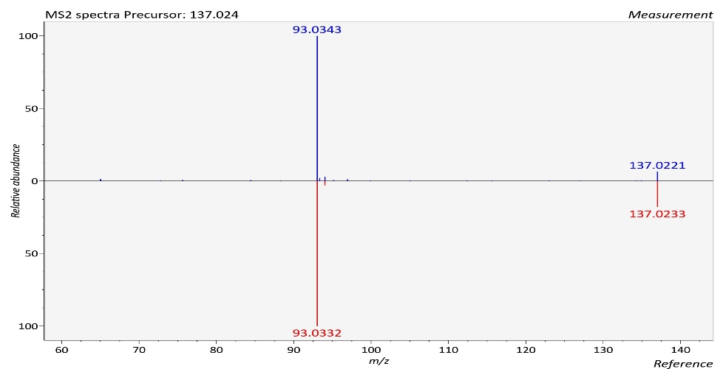

**Figure 3S.** The LC-ESI-QTOF-MS/MS characterization of 2-hydroxybenzoic acid; (**A**) A chromatograph of 2-hydroxybenzoic acid (Compound 3, Table 2), in the negative mode of ionization [M – H]− identified in DRL; (**B**) Mass spectra of 2-hydroxybenzoic acid with observed/precursor of *m/z* 137.0246; (**B**) MS / MS spectrum of 2-hydroxybenzoic acid reflecting the product ion of *m/z* 93, confirmation via online LC-MS library and database. Fragmentation of 2-hydroxybenzoic acid in negative mode [M – H]−, with precursor of *m/z* 137, showing product ion of *m/z* 93 due to the loss of a CO2 (44 Da).